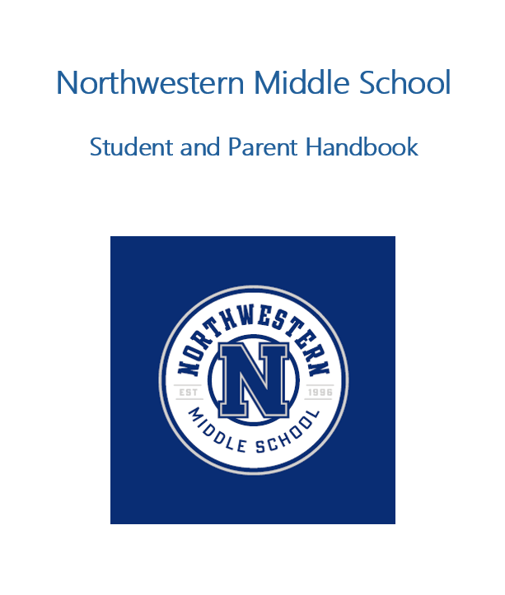


Wildcat Country!

Welcome to the 2026–2027 school year! I am honored to serve as your principal as I begin my 2nd full year. Since 1996, Northwestern has proudly served students in the Crabapple community, and our dedicated staff continues to uphold our school’s legacy of excellence. Each day, we strive to provide an educational experience that has a lasting impact on our students and families.
I grew up in Lilburn, Georgia, and am a proud graduate of Georgia State University. My wife, Saira, and I have two daughters, Audriana and Hannah. On the weekends, you’ll likely find us cheering them on at their soccer or basketball games.
As your principal, I want every student to feel confident in the caring adults who support them here at Northwestern. We are committed to building meaningful connections that extend beyond the classroom. Each student’s academic growth, as well as their social and emotional well-being, is at the core of everything we do.
Our staff shares a common vision: to show that we are ALL IN for our students. Our primary goal will always be to help every student achieve success. The teaching and learning that takes place each day are the core of our work, and our partnership with our families—is essential to helping every Northwestern student reach their full potential.
Thank you for your continued support of Northwestern Middle School. I look forward to a wonderful school year together!

Haaris Quraishy
Principal, Northwestern Middle School

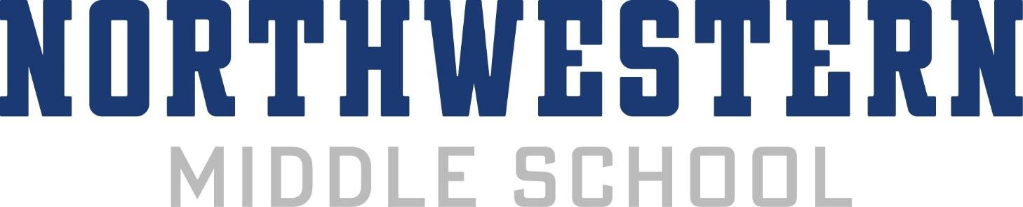

12805 Birmingham Highway, Milton GA 30004
Phone: (470) 254-2870
Email: nmsfrontdesk@fultonschools.org
Northwestern Website: https://www.fultonschools.org/northwesternms
Fulton County Schools Website: https://www.fultonschools.org
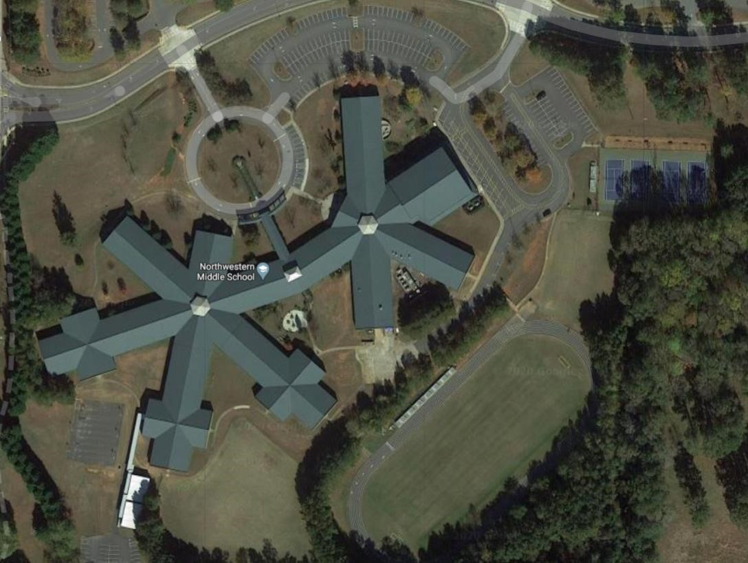

Northwestern Middle School Profile
Located in the historic Crabapple community in the northwestern corner of Fulton County, Northwestern Middle School (NMS) was established in 1996. It was named for Northwestern Elementary School, which served area students from 1933 until its closing in 1992. The newest Northwestern opened with a sense of tradition as well as a vision toward the future.
The school serves sixth, seventh, and eighth graders who live in the communities of Roswell, Alpharetta, and Milton.
Northwestern Middle School Mission Statement
Northwestern Middle School is committed to challenging our students to strive for academic excellence and personal growth.
Northwestern Middle School Vision Statement
We are committed to becoming a model middle school by:
- Achieving academic excellence through engaged learning
- Displaying respect and confidence
- Embracing the Northwestern Community
- Fostering productive citizens in a global, digital
- Facilitating and inspiring lifelong learners

School Governance Council Overview
The purpose of the School Governance Council is to provide parents, school staff, and community members with a leadership role in the management of the school. The School Governance Council is a governing body that is representative of the community and the school but operates under the control and management of the Board of Education. The Council is responsible for making decisions regarding the strategic direction of the school including:
- Approve the school strategic plan and updates
- Approve the annual budget and annual resource allocations
- Participate in hiring the principal (in the case of a vacancy)
- Provide annual feedback on principal performance.

School Governance Council Members for School Year 2026-27

Northwestern Middle School Administration


Principal, Haaris Quraishy
Email: quraishyh@fultonschools.org


6th Grade Assistant Principal, Amber Manganelli
Email: Manganellia@fultonschools.org

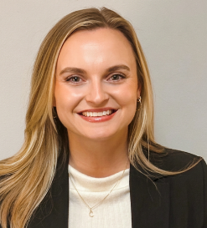

7th Grade Assistant Principal, Lauren Pritchard
Email: PritchardL@fultonschools.org


8th Grade Assistant Principal, Latoya Tolefree
Email: tolefree@fultonschools.org
SCHOOL CALENDAR FOR THE 2026-27 SCHOOL YEAR
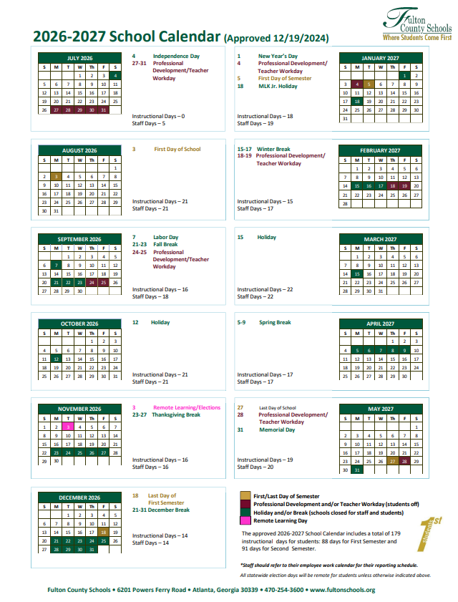

Northwestern Middle School Operations
Front Office Hours: 8:05 am – 4:30 pm
Clinic Hours: 8:25 am – 4:05 pm
Breakfast Hours: 8:30 am – 8:50 am
Media Center Hours: 8:30 am – 4:00 pm School Year 2026-27 Bell Schedule:

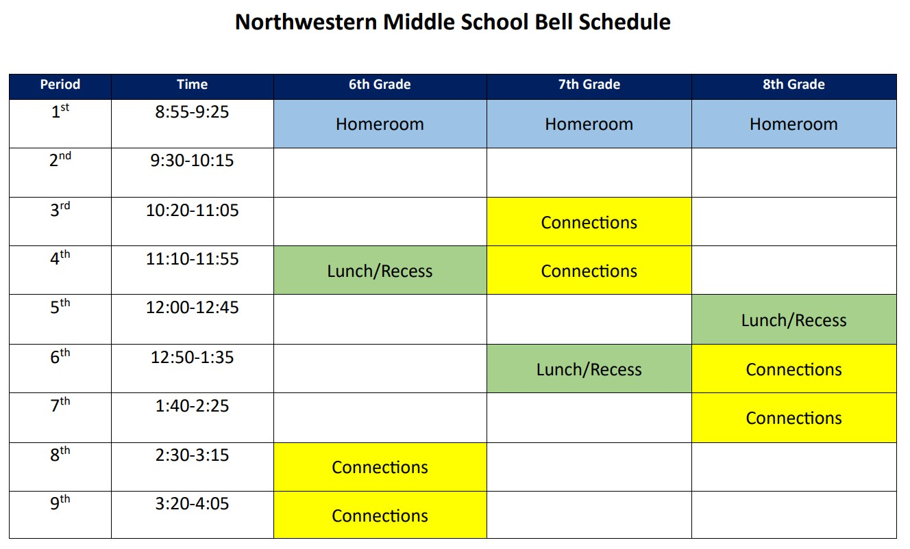

NMS School Leadership Team
Connections/CTAE/Music | Ms. Tara Romero |  | romerot@fultonschools.org
English Language Arts | Ms. Christie Street |  | street@fultonschools.org
Health/Physical Education | Mr. Jeff Montgomery |  | montgomeryj@fultonschools.org
Mathematics | Ms. Sherri Wylie |  | wylie@fultonschools.org
Media Center (METI) | Ms. Alison Tripp |  | tripp@fultonschools.org
Reading | Ms. Lisa Nickel |  | nickell@fultonschools.org
Science | Ms. Tracy Miller |  | MillerTA@fultonschools.org
Social Studies | Mr. Michael Brennan |  | brennanm1@fultonschools.org
Special Education/IRR | Ms. Kelley Hummel |  | hummelk@fultonschools.org
Special Education/MIMO | Ms. Jennifer Rindt |  | rindtj@fultonschools.org
Talented and Gifted (TAG) | Ms. Trinita Marshall |  | MarshallT5@fultonschools.org
World Language | Ms. Katherine Ziolkowski |  | ziolkowski@fultonschools.org
NMS Counseling Department
Website: https://northwestern.fultonschools.org/academics/counseling-department
Grade | Counselor | Phone | Email
6th | Jeanette Pena | (470) 254-8529 | penaj@fultonschools.org
7th | Jody Glude | (470) 254-8522 | GludeJ@fultonschools.org
8th | Euodia Harris | (470) 254-8520 | harrise1@fultonschools.org

NMS Student Support Staff
Student Support Role | Name | Phone | Email
Assistant Administrator | Julie Godfrey | (470) 254-2875 | godfreyj@fultonschools.org
School Improvement Coach/MTSS | Michelle Robbins | (470) 254-8531 | robbinsm2@fultonschools.org
Instructional Support Teacher | Mary Beth Tokarz | (470) 254-8515 | tokarzm@fultonschools.org
School Social Worker | Tamala Hodges | (470) 254-3600 | hodgest@fultonschools.org
Section 504 Coordinator | Erica Esslinger | (470) 254-2879 | esslinger@fultonschools.org
School Psychologist | Cindy Vinson | (470) 254-7885 | vinsonc@fultonschools.org

Clinic
Cluster Nurse: Marian Buckle – bucklem@fultonschools.org
Clinic Assistant: Sheana Jewell - jewells@fultonschools.org

Nutrition
Cafeteria Manager: Mr. Theo Smart – smartt@fultonschools.org
Menu Calendar - https://nutrition.fultonschools.org/MenuCalendar
Fulton County Schools Online Free and Reduced Application
School meals offer all five food groups at an incredibly wallet-friendly price. Prices cover food and operational expenses to prepare the food.

Transportation
Northwestern MS Transportation Administrator: Latoya Tolefree – tolefree@fultonschools.org
Transportation Supervisor: Ethan Martin – martinej@fultonschools.org
Transportation North Phone: (470) 254-2970
Here Comes The Bus – Download the App
- Download the Here Comes The Bus app on Google Play or the Apple App Store or visit www.herecomesthebus.com.
- Click the "Sign Up" button
- Enter school code: 87428
- Click "Next" followed by "Confirm"
- Complete the "User Profile" box
- Under "My Students," click "Add." Enter your child's last name and student ID number 7. Once you confirm your information, you're ready to go!

How does "Here Comes the Bus" work?
"Here Comes the Bus" uses global positioning system (GPS) technology to locate and track your child’s school bus. It is powered by software from Synovia Solutions, who are experts at tracking data, which they’ve been providing to fleet managers across North America for over 15 years.

How much does it cost?
"Here Comes the Bus" is available at no cost to all families. It's free!

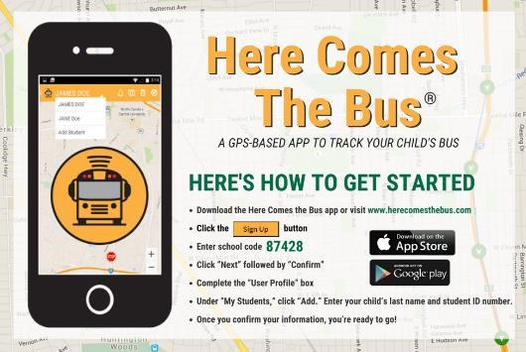

Student Arrival
- Any student entering the building before 8:45 AM will report to either the gym or the cafeteria.
- Our building will continue to open for all NMS students at 8:05 AM.
  - From 8:05–8:25, students will report to the cafeteria.
  - At 8:25, 6th and 7th graders will move to the gym, while 8th graders will remain in the cafeteria.
- At 8:45 AM, students will be dismissed to their first-period class.
- Carpool and bus arrival will remain the same.

Northwestern Middle School cannot assume responsibility for students prior to 8:05 am.
Only students who have teacher permission will be allowed to attend a help session prior to 8:30 am.

Student Dismissal
Car riders, bike riders, and walkers will be dismissed at 4:05 pm and exit the school using the main entrance and Wildcat Den doors. Bus riders will be dismissed at 4:05 pm to the gymnasium (6th/7th) and cafeteria (8th) until dismissed by staff to load their bus.

Please ensure your student(s) know how they are getting home every day. Please contact the front office to gain help the support for changes.

Attendance
FCBOE Policy JBD Absences and Excuses
The Board supports vigorous enforcement of Georgia's Compulsory School Attendance Law which makes school attendance the responsibility of the parent and the student. When possible, parents should avoid scheduling or arranging activities that require absences during the school day due to the detrimental impact on the student’s access to, and progress in, their educational program. Any child in the state of Georgia subject to compulsory attendance who during the school calendar year has more than five (5) days of unexcused absences is considered truant.

Late Arrival – Any time a student arrives after the beginning of the instructional day.
- Late arrivals follow the same rules for excused and unexcused as listed below
- Late arrivals follow the same rules for documentation but have different thresholds (see below) Early Checkout – Any time a student leaves school before the end of the instructional day.
- Early Checkouts follow the same rules for excused and unexcused as listed below
- Early Checkouts follow the same rules for documentation, but have different thresholds (see below)
Tardy – Any time a student arrives after the beginning of a specific class period.
- Tardies will be handled at the school level with guidance from the principal

Excused Absences – A hold harmless absence that has been documented, and relates to one of the following circumstances in accordance with State Board of Education Rule 160-5-1.10 and Georgia State Code, O.C.G.A. 20-2-690.1:
- Personal illness or when attendance in school would be detrimental to the health of the student or others
- A serious illness in the student’s immediate family necessitating absence from school
- A death in the student’s family necessitating absence from school
- Observance of religious holidays necessitating absence from school
- Compliance with a court order or an order issued by a governmental agency mandating an absence from school
- Visitation with an immediate family member who is on leave from or is being deployed to military service
- Important family events/celebrations for an immediate family member (graduation, wedding, religious ceremony, etc.)
- Compliance with an order for a pre-induction physical examination for service in the armed forces
- An absence for registering to vote or participating as an active voter in a local, state, or federal election
- A verified interview for college admission or a documented college visit
- A specialized, supplemental, or extracurricular program/event
- Other absences pre-approved by the principal

Unexcused Absence – Any absence not accompanied with a note or documentation or any absence that does not relate to the circumstances listed above is considered unexcused. The following non-exhaustive list includes examples of unexcused absences:
- Bad weather
- Missing the school bus
- Car trouble
- Shopping
- Babysitting
- Oversleeping
Northwestern Late Arrival Procedure: Parents/guardians should send a note with their student when he/she arrives late to school. Students who are late arrivals must report to the front office before reporting to class. Parents do not need to accompany their students into school for a late arrival.

Northwestern Early Checkout Procedure: If a student needs an early checkout before normal dismissal time, a note from the parent or guardian requesting early check out must be sent to school with the student. The student will show their teacher the note to be dismissed from class to come to the office at the time indicated on the note. Parents must sign out their student in the front office. In an emergency, a parent/guardian or approved individual may come directly to the office to request an early check out for their student. Approved individuals must be listed in Infinite Campus - no exceptions.

Parents/guardians or approved individuals must have a government issued driver's license or picture ID to check out their student(s) Only approved individuals listed in Infinite Campus can check out a student.

No early checkouts after 3:00 pm unless there is an emergency or have received prior admin approval. Parents, please help us with this as this supports our dismissal process.

Absences Recorded as Present:
- Per State Board of Education Rule 160-5-1-.10 and O.C.G.A. 20-2-692 & 20-2-292-2, students must be counted present under the following instances:
  - A student who is a Student Teen Election Participant (Maximum Two Days Per Year)
  - A student who is serving as a page in the Georgia General Assembly
  - A foster care student who attends court proceedings relating to the student’s foster care
- Per Fulton County Schools, students must be counted as present under the following instances:
  - Students attending a school field trip or other school-sponsored event
  - Students participating in dual enrollment or virtual school classes
- Students can substitute up to 5 absences per semester (a max of 10 per year) with a remote learning day by meeting the remote learning participation benchmarks (listed below). This would result in the student being counted as present for the day(s) they participate remotely.
Remote Learning Attendance:
Students should meet the following participation benchmarks to receive credit for attending in a remote learning setting:
- Middle & High School (Period Attendance)
- Must participate in at least over half of the school day to be given credit for attendance or participates asynchronously as defined by the teacher
To be considered absent but present, work that is assigned must be submitted within 2 days of absence. Students may not use a remote learning day on a summative assessment day.

Documenting illness or the illness of family members:
- After 3 consecutive absences, late arrivals, or early checkouts, a doctor’s note must be required
- After 7 cumulative absences and/or 10 cumulative late arrivals or early checkouts, a doctor’s note will be required for any subsequent illness-related absences, late arrivals or early checkouts
- If there is an on-going medical circumstance that requires a student to be absent, late, or checkout early from school frequently or intermittently, a doctor’s note will be required to address medical concerns and need for absences
  - In the event of a serious illness in the student’s immediate family, schools may require students to present medical documentation regarding the family member upon return to school for validating the excused absence, tardy, or early checkout

Documentation Requirements
Documentation for any absence type should be provided within five days of returning to school for an absence to be excused. Parents and/or guardians may send an email or handwritten note to the school to document a student absence. If needed, the principal or designee will verify the email address and the credibility of the email. The following should be included in all documentation:
- Student Name
- Student FCS ID Number (lunch number)
- Parent/Guardian Name
- Parent/Guardian Email & Phone Number
Excuses will be kept on file at the school for the duration of the student’s enrollment.

Northwestern Procedure: when a student is absent for any reason, a note from the parent/guardian can be brought to the front office or you can send an email with an attached note to nmsfrontdesk@fultonschools.org.

Any student who accumulates seven or more days in a given school year for any reason, will be required to provide additional documentation (doctor’s note, court order, etc.) for any subsequent absence, whether that absence be excused or unexcused. This excludes days accumulated during an Assigned Remote designation.

Student attendance records shall be corrected from unexcused to excused after proper documentation is provided.

Family Events and Pre-Approved Absences
Students/families must formally request for students to be absent for family events or other pre-approved absences. These requests should be made five school days in advance of the absence. Schools should create their own procedures to collect and approve requests for absences related to family events and/or other pre-approved absences. Only the principal or assistant principal(s) can approve these absence requests.

Northwestern Procedure: students/families requesting a pre-approved absence should email their grade level Assistant Principal in advance of the absence.

Before approving these requests, school administration should consider the student’s complete attendance record including excused, unexcused, disciplinary, or other absence types. The school administration should also consider the student’s academic standing before approving these absences.

If a student is absent for 10 or more consecutive days due to international travel, the student should be withdrawn from their school and then re-enrolled upon their return.

Middle & High School Attendance Messages
- Middle/High School attendance calls begin going out around 4:30 p.m. on the day of the absence.
- If your student is absent or misses one or more periods of the school day, they will be marked with an "A" (for absent) in our attendance system, and you will receive an automated phone call and email message to the designated contact info you provided in Infinite Campus. This includes excused absences that are approved in advance.
- Errors can occur and if you feel you received a phone call by mistake, contact your school front office to verify that your student’s attendance record is accurate.
- If your student's absence was unexpected, please remember to send a note when they return to school so the absence can be marked "excused" in the system.
Make-Up Work
Schools and teachers will make a good faith effort to have structures in place to clear late/missing assignments before grades are impacted.

When a student has missed instruction, the teacher should work with the student to ensure the delivery of content before the student is assessed.

Should there be an extenuating circumstance for a prolonged absence and/or missing assignments/assessments and/or tasks, the teacher and student will create an appropriate plan to deliver content and assess student learning. (Cross Reference: Policy IHA Grading and Reporting.)

Each school is required to notify the parent, guardian or other person who has control or charge of the student when a student accrues the following:
- Three consecutive unexcused absences without notification from parents
- Five cumulative unexcused absences
- Seven cumulative absences
- Ten late arrivals or early checkouts
Communication should include, at a minimum, the importance of attending school and the total number of attendance records to date.
After two (2) reasonable attempts to notify the parent, guardian or other person who has charge of the student the school shall send a written notice via first class mail.

Visitors to Northwestern
FCBOE District Policy KM Visitors to Schools
A. Limitations on Who May Visit
To ensure the safety and confidentiality of students, the System limits visitors to:
- The parents/guardians of current students.
- Other family members of current students who are approved by the student’s parent/guardian;
- Those persons invited by the System for official business, which may include delegations of students participating in out-of-system visits, and outside service providers who currently provide private educational or therapy services to a student.

B. Provisions for All Visitors
To minimize disruption to the instructional program, visits to classrooms or programs or requests to meet with specific personnel must comply with the following guidelines:
- All visitors must sign in at the school’s main office and obtain permission to visit any part of the school.
- Visits generally require notice at least 24 hours in advance.

Upon a visitor’s first entry to a school, each visitor presents a government-issued ID which is handed to a Fulton County Schools main office employee for visual verification and then scanned by the Driver’s License Scanner. The government-issued ID will be returned to the visitor immediately. Visitor

Management System does not store a copy of the driver’s license. First name, last name, DOB, photo, and first four digits of the license number are stored in our database for visitor and volunteer purposes only.

School Volunteers
FCBOE District Policy IFCD School Volunteers
Local school principals are charged by the Board of Education with responsibility to develop programs which utilize the services of volunteers to support the school. All volunteers who will be working directly with students of the school must complete the on-line Volunteer Registration Process each year.

On school property during the regular school day, volunteers and other non-System personnel should be observed at all times by appropriate System employees or be in an open area of the school building. When this is not possible, no less than two volunteers or non-System personnel must be present when a volunteer is engaged with an individual student.

A school volunteer is a non-paid person who serves in an auxiliary capacity under the direction and supervision of school personnel. A volunteer is one who performs duties that an employee could perform such as making copies, filing, sorting, escorting students, assisting with lunch duty media center or front office tasks. Any person who leads or assists students (other than their own student) in programs or tutors a student(s) is considered a volunteer.
Please visit the FCS Volunteer website for more information: https://www.fultonschools.org/volunteer

Deliveries for Students at School
NMS will not accept deliveries of flowers, balloons, and other items for students, even if they have already been pre-paid. These items create a disruption during the school day.

NMS will not accept deliveries from Doordash, Ubereats, any other food delivery service, or directly from restaurants for students, even if they have already been pre-paid. The school has no way to verify these meals purchased by a student's parent/guardian. This is a student safety issue, and your cooperation is greatly appreciated.

Any item (such as lunches, instruments, PE clothes, projects, homework, etc.) delivered to school by parents/guardians will be held in the office until the student comes to claim it. Students will NOT be called to the office for deliveries.

Student Backpack Policy
It is Northwestern policy that students will use their locker periodically during the school day, with regular opportunities to access their school materials and supplies.

Student lockers are 29" tall, 12" wide, and 11" deep. Please be mindful of these dimensions when purchasing a backpack, lunch box, and other school supplies for your student(s).

We recommend backpacks that are no bigger than 18"x15"x9" so it fits easily in the locker.

Students may carry their school issued device in their backpack during the school day and use the assigned device case issued by FCS.

Student Conduct and Support

https://www.fultonschools.org/all-departments/academics/student-services/student-discipline/student-code-of-conduct-discipline-handbook
Investigation
When an administrator receives information of an alleged disciplinary rule violation, he/she should investigate to determine whether the charge or complaint has a basis in fact. Such investigation may include, but not necessarily be limited to, an interview with the charged student or students, interviews with witnesses, if any, and an examination of any relevant documents, including written statements from teachers, staff and student witnesses.
Based on the evidence available, the administrator will determine whether a disciplinary rule(s) was violated. If the local school administration is uncertain as to the interpretation of the Code of Conduct, they are to contact the system office of student discipline.
Searches
School officials are authorized to conduct reasonable searches of students, staff and visitors pursuant to applicable law. When reasonable suspicion exists, school officials may search students whom they believe have either violated a law or rules of the school. The scope of the search will be reasonably related to the purpose of the search and not excessively intrusive considering the age and gender of the student and the nature of the suspected infraction.
School computers and school technology resources, as defined below, are not private and are open to school review at any time. Student lockers, desks and all school and classroom storage areas are school property and always remain under the control of the school. These areas are not private. Periodic general inspections of these areas may be conducted by school authorities for any reason at any time without notice, and without student consent.
Disciplinary Consequences
Once it has been determined that a rule(s) was violated, the Principal or designee will afford the student oral or written notice of the charges. If the student denies the charges, he/she shall be explained the evidence the school authorities have and an opportunity to present his/her side of the story.
The administrator will follow a progressive discipline process. The degree of discipline to be imposed by each school administrator will be in proportion to the severity of the behavior of the student and will consider the student's discipline history, the age of the student and other relevant factors. Disciplinary consequences may include local interventions, in-school suspension (ISS), short-term suspension, long-term suspension, expulsion and/or referral for a disciplinary hearing. Disciplinary hearings may result in assignment to an alternative education program, long- term suspension, expulsion, or permanent expulsion from all Fulton County schools.

Lost and Found
Personal items that have been left behind in common areas or in classrooms will be collected and stored in our lost and found room. Students may check lost and found daily before school from 8:25 am – 8:50 am. Students should contact their grade level Assistant Principal to check lost and found other than before school. Students may also go to the front office for added support.

RRRoar: Be Ready, Be Respectful, and Be Responsible
RRRoar is Northwestern Middle School’s PBIS (Positive Behavior Interventions and Supports) program. The goal of the RRRoar system is to increase student responsibility and achievement. By meeting the expectations outlined in the RRRoar Behavior Essentials matrix, students will earn recognition and realize academic success and personal growth. RRRoar is the Wildcat Way!
In order for students to be successful, students should be…
- Ready
- Respectful
- Responsible

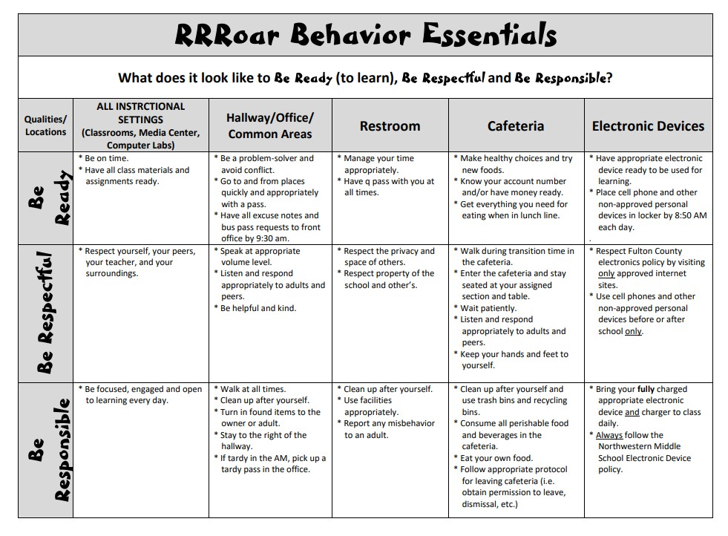
Academic Departments
Parent Expectations and Responsibilities

FCBOE District Policy KD Parent Expectations and Responsibilities
The following statement on the expectations and responsibilities of parents has been adopted by the Board of Education to describe the role of the parent and the role of the school in the attainment of a relationship that will support a successful school experience for each student.

Every parent can expect to:
- be treated with courtesy by all members of the school staff.
- have the opportunity to review school and school district rules, procedures, and policies
- be informed of the process for providing input into rules, procedures and policies
- expect that the local school and/or central office will return calls and acknowledge requests for information in a timely manner
- inspect his or her student's education record and participate in a records amendment process as permitted by the Family Educational Rights and Privacy Act (FERPA)
–can view all data and instruments used to determine a student’s placement to the extent that, and in a manner that does not invalidate/compromise an instrument or violate copyright, intellectual property rights and/or contractual obligations
- can request a waiver for their student to be placed beyond the on-level curriculum in certain subjects
- be accorded due process in resolving issues of the special education placement or program for his or her student
- the school district will further the progress and improvement of his or her student
- expect that reasonable attempts will be made by school personnel to ensure the timely posting of and receipt by parents of grades, report cards, important school news and messages
- expect reasonable supervision for his or her student while under school
- be aware of opportunities for parent involvement
- be made aware of educational and cultural programs available to students.

Every parent has the responsibility to:
- provide for the physical needs of the student.
- prepare the student emotionally and socially to make the student receptive to learning and discipline; - have the student attend school regularly and on time;
- encourage and lead the student to develop proper study habits at home and encourage the student to complete homework assignments.
- know school requirements and procedures.
- share concerns and communicate to prevent misunderstandings.
- discuss problems with the appropriate person or person closest to his or her student.
-support students’ ability to be responsible digital citizens;
- treat staff members with courtesy and respect; and
- work for the success and improvement of the school program.
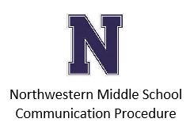
Communication
At Northwestern Middle School, we believe effective and timely communication is essential to our mission. NMS staff, students, and parents/guardians should maintain open, honest, and respectful lines of communication.
Students and parents are strongly encouraged to communicate directly with their teacher(s).
Our teachers pledge to be sensitive to your concerns and to partner with you to solve any problem.

Parents and Students
- Speak directly to the teacher. All students are encouraged to express their concerns directly to their teacher. If you are concerned about an issue involving your student’s education, classroom experience, or class grade, go right to the source and contact the teacher. Teacher emails are found on the Northwestern website at Staff - Northwestern Middle School (fultonschools.org) . Teachers will make every effort to get back to you as quickly as possible, but it may take a day or two. Please be patient. If you and the teacher cannot reach a resolution, proceed to the next step.

- Depending on the nature of your concern, please contact:
- Grade Level Counselor or Department Chair If you need an update on your student’s. If your concern is about the course progress (academic or behavior), content or curriculum, contact the grade level counselor the content area department chair.
- Special Education Case Manager or Section 504 Coordinator If you have specific questions or concerns about your student’s concerns about your student’s Individualized Education Plan (IEP) or 504.

- If you need further assistance, you should contact one of the following Administrative Team members:

6th Grade | Amber Manganelli | manganellia@fultonschools.org
7th Grade | Lauren Pritchard | pritchardl@fultonschools.org
8th Grade | Latoya Tolefree | tolefree@fultonschools.org

- Principal
- If you still need to speak with someone about your situation, you should contact Mr. Quraishy, quraishyh@fultonschools.org

Infinite Campus: The Infinite Campus portals – Campus Parent and Campus Student – provide access to information for all enrolled students in their household. Information includes grades, attendance, assignments, and school announcements.
More information about Infinite Campus can be found on the FCS website: Infinite Campus - Fulton County School System (fultonschools.org)
Have questions regarding your Parent/Student Portal account? Help is available by calling 470-254-2700 Monday through Friday, 7:30 a.m. - 6:00 p.m. or by emailing campusparent@fultonschools.org
Email: Students and parents can access the staff directory on our website: Staff - Northwestern Middle School (fultonschools.org)
Staff members will respond to student and parent email within one-to-two school days.
Conferences/Meetings: A teacher and/or parent/guardian may request a conference at any time during the school year. Conferences should be prearranged and confirmed at least 24 hours in advance by both parties through phone or email communication. Conferences are available through Microsoft Teams and in-person. Parents/guardians should follow our school visitor guidelines when coming to the school for a conference.

School Counselors: Each grade level counselor is available for conferences concerning problems at home or at school. They are also available to review test scores and student placement. Contact information for our three School Counselors can be found here Counseling Department - Northwestern Middle School (fultonschools.org).
Change of Address/Phone Number: Please inform the school through the Front Office of any changes in names, addresses, phone numbers, or emergency information during the school year. A change of address form and proof of residency will need to be completed for an address change.
Grading
FCBOE Policy IHA Grading and Reporting System (Effective August 2022)
Grading and Reporting System
Fulton County Schools is committed to consistent grading practices where grades are an accurate reflection of student learning. Refer to Grading & Reporting - Fulton County School System (fultonschools.org)

Grading Categories
Student grades will be determined by using the following categories:
- Major: An assignment or assessment that is cumulative in nature that measures learning targets from multiple standards/skills.
- Minor: An assignment or assessment that measures an individual learning target, standard, or subset of learning targets/standards/skills within a unit.
- Practice: Daily assignments, observations, and/or engagement activities given in class or for homework to build pre-requisite skills, measure progress towards mastery of a learning target or standard, enrich, and/or remediate skills.
Grading Weights
Middle (6-8)
- Majors: 50%
- Minors: 40%
- Practice: 10%
In accordance with State Board Rule, students taking an End-of-Course (EOC) assessment, must have the EOC count as a weighted percentage of the student’s total grade as specified by State Board Rule. If the state continues to use the 20% weight, the 2nd-semester of the course should reflect the following grade weights subject to State Board Rule. See the Final Exams section for more information.
EOC Courses 2nd Semester
- EOC: 20%
- Majors: 40%
- Minors: 30%
- Practice: 10%

Grading Scale
Fulton County Schools will grade students in grades 3rd-12th using a 100-point grading scale as follows:
A | 90 and above
B | 80-89
C | 70-79
F | Below 70
W | Withdrawn
P/F | Pass or Fail
NG | No grade
I | Incomplete
CR | Credit
NC | Non-Credit

Based on State Board Rule 160-4-2.13., the minimum passing score is a 70.

Grades are to be rounded to the next whole number when equal to 0.5 or greater.

Based on Continuous Achievement, students in a higher-level course will follow the grade weights and grading scale based on the course in which the student is enrolled.

Academic Integrity
Violations of policy JCD Student Academic Integrity will be handled as violations of the student code of conduct and addressed via the progressive discipline guidelines in the Student Handbook.
Grading Assignments, Assessments, and Tasks
All assignments, assessments, and/or tasks should be aligned to domains, standards, learning targets, or a set of standards to be used in calculating a student’s grade.

Non-Academic Skills
Non-Academic Skills- Feedback provided to students and/or parents/ guardians in areas beyond academic mastery.

Non-academic skills will be reported in a separate section from academic performance. Feedback will be given to students and parents/guardians every 9 weeks on the progress report/report card for K-12 students.

Fulton County Schools will use the following key to report non-academic skills critical to student success.
- Consistently demonstrates
- Often demonstrates
- Sometimes demonstrates
- Rarely demonstrates
6-12
- Self-Direction: The student follows directions and procedures, sustains attention during class, and/or resists distractions.
- Collaboration: The student works well with others, asks for help when needs it, and/or shares ideas.
- Problem Solving: The student can describe a problem, finds more than one way to solve a problem, and/or is aware that all actions have outcomes.
- Work Habits: The student comes prepared for class, manages time and materials, and/or stays on task.

Final Exams
The district will not require the administration of a final exam or midterm in any course or grade level except when a course includes a state-mandated end-of-course test. Final exams and/or midterms, if administered, can only count as one of the major assessments of the course and cannot have a separate weight. [When a course includes a state-mandated, end-of-course test, the student’s grade in the 2nd semester of that course will reflect the required percentage weight for that assessment based on State Board Rule in a separate category.

If a teacher chooses to administer a comprehensive final exam, the following provisions must be met:
- The final exam may only count as one of the major assessments in the course (minimum 8 per year)
- Exams must be designed to be completed within the normal allotted class period as determined by the school bell schedule
- If a final or midterm is given, multipliers may not be applied.

Recovery

Recovery: Administered throughout a unit to students who have failed to demonstrate mastery of the standards. Recovery should cover the standards that the student has not mastered.

Teachers should provide opportunities for each student K-12 to continue learning material that has not yet been mastered even if the student’s grade is not replaced.
- Students in K-12 should be afforded the opportunity to recover all major assessments if they score below 75% on the assessment.
- Students are limited to one recovery attempt per major assessment that meets the threshold for recovery.
- Recovery of a major assessment should occur before the next major is given.
- Students are eligible to earn a replacement grade on a recovery that is no higher than 75%.
- If a student’s recovery is below the original score, the original score should stand in the grade book.
- Before recovery, the teacher should work with the student to complete missing work and/or ensure delivery of the content through reteaching and relearning.
- The original score should be noted in the comment section of the grade book if a student recovers a major assessment.
Missing/Late Work
- Schools and teachers will make a good faith effort to have structures in place to clear late/missing assignments before grades are impacted.
- When a student has missed instruction, the teacher should work with the student to ensure the delivery of content before the student is assessed.
- Should there be an extenuating circumstance for a prolonged absence and/or missing assignments/assessments and/or tasks, the teacher and student will create an appropriate plan to deliver content and assess student learning.

Student Misses Work Due to Absence (Excused/Unexcused)
- Upon return to school, students will have an equal number of days as they were absent to complete any late/missing assignment, assessment, and/or task(s) for full credit.
- After the deadline of an equal number of days a student was absent, teachers may begin deducting points from a late/missing assignment, assessment, and/or task(s) (maximum 25% deduction).
- If a student fails to turn in a late/missing assignment, assessment, and/or task(s), then a zero may be entered in the grade book.

Student Present but Fails to Turn in Assignment, Assessment, and/or Task(s)
- Teachers may begin deducting points from a late/missing assignment, assessment, and/or task(s) (maximum 25% deduction).
- If a student fails to turn in a late/missing assignment, assessment, and/or task(s), then a zero may be entered in the grade book.

Documentation of Student Grades
All student work considered in the calculation of grades that are not returned to a student, including assignments, assessments, and tasks must be retained for one year per the system document retention schedule per Board Policy JR Student Records.

Grade Review
Teachers should make every effort to grade and report student work as fairly and accurately as possible according to the state standards. However, a student and/or parent(s)/guardian(s) who believes that a grade has been issued in error may ask the teacher to review the grade or report. The teacher may modify the grade if the teacher determines a modification is warranted. If the student and/or parent(s)/guardian(s) is not satisfied with the teacher's response, he/she may ask the principal for a review. Per O.C.G.A. 20-2-989.20 a teacher cannot be required to change a grade provided that system and school policies and guidelines were followed. The principal will determine if policy and guidelines were followed.

Courses will not be removed from a student’s transcript unless an error is discovered. No course substitutions will be made on student transcripts. A student may retake a course in which he or she was not successful, but grades for both course attempts will appear on the student’s transcript.

If a parent/student contends that a grade was recorded inaccurately, he or she should refer to the procedure contained in Policy JR Student Records.

Academic Integrity
FCBOE District Policy JCD Student Academic Integrity
The Board of Education regards academic honesty as a cornerstone of its educational mission. Cheating will not be tolerated in this school system. Each school shall have a rule prohibiting cheating which shall be made available to students and parents. At a minimum, the rule should contain the following:

- Examples of cheating, which could include areas such as
  - copying or "borrowing" from another source and submitting it as one's own work
  - seeking or accepting unauthorized assistance on tests, projects or other assignments
  - altering or forging grades, gradebooks, progress reports, report cards or other academic records
  - fabricating data, signatures or resources
  - providing or receiving test questions in advance without permission
  - working collaboratively with other students when individual work is expected and any other examples that the school wishes to include
- Range of possible disciplinary consequences, consistent with the Student Behavior Code (Operating Guideline JD).

- Range of possible academic consequences, which may include, when the principal or designee deems appropriate, repeating the assignment or a similar assignment, receiving a reduced grade or a zero on the test or assignment or other consequences at the discretion of the principal.

- Range of possible extracurricular consequences, which may include exclusion from extracurricular activities, interscholastic activities, honor societies and clubs; ineligibility for school offices or school honors; and other consequences at the discretion of the principal.

Promotion and Retention

FCBOE Policy IHE Promotion and Retention
1. Promotion/Retention/Placement Procedures for Grades K-8
Parents shall be notified yearly, through the Elementary and Middle School Curriculum Handbooks that placement or promotion of a student into a grade, class or program will be based on the academic achievement of the student on the state-mandated assessment (administered in grades 3-8) and criteria established by the Fulton County Board of Education (See I. A).

In order to help assure appropriate achievement as students progress through their school experience, the Fulton County Board of Education establishes the following basic promotion and retention procedures for elementary and middle schools:

A. Criteria
A student shall be promoted when, in the professional judgment of the teacher, the principal and other school staff, he/she has successfully met instructional-level standards for the grade level in which he/she is currently placed based on the following criteria:
- Georgia Standards of Excellence (GSE), Georgia Performance Standards (GPS) and /or
- Fulton County School System Curriculum Guides
- State mandated and other standardized test data, as appropriate
Middle school students in grades 6, 7 and 8 must have a passing grade in language arts, mathematics, social studies, science, reading/world language and one of the following: a combination of grades in the connections segment or the physical education/health connections segment.

A passing semester grade in the connections or physical education/health segment is accomplished by earning an average of 70 or above when averaging the combination of three nine-week grades during the semester. Any student who receives an average for both semesters of 69 and below shall fail the subject for the year.

A failing grade in a subject can be made up by the student earning a passing grade in an appropriate subject during a summer school session or other pre-approved remediation opportunity.

The following should also be considered by the professional school staff in determining promotion or retention of a student:
- Student's cumulative work folder
- Overall classroom performance and participation
- Previous interventions, including retentions • Age and level of social and emotional maturity • Regular school attendance.
Student Fines, Fees, and Charges
FCBOE District Procedure JS Student Fines, Fees, and Charges
I. Fees or Fines May Apply in the Following Categories

A. Textbooks, Library Books, Technology Devices (tablets, handhelds, laptops, etc., accessories for these devices, and Media Materials - The following sanctions may be taken against a student who fails or refuses to pay for a lost or damaged textbook, library book district-issued electronic device, accessories for these devices, or media material up to the replacement cost:
- refusal to issue any additional textbooks, library books, district-issued electronic devices, accessories for these devices, or media materials until restitution is made (schools will provide access to instructional materials necessary to complete course requirements); and/or
- withholding of all grade cards, diplomas or certificates of progress until restitution is made.

B. No school shall require any pupil or parent to purchase any textbook, library book, district-issued electronic devices, accessories for these devices, or media material except in cases where the student damages, loses or defaces such items. In such cases, students may be fined up to the full replacement cost of district property.

II. Charges May Apply in the Following Categories

- Music - At both the elementary and secondary levels a listing of instruments will be provided by the school. Instruments will be provided to students on an equitable basis until the supply is exhausted. Students may voluntarily participate using their own instruments. The school may not sponsor, endorse or participate in rental/purchase plans for students without receiving quotations from at least three commercial firms. All sheet music will be provided by the school.
- Visual Art – At secondary levels, basic art supplies are provided by the school. Students may voluntarily participate in purchasing unique or quality materials to enhance their educational experience.
- Physical Education - Students may reasonably be expected to provide an appropriate change of clothing for physical education; however, this does not constitute a uniform. The definition of "an appropriate change of clothing" shall be shorts and a shirt. Appropriate clothing for outdoor cold weather activities may be worn as needed.
F. The following sanctions may be taken against a student who fails to return or refuses to pay for lost or damaged school property, including but not limited to, musical instruments, sheet music, uniforms of all kinds, sports equipment, etc.:

- refusal to issue any additional school property until restitution is made; and/or
- withholding of all grade cards, diplomas or certificates of progress until restitution is made.

Payments for Meals
FCBOE Operating Guideline JS Payment for Meals and Meal Charges
Students/Parents/Guardians pay for meals in advance via https://nutrition.fultonschools.org/ Further details are available on our webpage at www.fcsnutrition.com. Funds should be maintained in accounts to minimize the possibility that a child may be without meal money on any given day. Any remaining funds for a particular student will be carried over to the next school year.
All school cafeterias possess computerized point of sale/cash register systems that maintain records of all monies deposited and spent for each student and said records are available by setting up an account at www.mypaymentsplus.com or by speaking with the cafeteria manager.
Middle School Students will pay for meals at the district’s published standard rate each day. Students must prepay or pay cash at the register for all meals and extra sale purchases. Charges are not allowed in Middle Schools, however students will be offered a designated menu alternate. Sample: cheese sandwich and milk.

Free Meal Benefit - Free status students will be allowed to receive a free breakfast and lunch each day. Extra sale purchases may be prepaid or paid with cash at the point of service.

Reduced Meal Benefit - https://nutrition.fultonschools.org/MealPrices

A student will be allowed to charge a maximum of three (3) days to their account after the balance reaches zero. Extra sale purchases may be prepaid or paid with cash at the point of service.

Online School Payments
Northwestern Middle School utilizes Online School Payments for all student fees. NMS will no longer accept cash or check for school transactions. All fees should be paid using the online system. There is a service fee and processing fee associated with Online School Payments.
3.5% per transaction
.35 cents processing fee

Please visit the NMS Online School Payments site to pay student fees: Northwestern MS (osmsinc.com)

Student Activities
FCBOE District Policy JH Student Activities
Membership in clubs, organizations and teams may depend upon meeting certain standards of scholarship, athletic achievement or other criteria, provided that standards are set in advance and the opportunity for membership is open for all who meet the standards.

The following regulations pertain to student activities in each school:
- Meetings of student organizations, clubs or activities should be monitored for the safety and general welfare of the students.
- Principals of the various schools shall have the responsibility of compliance with the eligibility requirements of governing agencies (such as the Georgia High School Association, BETA Club, etc.) for school organizations and activities.
- Eligibility for student activities may be based on the scholastic and discipline records of the student.
- No student is to be scholastically penalized for participation or nonparticipation in extracurricular activities unless such activity is a specified requirement of a credit course.

Student Organizations
FCBOE District Policy JHC Student Organizations
Notification to parents and guardians shall be provided annually via the student handbook and shall include the name of the extracurricular activity, student organization or club; information regarding the mission or purpose, description of past or planned activities, and the club’s custodial faculty member(s) or advisor(s) Any membership or financial requirements for a student to join or become a member of the activity, organization or club shall be provided prior to a student joining.

No student shall be allowed to participate in any school-sponsored extracurricular activity, organization or club if the student’s parent or legal guardian has indicated in writing that the parent will not allow the student to participate and has provided a copy of such written notice to the school principal.
For school clubs formed after publication of the student handbook, parents or guardians must approve their student’s participation via email, fax or written permission to the school principal.

School extracurricular activities, organizations, or clubs for purposes of this policy are those that are supervised or sponsored by a school system employee designated by the principal, and that meet in school facilities. No club or organizational meeting may materially and substantially interfere with the orderly conduct of educational activities within the school. School officials have the right to monitor all club meetings.

Non-curriculum clubs that espouse particular religious, political, or philosophical beliefs are subject to the following guidelines, in addition to those set by the school for all clubs and organizations:

Participation in the club must be voluntary.
Clubs must be student-initiated and student led;
Non-school persons may not direct, conduct, control, or regularly attend activities of student groups; and School personnel may not promote, lead, or participate in meetings, but may attend meetings to ensure order, student safety, and compliance with school processes.

All clubs will have equitable access to school resources such as meeting spaces, public address systems, yearbooks, school periodicals, and bulletin board space pursuant to school processes.

Northwestern Procedure
- Student clubs/organizations are required to have an NMS staff member sponsor.
- Student clubs/organizations are required to post the following information on our school’s website: Club Name, Sponsor Name, Sponsor Email, Club Description, Meeting Day and Time.
- Student clubs/organizations must be approved by the Club Coordinator. Students should contact Ms. Lauren Pritchard at pritchardl@fultonschools.org if there is interest in starting a new club/organization.
- Students need a signed Parent/Guardian Permission form to participate in school clubs.
Visit the NMS School Clubs Website for School Year 2024-25 clubs: NMS School Clubs
(fultonschools.org)
Intramural and Extramural Activities
FCBOE District Policy IDE Intramural and Extramural Activities
The Board of Education encourages each school to offer intramural and extramural activities for students. To be eligible for participation in intramural or extramural activities, an individual must be enrolled full time in the school that sponsors the activity.

Intramural activities are defined as extracurricular extensions of physical education programs that are structured and organized within each individual school. Any student enrolled in Fulton County Schools may participate in intramural activities. Tryouts are not permitted for intramural activities. Schools should offer a variety of physical activities to enhance enjoyment and foster skill and health-related fitness needs.

Extramural activities are defined as competitive exhibitions and programs that are extensions of seventh and eighth grade middle school intramural programs. Extramural activities are controlled interscholastic competitions between Fulton County middle schools. The following are permitted District extramural activities: Tennis, Gymnastics, Track, Volleyball, Basketball, and Soccer.

Extramural Activities
The District will follow all Georgia High School Association (GHSA) rules and regulations regarding participation in athletic activities as well as all State Board of Education Rules and State and Federal laws. There will be no competitive interscholastic athletic program in middle schools except for extramural activities. This extracurricular program is offered to seventh and eighth grade students who are eligible under state guidelines. All interested students must complete a Fulton County Schools physical form, proof of insurance, and transportation form prior to any tryout, practice, competition or exhibition. Students who do not provide completed documentation will not be permitted to tryout, practice, or participate in any extramural activity or event. There will be no competitive interscholastic athletic program, including extramural activities, for sixth grade students.

SPECIAL PROVISIONS:
Special Olympics or other programs designed exclusively for students with exceptionalities are separate. Northwestern Procedure: For information about Northwestern’s Intramural and Extramural programs, please visit our website at Athletics - Northwestern Middle School (fultonschools.org) or contact our school’s Athletic Director.
NMS Athletic Director: Ms. Johndra Jordan – jordanj@fultonschools.org

NMS Parent Teacher Organization (PTO)
Welcome to Northwestern Middle School (NMS). The mission of the NMS PTO is to support our students, teachers, staff, and administration in achieving their goals of success. We invite you to join us in our mission through your NMS PTO membership.

Membership is the only fundraiser at NMS, really!

Some of the areas supported by NMS PTO membership dues:
- Teacher Mini Grants  - Teacher & Staff Appreciation, monthly  - Student Enrichment  - Straight A Recognition, quarterly  - RRRoar Trading Post (PBIS) Rewards Recognition, monthly  - RRRoar Carnival (PBIS) Rewards  Recognition, once each semester | - Recess Equipment  - Pride Wall Recognition, quarterly  - Pizza with the Principal, monthly  - Grade Level Socials/Dances  - Field Trips, both in house and external  - Community Outreach  - Campus and Facility Enhancements, including landscaping maintenance  - and many others

NMS PTO uses a platform called Membership Toolkit. Many other feeder elementary schools use this as well and if this same login will work for NMS. However, we still ask that you join our PTO and support NMS: https://northwesternpto.membershiptoolkit.com

We look forward to you joining Wildcat County!
Follow us on Facebook: https://www.facebook.com/groups/373113133404620/
Follow us on X: @TheNMSWildcats
Follow us on Instagram: @northwesternpto
Email: northwesternmspto@gmail.com

