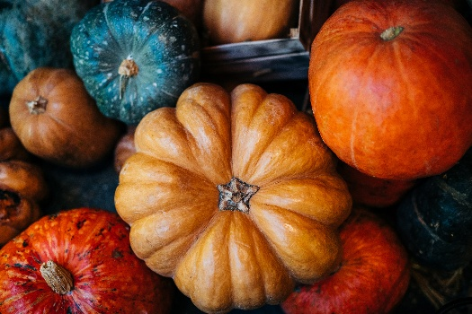 | Coquille High School  Lunch Menu  October 2026  L
Mon. | Tue. | Wed. | Thu. | Fri.
 |  |  | 1 | 2
 |  |  | Chicken Strips  Tuna Sandwich  Vegetables and Fruit  Milk | Pizza  Corndog  Vegetables and Fruit  Milk
5 | 6 | 7 | 8 | 9  No School  Work Day  No
Pizza Sticks  Cheeseburger  Vegetables and Fruit  Milk | Grilled Cheese  Fish Sticks  Vegetables and Fruit  Milk | Chicken Noodle Soup  Yogurt Basket  Vegetables and Fruit  Milk | Pizza  Sub Sandwich  Vegetables and Fruit  Milk | No School  Work Day
12 | 13 | 14 | 15 | 16
CornDog  Turkey Cheese Melts  Vegetables and Fruit  Milk | Chicken Leg w/Roll  Burrito  Vegetables and Fruit  Milk | Taco Wraps  Yogurt Basket  Vegetables and Fruit  Milk | Mozz Sticks  Sloppy joes  Vegetables and Fruit  Milk | Pizza  Chicken Nuggets  Vegetables and Fruit  Milk
19 | 20 | 21 | 22 | 23
Fajita Wraps  Cheeseburger  Vegetables and Fruit  Milk | Pizza Sticks  Sub Sandwich  Vegetables and Fruit  Milk | Chicken Alfredo  Yogurt Basket  Vegetables and Fruit  Milk | BBQ Pork Sandwich  Corndog  Vegetables and Fruit  Milk | Pizza  Chicken Strips  Vegetables and Fruit  Milk
26 | 27 | 28 | 29 | 30
Chicken Nuggets  Mozz Sticks  Vegetables and Fruit  Milk | Fish Sticks  Mac n Cheese  Vegetables and Fruit  Milk | Pork Rib w/ Potato’s  Yogurt Basket  Vegetables and Fruit  Milk | Taco Soup w/Chips  PB&J Packs  Vegetables and Fruit  Milk | Pizza  Cheeseburger  Vegetables and Fruit  Milk

*Students must take THREE components (Grain, Protein, Fruit, Vegetable, Milk) *One item must be a Fruit or Veggie
1% white milk & fat free milk offered, Fruit & veggies served with all meals. Menu subject to change based upon product availability.
This institution is an equal opportunity provider.

