White Plains High School Hall of Fame
550 North Street
White Plains, New York 10605

September 14, 2026 FOR IMMEDIATE RELEASE

Four Inductees Named to the
White Plains High School Hall of Fame

Four White Plains High School graduates have been selected for induction into the school's Hall of Fame this fall.

The Hall of Fame pays tribute to White Plains High School graduates who have distinguished themselves in their chosen careers and/or have significantly and positively impacted the lives of others.

The 2026 inductees are: Dr. Nancy Uscher ‘68, international concert violist and college administrator, Dr. Joseph Silverman ’73, prominent mathematician and university professor, Sean Bratches ‘79, sports and media marketing innovator, and Marie Houston ’80, White Plains community advocate and leader.

The honorees will visit the High School on Thursday, October 22 and will meet with students during the school day. The Induction Ceremony will take place in the Media Center at 3pm and will be followed by a reception. The public is invited.

This is the twenty-third class of distinguished alumni/ae selected since the Hall of Fame was established in 1996, bringing the total number of inductees to 98. It is estimated that more than 40,000 students have graduated from White Plains High School in its 130 years of continuous operation.

The inductees were selected by a committee of representatives of civic and school groups from nominations submitted by the public. New nominations are welcomed each year.

More information is available at https://hs.whiteplainspublicschools.org/organizations1/hall-of-fame.
Contact: Amy Geiger - wphshof@wpcsd.k12.ny.us

White Plains High School Hall of Fame
550 North Street
White Plains, NY 10605

2026 WPHS Hall of Fame Selectees
[To be inducted October 22, 2026]


NANCY USCHER, Class of 1968 – Following a successful career as a concert violist, performing and recording around the world, Dr. Uscher has had key leadership roles at major music educational institutions and is currently Dean of the College of Fine Arts at the University of Nevada, Las Vegas.

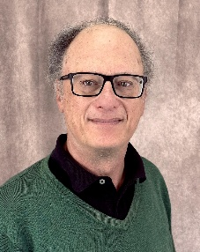
JOSEPH SILVERMAN, Class of 1973 – A recognized international expert on number theory and cryptography, Dr. Silverman is currently the Ford Foundation Professor of Mathematics at Brown University, where he has taught for 38 years, and is president of the 30,000 member American Mathematical Society.


SEAN BRATCHES, Class of 1979 – Mr. Bratches is one of the most influential people in American sports and media, primarily due to his 30 year tenure at ESPN where he rose to Executive Vice President of Sales and Marketing from 2005 to 2017 and helped fuel significant growth in ESPN’s brand and revenue.

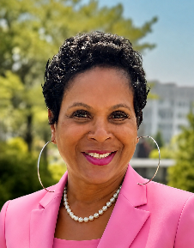
MARIE HOUSTON, Class of 1980 – Ms. Houston has been an active community leader and advocate, channeling her energy, ideas and talents into the Calvary Baptist Church, the Alpha Kapp Alpha Sorority, the City of White Plains, the NAACP White Plains/Greenburgh branch and the Westchester African American Chamber of Commerce.

