OCTOBER 2026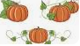 | PALACIOS ISD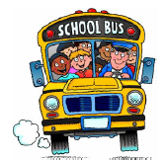 | HOME OF THE MIGHTY SHARKS | 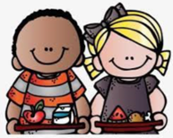 | 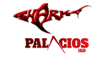 | Pre-K  Lunch  Menu Subject  To Change
MONDAY | TUESDAY | WEDNESDAY | THURSDAY | FRIDAY
 |  |  | 1 Cheese Pizza OR  Pulled Pork/Bun  Pinto Beans  Corn  Daily Fruit/Milk | 2  No School | All Students  Eat Free
5 Chicken Spaghetti  OR Burrito  Refried Beans/Corn  Daily Fruit/Bread  Sticks  Milk | 6 Beef Penne Pasta  OR Chili Dogs/Cheese  Sweet Potato Fries  Broccoli/Ranch  Daily Fruit/Crackers  Milk | 7 Hamburger OR  Grilled Cheese  Sandwich/Burger Salad/Tater Tots  Daily Fruit  Milk | 8 Pepperoni Pizza OR  Ham Cheese Sub  Cucumbers/Ranch  Green Beans  Daily Fruit  Milk | 9  Staff Development  Student Holiday | Meal Prices  Adults/Guest  Breakfast -$ 3.55  Lunch - $5.40
12Turkey Cheese Sub  Or Lasagna Roll  Green Beans/Ranch  French Fries/Hot Roll  Daily Fruit/Milk | 13 King Ranch  Casserole OR Corn  Dogs/Pinto Beans  Tomato Salad/Daily  Fruit/Crackers/Milk | 14 Cheeseburger OR  Crispito  Burger Salad/Carrots  Daily Fruit/Crackers  Milk | 15 Cheese Pizza OR  Chicken Fajitas  Broccoli/Ranch  French Fries/Tortilla  Daily Fruit/Milk | 16  No School | Assorted Daily  Fruit  Milk
19 Hamburger OR  Ham/Cheese Sub  Burger Salad  Tater Tots  Daily Fruit/Milk | 20 Chili Mac OR  Chicken Vegetable  Dumpling/Broccoli  Carrots/Bread Stick  Daily Fruit/Milk | 21 Hamburger OR  Popcorn Chicken  Burger Salad/Ranch  Cucumbers/Crackers  Daily Fruit/Milk | 22 Pepperoni Pizza OR  Chicken Tacos/Salsa  Refried Beans  Lettuce/Tomato Salad  Crackers/ Daily Fruit Milk | 23  No School
26 Turkey Cheese Sub  OR Mini Corn Dog  Broccoli/French Fries  Crackers/Daily Fruit  Milk | 27 Chicken Alfredo OR  Hot Pocket  Sweet Potato Fries  Corn  Daily Fruit/Milk | 28 Cheeseburger OR  Chicken Nuggets  Burger Salad  Green Beans/Crackers  Daily Fruit/Milk | 29 Cheese Pizza OR  Chicken Quesadilla  Pinto Beans/Lettuce  Tomato Salad  Daily Fruit/Milk | 30 No School | 
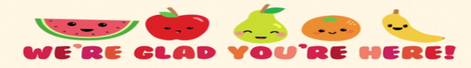This Product is funded by USDA. This institution is an equal opportunity provider.

