
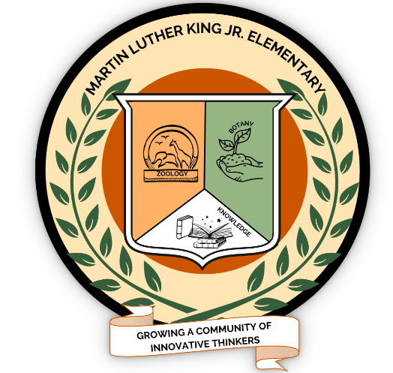
MARTIN LUTHER KING, JR
Botany & Zoology Magnet
ELEMENTARY SCHOOL
5745 WEST LEES MILL ROAD - COLLEGE PARK, GA 30349
PHONE: (770) 991-4651 - FAX: (770) 991-4679

Dr. Vanessa Muhammad Ms. Tami Lewis Mr. Marquavius Hardy Mrs. Daleesha Cheatom Mr. Joel White Principal Asst. Principal Asst. Principal School Counselor School Counselor

Right to Know Professional Qualifications of Teachers and Paraprofessionals

Date: August 6, 2026
Dear King Family!
In compliance with the requirements of Every Students Succeeds Act, Martin Luther King Jr. Elementary would like to inform you that you may request information about the professional qualifications of your student’s teacher(s) and/ or paraprofessional(s). The following information may be requested:
- Whether the student’s teacher—
- has met State qualification and licensing criteria for the grade levels and subject areas in which the teacher provides instruction;
- is teaching under emergency or other provisional status through which State qualification or licensing criteria have been waived; and
- is teaching in the field of discipline of the certification of the teacher.

- Whether the child is provided services by paraprofessionals and, if so, their qualifications.

If you wish to request information concerning your child’s teacher’s and/ or paraprofessional’s qualifications, please contact the principal, Dr. Vanessa Muhammad, vanessa.muhammad@clayton.k12.ga.us
or (770) 991-4651
Sincerely,

Dr. Vanessa Muhammad
Principal

