
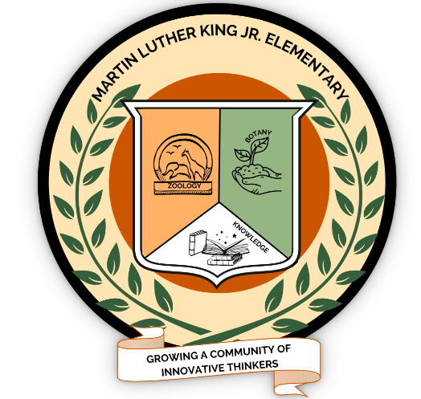
MARTIN LUTHER KING, JR
Botany & Zoology Magnet
ELEMENTARY SCHOOL
5745 WEST LEES MILL ROAD - COLLEGE PARK, GA 30349
PHONE: (770) 991-4651 - FAX: (770) 991-4679

Dr. Vanessa Muhammad Ms. Tami Lewis Mr. Marquavius Hardy Mrs. Daleesha Cheatom Mr. Joel White Principal Asst. Principal Asst. Principal School Counselor School Counselor

August 6, 2026
Hello Parents/Guardians,
We are excited to welcome you and your family to our school community. At Martin Luther King Jr. Elementary, we are committed to providing an environment that empowers students to become ambitious learners and productive, responsible members of a global society.
My name is Nefertiti Nzinga, and I am honored to serve as your Parent Liaison. I would like to personally invite you to visit the Coretta Scott King Parent Resource Center, located in Room 101.01 inside the Media Center. This center was created especially for you—a welcoming space where parents and families can find information, support, resources, and opportunities to stay connected with our school and community. The Parent Resource Center is conveniently open Monday through Friday, from 7:00 A.M. to 3:00 P.M.
My role is to support and connect parents and families with valuable information, services, and community resources. Some valuable levels of support include but are not limited to; parenting information, volunteer information, monthly calendars, employment resources, academic brochures, educational resources, and assistance creating an Infinite Campus parent portal. Additionally, there are computers available for use. It is my pleasure to assist all parents in becoming an important link between home, school, and community. I strongly believe that with viable resources on hand and ongoing parent participation. I will successfully accomplish my goal of strengthening the partnership between you and your child’s school.
Please stop by the Coretta Scott King Parent Resource Center during our regular hours. I am here to support you in any way that I possibly can. If you have any further questions, please don’t hesitate to reach me at 770-991-4651 Extn:135127. I can also be reached via email at nefertiti.nzinga@clayton.k12.ga.us
I am excited to meet each and every one of you.
Warm regards,

Nefertiti Nzinga
Parent Liaison

“The greatness of a community is most accurately measured by the compassionate actions of its
members…a heart of grace and a soul generated by love.”
~Coretta Scott King~

