ENTERING A TIME OFF REQUEST IN SKYWARD

To know the approved reasons to request time off, please refer to Article IV of the Collective Bargaining Agreement.
Time off codes include:
- Sick Time
- Personal Time
- Vacation Time
- Work Related Time Off (Conferences/Workshops with administrative approval, and Bereavement))
- Dock (Unpaid Leave)

- Click Skyward Employee Access
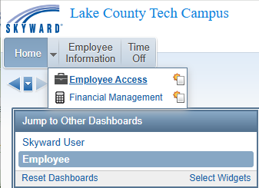

- Click on My Request

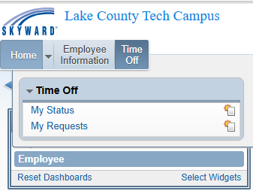
- In the next window, you will see all prior time off requests. To enter a new time off request, click “Add” on the far right.
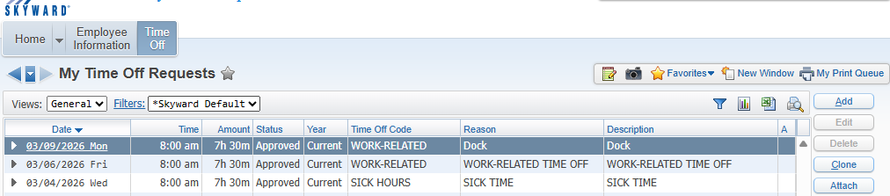
- A new window will appear (see below). Required entries (*) to enter time-off requests on this screen include: Note: Your available hours are listed in the top sec on of this window.

- Time Off Code: Select the appropriate code related to your time-off
- Reason: Select the appropriate reason related to your time-off
- Description: A brief description is not required but is preferred
- Start Date: Enter the date of your time-off
- Hours: Total time you are requesting
- Start Time: Enter the start time of your time-off request
- Select Employees: Be sure to choose ATTENDANCE on the distribution list (the first option) so the correct people are notified about your request.
- Save: Your request will go for approval.

Make sure boxes a, b, and c have the same code.
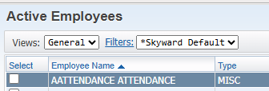
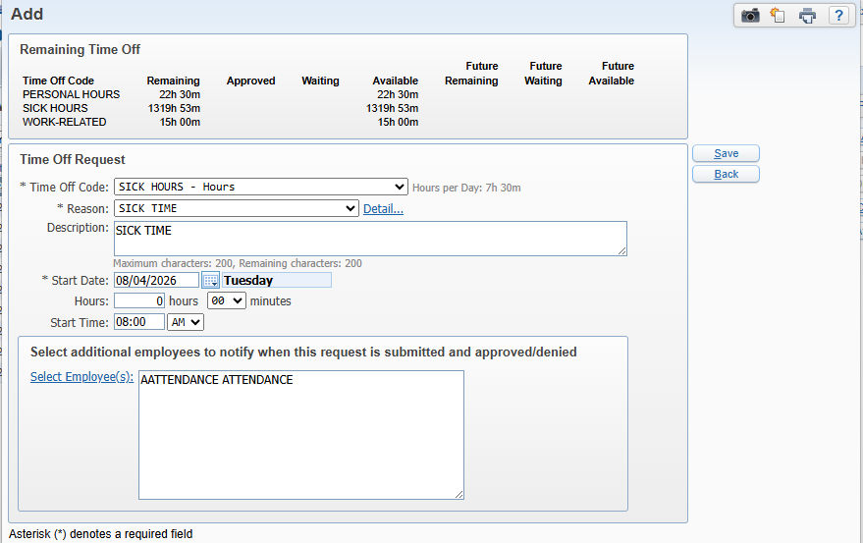
h)
g)
f)
d)
e)
a)
c)
b)
UNPAID TIME-OFF
Because people often get confused about how to request unpaid time off, here is an example of what the screen should look like when you do it. Make sure to email the Business Office informing them about the request.
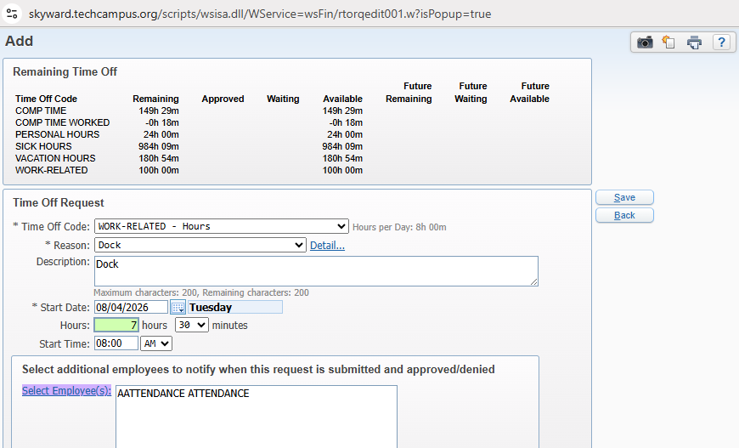

BEREAVEMENT TIME-OFF

