🐝 OUR GOALS FOR STUDENT SUCCESS

DISTRICT GOALS
- Build strong family-school partnerships.
- Keep families informed and connected.
- Provide families with resources and support.
- Promote a safe and welcoming environment for every child.

SCHOOL GOALS
- Encourage families to be active partners in their child’s learning.
- Maintain open and positive communication with families.
- Help every child learn, grow, and be ready for success.
- Provide family learning opportunities and resources.
- Work together to keep our Bumblebees safe, happy, and ready to learn. 🐝💛
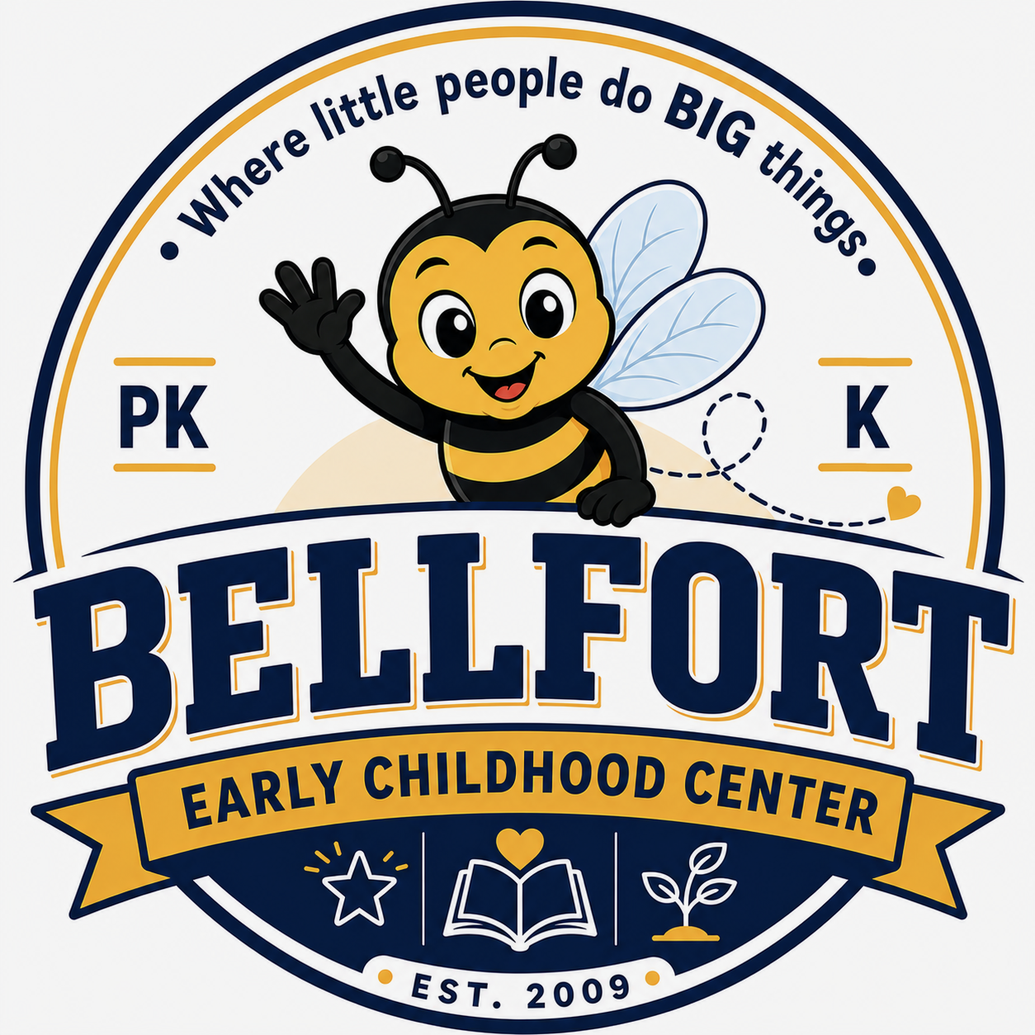

🍎 IN THE CLASSROOM: As a Teacher, I Will…
- Come prepared and ready to teach every day.
- Believe that every child can learn and grow.
- Provide a safe, caring, and welcoming classroom.
- Meet each child’s individual learning needs.
- Treat all students and families with kindness and respect.
- Keep families informed about their child’s learning and progress.
- Partner with families to support student success.
- Celebrate the unique strengths and differences of every child.

🏠 AT HOME: As a Parent/Guardian, I Will…
- Bring my child to school on time, every day, ready to learn.
- Make sure my child follows the school dress code.
- Read, talk, and practice learning skills with my child at home.
- Check my child’s folder/binder and ParentSquare regularly.
- Communicate with my child’s teacher and ask questions when needed.
- Support school and classroom rules and expectations.
- Attend conferences, family events, and school activities when possible.
- Encourage my child to be kind, independent, and excited about learning.
Parent/Guardian Signature:
______________________________
🐝 Together, we help our little Bumblebees learn, grow, and succeed!

🐝 AT SCHOOL: As a Student, I Will…
- Come to school on time and ready to learn every day.
- Follow the school dress code.
- Listen and follow directions from teachers and staff.
- Do my best and participate in learning.
- Use kind words and actions with others.
- Share, take turns, and be a good friend.
- Follow school and classroom safety rules.
- Take care of school materials and technology.
- Clean up after myself and take care of our school.
- Tell a trusted adult when I need help or feel unsafe.
- Make good choices and learn from my mistakes.
- Respect and celebrate everyone’s differences.

COMMUNICATION ABOUT LEARNING 🐝

At Bellfort Early Childhood Center, families and teachers work together to help every child learn and grow. We will stay connected through:
- ParentSquare messages and updates
- Student folders/binders
- Phone calls and teacher check-ins
- Parent-teacher conferences
- Progress reports and report cards
- Family events and meetings
Families + Teachers = Happy, Successful Little Learners! 🐝💛

Parent/Guardian Signature: _______________________________

🐝 AT SCHOOL: As a Student, I Will…

School Parent Compact
Bellfort Early Childhood Center
Cashe Alexander, Principal
Houston Independent School District
7647 Bellfort St.
Houston TX, 77061

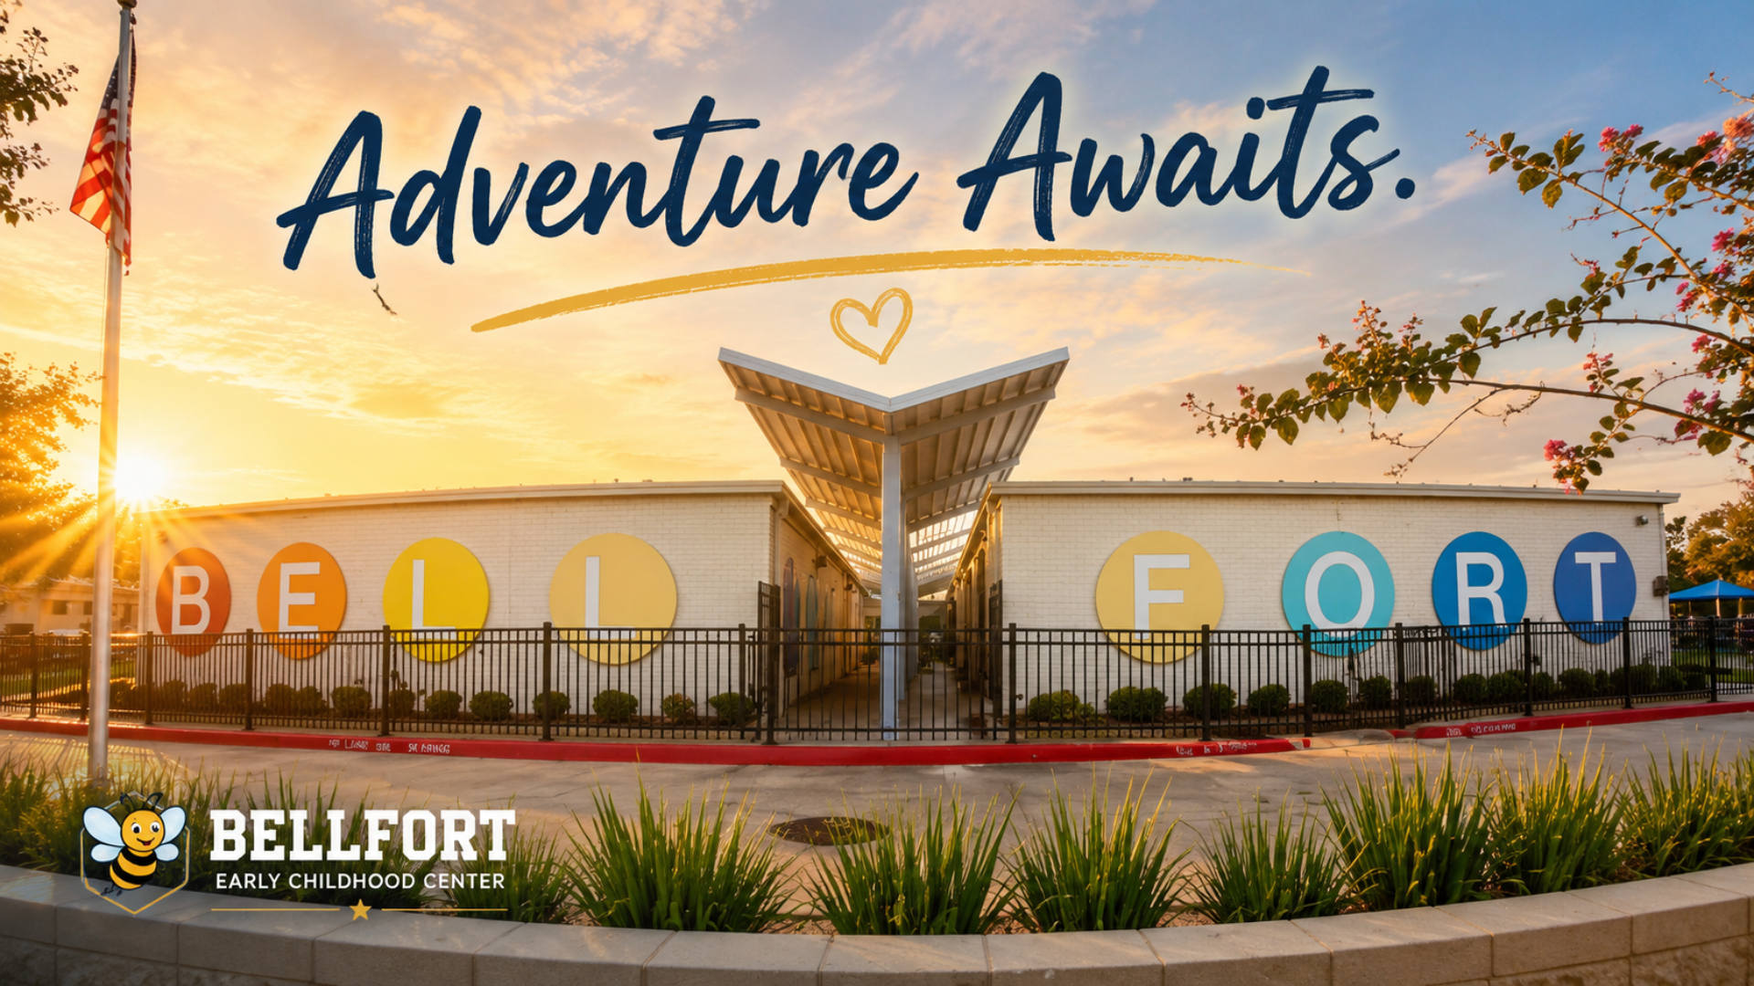

School Website:
http://bellfortecc.houstonisd.org
School Telephone:
(713)640 0950

🐝 ACTIVITIES TO BUILD FAMILY PARTNERSHIPS
At Bellfort Early Childhood Center, we love bringing our families, students, and staff together! Throughout the year, families will have opportunities to:
- Attend Meet the Teacher & Open House
- Join family learning nights and academic events
- Participate in Coffee with the Principal
- Attend student celebrations.
- Participate in family engagement activities
- Celebrate your child’s learning and growth with us
💛 Families + School = Stronger Bumblebees!

🌟 STUDENT LEARNING GOALS Our goal is to help every Pre-K and Kindergarten student learn, grow, and build confidence.

Students will work on:
- Reading and learning every day
- Practicing letters, sounds, numbers, and early learning skills
- Showing growth throughout the school year
- Using classroom and digital learning activities
- Becoming independent and confident learner.
🐝 Together, we can help every little Bumblebee succeed!

🐝 WHAT IS A SCHOOL-PARENT COMPACT?
A School-Parent Compact is a promise between families, teachers, and students to work together to help every child learn, grow, and succeed.
It explains simple ways we can support our Pre-K and Kindergarten students both at school and at home.

💛 CREATED TOGETHER WITH FAMILIES
Each year, Bellfort Early Childhood Center works with families, teachers, and staff to review our compact and discuss the needs of our young learners.
Families are encouraged to share ideas, ask questions, and provide feedback throughout the school year.
🐝 Together, we build a strong foundation for our little Bumblebees!

