Please support our fundraiser for the 2026-2027 school year, which is run through our incredible PTSA. This year, students will not be selling any products. Instead, they are collecting money to support a Walk-A-Thon on Friday, October 2nd during the school day. They are asking for flat donations, not donations per lap.
For our Walk-A-Thon this year, we're using an awesome web-based fundraising system that makes it much easier for you to request pledges from your family and friends, and for them to make secure credit card donations online. It's fun, it's easy, and people who use it typically raise twice as much as those who don't!
Throughout the next two weeks, we will be raffling off prizes for students who send emails, get donations, and more! The winning Lynx Life group (Storm, Seahawks, Mariners, or Kraken) who brings in the most money per student will win an ice cream party!
Remember, our Walk A Thon is October 2, so please register now to help our school raise as much as we can for club advisors and materials; sports- busses, referees, uniforms, equipment; materials and activities for school socials and assemblies.
Using your computer's browser:
- Go to http://pcms.pledgestar.com/
- Click "Not Registered For This Year's Event"
- Enter your name and email address (do NOT use student school email address- use parent/guardian email), then click "Submit"
- Follow the instructions on-screen to register Walker(s) and add family and friends
  - Make sure you register your student under their LYNX LIFE teacher.
  - If you have multiple students who attend PCMS, you can register both of them on the same account. All donations will be split evenly amongst the students in that family.
When you finish, the system emails pledge requests to your family and friends, and allows them to make secure credit card donations online. You get notified each time a pledge is made, and you can track your pledge progress online.
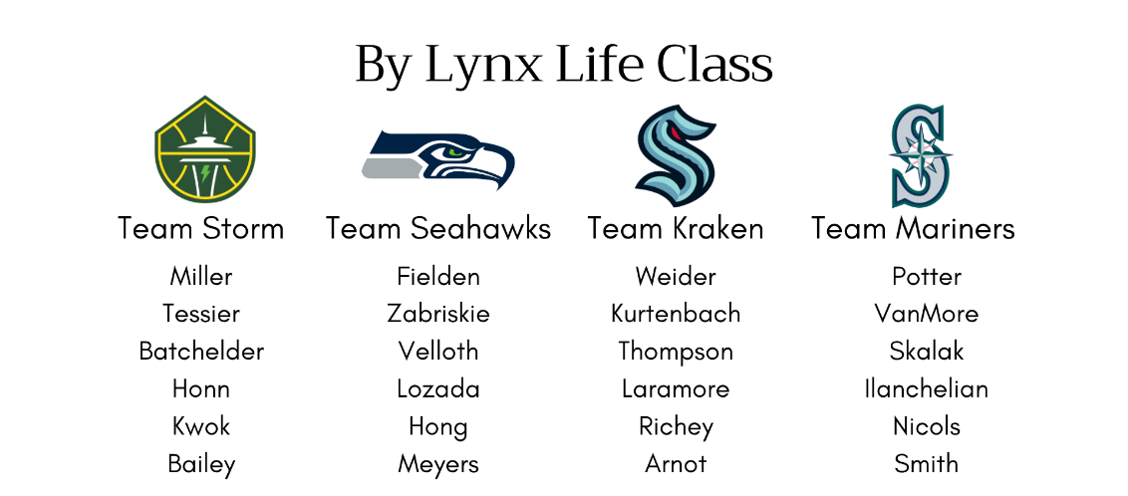
Call 1-888-598-7510 if you need help registering or using the website.

