A Peek at our Week
Mrs. Bird
Monday, September 21 – Friday, September 25, 2026
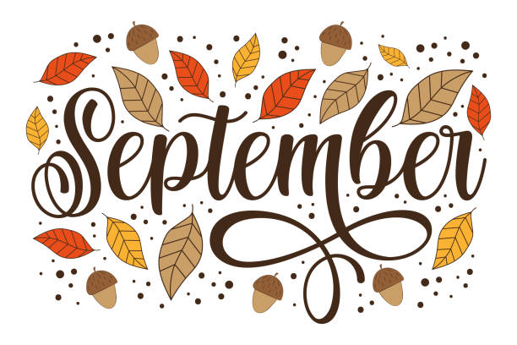
**The Scholastic Book Fair is next week!**
WORD WALL WORDS: toss, stall, shall, full, pull
Please practice reading and spelling these words each night!
Homework Schedule
PICTURE DAY  Monday  *Spanish & Health/Gym* | Tuesday  *STEAM& Health/Gym* | Wednesday  *Art* | Thursday  *Health/Gym* | DRESS LIKE DOLLY PARTON DAY  Friday  *Music & Health/Gym*  Library Visit Biweekly
Math: Additional Practice 1.9  Reading: Log | Math: Additional Practice 1.10  Reading: Log | Math: Worksheet  Reading: Log | Math: Worksheet  Reading: Log | Have a wonderful weekend!
Taking a Closer Look…
- Math: We will complete Topic 1 on strategies to fluently add and subtract within 20. Our test is scheduled for Friday!
- Social Studies: We will continue our first unit on communities. We will learn about the past vs. present and how communities change over time.
- Reader’s Workshop: We will launch our first reading unit called, Becoming a Big Kid Reader. We will review reading strategies and good reading habits.
- Writer’s Workshop: Students will begin the writing process of their first small moment story, while trying to include transition words and feeling words.
- Fundations: We will begin Unit 2 in our Fundations program. We will practice the bonus letters ff, ll, ss that come after short vowels. For example: stuff, hill, and miss.

**Remember to have sneakers for gym class!**

