
AHS COUNSELOR ASSIGNMENTS
Phone: 386-322-6100
Fax: 386-243-3798
*Scan QR code for questions, schedule changes, or to make an appointment to meet with a counselor

Counselor | Contact Information | Names
Mrs. Charles | 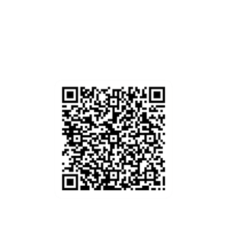  Ext. 38130  rkcharle@volusia.k12.fl.us | Last Name:  A - F
Ms. Opfer | 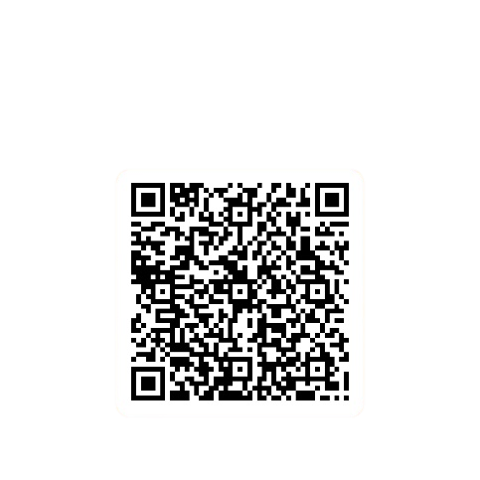  Ext. 38225  jlopfer@volusia.k12.fl.us | Last Name:  G - L
Ms. Tai | Ext. 38139  fftai@volusia.k12.fl.us  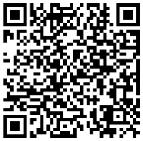 | Last Name:  M - R
Ms.  Provenzano  Counseling  Director | Ext. 38131  bprovenz@volusia.k12.fl.us  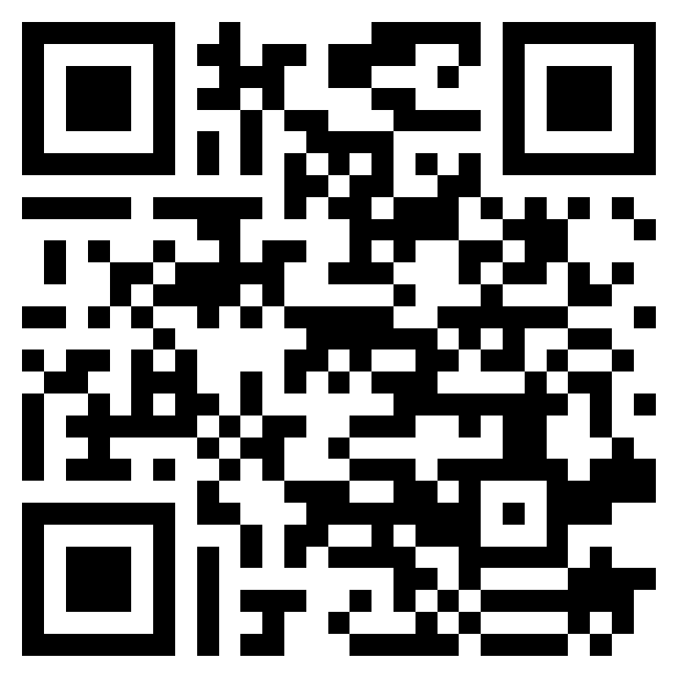 | Last Name:  S - Z

Guidance Clerk: ext. 38497
Register: ext. 38141

