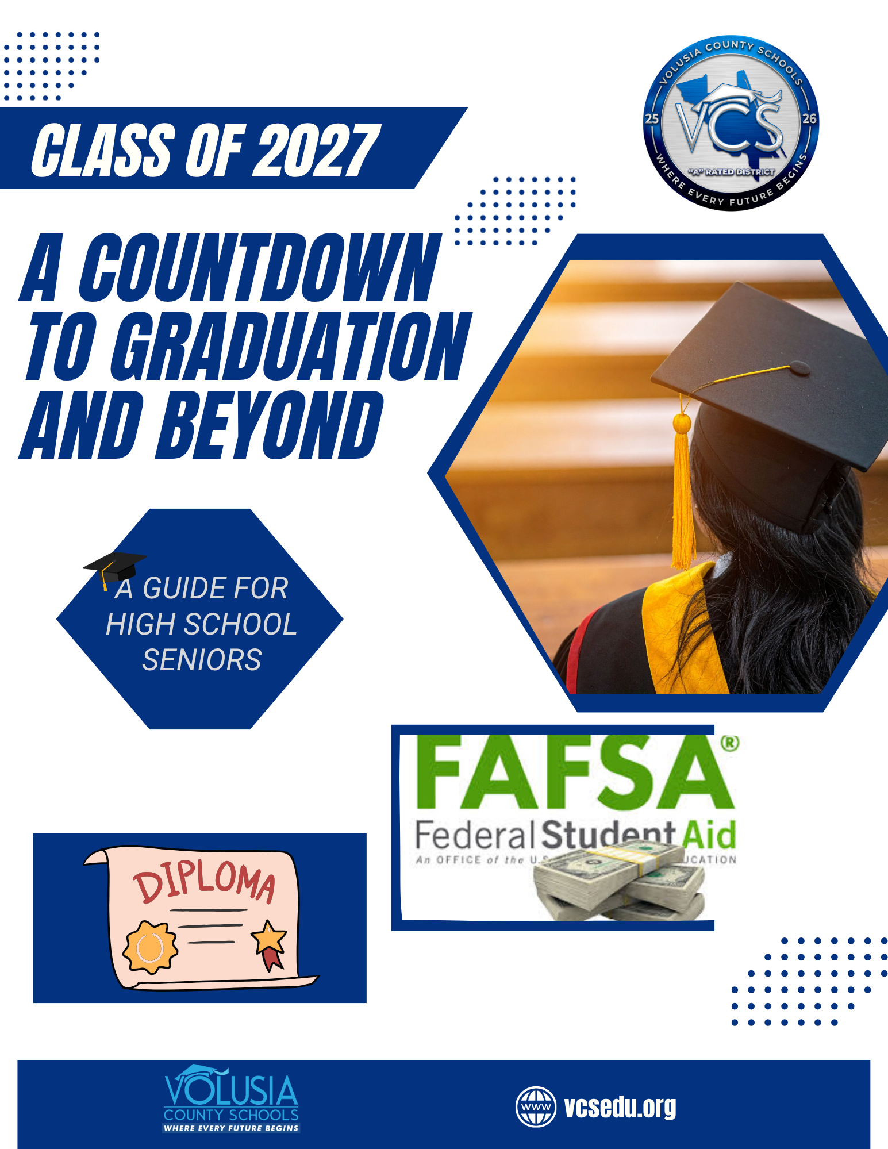

Atlantic High School
Principal
j watson

Assistant Principals
T CULVER
M CURRAN
D. GARIEPY

Administrative Teachers on Assignment
R. VALLE

School Counseling Department
Director
BETH ANN PROVENZANO
Address:
1290 REED CANAL ROAD
PORT ORANGE, FL 32129
School Phone Contact:
386-322-6100

Counselors | Student Assignment | Email | Extension
RACHEL CHARLES | A-F | RKCHARLE@VOLUSIA.K12.FL.US | 38130
JESSICA OPFER | G-L | JLOPFER@VOLUSIA.K12.FL.US | 38225
ANNA TAI | M-R | FFTAI@VOLUSIA.K12.FL.US | 38139
BETH ANN PROVENZANO | S-Z | BPROVENZ@VOLUSIA.K12.FL.US | 38131

Dear Senior:
We want you to have the best possible senior year, and that means being prepared. We want you to be successful in your classes to meet graduation requirements and be prepared for your future after high school. Be sure to review the information in this booklet very carefully and share it with your parents. You should then set up an appointment to review your post-secondary plans with your school counselor. By meeting early in the school year, we can help you plan for your final year of high school and the beginning of your future.

In this booklet you will find facts related to senior year expenses, ACT, CLT, and SAT test dates, Bright Futures Scholarship qualifications, and basic scholarship information.

This booklet is provided as a planning guide. In many cases, additional important information will be provided during the school year. You are advised to listen to the daily announcements, check FOCUS to track your graduation requirements, and to check the school website for updates. On-site visits from college representatives will also be announced during the Fall semester as they are scheduled.

On behalf of the entire School Counseling Department, we look forward to working with the senior students and families this year. Please do not hesitate to contact your School Counselor for assistance.

TABLE OF CONTENTS

CLASS OF 2027 DIPLOMA OPTIONS 1
OTHER GRADUATION REQUIREMENTS 6
COUNTDOWN CALENDAR 7
10 ACT/CLT/SAT TEST – TAKING TIPS 10
COLLEGE READINESS EXAM 11
TEST DATES 11
SENIOR TIDBITS 12
SENIOR EXPENSES 15
GRADUATING THE CLASS OF 2027 16
GRADUATION DESIGNATIONS 17
COLLEGE REPS 19
SELECTING A COLLEGE: 19
THE CAMPUS VISIT 22
COMPLETING THE COLLEGE APPLICATION 23
COLLEGE DEMOGRAPHICS FOR 2026-2027 24
RESUME WORKSHEET 26
PREPARING FOR A JOB INTERVIEW 28
MILITARY OPTIONS 29
FINANCIAL AID 30
FEDERAL STUDENT AID 31
FLORIDA BRIGHT FUTURES SCHOLARSHIP FFAA 33
FLORIDA BRIGHT FUTURES REQUIREMENTS 2026-2027 Graduates 34
SENIORITIS 36

CLASS OF 2027 DIPLOMA OPTIONS

(Students who entered 9th grade in 2023 - 2024)

CATEGORIES (18 Credit ACCEL Diploma) | CREDITS
ENGLISH LANGUAGE ARTS | 4
MATHEMATICS  - 1 credit in Algebra I  - 1 credit in Geometry (EOC = 30% of final course grade)  - 2 credits in additional math courses  - Industry Certifications that lead to college credit may substitute for up to 2 math credits (excluding Algebra 1 & Geometry) *  - An identified computer science credit may substitute for one math credit (excluding Algebra 1 and Geometry) ** | 4
SCIENCE  - 1 credit in Biology (EOC = 30% of final course grade)  - 1 credit in a physical science course  (Earth/Space Science, Physical Science, Chemistry, or Physics)  - 1 credit in an additional science credit  - Industry Certifications that lead to college credit may substitute for 1 science credit (excluding Biology) *  - An identified computer science credit may substitute for 1 science credit (excluding Biology) ** | 3
SOCIAL STUDIES  - 1 credit in World History  - 1 credit in United States History (EOC = 30% of final course)  - ½ credit in Economics  - ½ credit in United States Government | 3
Performing or Fine Arts/Speech & Debate/CTE | 1
Personal Finance Literacy | .5
ELECTIVES | 2.5
TOTAL | 18 Credits
Other Graduation Requirements:
- 2.0 Grade Point Average (GPA) on a 4.0 scale
- Passing score on the Grade 10 ELA Reading or concordant score.
- Passing score on the Algebra 1 End of Course Assessment or comparative score.

* Credit earned by industry certification does not count for SUS admission.
**A computer science credit may not be used to substitute both a math and a science credit

CATEGORIES (18 Credit Career and Technical Education Diploma) | CREDITS
ENGLISH LANGUAGE ARTS | 4
MATHEMATICS  - 1 credit in Algebra 1  - 1 credit in Geometry (EOC = 30% of final course grade)  - 2 credits in any additional math courses  - Industry Certifications that lead to college credit may substitute for up to 2 math credits (excluding Algebra 1 & Geometry) *  - An identified computer science credit may substitute for one math credit (excluding Algebra 1 and Geometry) ** | 4
SCIENCE  - 1 credit in Biology (EOC = 30% of final course grade)  - 1 credit in a physical science course  (Earth/Space Science, Physical Science, Chemistry, or Physics)  - 1 credit in any other equally rigorous science course  - Industry Certifications that lead to college credit may substitute for 1 science credit (excluding Biology) *  - An identified computer science credit may substitute for 1 science credit (excluding Biology) ** | 3
SOCIAL STUDIES  - 1 credit in World History  - 1 credit in United States History (EOC = 30% of final course grade)  - ½ credit in Economics  - ½ credit in United States Government | 3
Personal Finance Literacy | .5
CAREER & TECHNICAL EDUCATION  - The courses must result in a program completion & industry certification | 2
WORK-BASED LEARNING PROGRAMS OR ELECTIVE CREDITS | 1.5
TOTAL | 18 Credits
Other Graduation Requirements:
- 2.0 Grade Point Average (GPA) on a 4.0 scale
- Passing score on the Grade 10 ELA Reading or concordant score.
- Passing score on the Algebra 1 End of Course Assessment or comparative score.
* Credit earned by industry certification does not count for SUS admission.
** A computer science credit may not be used to substitute both a math and a science credit
(Students who entered 9th grade in 2023 - 2024)
(Students who entered 9th grade in 2023 - 2024)
CATEGORIES (24 Credit Diploma) | CREDITS
ENGLISH LANGUAGE ARTS | 4
MATHEMATICS  - 1 credit in Algebra I (EOC = 30% of final course grade)  - 1 credit in Geometry (EOC = 30% of final course grade)  - 2 credits in additional math courses  - Industry Certifications that lead to college credit may substitute for up to 2 math credits (excluding Algebra 1 & Geometry) *  - An identified computer science credit may substitute for one math credit (excluding Algebra 1 and Geometry) ** | 4
SCIENCE  - 1 credit in Biology (EOC = 30% of final course grade)  - 1 credit in a physical science course  (Earth/Space Science, Physical Science, Chemistry, or Physics)  - 1 credit in an additional science credit  - Industry Certifications that lead to college credit may substitute for 1 science credit (excluding Biology) *  - An identified computer science credit may substitute for 1 science credit (excluding Biology) ** | 3
SOCIAL STUDIES  - 1 credit in World History  - 1 credit in United States History (EOC = 30% of final course)  - ½ credit in Economics  - ½ credit in United States Government | 3
PHYSICAL EDUCATION  - ½ credit in Personal Fitness  - ½ credit in any other PE course | 1
Performing or Fine Arts/Speech & Debate/CTE | 1
Personal Finance Literacy | .5
ELECTIVES | 7.5
TOTAL | 24 Credits
Other Graduation Requirements:
- 2.0 Grade Point Average (GPA) on a 4.0 scale
- Passing score on the Grade 10 ELA Reading or concordant score.
- Passing score on the Algebra 1 End of Course Assessment or comparative score.

* Credit earned by industry certification does not count for SUS admission.
** A computer science credit may not be used to substitute for both a math and a science credit.
Cambridge AICE Diploma Requirements
Current high schools offer this diploma option: Deltona, New Smyrna Beach, Pine Ridge, Seabreeze, and University.
To achieve the Cambridge AICE Diploma Award, learners must achieve a minimum of seven credits (including Cambridge International AS Level Global Perspectives & Research) from subject groups 1, 2, and 3 (and optionally Group 4) to be awarded the Diploma. Learners must achieve at least one credit from each of Groups 1, 2 and 3.
The remaining credits can come from any of the groups. A Cambridge International AS Level is awarded one credit, and a Cambridge International A Level is awarded two credits.
The following combinations of credits are valid for the Diploma Award:
A Levels (2 credits each) | AS Levels (1 credit each) | Cambridge International AS Level Global Perspectives & Research (9239) | Total
3 | 0 | 1 | 7 credits
2 | 2 | 1 | 7 credits
1 | 4 | 1 | 7 credits
0 | 6 | 1 | 7 credits

For students participating in this diploma award option, speak to your school’s Cambridge AICE Coordinator to obtain more information.
High School | Coordinator
Atlantic High | Jessica Jones
Deltona High | Jennifer Lupica
Mainland High | Kallie Walker
New Smyrna Beach High | Nicole McDonald
Pine Ridge High | Danielle Gregory
Seabreeze High | Dodi Gaines
Taylor High | Jamie Raulerson
University High | Kaila Cain
International Baccalaureate (IB) Program
Current high schools offer this diploma option: DeLand and Spruce Creek.

26 credits are needed for an IB diploma, but you must also have a certain number of points on the tests.

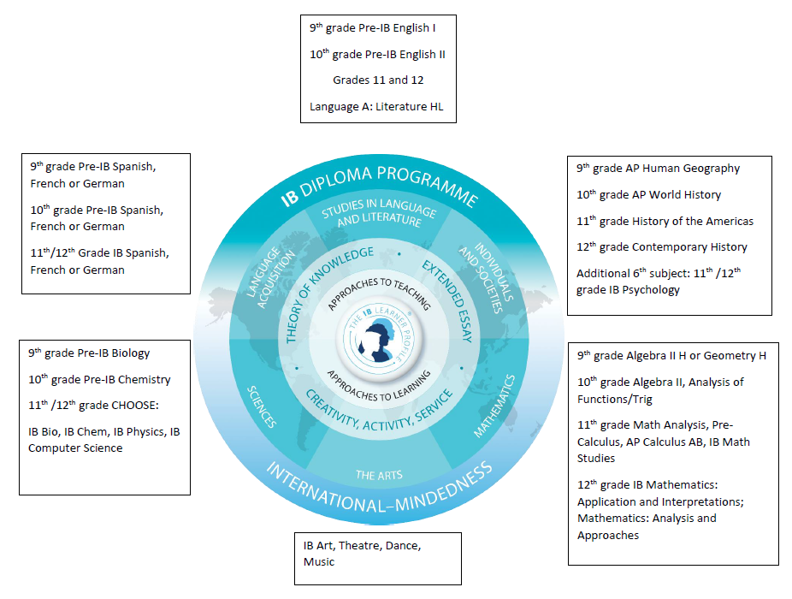For students participating in this diploma option, speak to your school’s IB Coordinator to obtain more information.
High School | Coordinator
DeLand High | Lisa Nehrig
Spruce Creek High | Karie Cappiello

OTHER GRADUATION REQUIREMENTS

While you must earn all the credits in your chosen diploma option to earn your high school diploma, you also are required to meet additional graduation requirements, which are listed below.

- You must have an unweighted 2.0 GPA, “C” grade average, to earn your high school diploma.

- You must earn a 3 or higher on the Grade 10 English Language Arts Exam (FAST ELA). If you do not pass this exam, you can take the ACT, CLT, or SAT exams to meet this requirement with a concordant score. The required test scores are below:

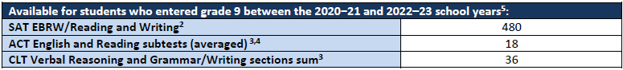
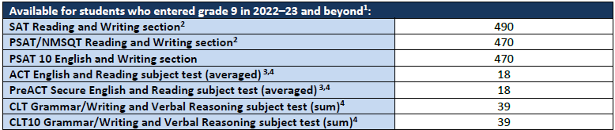

- You must earn a 3 or higher on the Algebra 1 End of Course Exam (EOC). If you do not pass this exam, you can take a PSAT/NMSQT, SAT, ACT, CLT, or Geometry EOC to meet this requirement with a comparative score. The required test scores are below:
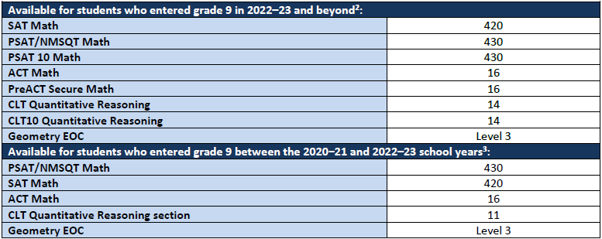

* The average of the ACT Reading and English scores, which can be rounded up. Example: 17.5=18= Graduation!

COUNTDOWN CALENDAR

The Countdown Calendar is a list of important dates and things you need to do so you are ready for graduation. Keep this copy handy and use it to meet those all-important deadlines.

September — October

- Meet with your counselor to review career and college plans. Review the Florida Bright Futures Scholarships requirements. Visit: www.floridashines.org/go-to-college/pay-for-college and visit www.bigfuture.collegeboard.org for other scholarship opportunities.

- Visit the School Counseling office for college and financial aid information and for college representatives’ visitation dates.
- Narrow your choices to the top three or four colleges in which you are most interested and contact the admissions offices to schedule campus visits.

- Attend the Volusia County Schools College Expo on October 1, 2026 at Embry-Riddle Aeronautical University. Financial Aid Session begins at 5pm with the college exploration starting at 6pm. Over 65 schools from around the US will be present.

- Begin your search for private scholarships. Talk with your counselor, college financial aid offices, churches, and civic organizations.

- Consult your counselor for college entrance exam test dates and register for those tests. While many colleges or universities will accept either the ACT, CLT, or SAT, be sure to check with the institutions to which you are applying.

- Meet with the school counselor to arrange 2nd semester dual enrollment at Daytona State College (deadline December 4, 2026) or arrange any course work you may need for credit recovery/ remediation.

- FAST Grade 10 ELA and BEST Algebra 1 EOC retakes, SAT, ACT, Non-College Reporting ACT (October 14-16), School Day SAT (October 23) for seniors who still must pass the graduation exams.

- Apply for admissions to the colleges in which you are interested.

- Obtain financial aid information from those colleges. Carefully review information explaining available financial aid, application procedures, and deadline dates.

- Attend college fairs and financial aid information nights.

- Take or retake the SAT and/or ACT.

- Collect the family W-2 forms and completed federal tax return for use in completing the FAFSA if you have not already done so.
  - Complete the Florida Financial Aid Application (FFAA) for the Bright Futures Scholarship program; Open October 1 to apply.
  - Complete the Free Application for Federal Student Aid (FAFSA) online at http://www.fafsa.ed.gov, Open October 1st to apply.
November — December

- Continue to apply for admission to colleges in which you are most interested.

- Meet with college reps.

- Take or retake the ACT, SAT, and/or Grade 10 ELA.
- Take Civics Literacy Exam.
- UF dual enrollment Spring 2027 registration deadline November 6, 2026.
- DSC dual enrollment Spring 2027 registration deadline December 4, 2026.

January

- Meet with counselor to review graduation plans and ensure you are on track for high school graduation.

February

- Promptly respond to requests for information from college admission and financial aid offices.

- Complete applications for community scholarships.
- Retake the ACT, CLT, SAT, Grade 10 ELA, and/or Alg. 1 EOC.
March

- Review your financial aid award from the colleges to which you have applied for financial aid. Your package may include various forms of assistance including student loans.

- ACT NCR for seniors who still must pass the graduation exams (March 10-12).

April

- ASVAB testing
- Academic Signing Day application deadline
- Academic Signing Day Ceremony
- Make your final decision on college attendance and notify the appropriate admissions office.

- Promptly respond to requests for information from the college admissions and financial aid offices at your chosen college.

- Pay required deposits for enrollment and/or residence hall.

- Retake ACT, CLT, and/or SAT for scholarships, college admissions, or exam diploma
requirements.

May

- AP, IB, AICE and/or Career and Technology Industry exams.
- Civic Literacy Exam.
- Senior Awards Night.
- Retake ACT, CLT, and/or ACT.
- Complete all FLVS, VOL or Edgenuity coursework for graduation and Bright Futures eligibility.
- Graduation rehearsal.
- Turn in volunteer hours before graduation to qualify for Bright Futures!
- Algebra 1 EOC retakes, ACT, CLT, or SAT for seniors who still must pass the graduation exams.
- Graduation!

June — August

- Request FINAL high school transcripts to be sent to your college of choice. Final transcripts will not be available until mid-June at the earliest (graduates are responsible for this!).

- Attend the orientation program for the college/university you will attend.

- Retake the ACT, CLT, or SAT if necessary. August 31 is the date that scores will count for Bright Futures and the application deadline.
- Final transcripts for Bright Futures are submitted from early to mid-July.

10 ACT/CLT/SAT TEST – TAKING TIPS

- Know the test directions. For every five minutes you spend reading directions, you will have five fewer minutes available to answer questions. Learn the directions now.

- Know what to expect. Questions of the same type are grouped together. Except for the critical reading questions, the easier questions are at the beginning of the section and the harder questions are at the end.

- Answer the easy questions first. You earn just as many points for easy questions as you do for hard questions.

- Know how the tests are scored. See the ACT, CLT, or SAT practice test information or go to the appropriate test website.

- Guess smart. If you can rule out one or more answer choices for a multiple-choice question as definitely wrong, your chances of guessing the right answer improve.

- Do not panic if you cannot answer every question. You do not have to answer every question correctly to get a good score. On the practice test in Taking the SAT I: Reasoning Test, you can get an average score by just answering about half of the questions correctly (and omitting the remaining questions).

- Use your test book to do scratch work to cross off answers you know are wrong and to mark questions you did not answer so you can go back if there's time. Be sure to mark your answers on the separate answer sheet, because you will not receive credit for any answers you mark in the test book.

- Do not make extra marks on your answer sheet. The answer sheet is machine-scored, and the machine cannot tell an answer from a doodle.

- Mark only one answer to each multiple-choice question. See examples in Taking the SAT I: Reasoning Test. Also, check during the test to make sure that you are marking the correct oval on the answer sheet.

- Get a good night’s sleep the night before the test; and on the morning of the test, eat a good breakfast!

COLLEGE READINESS EXAM

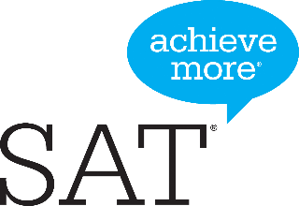
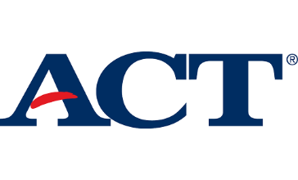
TEST DATES

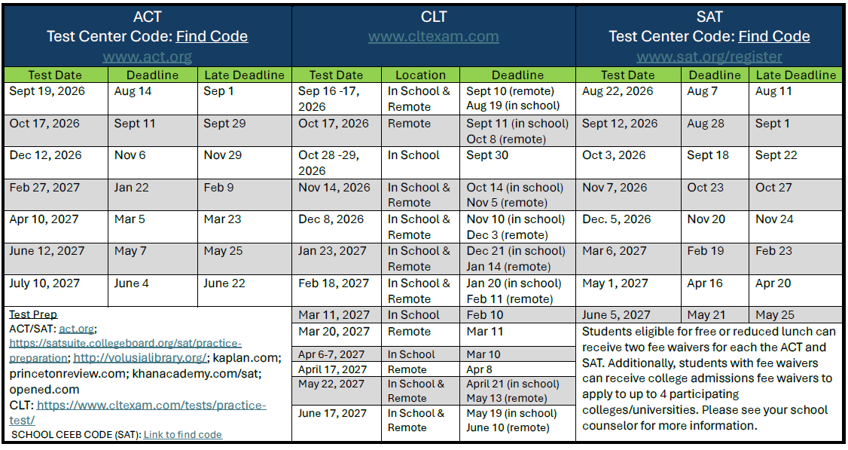

- ACT NCR Grade 12 (select students): October 13-15, March 9-11.
- SAT School Day: October 22

ATLANTIC High School’s CEEB Code number is 101443.

ACT/CLT/SAT CONCORDANCE TABLE
The ACT and SAT contain different types of questions; many students take both tests and then compare their performance using this concordance table. There is a newer test of the two is the CLT. Here is a concordance table for the CLT with the ACT and SAT. The Florida Bright Futures Scholarship Program and the NCAA Clearinghouse will use your highest score.
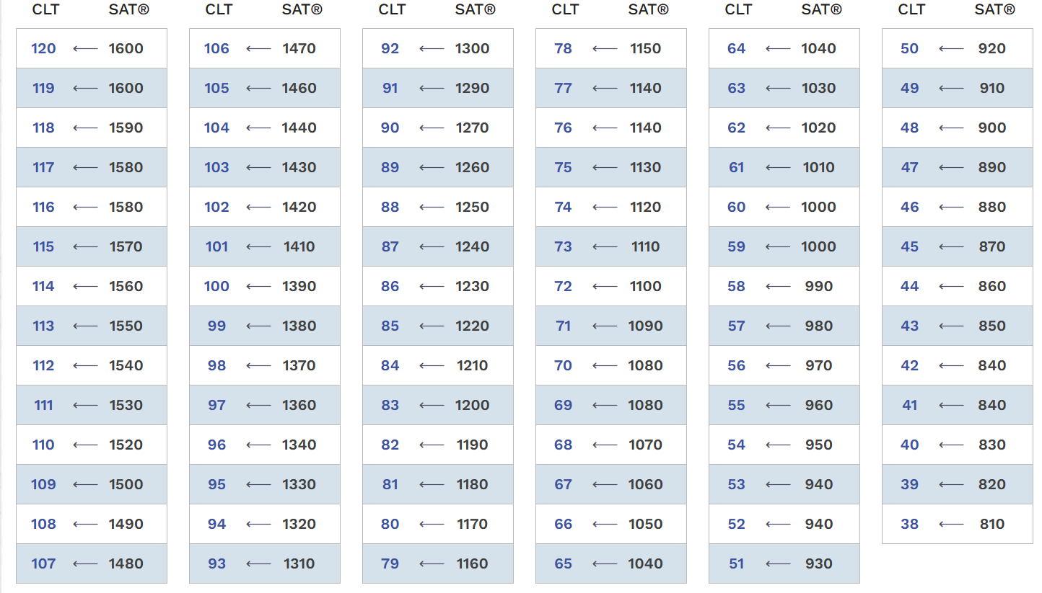
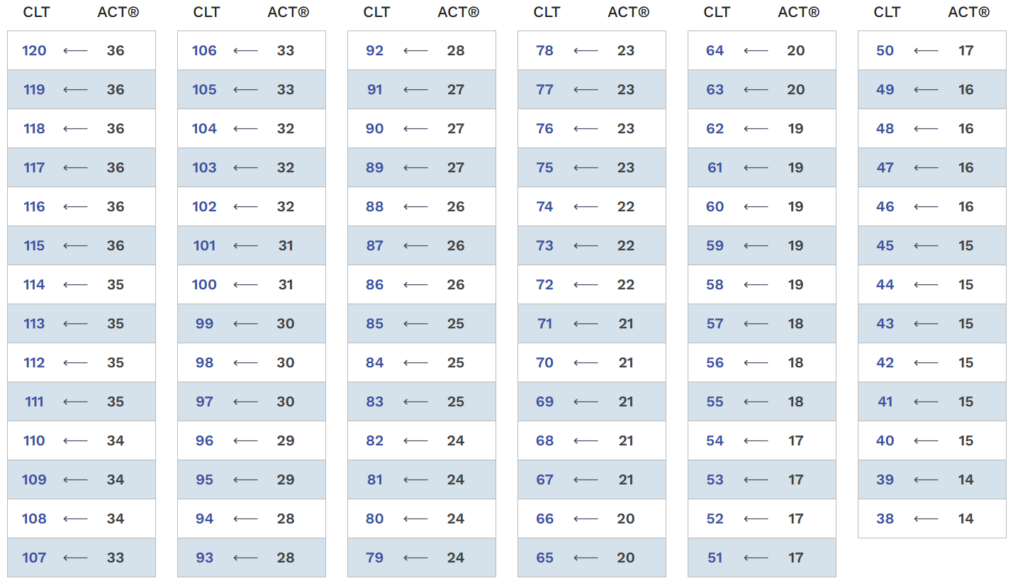
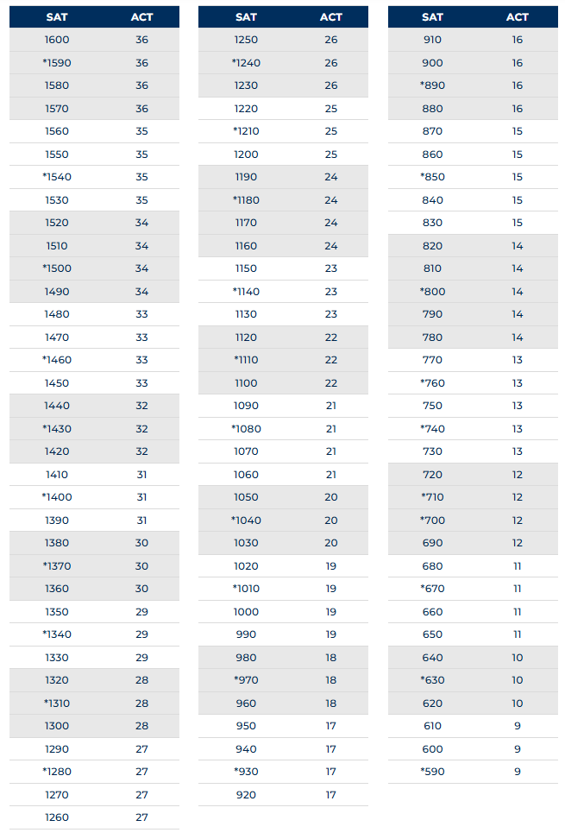

SENIOR TIDBITS

Career Choices: | Unsure of your future? You can learn a great deal about yourself by using ‘career’ software that will help you to find careers that best interest you. Online interest inventories are available. The ASVAB is an excellent tool to identify your aptitude and strengths.
Community Service: | Do not put off fulfilling your service requirements. You will need to complete a community service workshop quiz before we begin to record your service activity. All service hours are due before graduation.
GPA: | Remember that you need an unweighted 2.0 GPA or better to graduate.
Immunizations: | Many colleges now have immunization requirements. Check with the college/university that you plan to attend to see what is required for admission.  Your immunization record needs to be updated before graduation. The Health Department may provide free immunizations for eligible students – contact the Health Department for details. Your school Registrar will supply you with a copy of your shot records; however, you need to give them your new immunization dates so it can be included in your final transcript.
Military Choices: | Interested in the military? Recruiters from various branches of the military visit our campus on a regular basis. Different military branches, including the National Guard, offer a variety of scholarship opportunities. The ASVAB is scheduled to be administered on campus 10/29/2026 AND 2/25/2027. Sign up at the designated area. See your school counselor.
Progress Reports: | Progress reports are issued at the midpoint of the grading period. In addition to the mid-term grades, progress reports contain information about make-up work, conduct and classroom progress. Progress reports are sent home with the student.
Stay Informed: | Keep on top of the latest news and information. Listen to morning announcements, visit the school web site often, and check-out the ‘SENIOR’ bulletin board in the School Counseling office. Take advantage of every opportunity coming your way by staying informed.
Transcripts: | Transcripts must be requested in advance (at least 2 to 3 days). There is a form that must be completed and signed by your parents. Provide the mailing address if the transcript is going to an out of state or private college or university.  You will need to request a FINAL TRANSCRIPT at the end of the school year once you are sure which college/university or another program you will be attending. The final transcripts will not be sent out right away. Check in the School Counseling office for this date.

SENIOR EXPENSES

The following items are optional, approximate expenses. This will give you an idea on how to budget your money and possible expenses related to your senior year. These are approximations and subject to change.

- Yearbook - $65
- Grad Bash at Universal Studios – around $165
- Homecoming dance - $35, $70 at the door
- Prom – around $70, more at the door
- SENIOR FEES (dues, cap and gown, t-shirt) $110

Optional, prices vary according to your selection.

- Senior pictures - Varies

- Class ring - Varies

- Graduation announcements - Varies

- Class portraits - Varies



GRADUATING THE CLASS OF 2027

The Commencement Ceremony for the Class of 2027 is on JUNE 4, 2027 AT 12:30 PM. There are many events leading up to this auspicious occasion. Please be sure to review the information provided during the school year so that you are completely knowledgeable about these occasions.

Senior Awards Night | All seniors are strongly encouraged to attend with their family members. This is a night for special recognition of academic achievement as well as awarding local community scholarships. The ceremony is held on MAY 19, 2027 in the AUTIRORIUM and begins promptly at 6 PM. THIS IS BY INVITATION ONLY. Attire requirements are the same as for graduation.
Graduation Attire | Graduates are suggested to wear a cool dark, solid colored dress, dark blue or black dress pants under the graduation gown. Be sure to choose a style with a simple neckline that will not interfere with the neckline of the graduation gown.  Wear dress shoes. If your shoes are heeled, wear medium heels for your safety in getting on and off the stage.
Leave your purse, cameras, and other valuables at home or with a friend or relative while participating in the ceremony. There is no place provided to secure items during the program.

GRADUATION DESIGNATIONS

INDUSTRY SCHOLAR DESIGNATION
In addition to meeting the standard high school diploma requirements students must attain one or more industry certifications from the list established (per s. 1003.492, F.S.)

Industry Certifications within VCS
Cert ID | Description
ADESK002 | Autodesk Certified User - AutoCAD
ADESK008 | Autodesk Certified User - Revit
ADESK011 | Autodesk Certified User - Inventor
ADESK032 | Autodesk Certified User - Fusion 360
ADOBE023 | Adobe Certified Professional in Video Design (Requires Premiere Pro and After Effects or Photoshop)
ADOBE024 | Adobe Certified Professional in Visual Design (Requires Photoshop and Illustrator or InDesign)
CERHB001 | Biotechnician Assistant
CERTI009 | Information Technology Specialist (ITS) - Device Configuration and Management
CERTI010 | Information Technology Specialist (ITS) - JavaScript
CERTI012 | Information Technology Specialist (ITS) - Python
CERTI013 | Information Technology Specialist (ITS) – Java
CPREC001 | Child Development Associate (CDA)
FDMQA030 | 911 Public Safety Telecommunicator
FEDAA011 | FAA Private Pilot
FLDOE004 | Florida Teacher Certification Examinations (FTCE) - Professional Education Test
FLFBR001 | Agritechnology Specialist Certification
FLFBR005 | Animal Science Specialist Certification
HVACE001 | HVAC Excellence Employment Ready - Heat Pump
HVACE002 | HVAC Excellence Employment Ready - Air Conditioning
HVACE011 | HVAC Excellence Employment Ready - Electrical
INTUT001 | QuickBooks Certified User
INTUT002 | Entrepreneurship & Small Business
INTUT004 | Intuit Certified Bookkeeping Professional
NIASE007 | ASE Automobile/Light Truck Technician: Brakes (A5)
NRAEF003 | Certified Food Protection Manager (ServSafe®)
NRFSP001 | Certified Food Safety Manager (National Registry of Food Safety Professionals)
PROSO017 | Certified Internet Web (CIW) JavaScript Specialist
PROSO027 | Certified Internet Web (CIW) Advanced HTML5 & CSS3 Specialist
PROSO032 | Certified Internet Web (CIW) User Interface Designer
UNITY002 | Unity Certified User: Programmer
USINS001 | Small UAS (sUAS) Safety Certification: Level 1


SCHOLAR DESIGNATION
In addition to meeting the standard high school diploma requirements:
- 1 credit in Algebra 2 or an equally rigorous course
- 1 credit in Statistics or an equally rigorous math course
- Pass Biology 1 EOC*
- 1 credit in Chemistry or Physics
- 1 credit in a course equally rigorous to Chemistry or Physics
- Pass US History EOC*
- 2 credits in the same World Language
- Earn at least 1 credit in an AP, IB, AICE or a dual enrollment course.
* Students who take respective AP, IB, or AICE Biology and/or US History assessment and earn a minimum score to earn college credit are exempt from the EOC requirement for these courses.

FLORIDA SEAL OF BILITERACY

The Florida Seal of Biliteracy identifies students who have attained a certain level of proficiency in at least 2 languages by high school graduation.

- Gold Seal of Biliteracy: 4 or 5 on FSA/FAST ELA plus 4 credits (3.0+ unweighted) in a world language or the appropriate score on any of the approved assessments or portfolio.
- Silver Seal of Biliteracy: 3 on FSA/FAST ELA plus 4 credits (3.0+ unweighted) in a world language or the appropriate score on any of the approved assessments or portfolio.
FLORIDA SEAL OF FINE ARTS

The Florida Seal of Fine Arts Program is a state level seal honoring high school graduates who have met exemplary benchmarks in fine arts coursework by the award of a seal on a standard high school diploma.

Criteria for Eligibility. Beginning with the 2024-25 school year, the Florida Seal of Fine Arts shall be awarded to a high school student who demonstrates the following requirements have been met:
- (a) The student earned a standard high school diploma.
- (b) The student completed at least three (3) year-long courses in dance, music, theatre, or visual arts with a grade of “A” or higher in each course, or earned three (3) sequential course credits in such courses with a grade of “A” or higher in each course pursuant to Rule 6A-1.09441, F.A.C.; and
- (c) The student completed at least two (2) of the following requirements:
- Completed a fine arts International Baccalaureate, advanced placement, dual enrollment, or honors course with a grade of “B” or higher.
- Participated in a district or statewide organization’s juried event as a selected student participant for two (2) or more years.
- Recorded at least twenty-five (25) volunteer hours of arts-related community service in his or her community and presents a comprehensive presentation on his or her experiences pursuant to district procedures.
- Submits a portfolio that demonstrates the student is an exemplary practitioner of fine arts, as described in subsection (3); or
- Received district, state, or national recognition for the creation and submission of an original work of art.

COLLEGE REPS

Many colleges and universities in the area will send a representative to our school during the fall. These representatives usually bring information about their school, give a brief talk on entrance requirements and campus life, and answer questions. While you should visit college campuses you are most interested in, you should also make a point of meeting with the representative as a part of your college selection process.

College representative visits will usually be posted two weeks prior to the visit – in the School Counseling office. You must sign up in advance to receive a pass to attend. If you have questions, please contact your counselor.
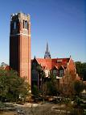
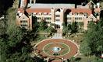
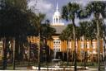


SELECTING A COLLEGE:
ONE SIZE DOES NOT FIT ALL

College and universities come in different sizes and types with different emphases and opportunities. Your needs and priorities will determine how you select from such a wide range of choices (public/private, large/small, four year/two year, urban/rural, secular/religious…) and find an institution that is appropriate for you.

Choose a LARGE UNIVERISITY (enrollment greater than 10,000) if you want:

- many academic majors, a large university available academic major often number in the hundreds, not dozens. If you change your major or career choice, a large university is more able to accommodate changes.
- more sophisticated laboratory equipment and libraries of considerable size available for undergraduate use.
- a multiplicity of services designed to help students identify and pursue career options
- more student activities and more varied opportunities to associate with other students.
- a variety of opportunities for student involvement—organizations which cater to a wide range of interests, religious denominations, political involvement, etc.

- student services staffs – personal counseling and other opportunities to improve social awareness and skills as well as improved opportunities for career identification and job seeking.

- to meet students whose backgrounds, present a wide variety of experiences, values and perspectives. A large university is an excellent place to gain experience in being able to live and work with a wide variety of people.

Choose a MID-SIZE STATE UNIVERSITY if you want:

- a less expensive institution compared to a private institution.

- the possibility of living at home while pursuing your degree.

- to take advantage of state scholarship programs.

- to use a system that is supported by your tax dollars.

- proximity to parents, friends, and your home community.

- an integrated educational program with easy transfer from campuses as well as two-year institutions.

- cooperative extensions, continuing education, or satellite program because you cannot attend full-time on campus.

- opportunities to establish long-lasting relationships as a source of friendship and professional.
- contacts for a lifetime in your home state.

Choose a TWO-YEAR COLLEGE (designed to prepare you for continuation at a four-year institution) if you want:

- to start with the essential foundations of undergraduate training.

- access to faculty. You often get to know professors on a one-to-one basis in the classroom and socially at extracurricular events.

- less expensive (especially if you plan on commuting).

- more opportunities for leadership and participation in the first two years of your college career.

- an entire institution’s budget spent on the first two undergraduate years.

- emphasis on the basics – reading, writing and math.

- to transfer to a four-year institution better prepared and with a greater possibility of being accepted than if you were right out of high school.

Choose an INDEPENDENT RESEARCH UNIVERSITY if you want:

- a school with an extraordinary reputation and academic circles boasting an outstanding faculty.

- to learn as much from your gifted fellow students as from your professors.

- informal associations between yourself and your professors.
- seminar classes with leaders in public affairs and the arts and sciences.
- a diverse student body (deliberately created by the admissions office).
- a smaller size school provides a critical mass for a wide variety of activities and sense of community.
Choose a HISTORICALLY BLACK COLLEGE or UNIVERSITY if you want:

- excellent scholarship opportunities
- typically, small class sizes allow interaction and personal attention from the faculty.
- a “family atmosphere” where strong friendships are easily formed with a wide range of extracurricular activities.
- an excellent alumni network, strong job placement, and career counseling.
Choose a CHURCH-RELATED COLLEGE or UNIVERSITY if you want:

- a values-based education. A church-related institution offers the opportunity to explore the values inherent in the ideas and behaviors presented in the curriculum.
- spiritual growth opportunities. A church-related institution operates with the idea of educating the whole person spiritually and intellectually.
- a broader view of the role of ethics in society. You will be encouraged to develop and maintain a personal perspective as a moral being in the workplace and at home.

Choose a COLLEGE FOR WOMEN if you want:

- to develop your leadership skills. Women hold all the leadership positions in a women’s college. This leadership extends into the working world – 40% of female members of Congress and a third of the women board members of Fortune 1000 companies are graduates of women’s colleges.
- to attend graduate or professional school after graduation. Graduates of women’s colleges are more than twice as likely as graduates of coeducational colleges to receive doctorate degrees.
- to study science, math, or economics. Women’s colleges produce a disproportionate share of women who enroll in fields such as science, math, and economics.
- to pursue a career which is nontraditional for women. About 50% of the working women who graduate from women’s colleges are in nontraditional jobs, for example, law, medicine, business management and computer science.

THE CAMPUS VISIT

Campus visit gives you an opportunity to give the college a “test run.” Although the facts and figures may indicate that a particular college is right for you, the campus visit will often help you decide whether you will feel comfortable in that college environment. Given the experience of college education, it makes sense to shop for the school that best fits your needs, and this includes considering your own reaction to the school environment.

When to Visit

- If possible, visit when the college is in session.

- Try to schedule visits when High School is not in session. It is important that you continue to work hard during your senior year, and this requires an excellent attendance record. There are virtual visits for many schools as well.

- Visit early in your senior year to narrow down choices of schools and to submit early applications.

Procedure for Arranging a Campus Visit:

Call or go online to the Admissions Office to find out about special visitation days for high school students and/or the procedure for a regular campus visit.

If you are unable to visit on these special days, call, e-mail or register online at the Office of Admissions to arrange a visit. Depending on whether the purpose of your visit is to get a general impression or an in-depth experience of campus life, you may request:

- campus tours
- an interview with an admission counselor
- to attend classes (freshman courses, in your major field of interest)
- to eat in a college cafeteria
- to stay overnight in a dorm
- to attend a social, athletic, political, or cultural event
- to meet with a coach or department head, call ahead for appointment.

Although VCS expects students to arrange campus visits for days when high school is NOT in session, sometimes it is necessary to miss a school day. If this is the case, the student should bring a note from parents indicating the purpose of the absence and the dates. Bring the note to the Attendance Office. Absences just before or after school vacations are usually considered unnecessary since the visits could take place during the vacation.

COMPLETING THE COLLEGE APPLICATION

Decide on your college choices.

- Take or retake the ACT, CLT, and/or SAT.

- Complete an application from the college of your choice.

- Know and meet deadlines
  - for early admission
  - for regular admission
  - for financial aid and scholarships
  - for special programs
  - for housing

- Fill out an authorization form for release of records.

- Remember –ATLANTIC High School CEEB Code is 101443.

Timeline

- Applause if you apply in the fall. I highly recommend an early October deadline!

- Smiles if you apply before the Holiday break.

- Nail biters wait until February.

- A kick in the pants for those who wait until Spring Break.

- May applicants – fix up your bedroom at home – you will still be there! Or, you can attend a local state college as well.




COLLEGE DEMOGRAPHICS FOR 2026-2027

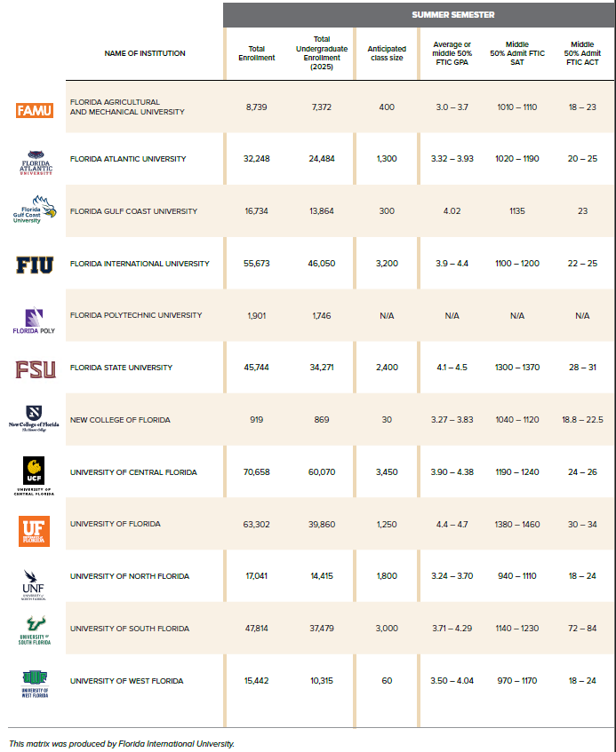

College Demographics Continued…

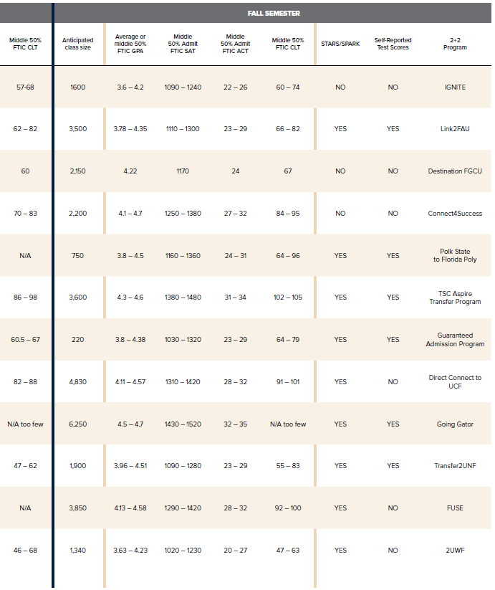

RESUME WORKSHEET

Complete the following sections to use as a guide in starting your resume. Do not limit yourself; list everything even if it seems trivial. Using this worksheet will help you not only keep track of your “stuff and activities” for four years but will also help guide you. Fill in the missing pieces or areas in which you might be weak in. This worksheet will be helpful for whoever is writing your letter of recommendation also.

PERSONAL INFORMATION
Name:
Address:
Phone:
E-Mail:

EDUCATION
High School:
City, State:
Graduation Date:
Type of Diploma:
Major:

HONORS AND AWARDS
Any academic, athletic, or community honors
Award:
Sponsoring organization:
Date awarded & what grade:
Reasons for recognition:

ACTIVITIES
Describe the activities you are involved in, both in and out of school. Include any leadership positions held. Include club, athletics, drama, music, newspaper, yearbook, student council, community service.
Position held:
Organization:
Dates of involvement and what grade:
Description of activities:

WORK EXPERIENCE
Include both paid and unpaid after school, weekend, or summer employment. Describe your skills, qualifications, and accomplishments.
Job Title:
Name or employer or organization:
City, State:
Dates worked:
Description of work, skills used, special projects and accomplishments.

SKILLS (AND SPECIAL INTERESTS)
Languages:
Computer skills:
Interests:

Sammy T Senior
2023 Graduate Way • Somewhere, FL 32725 • (386) 734-7190 • agreatstudent@gmail.com

Education
Senior, ABC High School, 100 Way Street, Somewhere, FL 32725
Anticipated Graduation Date: May 2026

Objective
Reliable and mature high school senior seeking a part-time retail sales position within a youth-oriented clothing environment to gain experience and insight into the fashion industry for a future career in fashion design and merchandising.

Skills Summary
◻ Customer Service  Cash Register Experience  File Management
◻ Computer Savvy  General Office Skills  Phone Etiquette

Work Experience

Country Club, 321 Uppity Drive, Somewhere, FL 32725
Summer 2022 to current • Lifeguard
- Monitored swimming areas for rule violations and drowning victims.
- Assisted in maintaining pool facilities and recreation areas surrounding pool area.
- Supervised entertainment activities sponsored by the country club.
- Worked assigned shifts at check-in and concession stand.

Smith & Smith, Attorneys at Law, 123 Numbers Way, Somewhere, FL 32738
Fall 2019 – Spring 2022 • Office Aide/Messenger
- Picked up and delivered catering and supplies for luncheons and corporate functions.
- In-house mail delivery and sorting.
- Office supply pick up for local merchants.
- Assisted clerk in the law library.

Volunteer Work

Big Brothers/Big Sisters • 2019 – 2021
- Assisted with and participated in group activities and field trips.
- Tutored ages 8 – 13 and assisted with homework assignments.

School Organizations

National Honor Society 2018—2021

Debate Team 2019—2021

Decorations Committee Chair 2020

Spanish Club 2018—2021
- Secretary 2021

PREPARING FOR A JOB INTERVIEW

There are a few things you should keep in mind before your first interview. Review your personal data so that you will be able to answer whatever questions may be asked of you. The interviewer will generally want to learn about your:

- Attitude toward people and work
- Educational and work experience
- Future career plans

BEFORE THE INTERVIEW
- Prepare clothing
- Verify the day, time and location of the interview
- Verify the interviewer’s name and correct spelling
- Gather up a resume, list of references, social security card and a pen
- Practice introducing yourself and shaking hands
- Give yourself a 20–30-minute leeway, but be prepared to walk in 5 minutes early

WAITING FOR THE INTERVIEW
- Be courteous, especially to the receptionist
- Be aware of your actions, you may be observed
- Read any company literature, if available

DURING THE INTERVIEW
- Be aware of your body language
- Listen carefully to the questions and reflect before responding
- Be honest, positive and direct when responding to questions
- Ask questions of the interviewer: show interest and knowledge of the job

CLOSING THE INTERVIEW
- Express a continued interest in the job.
- Find out when a decision will be made
- Initiate follow-up/call back
- Thank the interviewer

AFTER THE INTERVIEW
- Send a thank you letter/not e-mail.
- Follow through on follow-up/call back
- Continue job search efforts

TOP FIVE QUESTIONS AN INTERVIEWER ASKS:
- Tell me a little bit about yourself
- Why do you want to work for this company?
- Where do you see yourself in three to five years?
- Why should I hire you?
- Do you have any questions?

MILITARY OPTIONS

Many opportunities await the student who joins one of the branches of the armed services upon graduation. Recruiters from the United States Air Force, Army, Coast Guard, Navy, Marines and National Guard visit our campus regularly. They are eager to meet with interested students.

You will need to earn a regular high school diploma to be considered by most, if not all the services.

Each branch of the service offers different opportunities, and you may want to ask about…


• Opportunities for further education
• Scholarship opportunities
• Career training, jobs, and your choices
• Military lifestyle (travel, impact on family life, etc.)
• Time commitments
• Expected income
• Basic training
• Military training
• Duty stations (what type? where?)


The ASVAB (Armed Services Vocational Aptitude Battery) test is required.


FINANCIAL AID

Figuring out the financial aid process does not have to be overwhelming. Some of the best steps to take include:

- Attend Volusia County School Financial Aid Night on October 1 @ 5 PM at Embry Riddle Aeronautical University, Student Union. We will present information to parents and students about financial aid and completing the Free Application for Federal Student Aid (FAFSA).

- Once you have decided on a post-secondary institution, meet with a representative from the financial aid office to discuss the financial aid process and options.

If your family’s annual income is over $60,000 you may not receive much federal financial assistance. However, if you are a good student, many colleges with high costs will utilize funds from endowments to help you finance your education. Experts on financial aid advise you to plan by completing the Expected Family Contribution (EFC) worksheet.

Scholarship Scams

Be careful when searching for information on student financial assistance. Make sure information and offers are legitimate. Do not fall prey to fraud.

Estimates show that families lose millions of dollars to scholarship fraud every year. The College Scholarship Fraud Prevention Act enhances protections against fraud in student financial assistance. The Federal Trade Commission (FTC) cautions students to look for these telltale lines:

- "The scholarship is guaranteed or your money back."
- "You can't get this information anywhere else."
- "I just need your credit card or bank account number to hold this scholarship."
- "We'll do all the work."
- "The scholarship will cost some money."
- "You've been selected by a 'national foundation' to receive a scholarship" or "You're a finalist" in a contest you never entered.



FEDERAL STUDENT AID

This Guide provides you with information on student financial aid from the federal government. These three pages are an "at a glance" view of the student aid process. Approximately two-thirds of all students’ financial aid comes from federal programs administered by the U.S. Department of Education's Student Financial Assistance (SFA) office (www.studentaid.gov).

For additional sources of financial aid, other than the federal government, remember to talk to the financial aid administrator at the school you plan to attend, visit the library and the Internet and search under "financial aid" and "student aid."

Beware of scams and services that will search for financial aid money for you for a fee.

WHAT is federal student aid?
Federal student aid is financial help for students enrolled in eligible programs at participating schools to cover school (a four-year or two-year public or private educational institution, a career school or trade school) expenses, including tuition and fees, room and board, books and supplies, and transportation. Most federal aid is need-based. The three most common types of aid are grants, loans, and work-study.

GRANTS…financial aid that does not have to be repaid. Generally, grants are for undergraduate students, and the grant amount is based on need, cost of attendance, and enrollment status.

Federal Supplemental Educational Opportunity Grants (FSEOG) range from $100 to $4,000.

LOANS…borrowed money that must be repaid with interest. Both undergraduate and graduate students may borrow money. Parents may also borrow money to pay education expenses for dependent undergraduate students. Maximum loan amounts depend on the student's year in school.

Federal Stafford Loans are made to students and PLUS loans are made to parents through two loan programs.

- William D. Ford Federal Direct Loan (Direct Loan) Program: eligible students and parents borrow directly from the federal government at participating schools.

- Direct Loans include Direct Stafford Loans, Direct PLUS Loans, and Direct Consolidation Loans.

- Federal Family Education Loan (FFEL) Program: private lenders provide federally guaranteed funds. FFELs include FFEL Stafford Loans, FFEL PLUS Loans, and FFEL Consolidation Loans.

Perkins Loans are offered by participating schools to provide students that demonstrate the most need with low-interest loans.

WORK-STUDY…lets you earn money while enrolled in school to help pay for education expenses.

NOTE: Not all schools participate in all the Federal Student Aid programs. Ask your college's financial aid administrator which programs are available.

WHO gets federal student aid?
Some of the requirements to receive aid from the U.S. Department of Education's SFA programs are that you must

- Be a U.S. citizen or eligible noncitizen with a valid Social Security Number.

- Have a high school diploma or a General Education Development (GED) certificate or pass an approved ability-to-benefit (ATB) test;

- Enroll in an eligible program as a regular student seeking a degree or certificate; and Register (or have registered) with the Selective Service if you are a male between the ages of 18 and 25.

HOW do you apply for federal student aid?

- Complete the Free Application for Federal Student Aid (FAFSA).
The FAFSA lists deadlines for federal and state aid. Check deadlines! Schools and states may have different deadlines for aid.

You may get a FAFSA
- online at www.fafsa.ed.gov;
- from the School Counseling office.
- from a college financial aid office.
- from a local public library; or
- from the Federal Student Aid Information Center at 1-800-4-FED-AID (1-800-433-3243)

- Review your Student Aid Report (SAR). One to four weeks after you submit your FAFSA, they will send you a SAR. The SAR confirms the information reported on your FAFSA and will tell your Expected Family Contribution (EFC). The EFC is an index of need that your financial aid administrator will use to determine the amount of federal student aid for which you qualify.

- Contact the school(s) you may attend.
Talk with the financial aid administrator at the schools you are interested in attending. They will review your SAR and prepare a letter outlining the amount of aid (from all sources) that their school will offer you.



FLORIDA BRIGHT FUTURES SCHOLARSHIP FFAA

www.floridastudentfinancialaid.org/SSFAD/bf/

The Florida Bright Futures Scholarship Program establishes three lottery-funded scholarships for Florida high school graduates who demonstrate high academic achievement and enroll in eligible Florida public or private postsecondary institutions. There are three award levels for which high school seniors may qualify. The scholarship may be used for either full-time or part-time enrollment and is renewable. All initial applicants must meet the general requirements for participation in this program, and specific requirements for the individual award.

GENERAL REQUIREMENTS FOR ALL AWARD TYPES

To be eligible for an initial award from any of the four types of scholarships, a student must:

- Apply by completing the Florida Financial Aid Application during the last year in high school. You may apply on-line at www.FloridaStudentFinancialAid.org. Applications should be submitted no later than August 31 after graduation, or you will forfeit all future eligibility for a Bright Futures Scholarship.
- Earn a Florida standard high school diploma or its equivalent.
- Be accepted by and enrolled in an eligible Florida public or independent postsecondary education institution. (All community colleges and state universities are eligible, as are many private colleges. For a list of eligible private institutions, see the Bright Futures website at www.floridastudentfinancialaid.org/SSFAD/bf/.)

- Be enrolled for at least six semester credit hours or the equivalent.

- Not have been found guilty of, or pled no contest to, a felony charge.

- Begin using the award within three years of high school graduation (call the Bright Futures Office for application deadlines).

Eligibility requirements for each of the types of awards for high school graduates can be found on the following pages. A student may receive funding for only one award. The highest award earned will be selected. Also, this information is based on the latest printed material. The Florida State Legislature can amend any and/or all parts of this information at any time. Please continue to visit the Florida Bright Futures’ website at:
www.floridastudentfinancialaid.org/SSFAD/bf/

FLORIDA BRIGHT FUTURES REQUIREMENTS
2026-2027 Graduates
 | Florida Academic Scholarship (FAS)  -Covers 120 credit hours- | Florida Medallion Scholarship (FMS)  -Covers 120 credit hours- | Florida Gold Seal Vocational (GSV)  -Covers 72 credit hours- |  |  | Florida Gold Seal CAPE Scholars (GSC)**
Award Amount¹ | 100% of tuition & applicable fees at a public Florida institution. Students attending a nonpublic institution will receive a comparable amount noted in the Private Award Chart. | 75% of tuition & applicable fees at a public Florida institution. Students attending a nonpublic institution will receive a comparable amount noted in the Private Award Chart. | Up to:  $48/credit hour – AS, AAS, CCC*  $39/credit hour– PSAV*  $39/credit hour – ATD* |  |  | Up to:  $48/credit hour – AS, AAS, CCC*  $39/credit hour – PSAV*  $39/credit hour – ATD*  $48/credit hour – BS, BAS*
Requirements:
1. GPA | 3.5 weighted Bright Futures GPA | 3.0 weighted Bright Futures GPA | 3.0 weighted in non-elective classes AND 3.5 unweighted in the CTE credits
2. Core Classes (credits) | 4- English  (3 with substantial writing)  4- Math (at or above Algebra 1)  3- Natural Science  (2 with substantial lab)  3- Social Science  2- World Language - (sequential, in the same language) | 4- English  (3 with substantial writing)  4- Math (at or above Algebra 1)  3- Natural Science  (2 with substantial lab)  3- Social Science  2- World Language - (sequential, in the same language) | Earning a standard high school diploma  3- Career Tech Ed credits (On-the-job training may not be substituted for any of the three required career credits) |  |  | - Earn a standard high school diploma.  - Earn a minimum of 5 postsecondary credit hours through CAPE industry certifications that articulate for college credit
3. Service Hours | 100 volunteer or 100 paid hours or 100 combined | 75 volunteer or 100 paid hours or 100 combined | 30 hours or 100 paid hours or 100 combined |  |  | 30 hours or 100 paid hours or 100 combined
4. Test Scores | ACT – 29 (Composite)  ~OR~  CLT – 95  ~OR~  SAT – 1330 (CR & Math only) | ACT – 24 (Composite)  ~OR~  CLT – 82  ~OR~  SAT – 1190 (CR & Math only) | ACT  19 Reading  17 English  19 Math | SAT (3/1/24 thereafter)  490 Reading/Writing  480 Math
4. Test Scores |  |  | SAT (Prior 3/1/24)  24 Reading  25 Writing & Language  24 Math |  | PERT  106 Reading 103 Writing  114 Math

¹Award amounts are approximate and subject to change after each legislative session. ²Algebra 1A/1B equals one credit. ³Algebra 1A/1B equals two credits.
*Semester, see the Bright Futures Student Handbook, Chapter 2, page 4 to find the breakdown of award amounts for quarters and clock hours
**GSC recipients who earn a qualifying A.S. or A.A.S degree may receive an award toward a qualifying B.S. or B.A.S. degree.

Students must APPLY for the scholarship by submitting the Florida Financial Aid Application (FFAA) no later than Aug 31 after high school graduation. If a student does not apply for the scholarship by the deadline, a student cannot receive the scholarship! All eligibility requirements must be met by high school graduation; however, scores of ACT®/CLT®/ SAT®/ P.E.R.T tests should be achieved no later than August 31 of the graduation year (or January 31 for mid-year graduates). Students must earn the required volunteer service, paid work hours, or a combination of both equal to 100 total hours.

After submitting the FFAA, the student is responsible for tracking application and award status online and keeping the Office of Student Financial Assistance (OSFA) informed of any demographic or institutional changes. Students are responsible for ensuring that funding for an academic year is accurate by contacting their institution’s financial aid office.

OTHER WAYS TO QUALIFY:
Students who have demonstrated academic merit through a recognition program may be eligible for Bright Futures without having to meet one or more of the requirements. Note: Both AICE and IB Diplomas must be earned prior to high school graduation. Confirmations may come from AICE and IB as late as September. Please refer to the table below for how to qualify based on one of the merit recognition programs.

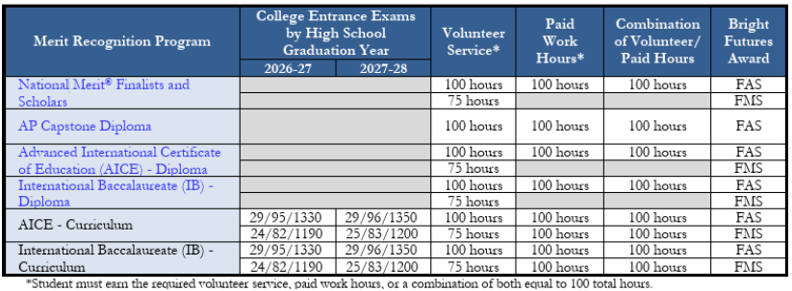

The Florida Legislature is authorized to change eligibility requirements for future graduating classes. Visit the Bright Futures site to view the student handbooks for more information. https://www.floridastudentfinancialaidsg.org/SAPBFMAIN/SAPBFMAIN

SENIORITIS

“What’s senioritis? Imagine a dog left in a kennel for a month, waiting for his owner to come get him. Then he sees his owner and he know he is going to be home soon! He goes berserk, banging on the cage! That is how most seniors feel this time of year while they are waiting for high school to be over.”

As students go back to their final year of high school, they have lots on their minds. College, parties, friends, jobs - everything but studies! There is no doubt about the fact that senior year should be the most enjoyable and memorable of them all. However, one should not forget that the last year of high school should also fulfill its primary purpose: to equip students in making a smooth transition from high school to post-secondary.

Colleges are looking more closely at how high school seniors perform after they are accepted early in senior year. Students who drop tough courses or whose grades show significant declines after acceptance may have their admissions revoked. Colleges have always had the right to do this, but revocation was rare in the past. Now with increasingly competitive admissions, colleges are tough on high school seniors who slack off.

Other students have too much on their mind (going off to college, leaving family, having to work, finding how to pay for college) to concentrate on their studies. The fact that these 18-year-old "adults" must adhere to rules made for their 15-year-old freshman counterparts only adds to their frustration. The result: a dangerous case of high school "senioritis."

For those of you who still think senioritis is a paranoid conspiracy theory, things have gotten so bad that the government has had to set up a commission to deal with the problem! Although the name is not all that original (any guesses on what it is called, anyone?), the National Commission on the High School Senior Year is actively helping students, parents, and teachers to make the final year of high school more productive and effective.

Tips to help you survive senioritis:

- Create your own motivation - Even if you have already been accepted to college, keep setting goals for yourself, in and out of the classroom, and working towards them.

- Challenge Yourself - Take the most rigorous courses available at your school, such as AP® courses. If you would like a preview of college work, consider signing up for a course at a local college.

- Stay involved and active - Keep up your participation in school activities, sports, volunteer work, etc.


- Keep things in balance - Try not to let one area of your life (schoolwork, social life, outside interests, job) totally dominate other areas.


NOTES:

________________________________________________________________________________________________________________________________________________________________________________________________________
________________________________________________________________________________________________________________________________________________________________________________________________________
________________________________________________________________________________________________________________________________________________________________________________________________________
________________________________________________________________________________________________________________________________________________________________________________________________________
________________________________________________________________________________________________________________________________________________________________________________________________________
________________________________________________________________________________________________________________________________________________________________________________________________________
________________________________________________________________________________________________________________________________________________________________________________________________________
________________________________________________________________________________________________________________________________________________________________________________________________________
________________________________________________________________________________________________________________________________________________________________________________________________________
________________________________________________________________________________________________________________________________________________________________________________________________________
________________________________________________________________________________________________________________________________________________________________________________________________________
________________________________________________________________________________________________________________________________________________________________________________________________________
________________________________________________________________________________________________________________________________________________________________________________________________________
____________________________________________________________________________________________________

