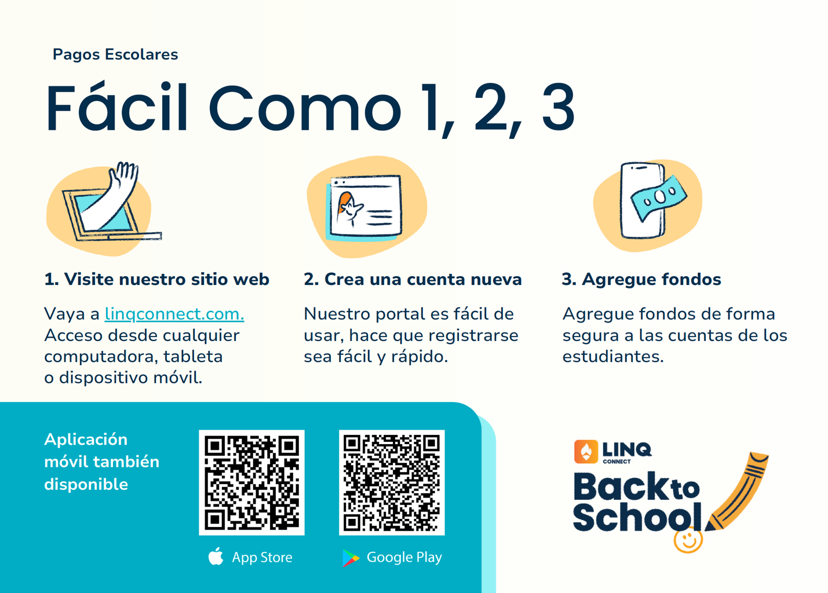
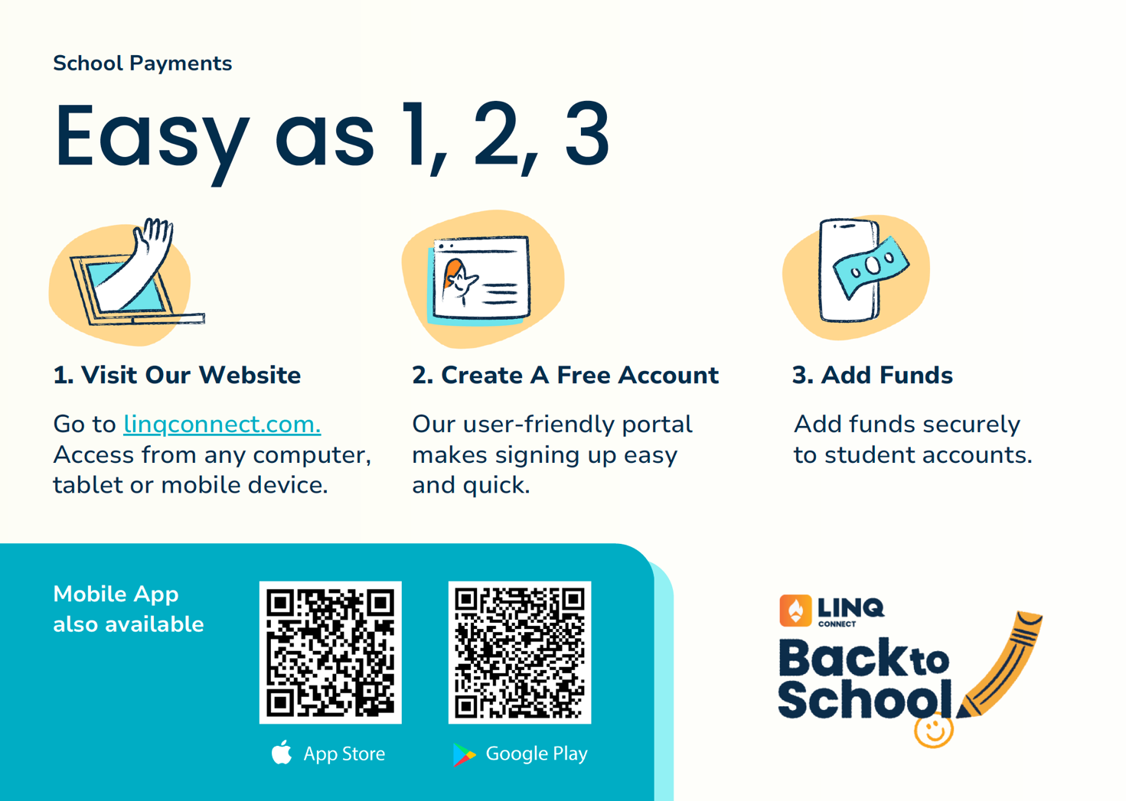
Efectivo o cheque puede ser depositado lunes - viernes 9:00 a.m. – 1:00 p.m.
En la oficina de Child Nutrition Program 2001 U-Tex Drive, San Benito, TX 78586 PH. 956-361-6400

Cash or check may be deposited Monday – Friday 9:00 a.m. – 1:00 p.m.
At the Child Nutrition Program Office at 2001 U-Tex Drive, San Benito, TX 78586 PH. 956-361-6400

