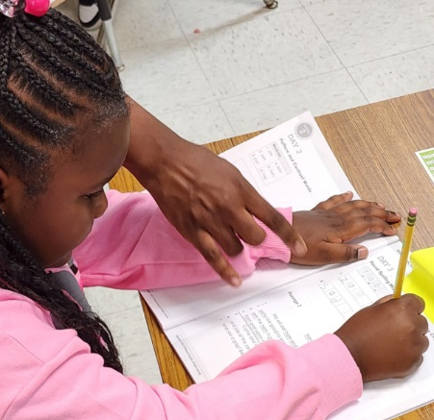
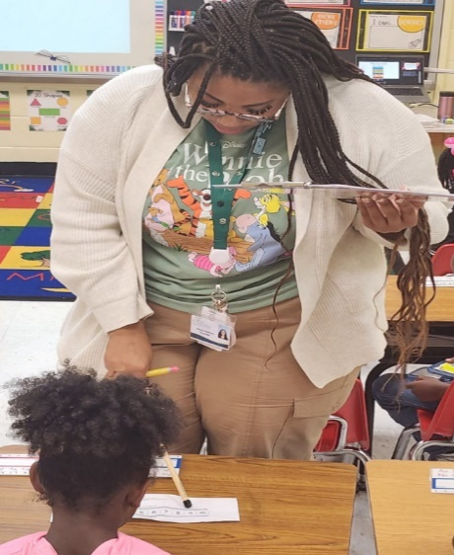
School Plan for Shared
Student Achievement

What is it?
This is a plan that describes how Love. T Nolan Elementary will provide
opportunities to improve family engagement to support student learning.
Love. T Nolan Elementary values the contributions and involvement of parents and
family members to establish an equal partnership for the common goal of
improving student achievement. This plan describes the different ways that
Love. T Nolan Elementary will support family engagement and how parents
can help plan and participate in activities and events to promote student learning at school and at home.

How is it revised?
Love. T Nolan Elementary School invited all parents to attend our Input Meeting last spring to review and revise this parent and family engagement policy, as well as the schoolwide plan, our school-parent compact, and the family engagement budget. Parents and family members of children receiving services shall be involved in the decision-making of how the funds reserve is to be allotted. Additionally, parent input and comments regarding this plan are welcome during the school year through opportunities to participate in survey submissions. The plan is posted on our school website for parents to view and submit feedback throughout the year. All parent feedback received during the year will be used to revise the plan for the next school year. We also distribute an annual survey online to ask parents for their suggestions on the plan and the use of funds for family engagement. Parents and family members can also give feedback during several parent meetings and activities during the school year, including our annual Math and Literacy Nights.

Who is it for?
All students participating in the Title I, Part A program, and their families are encouraged and invited to fully participate in the opportunities described in this plan. Love. T Nolan Elementary will provide full opportunity for the participation of parents and family members with limited English, with disabilities, and of migratory children.

Where is it available?
At the beginning of the year, the plan is distributed to all families virtually and given as a hard copy to all students. As a reminder, we will email and distribute the plan to all parents in August. The plan will also be posted on the school website and social media. Parents can also retrieve a copy of the plan in the Parent Resource Center located in the Media Center.

Love T. Nolan Elementary School
Parent and Family Engagement Policy and Plan for Shared Student Success

2026-2027 School Year

Love T. Nolan Elementary School
Dr. Earleana Smith, Principal
2725 Creel Road
College Park, GA 30349
(470) 254-7950
https://lovetnolan.fultonschools.org/homepage

Plan Revised 06/09/2026

What is Title I?
Love T. Nolan Elementary is identified as a Title I school under the Every Student Succeeds Act (ESSA). Title I is designed to support State and local school reform efforts tied to the challenging State academic standards to improve teaching and learning for students. Title I programs must be based on effective means of improving student achievement and include strategies to support family engagement. All Title I
schools must jointly
develop with
parents and family
members a written
parent and family
engagement
policy.

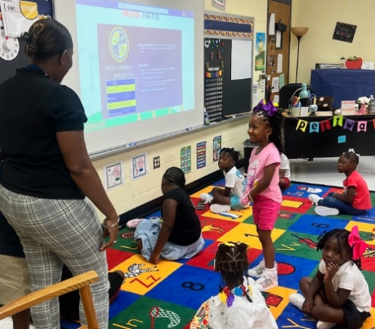
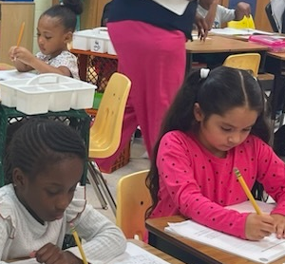
2026-2027 District Goals
1. Increase the percentage of all students scoring proficient or distinguished on Reading Milestones.
2. Increase the percentage of all students scoring proficient or distinguished on Math Milestones.

2026-2027 School Goals
ELA & Math Goal:
1. By May 2027, 80% of K-5 students will place at or above grade level on the iReady Reading Diagnostic.
2. By May 2027, 80% of K-5 students will place at or above grade level on the iReady Math Diagnostic.

School-Parent Compacts
As part of this plan, Love. T Nolan Elementary and our families will develop a school-parent compact, which is an agreement that parents, teachers, and students will develop that explains how parents and teachers will work together to make sure all our students reach grade-level standards. The compacts will be reviewed and updated annually based on feedback from parents, students, and teachers during the Annual Title 1 meeting in September. The
school-parent compacts
also are shared with
parents during
parent-teacher
conferences and several copies kept in the Parent Resource Center.
.

Let’s Get Together!
Love. T Nolan Elementary will host the following events to build the capacity for strong family engagement to support a partnership among the school, parents, and the community to improve student academic achievement.

Open House – July 30, 2026
Meet your child’s teacher and our friendly and helpful school staff for the year.

Annual Title I Meeting – September 10, 2026
We invite you to an evening of learning and sharing about our Title I program, including our parent and family engagement policy, the schoolwide plan, the school-parent compacts, and parents’ requirements. Invitations will be emailed, posted in the school newsletter, and posted on Class Dojo.

Curriculum Night – September 10, 2026
Fun and educational evening with families, where the school will describe and explain the curriculum used in the school. Parents will also be provided with information explaining how we measure students' progress and achievement levels of the State academic standards.

Reading Across the World – October 8, 2026
A celebration of all the international students of Love. T. Nolan. We will explore all the cultures that exist within our school community.

Technology & Assessment Meeting – November 5, 2026 (Virtually)
Meeting to provide parents with information on how to retrieve student assessment results. Parents will also learn

Reading, Writing & Arithmetic Rodeo – February 25, 2027
Enjoy a rodeo-themed Reading and Math Night. Come ready to have fun and do activities that support learning.

Parent-Teacher and Student Conferences – Schedule with Teacher
Scheduled updates on your child’s progress.

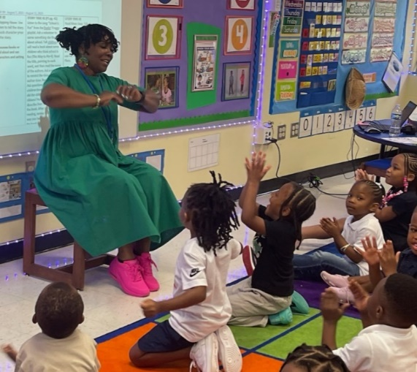
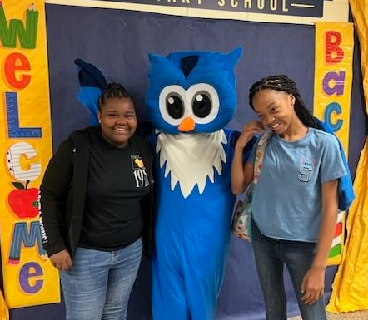
Love. T Nolan Elementary is committed to helping our parents and families attend the family activities listed in this policy.
Please call or email us if you need
assistance with childcare or
transportation to participate
in our programs.

Kizma Hampton – School Counselor
Hamptonk@fultonschools.org

Parent Resource Center
Visit the Parent Resource Center located in the Media Center to check out books and activities to use at home with your child. Computers are available for parents to explore the Parent Portal and educational resources.

Monday – Friday, 8:00 am – 2:00 pm

Love. T Nolan Elementary is
One Heart…One Beat!

Love. T Nolan Elementary will take the following measures to promote and support parents and family members as an important foundation of the school to strengthen the school and reach our school goals. We will:

- Ensure that all information related to school and parent programs, meetings, and other activities is published in both English and Spanish, posted on the school website, and included in the monthly school newsletter for all families.

- Provide monthly trainings for staff during their planning periods on strategies to improve communication with parents and ideas to increase family engagement with reading and math activities for our students outside of the classroom. Staff will also share best practices during regularly scheduled faculty meetings.

- Partner with early childhood programs, middle and high schools, college and career-ready resources or organizations, parent resource centers, or other programs (as applicable) to help prepare parents and their children for successful school transitions.

- Share information in English and Spanish on the school blog and in the school newsletter for parents to understand the school’s academic standards and assessments as well as the ways parents can monitor their child’s progress and work with educators.

- Communicate with all families and the community regularly regarding schoolwide events and activities, through phone messages, social media, and flyers.

- Work with our parents to develop relevant trainings and helpful presentations to educate our staff on the importance of parent and family engagement and how to support student learning.

- Provide necessary materials and handouts for parents at conferences, meetings, and activities to help parents work with their child to improve their child’s achievement.

- Use our Partners in Education and School-Community Team to improve awareness of the activities and events listed in the school parent and family engagement policy.

- Collect feedback from parents and family members at all events, place input cards around the building, and post a suggestion form on the school website to respond to parents’ requests for additional support for parent and family engagement activities.
Parent and Family Engagement
Love. T Nolan Elementary believes that family engagement means the participation of parents and family members in regular two-way, and meaningful communication involving student academic learning and other school activities, including ensuring:

- That parents play an integral role in assisting their child’s learning.
- That parents are encouraged to be actively involved in their child’s education at school through the PTA and Parent Volunteer Opportunities.
- That parents are full partners in their child’s education and are included, as appropriate, in decision-making and on advisory committees to assist in the education of their child.

- The carrying out of other activities as described in this plan.

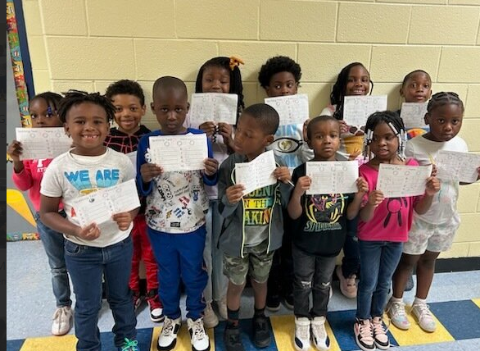
Parent Teacher Association
Love. T Nolan Elementary invites all parents to join the Parent Teacher Association (PTA) to share ideas and support parents and family members to build partnerships with school, families, and the community. The PTA will meet bi-monthly during the school year, but parents and family members can also submit their ideas or suggestions through our parent surveys and website. If you would like to learn more about the PTA, please contact the school at 470-254-7950.

Share Your Thoughts
We want to hear from you. If you have any suggestions or if there is any part of this policy that you feel is not satisfactory with the students’ and the school’s goals for academic achievement, please provide us with your comments in the space provided and leave this form in the Main Office:

Name: (optional)

Telephone Number: (optional)

Opportunities for Parents

- Yes, I am interested and wish to join the PTA.
- Please contact me so I can learn more in joining the PTA.
- Please send me notifications about future meetings and updates.

Name:

Child’s Name and Grade:

Address:

Phone Number:

Email address:
Parent and Family Engagement Standards
Love. T Nolan Elementary and our parents have adopted the National PTA Standards for Family-School Partnerships as the school’s model in engaging parents, students, and the community. These standards are:

- Welcoming All Families
- Communicating Effectively
- Supporting Student Success
- Speaking Up for Every Child
- Sharing Power
- Collaborating with Community

