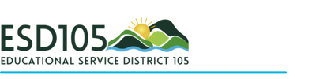

ESD105 Student Art Exhibit
Central Washington State Fair
September 23, 2026 – October 5, 2026

Yakima County District Administrators, Art Teachers:
School Districts are invited to participate in the Central Washington State Fair Student Art Exhibit again this year. This is a Yakima County wide community effort to showcase student art. We welcome all high school, middle school art educators, and all elementary teachers to participate. The exhibition will be in the Ag Building Annex, 2nd floor.

Hanging the Show:
We are asking that one teacher be responsible for hanging the artwork for your building. They will need to be released on Wednesday, September 23, 2026. Teachers will check in with the ESD105 Program at the Ag. Building Annex. Teachers will work in grade level teams to help each other hang the show.

Taking down the show:
On October 5, 2026, each school will be responsible for sending a school representative to pick up the artwork to return to the school.

Please review the schedule below:

Set-up day
Date: September 23, 2026
Time: 8:00 AM - 4:00 PM
Location: Ag Building Annex

Take-down – Retrieving your artwork
Date: Monday, October 5, 2026
Time: 8:00 – 4:00 PM

IMPORTANT: The fair has no storage space for the artwork – therefore all art must be picked up by 4:00 PM, October 5th.

For more information about the art exhibition contact:
Yvonne Avalos
yvonne.avalos@esd105.org

