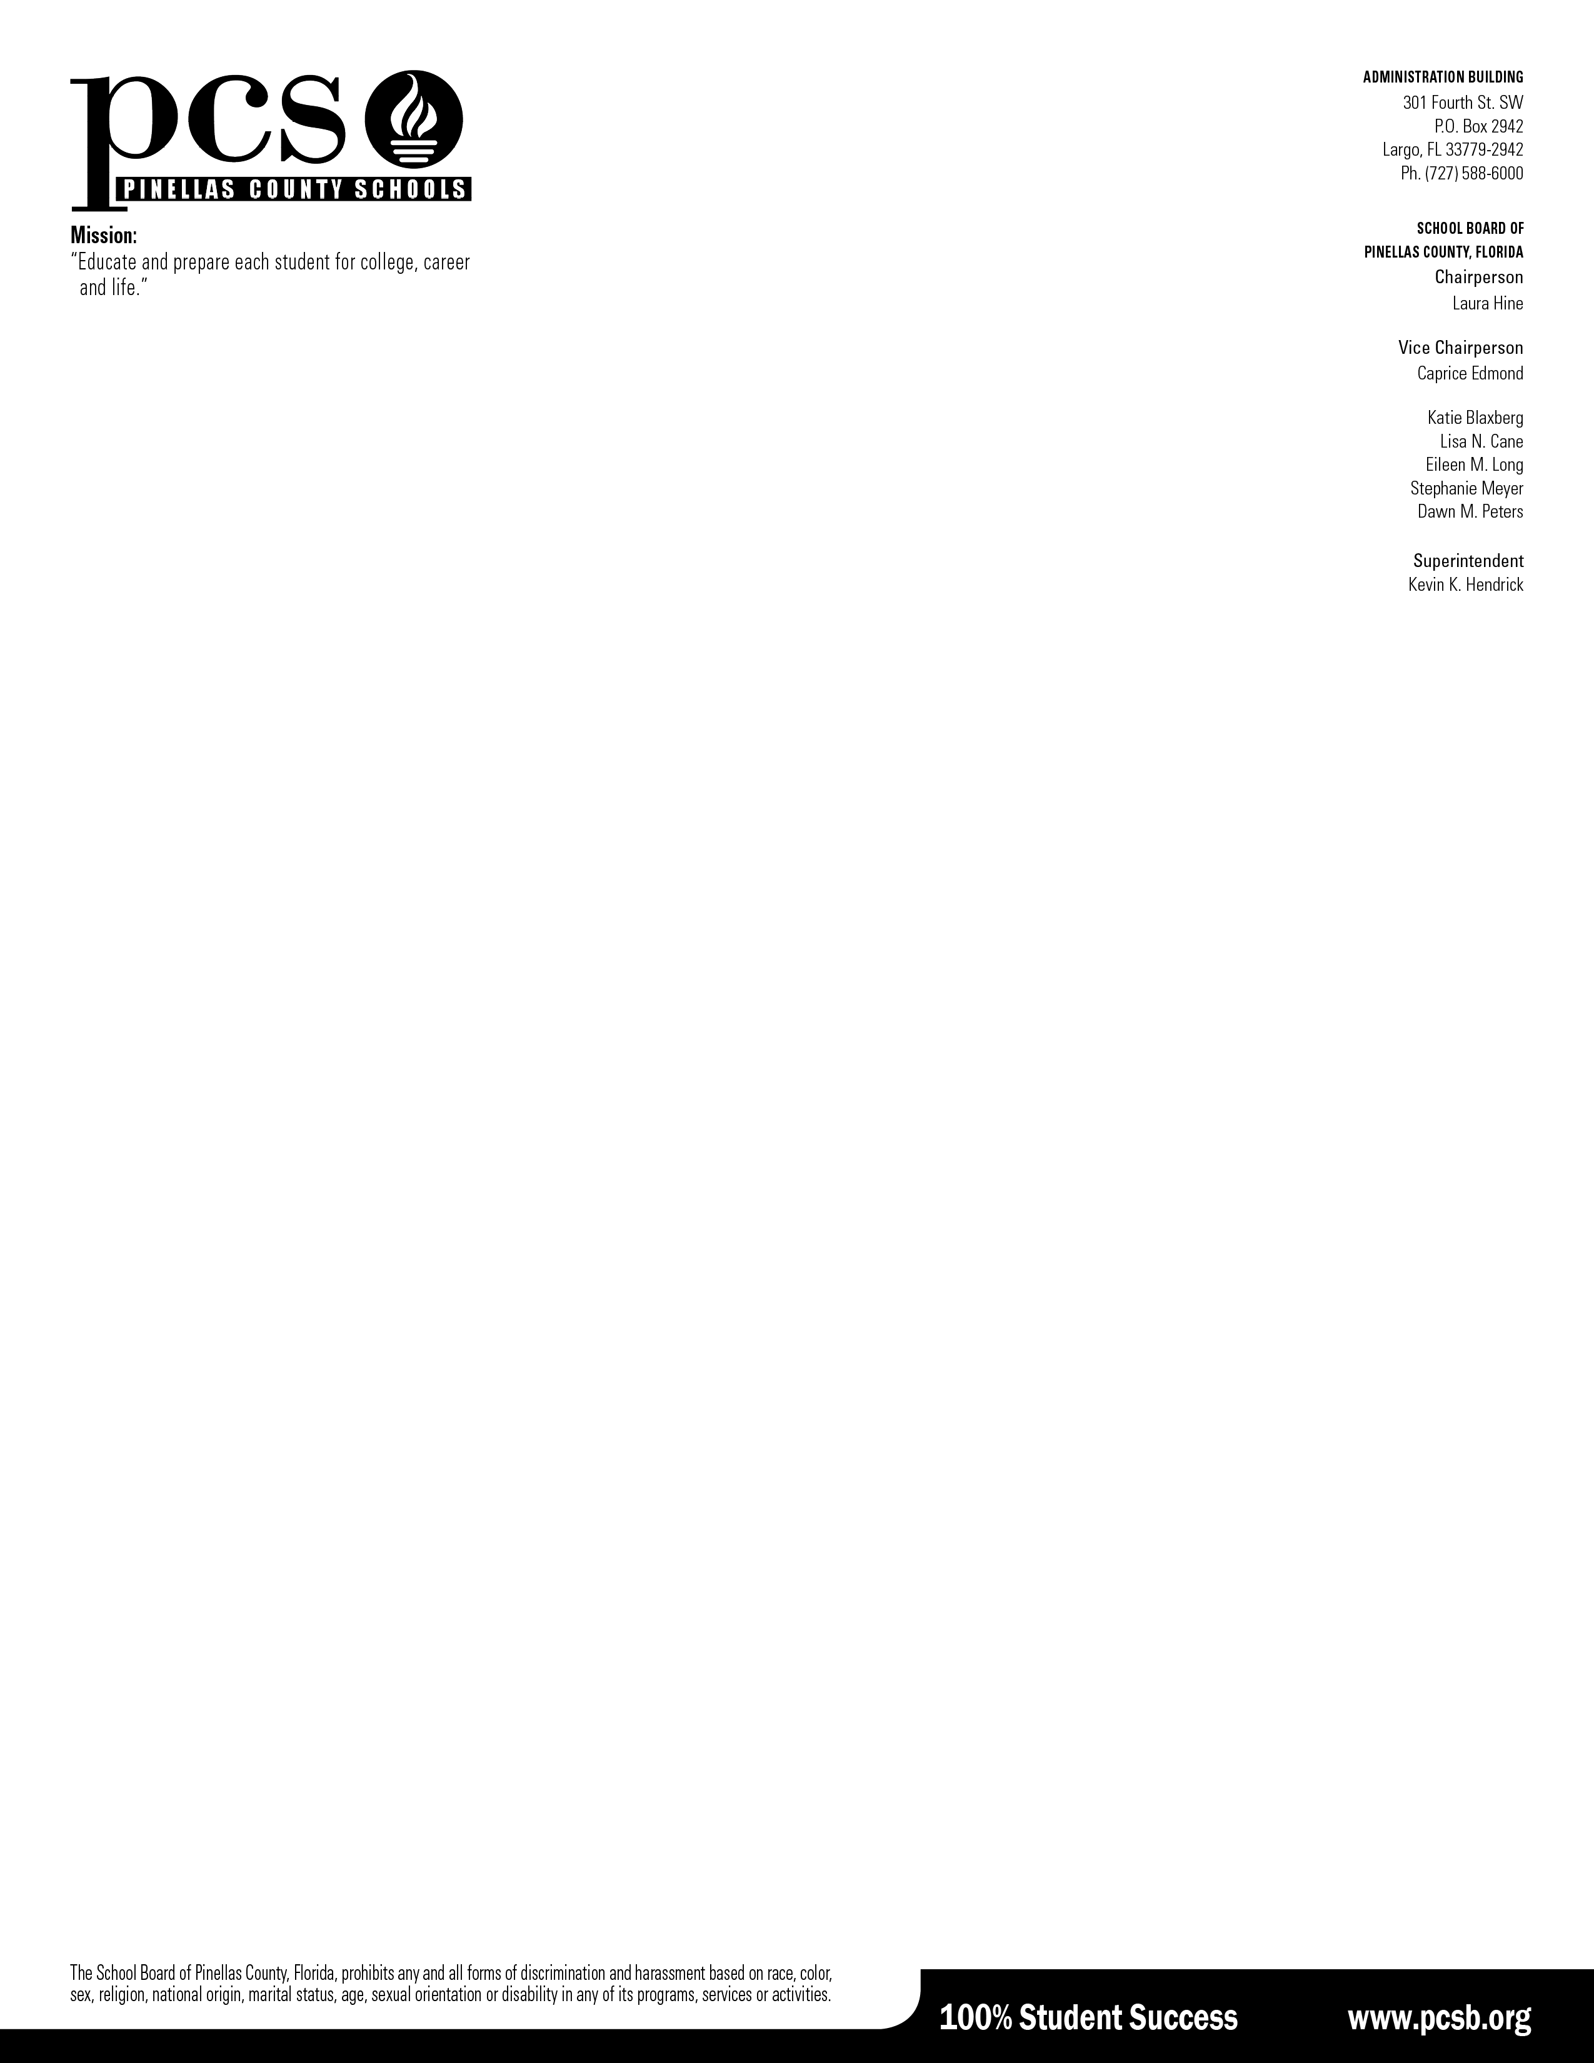
September 15, 2026

Dear Students and Families,

During the month of October, all 8th–11th grade students will take the preliminary SAT/National Merit Scholarship Qualifying Test (PSAT/NMSQT), a powerful tool that supports academic growth, SAT readiness, and college and career planning.

Why it matters:
- SAT Prep: The PSAT/NMSQT tests the same skills as the SAT, making it a smart first step in preparing for your future.
- Course Potential: Recommendations for future AP courses in which the student is likely to succeed.
- Personalized Feedback: Students receive detailed insights into their strengths and areas for growth.
- Free Resources: After the test, students gain access to:
  - A customized SAT study plan via Khan Academy
  - Score reports with answer explanations
  - A personality test to explore majors and careers
  - A college list tailored to interests and goals

Taking the PSAT/NMSQT in earlier grades helps students improve over time and boosts their chances of qualifying for scholarships and academic honors in 11th grade. We encourage all students to give their best effort on test day—you’re investing in your future.

Warm regards,

Dr. Andrea Flocken, Specialist, Advanced Studies & Academic Excellence

No action is needed if your child will participate. If you do not want your child to take the PSAT/NMSQT, please return this signed form to your student’s school counselor.
- - - - - - - - - - - - - - - - - - - - - - - - - -- - - - - - - - - - - - - - - - - - - - - - - - - - - - - - - - - - - - - - - - - -

I do not want my child to take the PSAT/NMSQT.
Student Name: ________________________________ Date:

Parent/Guardian Name: __________________ Parent/Guardian Signature: __________________

