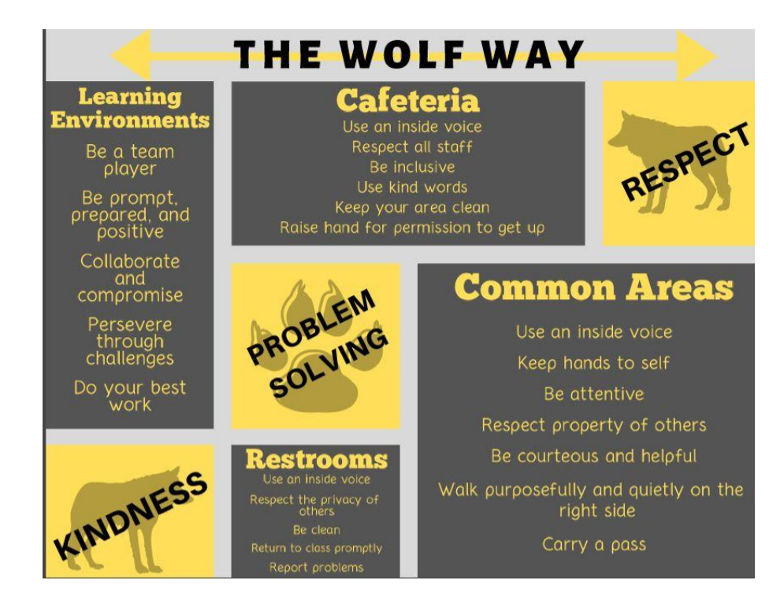
2026-2027 STUDENT HANDBOOK

LETTER FROM THE PRINCIPAL 4
MISSION STATEMENT 5
VISION STATEMENT 5
MOTTO 5
THE WOLF WAY 6
GENERAL INFORMATION 7
ACADEMIC HONESTY 7
ACCIDENTS 7
ARRIVAL AND DISMISSAL 7
ATTENDANCE 8
STEPS TO FOLLOW WHEN ABSENT 8
STEPS TO FOLLOW FOR EARLY DISMISSAL/CHECK OUT 8
Attendance Descriptions 8
CAFETERIA 9
CHANGE OF ADDRESS/PHONE NUMBER 9
CLASSROOM PARTIES 9
CLINIC 9
CLUBS/ACTIVITIES 9
CONDUCT 9
STUDENT ROLE IN CONDUCT 9
RIVER TRAIL MIDDLE SCHOOL’S GENERAL RULES OF CONDUCT (Violation of rules may result in disciplinary action.) 10
BUS CONDUCT 10
CAFETERIA CONDUCT 10
CAMPUS PARENT 11
CELL PHONE 11
CLASSROOM CONDUCT EVALUATION 11
DELIVERIES FOR STUDENTS AT SCHOOL 11
DISMISSAL - AFTERNOON ……………………………………………………………………………………………………………………………………………… 11
DRESS CODE 12
RIVER TRAIL MIDDLE SCHOOL DRESS CODE: 12
EMERGENCY DRILLS 12
EMERGENCY SCHOOL CLOSINGS 12
EVACUATION FROM RIVER TRAIL MIDDLE SCHOOL 12
FIELD TRIPS 12
GRADE REPORTING 13
RECOVERY 13
GRADING SCALE 13
GRADING STUDENTS WHEN ABSENT FROM SCHOOL 13
GRADING STUDENTS WHEN TRANSFERING FROM ANOTHER SCHOOL 13
HALL PASSES …………………………………………………………………………………………………………………………………………………………………… 13
HOMEBOUND SERVICES 13
HOME-SCHOOL COMMUNICATION 13
HOMEWORK/PRACTICE 14
HONOR ROLL AND PRINCIPAL’S HONOR ROLL 14
INSURANCE 14
INTRAMURAL/EXTRAMURAL PROGRAM 14
LAPTOPS 14
LINEWISE ……………………………………………………………………………………………………………………………………………………………………….. 15
LOCKERS 14
LOCKER DECORATION RULES 15
LOST OR DAMAGED INSTRUCTIONAL MATERIALS 15
MEDIA CENTER 15
MEDICATION 15
PARENTAL CONCERNS 15
PARENT AND GUEST VISITATION TO THE CLASSROOM 16
Classroom Observations by Parents of Students Currently Enrolled in the School. 16
PARENT TEACHER ORGANIZATION 16
PERSONAL PROPERTY/LOST AND FOUND 16
PROMOTION POLICY 16
RESTROOM …………………………………………………………………………………………………………………………………………………………………….. 17
SCHEDULE CHANGES 16
SCHOOL GOVERNANCE COUNCIL (SGC) 17
SCHOOL SECURITY 17
SCHOOL STORE 17
SEX EDUCATION 17
STANDARDIZED TESTING 17
TECHNOLOGY ACCEPTABLE USE POLICY 17
TEENAGE AND ADULT DRIVER RESPONSIBILITY ACT 17
TEXTBOOKS 18
TRANSPORTATION 18
VOLUNTEERS 18
WOLFPACK TIME 18
WORK PERMITS 18
YEARBOOKS 18

River Trail Middle School
2026-2027
https://rivertrail.fultonschools.org

10795 Rogers Circle 470-254-3860
Johns Creek, Georgia 30097 Fax 470-254-3866

Fulton County Board of Education
Dr. Michael Looney, Superintendent
Mr. Neil Pinnock, Principal
Mr. Guy Crotsley, Assistant Principal
Ms. Amy Palermo, Assistant Principal
Ms. Lori Lahmann-Scullion, Assistant Principal
Ms. Alex Schoessler, Assistant Administrator

LETTER FROM THE PRINCIPAL
Dear Students and Parents:
Welcome to River Trail Middle School, “Home of the Wolves!” You will enjoy a safe and challenging educational environment that will empower you with the knowledge, skills, and attitudes necessary for success both now and in the future. You are encouraged to actively participate in the many clubs, activities, and opportunities we offer here at RTMS. The interest and enthusiasm you demonstrate will benefit you as well as our school. Another way you contribute to making RTMS a great school is by treating others well each and every day. Treat others as you would like to be treated and try your best to make others feel included and welcome. Remember, this is your school. Pride in the school, pride in others, and pride in yourself will help to create a memorable middle school experience.
The front section of the agenda has the school handbook, which contains information regarding school rules, expectations, and procedures. Please take time to read through this handbook. If you have questions that the handbook does not answer, do not hesitate to seek help from your teachers, counselors, or principals.
The second part of the agenda is to serve as a planner to help you keep track of daily assignments, major class projects, homework, events that require your attendance, and a great tool for communication between school and parent/guardians at home. It will help you with organization and save you time every day.
You are in for a tremendous year of “Blazing trails to new horizons!”

Sincerely,
Neil Pinnock, Principal

MISSION STATEMENT

The mission of River Trail Middle School is to advance student creativity, critical thinking, and citizenship by engaging students in educational and social opportunities through school and community collaborations.

VISION STATEMENT

Our vision is to guide all students toward their full potential as productive members of society.

MOTTO
“Blazing trails to new horizons!”

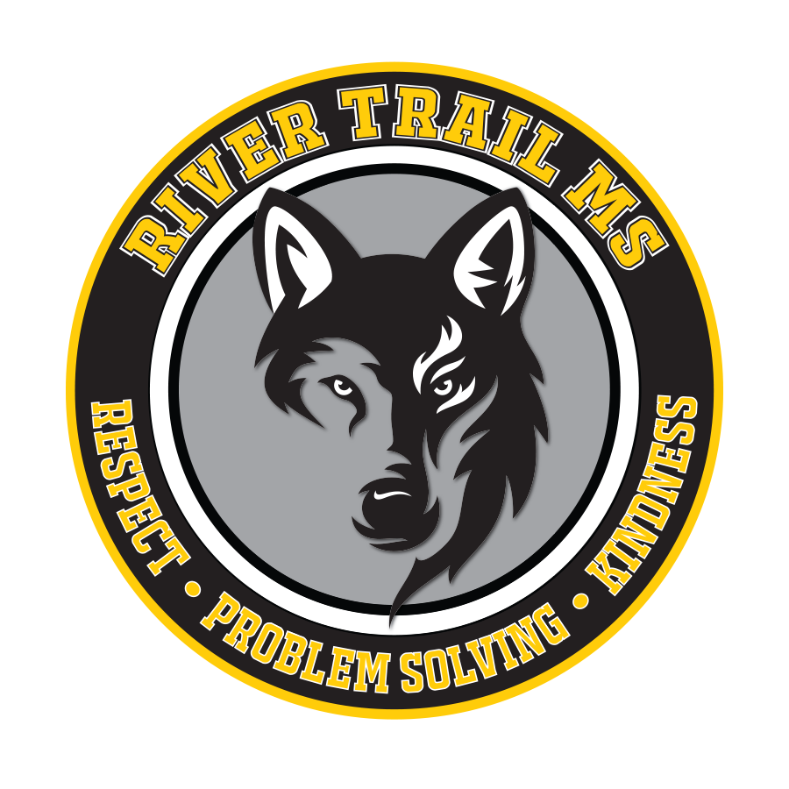

THE WOLF WAY

The Wolf Way reflects our belief and value in a student being a Problem Solver, being Kind, and being Respectful. The chart below shows how students demonstrate the wolf way throughout the building.

Expectations | Learning Environments | Cafeteria | Transitions | Restrooms | Technology
Kind | Encourage others and yourself. | Be courteous and inclusive. | Use courteous language and an inside voice. | Use a calm tone and an inside voice. | Think before you speak or type.
Respectful | Be prompt and prepared to learn.  Keep hands, feet, and objects to self. | Use an inside voice.  Clean up after yourself. | Walk with a purpose.  Keep hands, feet, and objects to self. | Honor the privacy of others.  Keep it clean. | Keep phone off and put away.  Use device when instructed.  Use teacher directed websites.
Problem Solver | Read directions first.  Do your best work. | Follow arrows and guides.  Raise your hand for permission to get up. | Retrieve the necessary materials. | Be efficient and return to class quickly. | Read directions first.  Charge and bring your device to school.

GENERAL INFORMATION

ACADEMIC HONESTY
The Fulton County Board of expects students to practice academic honesty. The Student Academic Integrity policy states: “The Board of Education regards academic honesty as a cornerstone of its educational mission. Cheating will not be tolerated in this school system.” Examples of cheating, can include, but are not limited to:
- copying or “borrowing” from another source and submitting it as one’s own work
- seeking or accepting unauthorized assistance on tests or assignments
- altering or forging grades, grade books, progress reports, report cards, adult signatures, or other academic records
- fabricating data, signatures, or resources
- providing or receiving test questions in advance without permission
- working collaboratively with other students when individual work is expected
- any other examples that the school wishes to include.
- AI – AI tools are permitted only with explicit teacher approval for specific assignments. AI can serve as an aid to enhance understanding and interaction with course content, within boundaries of academic integrity. If AI tools are used, all AI – generated content must be accurately cited, and students are responsible for the integrity and correctness of their submissions, including any content derived from AI tools. It is essential to critically evaluate AI outputs to ensure they meet academic standards. Unauthorized use of generative AI, without proper citation, is considered a violation of the Fulton County Schools Code of Conduct and may result in disciplinary action.
- If a student is caught cheating at RTMS, he/she will be subject to a tiered system of consequences.
For the first offense:
- Student will receive a zero for the assignment but will be given the opportunity to make up the assignment with a maximum of 50%.
- Student must have a conference with a parent and the teacher.
For the second offense:
- Student will receive a zero for the assignment. (For students who need recovery at the end of the semester, the assignment may be completed for the student to be eligible for recovery work.)
- Student will have a consequence, such as detention).
- Student must have a conference with a parent, teacher, and administrator.
For the third offense:
- Student will receive a zero for the assignment.
- Student will lose all extracurricular privileges including field trips, clubs, and intramural/extramural activities.
- Student can receive one day of In-School Suspension.

ACCIDENTS
Any student who is injured on the school grounds or in the school building at any time must report the injury to the supervising staff member. If the student is not in class at the time of the injury, he/she should go directly to the clinic or office. Appropriate safety precautions will be taken. The student will receive any necessary first aid. Parents will be notified if the injury is considered anything other than minor. An accident report will be completed and signed by the supervising faculty member.

AGENDAS
Students are to use their agenda for schoolwork. It also serves as their pass to be out of class. If students lose their
agenda, they will need to be replaced by purchasing their own agenda.

ARRIVAL aND DISMISSAL
The building is open for student arrival beginning at 8:15 AM each morning. Students should not arrive before 8:15 AM; students who arrive between 8:15 and 8:40 AM are to report to the cafeteria (6th graders) or gym (7th & 8th graders). Staff members are on duty to supervise during this time. Students will be dismissed from the cafeteria/gym at 8:40 AM to go to their classrooms. Students must have a teacher-written pass prior to reporting to a teacher before 8:40 AM. Students are to remain in their classrooms until they are dismissed in the afternoon.

ATTENDANCE
For students to learn and achieve to their fullest potential, it is critical that they are in school and engaged in the learning process. Students who are absent from school are deprived of a variety of educational experiences shared with their peers. Whenever a student is absent for any reason, a parent or guardian must report to the front office indicating the specific reason for the absence. If communication is not received in the front office by the fifth day, the absence will be considered unexcused. Parents of students who accumulate 5 or more unexcused absences will be sent a letter notifying them of their legal status about the Georgia law on attendance. (FULTON COUNTY BOARD OF EDUCATION POLICY JBD) link has info

STEPS TO FOLLOW WHEN ABSENT
- Parent/Guardian reports to the front office via note/email indicating the specific reason for absence. Communication must include the child’s name, date(s) of absence(s), reason for absence, and parent/guardian signature. The note/email should be provided to the front office within five days of returning to school.
- It is the student’s sole responsibility to contact the teacher(s) to initiate all make-up work within one school day of returning. The teacher will establish a reasonable schedule in which make-up work will occur.
- Students will receive the actual grade earned on make-up work if the make-up work is completed satisfactorily within the specified time by the teacher.

STEPS TO FOLLOW FOR EARLY DISMISSAL/CHECK OUT
- The morning of the requested early dismissal, Parent/Guardian communicates to the front office via note/email indicating the specific reason to leave school early.
- Student needs to take note a to the front office on the morning of the early dismissal to be verified and listed on the check-out sheet.
- The student will let the teacher know about the early dismissal and report to the front office at the designated time.
- Parent/Guardians must come into the office to sign out their children.
Please refrain from checking out students between 3:40- 4:05 pm as this allows us to protect instructional time at the end of the day for all students.

Attendance Descriptions
Late Arrival – Any time a student arrives after the beginning of the instructional day.
Early Checkout – Any time a student leaves school before the end of the instructional day.
- Late arrivals/ Early check out, follow the same rules for excused and unexcused Absences.
Tardy – Any time a student arrives after the beginning of a specific class period.
Excused Absences – A hold harmless absence that has been documented, and relates to one of the following circumstances in accordance with State Board of Education Rule 160-5-1.10 and Georgia State Code, O.C.G.A. 20-2-690.1:
- Personal illness or when attendance in school would be detrimental to the health of the student or others
- A serious illness in the student’s immediate family necessitating absence from school
- A death in the student’s family necessitating absence from school
- Observance of religious holidays necessitating absence from school
- Compliance with a court order or an order issued by a governmental agency mandating an absence from school
- Visitation with an immediate family member who is on leave from or is being deployed to military service
- Important family events/celebrations for an immediate family member (graduation, wedding, religious ceremony, etc.)
- Compliance with an order for a pre-induction physical examination for service in the armed forces
- An absence for registering to vote or participating as an active voter in a local, state, or federal election
- A verified interview for college admission or a documented college visit
- A specialized, supplemental, or extracurricular program/event
- Other absences pre-approved by the principal (see below)
Participating Remotely – Students can substitute up to 5 days per semester (a max of 10 days per year) with a remote learning day by meeting the remote participation benchmarks listed in the policy. This would result in the student being counted as present for the day(s) they participate remotely.
- To be marked present, work must be submitted within 2 days of absence.
- Students may not use a remote learning day on a test day
- Parent/guardian or student must notify the Assistant Principal in advance to start the instructional day to utilize the participation rule benchmark.
- Schools will make their best effort to provide assignments given early notice
- For security reasons, students who are out of the country may not participate in remote learning.
Pre-Approved Absence – Any absence not listed above must receive an administrative pre-approval through email prior to the absence. Requests should be made at least five days in advance, by emailing the grade level assistant principal. Students are expected to be present on exam days; exams will not be given in advance.
Unexcused Absence – Any absence not accompanied by a note or documentation or any absence that does not relate to the circumstances listed above is considered unexcused.

CAFETERIA
The school cafeteria offers several choices of nutritional, well-balanced meals each day. Breakfast and lunch programs are available to each student. Breakfast is provided between 8:15-8:40 am. Students may choose to purchase a la carte items. Students are encouraged to keep money in their cafeteria account. Cafeteria accounts are not to be shared among students; purchasing food for others and sharing food is prohibited. “Fast food” and soft drinks are prohibited. Repeated occurrences will result in the student not receiving the fast food and the food being thrown away. Glass bottles are not permitted for safety reasons. All food and drinks are to remain in the cafeteria.

CHANGE OF ADDRESS/PHONE NUMBER
Please inform the front office of any change in name, address, phone number, or emergency contact information during the school year.

CLASSROOM PARTIES
Birthday and holiday celebrations/parties/treats are not permitted in middle school.

CLINIC
The clinic is staffed by a clinic assistant during the day. Students must have a pass upon visiting the clinic. First aid will be administered in the clinic as needed. Students who are ill must go to the clinic to get checked out.

CLUBS/ACTIVITIES
A wide range of clubs and activities is offered for students before and/or after school. A full listing of these clubs and activities will be available during the fall and opportunities will be provided for students to enroll in these activities. Students must be counted present for at least half the school day to participate in school clubs/activities on that day. Click here for clubs/activities

CONDUCT
To establish an effective educational and social climate, it is important that students understand that appropriate standards of behavior are always required. Students are expected to behave in a positive manner conducive to learning. In addition, students are to follow the rules of behavior expected by our faculty. Consequences will be administered when an individual’s actions interfere with the right of students to learn and teachers to teach. To ensure student support in this area, a close and cooperative relationship must exist between home and school. All students should be familiar with and follow the Fulton County Code of Conduct FCS student discipline link.

STUDENT ROLE IN CONDUCT
Students have a responsibility to:
- Attend school regularly, arrive on time, be prepared, bring appropriate materials to class, participate in class, and complete homework.
- Strive for academic growth.
- Respect the rights, feelings, and property of fellow students, parents, school personnel, visitors, guests, and school neighbors.
- Conduct themselves properly on school grounds, en route to and from school, at bus stops, at any school related activity, and in the classroom so as not to interfere with the rights of another student to learn.
- Accept the consequences of their own actions and follow discipline guidelines adopted by the school and district.

Students have the right to:
- Receive a copy of the guidelines for student behavior.
- Discuss educational concerns with teachers and other school staff members.
- Receive special help as needed from professional staff members.
- Receive fair discipline without discrimination in every aspect of the educational system.
- Study and learn in a positive atmosphere free from verbal and physical threats and abuse.
- Review their own records within the appropriate guidelines.

RIVER TRAIL MIDDLE SCHOOL’S GENERAL RULES OF CONDUCT (Violation of rules may result in disciplinary action.)
- Students should adhere to Fulton County Code of FCS student discipline link.
- Students are to attend all classes as assigned. Students must have a hall pass to be out of a classroom.
- In alignment with Georgia House Bill 340 (Distraction-Free Education Act) and the updated Fulton County Schools Policy IFBGA: Electronic Communications, students in grades 6–8 are prohibited from using personal electronic devices on the school bus and during the school day. This includes cell phones, e-readers, smartwatches, tablets, headphones, and laptops (unless issued or approved by the school).
- Students should adhere to the dress code (see “Dress Code”).
- Students are expected to walk, not run, on the right side of the hall while in the school building.
- Bottled or canned drinks are prohibited in the hallways, classrooms, restrooms, and gymnasium.
- Non-instructional items are not to be used during school hours.
- Objects shall not be thrown or propelled at any time.
- Damage, alter, or theft of school or private property is prohibited.
- Profanity and obscene gestures are prohibited.
- Harassment/bigotry in any form is unacceptable behavior.
- Any student who engages in an activity that threatens (regardless of intent), intimidates, or physically harms another person.
- Fighting and general disruptive behaviors are prohibited on the campus, on the buses, en route to and from school, and at any school activity. “Horseplay” (improper physical contact not meant to harm) is prohibited.
- Public displays of affection are prohibited.
- Students may not sell or distribute products of any kind on the school campus or on school transportation unless duly authorized by the principal.
- Special rules or standards of conduct will be established for field trips and events. Parents will be notified of these rules and regulations. Chronic misbehavior may result in disciplinary action and/or exclusion from participation in school activities.
- Book bags, hats, and coats are to be kept in student lockers or other designated areas throughout the school day. Lockers must be remained locked at all times.

BUS CONDUCT
All students are expected to follow the directions of the bus driver and procedures.
Failure to abide by these safety procedures will result in parent notification and disciplinary actions which will be determined by the local school.

CAFETERIA CONDUCT
Students should observe the following procedures:
- Walk with class/teacher in orderly fashion to the cafeteria.
- Enter the cafeteria in an orderly fashion and either proceed to a serving line or go directly to a designated area.
- Students should sit with the class that they attend lunch with every day. (Exceptions may be given for special circumstances or activities.)
- Use good manners and speak in an indoor voice.
- To get out of your seat, raise your hand, and wait for direction from a supervising adult.
- Do not leave the cafeteria without verbal permission from a supervising adult.
- Students need to wait for their teacher to dismiss them from the cafeteria.
- Check your table and area to see that it is clean before disposing of your trash in the designated area.
- The two students assigned for lunch clean-up for the week will wipe off tables/sweep floor area (TBD).
- Food should be consumed and remain in the cafeteria at all times.
- Students are not allowed to buy food for or share food with other students.

CAMPUS PARENT
Campus Parent is an internet and app-based program that allows parents to get more involved in their child’s day to day education. It gives parents timely information about their child’s progress in school. Using the internet, parents can access their child’s grades, attendance, assignments, and discipline records. Contact the school front office for additional information. Parents and guardians may also access their child’s grade on CANVAS.

CELL PHONE
In alignment with Georgia House Bill 340 (Distraction-Free Education Act) and the updated Fulton County Schools Policy IFBGA: Electronic Communications, students in grades 6–8 are prohibited from using personal electronic devices on the school bus and during the school day. School day begins as soon as a student steps on campus and includes dismissal and on the way to carpool or the school bus. This includes cell phones, e-readers, smartwatches, tablets, headphones, and laptops (unless issued or approved by the school).

If a student violates the school’s cell phone policy, the following may occur:

- First offense: The student’s cell phone, smart watch, or other personal communication device will be confiscated by a staff member and held in the main office until the end of the school day. Before being allowed to pick up their phone at the end of the day, students must discuss and review the cell phone policy with a staff member.
- Second offense: The student’s cell phone, smart watch, or other personal communication device will be confiscated and held in the main office until the student’s parents are able to come to pick it up. The student’s parents will be contacted and informed of the refusal to follow the school’s cell phone policy.
- Third offense: The student’s cell phone, smart watch, or other personal communication device will be confiscated and held in the main office until the student’s parents are able to come to pick it up. The student will receive an administrative detention and will be prohibited from bringing their cell phone back on school grounds for two weeks.

Students will not be called from class to talk on the telephone during school hours, nor are they allowed to make outgoing calls, except in the case of extreme emergency. As part of an effort to teach responsibility, students will not be permitted to call home during the school day for forgotten items or to make arrangements for after school. The front office has a phone for students to use to contact parents when necessary.

CLASSROOM CONDUCT EVALUATION
Students receive non-academic skills feedback as well as a numerical grade for the work done in every class. The teacher(s) of each class determines the feedback. Students who are selected for participation in special trips, for awards, or to represent the school in special events or competitions must have non-academic skills feedback which indicates they are responsible students.

DELIVERIES FOR STUDENTS AT SCHOOL
Parents and other individuals should not deliver flowers, balloons, or fast-food lunches to students at school. Such items create a disruption to teaching and learning and will remain in the school office until the end of the school day. Students cannot use food delivery services. If a student does use a food delivery service, the student will not receive the food and may receive possible disciplinary action.

DISMISSAL-Afternoon
After and following the direction of the announcements when teacher dismisses students for the day, students will walk to their bus or carpool in an orderly manner. Students should not remain after school unless participating in an activity supervised by a Faculty/Staff Member. Carpool is in front of the school on the cafeteria side. Students are to watch for their ride as they wait in an orderly manner. They are to enter the car on the sidewalk side. Students are not allowed to go into the parking lot without an adult and must always use the crosswalk.

DRESS CODE
Fulton County Board of Education Dress Code Policy (Procedure JD, Rule 13): Students are expected to dress and groom themselves in such a way as to reflect neatness, cleanliness, and safety. All students shall dress and groom themselves appropriately so as not to disrupt or interfere with the educational program or the orderly operation of the school. Extremes in dress and grooming will not be permitted. Examples are lack of cleanliness in person or dress, shoeless-ness, “short short” clothing, bare midriffs, tank tops, see-through clothing, apparel which designates gangs or similar organizations, or any dress or grooming that is disruptive to the educational process. Designated dress involving school activities approved by the principal shall be acceptable. The principal or other duly authorized school official shall determine whether any mode of dress or grooming results in a violation of the spirit and/or intent of this rule.

RIVER TRAIL MIDDLE SCHOOL DRESS CODE:
- Hats, bandannas, sweat bands, chains, sunglasses, oversized coats, slippers, hoods, and face/body paint are not to be worn during school hours.
- Clothing that is excessively revealing such as short mini-skirts, short-shorts, tight shorts, low-cut blouses, or halter tops, see through tops, strapless or “spaghetti strap” tops or shirts exposing cleavage and/or the midriff are not permitted.
- All t-shirts must be middle school appropriate (no suggestive wording or illustrations or advertisements for items which are illegal for middle school students, i.e., alcohol and tobacco products, etc.)
- Athletic tank tops with oversized arm holes should not be worn unless accompanied by an undershirt.
- Jeans with holes or tears above the mid-thigh exposing skin are not permitted.
- Pajamas and or sleep-like pants are not to be worn at school.
- Pants must be worn at the waist, not sag, and undergarments must not be exposed.
- Shoes must always be worn. No slippers.
- School is a professional environment and students must dress accordingly.

Students and parents are expected to honor the dress code so valuable school time is not spent examining student attire to determine appropriateness.
Students who violate the dress code will be asked to change into appropriate clothing. If students do not have an appropriate change of clothing at school, they will change into school PE clothes, or clothing will be provided by the school.

EMERGENCY DRILLS
Emergency drills are held frequently throughout the school year. It is important that students remain silent and follow all instructions of school personnel during these drills.

EMERGENCY SCHOOL CLOSINGS
Once a decision has been made by the central office to close school due to inclement weather, local TV and radio stations will broadcast this information. The School Blackboard system will also send a notification. Please avoid calling the school. Each Fulton County school has detailed disaster plans and evacuation plans which are reviewed and updated each year. In the event of these plans being used, parents will be notified by the district, school, and/or local media.

EVACUATION FROM RIVER TRAIL MIDDLE SCHOOL
In the event of an emergency, if it becomes necessary to move students from the premises of River Trail Middle School, they will be evacuated to Shakerag Elementary School. In the event of such an emergency, it will be impossible for parents to contact River Trail. The school will contact parents, and students will be released to parents from the alternate site.

FIELD TRIPS
Field trips are a valuable part of the middle school educational process and may be taken at various times throughout the school year. Official Fulton County permission slips must be signed by parent/guardian and returned to the school. Standard conduct must be met to be eligible to attend school field trips. Field Trips are a privilege at River Trail Middle School. The history of student behavior can be used as a determining factor for participation.

GRADE REPORTING
Progress Reports and Report Cards are available in Campus Parent throughout the year. Grading is the responsibilities of the individual teacher and is subject to approval and review by a school administrator. Careful evaluation by the teacher and principal will ensure that all grades issued, and recommendations made will be in the best interest of the student. Numerical grades will be used to report academic performance in all courses.

RECOVERY
All students will have the opportunity to one recovery attempt per major assessment.
- Recovery of a major assessment should occur before the next major is given
- Students are eligible to earn a replacement grade on a recovery that is no higher than 75%
- Before recovery, the teacher should work with the student to complete missing work and/or ensure delivery of the content through reteaching and relearning.
- If a student’s recovery is below the original score, the original score should stand in the grade book
- The original score should be noted in the comment section of the grade book if a student recovers a major assessment.

GRADING SCALE
The grading scale is based on Fulton County policy. The state of Georgia has set 70 as the minimum passing grade.
A = 90 – 100 B = 80 – 89 C = 70 – 79 F = Below 70

GRADING STUDENTS WHEN ABSENT FROM SCHOOL
Following an absence, it is the student’s responsibility to contact the teacher(s) to request make-up work the day he/she returns. Make-up work must be completed by the student within the time specified by the teacher to receive full credit. Assignments are not provided in advance for pre-approved absences.

GRADING STUDENTS WHEN TRANSFERING FROM ANOTHER SCHOOL
For students entering with grades from another school, the teacher will include the withdrawal grade from the previous school with grades earned at River Trail to determine the numerical grade for that grading period.

HALL PASSES
Students must have a pass anytime they are out of their class during the school day, or if they need to go to a class/club/help session before school.

HOMEBOUND SERVICES
Homebound services are available to students expected to be absent for more than 10 school days due to surgery or non-contagious illnesses. A doctor’s statement is required. Referral forms are available through the counseling office.

HOME-SCHOOL COMMUNICATION
The weekly newsletter, the "Wolf Den News”, is e-mailed to families each Friday and is posted on the River Trail Middle School website each week throughout the year. If you do not have email or internet access, please come by the school, and pick up a copy. PTO directories are produced each fall and contain names, addresses, and phone numbers of designated families. Parent-Teacher conferences are also a vital part of communication. Parents who would like to have a conference with any staff member should email that person. Teachers cannot be called from class to receive phone calls but will return calls within 24 hours. Guidance counselors are available for conferences concerning problems at home or at school. They are also available to review test scores and student placement. Student papers may be sent home by the teacher for parents to review. Student agendas will be used for hallway passes, writing homework assignments, and teacher/parent communication.

HOMEWORK/PRACTICE
Homework is an important part of academic growth in middle school. Students will be given homework in most classes on a regular basis, and timely, successful completion of this work is a part of each student’s evaluation. The teams of interdisciplinary teachers meet on a regular basis to ensure that the amount of homework assigned is reasonable. Assignments may be overnight or long term. It is important that students complete the work independently, so teachers can obtain an accurate assessment of their understanding. Parents with questions regarding homework should contact teachers. Students are expected to approach homework seriously, and parents should emphasize its importance.

HONOR ROLL AND PRINCIPAL’S HONOR ROLL
Principal’s Honor Roll (All A’s) and Honor Roll (All A’s and B’s) status will be recognized at the end of each semester.

INSURANCE
Student insurance may be purchased in the fall on the district’s website. The insurance is for accidental coverage. The three types of insurance which may be purchased are: 24-hour coverage, school time coverage, and dental coverage. Further information may be obtained on the district website. River Trail Middle School does not carry insurance to cover accidental injuries of students. Parents are urged to consider purchasing student insurance.

INTRAMURAL/EXTRAMURAL PROGRAM
A program of intramural athletic activities is offered to students before and after school Monday through Thursday. It is the responsibility of the parent or guardian to see that the student is picked up no later than 5:15 PM. If students are not picked up on time, they could lose the privilege of participating in the program. To participate in the intramural program, each student must have an intramural registration form signed by a parent or legal guardian on file at the school. Intramural activities vary each semester. Read “Wolf Den News” to find out which activities are offered during specific time periods. As an extension of the intramural program, seventh and eighth grade boys and girls may be selected for a traveling team, consisting of a six-game schedule, in the following sports in the extramural program:
Fall – Soccer Winter – Volleyball Spring – Basketball & Track
A fee may be assessed for participation in the extramural program when team shirts are needed. Special regulations exist concerning participation by 7th and 8th grade students on the Fulton County extramural teams.
Regulations include:
- Participation 80% of the time for a particular sport in the school’s intramural program.
- Acceptable school conduct, (i.e., no suspensions during the semester of participation). Students will sign a “Code of Conduct for Extracurricular Program” for River Trail Middle school at the first meeting for each club or activity.
- In the semester preceding participation, the student must pass 5 out of 6 classes which carry credit toward grade promotion.
- A physical examination packet documented on the appropriate physical form and proof of insurance coverage is required before a student may try out for an extramural team. River Trail Athletic link

LAPTOPS
Students will be issued laptops for instructional use. Students and parents must sign a usage agreement and complete digital citizenship lessons. Damage to, or loss of, the laptop and/or its accessories will result in fines. Students are to use their laptops according to Fulton County School’s technology guidelines. not touching or using any other student’s device or allowing another student to use your device or touch it. Refer to page 14 of the FCS Device Handbook for the types of damage and fines that may occur per Fulton County’s Technology guidelines. Students may not remove laptops from the district-provided case unless directed to do so by a staff member.

LINEWISE
Linewise is installed on every Fulton County issued student device. Linewise will monitor all student online activity around the clock, 24 hours a day, 7 days a week to help ensure school safety. At home, Qubo allows parents to track student device use, helping them monitor digital behavior and support responsible technology habits outside of school.

LOCKERS
Students rent lockers for the safekeeping of books and personal property. It is the responsibility of the student to guard his/her combination and to see that his/her locker is secure. Lockers remain the property of the school and are subject to periodic announced and unannounced inspections by school personnel at any time during the year. Students are not to share lockers. Locker rental fees for hall and PE lockers can be paid here.

LOCKER DECORATION RULES
- Lockers are to be decorated only for birthdays.
- The decorations must be appropriate and within the school’s guidelines.
- Only the face of the locker can be decorated with birthday wrapping paper; any other area of the locker or the area above or surrounding it may not be decorated.
- Balloons, candy, or stickers are not to be attached to the locker.
- Inappropriate language is not permitted on the locker decorations.
- All locker decorations must be removed after three days.
- Up to three students may decorate a locker; a hall pass must be obtained in advance from any teacher.
- The students who decorate the locker must keep the area around the locker clean and free of trash.

LOST OR DAMAGED INSTRUCTIONAL MATERIALS
Students are responsible for the care and protection of textbooks, laptops, library books, musical instruments, and other instructional materials assigned to them or checked out by them. The following sanctions may be taken against a student who fails to return or refuses to pay for lost or damaged textbooks, laptops, library books, media material, or school property, including but not limited to musical instruments, sheet music, uniforms of all kinds, sports equipment, etc.:
- Refusal to issue any additional textbooks, laptops, library books, media materials or school property until restitution is made.
- Withholding of all grade cards, transcripts, diplomas, or certificates of progress until restitution is made; and/or
- Exclusion of ceremonies, dances, intramurals, and/or participation on teams or in clubs.
A record of any outstanding fees, fines or charges will accompany students’ records whenever he/she moves from school to school within the school system, and sanctions may be taken against a student by his/her new school until the student settles matters with his/her former school. Appropriate restitution for a lost or damaged book is the cost of a new copy. If a student cannot afford the entire charge, the student will be put on a payment plan until the amount owed is paid in full.

MEDIA CENTER
The Media Center operates on an open access basis allowing students almost unlimited use of media materials. The collection contains over 10,000 books. The circulation period is two weeks with renewals allowed. Overdue fines will be charged. The hours are 8:15 AM until 4:05 PM, Monday through Friday. For students to use the Media Center before regular school hours, they must obtain a pass from a teacher and notify the media center the day before to confirm staff supervision. A staff member must be present when a student is in the media center.

MEDICATION
Internal medication (prescription or over the counter) may not be given without the necessary Fulton County forms on file in the clinic. Prescription medication requires that the form be signed by the prescribing physician; over-the-counter medication requires that the form be signed by a parent. Medication should be clearly labeled in the original container and sent to the clinic where it will be administered under the direct supervision of school employees. Students may NOT carry medication while at school. Student may not share any kind of medication with other students. clinic link

PARENTAL CONCERNS
Parents with concerns about any procedure or policy used in connection with their child are encouraged to seek assistance from school personnel. It is requested that the following sequence be utilized in asking for assistance:
1. Classroom teacher 2. Counselor 3. Assistant Principal 4. Principal

PARENT AND GUEST VISITATION TO THE CLASSROOM
The Fulton County School system values the concept of parents as partners in education. Parent and community support and assistance are vital in all facets of the school program. Parents and community members are especially welcome to observe students in the academic setting through special activities and events taking place in the school. Parents may also participate directly in the instructional program through volunteer work, chaperoning field trips, membership on school advisory committees, and individual teacher/parent conferences. Safety and child abuse reporting protocols must be completed before a person may volunteer in the school. The school resource officer coordinates the specifics of this requirement. All visitors sign in using the Checkmate system in the front office.

Classroom Observations by Parents of Students Currently Enrolled in the School:
The parent should:
- Make the request to the principal in writing at least twenty-four hours prior to the proposed visit.
- State the purpose of the visit, i.e., identify what is expected to be accomplished by the visit.
- Sign in at the office and be escorted to the classroom.
- Stay no longer than one class period.
- Refrain from engaging the attention of teachers or students through conversation or other means.
- Return to the office for a brief conference at the end of the visit.

For the safety of students, no unauthorized persons are allowed in the building without administrative approval. Students not enrolled at River Trail Middle School are not permitted to visit during the school day due to unnecessary classroom disruptions which are detrimental to the learning process.

PARENT TEACHER ORGANIZATION
The PTO serves as a valuable resource for River Trail Middle School. Many parents volunteer their time, financial resources, and expertise through this organization. In lieu of school wide fundraising, we encourage all families to join the PTO.

PERSONAL PROPERTY/LOST AND FOUND
The school makes every effort to help students safeguard their valuables. However, the ultimate responsibility for this lies with the student. Name labels should be placed on personal articles and apparel, especially on P.E. uniforms. All lost articles will be placed in the lost and found area. Students are encouraged to check the lost and found area, located adjacent to the Clinic, for lost or missing items. Unclaimed items will be donated to a charitable organization at the end of each semester. Students should not bring large amounts of money to school. All valuables should be left in lockers, particularly during P.E. The school will not be held accountable for lost, damaged, or stolen articles, this includes cellphone or other technology devices.

PROMOTION POLICY
Promotion or retention in middle school grades (6-8) will be based on student performance for the entire school year. Middle school students are expected to have a passing grade in language arts, mathematics, social studies, science, reading/foreign language, and PE/Connection classes. Any student who receives an average for both semesters of 69 or below shall fail the subject for the year. Students who are not promoted are either placed in the next grade or retained in the same grade. A failing grade in a subject can be made up by earning a passing grade in an appropriate subject during a summer school session. Promotion or retention of students receiving special education and English Language Learner(ELL) services shall be determined by a staffing committee which develops the Individual Educational Plan (IEP) for each student.
Eighth grade students must also pass the End-of-Grade Milestones Assessment in Reading & Mathematics to be promoted to 9th grade.

RESTROOM
Students must get permission from their teacher to go to the restroom, and they must have a pass.

SCHEDULE CHANGES
Class schedule changes are rarely made and are not done to accommodate requests for specific teachers or specific periods of the day. Students (or parents) who believe they are misplaced or who wish to waive into a different level of a course should request consideration within the first 5 days of the semester by contacting the grade-level counselor. Requests after that time frame will not be honored. Counseling

SCHOOL GOVERNANCE COUNCIL (SGC)
The purpose of the School Governance Council is to provide parents, school staff, and community members with a leadership role in the management of the school. The School Governance Council is a governing body that is representative of the community and the school but operates under the control and management of the Board of Education. The Council is responsible for making decisions regarding the strategic direction of the school. Elections for new parent and teacher representatives will be held in the spring. River Trail’s SGC meets monthly. Meetings are open to the public; see school website for dates and times. SGC

SCHOOL SECURITY
Every effort is made to ensure the safety of students and staff while at school. River Trail Middle School has a police officer and a campus security associate on duty. The certified police officer has the authority to make arrests if necessary. Any visitor to River Trail Middle School must check in and out at the front office. All visitors to the school must wear a visitor’s badge while on campus. Please be advised that the doors in the rotunda area are the only public entrances/exits to the building at any time.

SCHOOL STORE
The school store is open Wednesdays from 8:15 AM until 8:50 AM and is staffed by PTO volunteers. A wide variety of school supplies and spirit wear are available at a nominal cost. Proceeds from this operation are used to re-supply the store and purchase instructional items for students.

SEX EDUCATION
The Fulton County School System offers human sexuality education and AIDS education in the required health courses taught in grades 6, 7, and 8. The school system believes that all students should have access to factually accurate and appropriate information about these topics. Students who are armed with the facts are better able to make good, healthy decisions. All instruction in the sex education unit of health is based on the belief that abstinence from sexual activity is best for school-aged children. All students are required to take a nine-week health education course at each grade level. At least two weeks prior to the sex education unit of the course, a letter will be sent home to parents informing them of their right to remove their children from this unit. Parents are requested to sign and return the form indicating whether or not their child is to participate in the sex education unit. Students not participating in the sex education portion of health will be given alternative health assignments. Parents may contact their child’s health teacher and make an appointment to review the materials used in the health course.

STANDARDIZED TESTING
Standardized testing is scheduled for all grade levels during the school year. It is very important for all students to be present for their grade level testing. More specific information regarding specific dates and times will be provided in advance.

TECHNOLOGY ACCEPTABLE USE POLICY
Each student, parent, and staff member must read, sign, and agree to abide by the Technology Acceptable Use Policy guidelines before gaining access to the school’s network, internet, and computer workstations. River Trail is a one-to-one school, with laptops issued to students each year. Students shall not alter or attempt to alter school or private property including technology hardware and software. Students are not permitted to bring software or hardware equipment to school without prior permission from the technology specialist and school administration. In addition, students should not access inappropriate internet sites. NOTE: Failure to comply with these guidelines may result in disciplinary action.

TEENAGE AND ADULT DRIVER RESPONSIBILITY ACT
In addition to the discipline specified in this Code of Conduct for attendance and selected conduct, students fifteen (15) through seventeen (17) years of age may find their eligibility for a Georgia instructional/learner’s permit or driver’s license impacted by their school enrollment and/or conduct. Students must obtain a Certification of Enrollment from their school stating that the student is enrolled in and not under expulsion to be eligible for a driver’s license or learner’s permit. FCS student discipline link.

TEXTBOOKS
All basic texts are loaned to students for their use during the school year. These books are the property of the Fulton County Board of Education. Textbooks are expected to be kept clean and handled carefully. Students should write their names and their teachers name in ink in the space provided in each of their textbooks. It is the responsibility of the student to keep up with and to protect all books with book covers. If a textbook is lost or damaged, the cost of a new book will be charged.

TRANSPORTATION
Transportation is provided for all students living more than a mile and a half from school and/or for students living in areas designated by the county transportation department as hazardous. Students should recognize that riding the bus is a privilege contingent upon proper and courteous conduct. Students are expected to follow the instructions of the driver and the local school. Any student failing to do so may be denied the privilege of riding the bus. The length of time of suspension from the bus is left to the discretion of the administrative staff. Students may not ride buses other than the one to which they are assigned, and they must get on and off the bus at their regularly scheduled stop. If other arrangements are necessary, parents must receive permission from the Transportation Department at 470-254-2970. Students who arrive by car should be dropped off in front of the school no earlier than 8:15 AM. Bicycle riders may park their bikes in the designated bike rack. Bikes should be locked during the day. The school cannot accept responsibility for students’ bikes. Skateboards, roller skates, roller blades, and all-terrain vehicles are prohibited on the campus at any time except for an approved club or activity.

In accordance with Georgia law and guidance provided by the Johns Creek Police Department, only Class 1 and Class 2 e-bikes are permitted for student use outside of personal private property. These classes are defined as follows:
- Class 1: Pedal- assist only (no throttle) with a maximum assisted speed of 20 mph
- Class 2: Throttle-assisted with a maximum speed of 20 mph
To ensure the safety of all students, please note the following requirements:
- All students riding e-bikes must always wear a helmet.
- Class 3 e-bikes, which can reach speeds of up to 28 mph, are not permitted, as riders must be at least 15 years old

VOLUNTEERS
Parents are encouraged to volunteer in the school. Some of the volunteer positions include media center assistants, bookroom volunteers, and school store volunteers. The PTO coordinates the parent volunteer program. PTO.

WOLFPACK TIME
Wolfpack is a daily, schoolwide, stress-free time for students to build relationships with teachers and peers, and to cultivate a sense of school pride and community. In addition, grade levels may use this time to address organizational and academic needs specific to the group.

WORK PERMITS
Student work permits are available online at www.dol.state.ga.us under “child labor.”

YEARBOOKS
A school yearbook, highlighting the events of each school year, is developed annually by the yearbook staff. Orders to purchase a yearbook will be taken during Sneak Preview and announced times during the fall semester. Yearbooks will be distributed on the last day of school. The school is not responsible for lost or damaged yearbooks.

All handbook information is subject to change. Should a change occur, notification will be made in writing.

