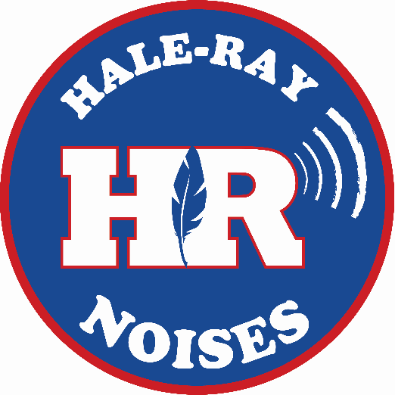
2026-2027

Nathan Hale-Ray High School
Address: 15 School Drive
Moodus, CT 06469

Phone: 860.873.5065
Fax: 860.873.5074

CEEB Code: 070430

Website: nhrhs.easthaddamschools.org

Administration
Dr. Teresa DeBrito, Superintendent
Mr. Christopher Eckert, Principal
Ms. Allison Stroili, Asst. Principal

School Counselors
Ms. Emily Cady
Mr. Greg Little
Location & Description
Nathan Hale-Ray High School is a fully accredited school of approximately 237 students located in rural Moodus, a village in the town of East Haddam, CT. East Haddam is bordered on the west by the Connecticut River and is 25 miles south of the capital city of Hartford. It is 10 miles north of the shoreline town of Old Saybrook. Nathan Hale-Ray High School is one of three schools serving the residential town that has a growing and diverse socio-economic population of 9,500.
Graduation Requirements – 25 Credits (28 Credits for Class of 2029 and beyond)*
English 4.0
Math 3.0
Social Science 3.0
Science 3.0
World Language 1.0
Health 1.0
Physical Education 1.0
*Highlighted sections denote changes for Class of 2029 and beyond

Electives
Art/Music .5
Humanities 1.5
STEM 2.0 (3.0)
CTE 1 (1.5)
General 3.0 (4.5)
Senior Project 1.0

Graduation Competencies
A Nathan Hale-Ray High School graduate is:
- An effective communicator who exchanges thoughts and ideas in a variety of formats and settings.
- An informed thinker who uses critical thinking skills to draw conclusions and reach justifiable decisions.
- A problem solver who strategizes and innovates to develop solutions.
- A self-directed learner who engages in inquiries across multiple disciplines and contexts.
- A responsible citizen who contributes to the school and larger communities.
Core Values & Beliefs
Nathan Hale-Ray High School prepares all students to meet 21st century expectations as self-motivated, lifelong learners in a positive environment. The school
collaborates with the community to promote the
development of college and career ready citizens in a
diverse, global society.
Grading
A B C D F
100-90 89-80 79-70 69-60 below 60
Class Rank & GPA
The GPA and class rank are based upon a weighted 12.0 scale. They are a combined cumulative measure of the grade of each high school course and course level.
Students must be enrolled full time at NHRHS for at least three semesters to be included in class rank. To calculate GPA from a 12.0 scale to an approximate 4.0 scale, use the following conversion: (GPA +1) / 3 = GPA on a 4.0 Scale.

A+ 12 13 14
A 11 12 13
A- 10 11 12
B+ 9 10 11
B 8 9 10
B- 7 8 9
C+ 6 7 8
C 5 6 7
C- 4 5 6
D+ 3 4 5
D 2 3 4
D- 1 2 3
F 0 0 0
Grade Academic Accelerated AP
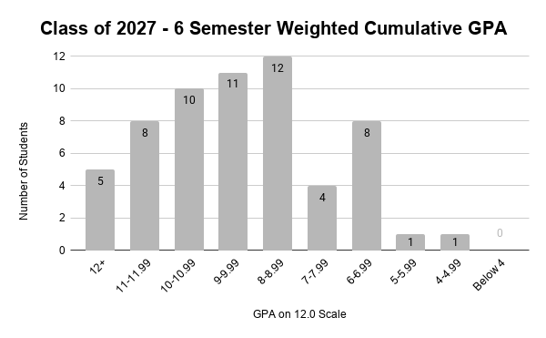
General School Information
Type: Public
Accreditation: Connecticut State Department of Education and New England Association of Schools & Colleges
Enrollment: Seniors: 65 Grades 9-12: 249
Faculty: Administrators: 2
Student Support Services: 2.5
Teachers: 37
Students taking
Advanced Courses: 35%
UConn Early College Experience:
ECE Behavior & Training of Domestic Animals, ECE French IV: Grammar & Composition, ECE French V: Global Culture I, ECE Fundamentals of Sight-Singing & Ear Training, ECE Human & Family Development, ECE Intro to Companion Animals, ECE Music Appreciation, ECE Problems of Philosophy
Advanced Placement Courses:
AP Art History, AP Art Studio, AP Biology, AP Calculus, AP Chemistry, AP English Language and Composition, AP English Literature and Composition, AP European History, AP Psychology, AP Spanish Language and Culture, AP Statistics, AP U.S. Government & Politics, AP U.S. History, AP Precalculus, AP French Language and Culture

Curriculum
Partnership Programs: Students who are juniors and seniors with a
minimum “B” average have the opportunity to enroll in courses at Wesleyan University and/or Middlesex Community College
Regular Program: English, Mathematics, Sciences, Social Studies, World Languages, Art, Music, Technology Education, Business Education, Agriculture Education, Senior Project - Capstone, Health, and Physical Education
Virtual High School: Students have the opportunity to take online courses through VHS that would not otherwise be available to them at school.
Colleges and Universities Attended by Hale-Ray 2020-2026 Graduates

Class of 2027 SAT School Day Scores (Spring 2026)
Mean Reading & Math
Score Writing
NHRHS 997 512 485
Connecticut 972 497 475
Class of 2026 Future Plans
Four Year College: 69%
Two Year College: 8%
Trade/Vocational: 5%
Employment: 14%
Full Sail University
Gettysburg College
Goodwin College
Gordon College
Goucher College
Hallmark Institute of Photography
Hamilton College - NY
Hampshire College
Hartwick College
Hofstra University
Humboldt State University
Husson University
Indiana University at Bloomington
Johnson & Wales University
Keene State College
King's College
Landmark College
Lasell College
Lincoln Culinary Institute
Lincoln Technical Institute
Lyme Academy College of Fine Arts
Manchester Community College
Manhattanville College
Marymount Manhattan College
Massachusetts Bay Community College
Massachusetts College of Art and Design
Massachusetts Maritime Academy
McGill University
Merrimack College
Middlesex Community College

Full Sail University
Gettysburg College
Goodwin College
Gordon College
Goucher College
Hallmark Institute of Photography
Hamilton College - NY
Hampshire College
Hartwick College
Hofstra University
Humboldt State University
Indiana University at Bloomington
Johnson & Wales University (Providence)
Keene State College
King's College
Landmark College
Lasell College
Lincoln Culinary Institute
Lincoln Technical Institute
Lyme Academy College of Fine Arts
Manchester Community College
Manhattanville College
Marymount Manhattan College
Massachusetts Bay Community College
Massachusetts Institute of Technology
Massachusetts Maritime Academy
McGill University
Messiah College

The University of Oklahoma
Three Rivers Community College
Towson University
Trinity International University
University of Bridgeport
University of Connecticut
University of Delaware
University of Hartford
University of Kentucky
University of Maine
University of Massachusetts, Boston
University of Missouri Kansas City
University of Nebraska at Omaha
University of Nevada-Reno
University of New England
University of New Hampshire
University of New Haven
University of Pittsburgh
University of Rhode Island
University of Saint Joseph
University of South Carolina - Columbia
University of Southern Maine
University of Utah
University of Vermont
Virginia Tech
Wellesley College
Western Connecticut State University
Western New England University
Worcester Polytechnic Institute
Wentworth Institute of Technology
Aberystwyth University
Albertus Magnus College
American International College
Anna Maria College
Becker College
Bentley University
Boston University
Brigham Young University - Idaho
Bryant University
Cedarville University
Central Connecticut State University
Champlain College
Clark University
Coastal Carolina University
Colby-Sawyer College
College of Charleston
Columbia University
Dean College
DeSales University
Duke University
Eastern Connecticut State University
Elmira College
Embry-Riddle Aeronautical University
Emmanuel College
Endicott College
Fairleigh Dickinson University
Florida Gulf Coast University
Florida Southern College
Florida State University
Fordham University
Franklin Pierce University

Mitchell College
Mount Holyoke College
Northeastern University
Northern Vermont University-Johnson
Norwich University
Northwood University
Ohio State University
Pace University
Pennsylvania State University
Plymouth State University
Quinnipiac University
Rensselaer Polytechnic Institute
Rhode Island College
Rochester Institute of Technology
Roger Williams University
Rutgers University
Sacred Heart University
Salve Regina University
Savannah College of Art and Design
Skidmore College
Southern Connecticut State University
Springfield College
St. John's University
Stonehill College
Stony Brook University
Suffolk University
SUNY College at Cortland
Syracuse University
The American Musical & Dramatic Academy
The Culinary Institute of America - NY

