2026-27 Senior Yearbook Packet
Important Information Enclosed!
All information in this packet can also be found on our website: Pittsfordschools.org>Sutherland>parents&students>yearbook
This packet includes:
- Important Deadlines
- Senior Quote Form – online submission and a hard copy form
- Yearbook teacher dedication – online submission and in form
- Senior Superlative Information – online submission and in form
- “Now and Then” Picture Submission Information – online submission
- “Baby/Recognition Ad’” Information - Parent pamphlet is attached
(Give this to your parents!)

- See Yearbook Information for this information and packet.
The yearbook staff is providing you with some very important information in this packet.
PLEASE read everything very carefully.
Everything in this packet is DUE no later than:
Friday, November 6, 2026
Including Senior portraits
Parents - See the last page of this Senior packet for instructions regarding Baby/Recognition Ads for Seniors!
They are done online through Jostens.
You can tell your student how proud you are of them! Due 12/1/26
Link to order online – enter Pittsford Sutherland in Search box
Pittsford Sutherland High School Pittsford, NY - Yearbook - Jostens

If you have any questions, please contact:
Ms. Otto: Kristina_Otto@pittsford.monroe.edu

Class of 2027 Seniors
Yearbook Important Dates & Deadlines
All of the following items are due by:
Friday, November 6th

The Yearbook staff needs to work within printing deadlines. If we do not get your completed forms on time, we cannot guarantee that the information will be included in the yearbook. This is most important in regard to your senior quote & portrait!

Senior Portraits: Senior portrait specifications are posted on the SHS website on Students and Parents webpages (See Students>Yearbook)
- We require a head and shoulders pose in color, no hats, props, or bare shoulders.

- ***IMPORTANT*** Students or families can now upload their own Senior portraits at https://photos.jostens.com/QUH238
Images should be in jpeg format at a minimum DPI 300
  - Complete all required information and make sure to use correct spelling for your name!
- Note: If unable to upload your digital image to the site, contact Ms. Otto at 267-3499
- If we do not receive your portrait by November 6th, we will use your CLIX portrait (taken for your school ID).
- Please contact Ms. Otto if you have questions, need help uploading your photo, or you have extenuating circumstances regarding your portrait.

We have created online forms as well as written for your convenience. Complete each online form for the following:
1. Senior Quote/Name: All quotes are reviewed by an administrator before going to print. Please be thoughtful and appropriate. A sheet is provided to plan/write out your quote - the approximate number of characters or amount of space that you can use.
2. Superlatives: Online Voting - Choose classmates who best fit each category.



https://photos.jostens.com/QUH238
Now & Then Photos: Recreate a favorite photo pose from the past.
- Submit your information using the online form (or use Yearbook Drop box in the Main Office)


Baby Picture/Recognition Ads: Ad opportunities from Jostens for parents – ask your student for the pamphlet - we have extras in the Main Office (also posted on the Yearbook webpage) Jostensadservice

Senior Class Group Photo
Date TBD
Assemble on the Football Bleachers
Watch the announcements & Instagram

To Order a Yearbook
Go to www.Jostensyearbook.com and follow the prompts.
Enter Pittsford Sutherland in the search box if needed.
We will also have hard copy order forms available in the Main Office.

1.
Senior Quote
Online submission at

Senior Quotes 2026-27 – Fill out form – please select a quote that has been inspiring or meaningful to you.
*Note: You must be logged in to PCSD network and Office 365.

Paper quote submission:
The yearbook needs your name and quote exactly
as you would like them to appear in the yearbook.
Be sure to use capitalization and punctuation.

Senior Quotes are reviewed by administrators. Inappropriate quotes will not be accepted. Please use the online form to submit your Senior Quote. Please note that quotes referring to violence or harm to others in any way will not be accepted Senior Quotes 2026-27 – Fill out form

Deadline: Friday, November 6

Your Name, exactly as you want it to appear in the Yearbook:

______________________________________________________________________________

2.
Senior Superlative Information
We will be tabulating the Senior Superlatives voting using an online link and by paper.
Senior Superlatives 2026 -27 Nominate 2 per category (Copy) – Fill out form


Please follow the instructions carefully. You may only vote for two people in each category, and it must be done in one sitting. Once you hit SUBMIT, you cannot go back and change your vote. You can use the following list to write the name of the Seniors you wish to vote for in the category, then go online to complete your voting. Choose two people for each Category. PLEASE THINK ABOUT THE ENTIRE CLASS ROSTER.

Senior Superlative Categories

Category | Person 1 | Person 2
- Most Comedic
- Most Musical
- Most Theatrical
- Most Artistic
- Most Likely to Write a Book
- Most Fashionable
- Most Positive Energy
- Best Laugh
- Luscious Locks
- Social Butterfly
- Future Olympic Athlete
- Most School-Spirit
- Next Einstein
- Most Likely to Become a Politician
- Most Likely to Return as a Teacher
- Most Unforgettable
- Kindest Heart
- Most Fearless
- Most Nonchalant
- Most Genuine

3 Teacher Dedication:

Please nominate a staff member who has NOT received this honor in the recent past. (2016 Ms. LoRe, 2017 Sra. Hill, 2018 Mr. Wing, 2019 Ms. Rabinowitz, 2020 Sr. Petroske, 2021 Mr. Steele, 2022 Mrs. Maine, 2023 Mr. Roberti, 2024 Mr. Hosey, 2025 Mr. Benz, 2026 Mr. LeVan). Please use the online form to submit your nomination.
Teacher Yearbook Dedication 2026 - 2027 – Fill out form

Now & Then Photos
Deadline: Friday, November 6th
Online submission at: https://photos.jostens.com/QUH238
Do you have a picture with one or more of your senior classmates from “back in the day”? Submit it for the Now & Then section of the Yearbook. You need to gather your CURRENT senior classmates
who are in the original picture and recreate the pose
to take your Now picture. Then submit both the “Now” and “Then” pictures for publication.

DUE TO SPACE LIMITATIONS, ONLY 2 PAIRS OF PICTURES
(4 pictures total) WILL BE ACCEPTED PER STUDENT!!
There is NO charge for Now & Then photos.

Photos should be in a digital format
Photos should be in jpeg format and 300 dpi.
Email to Kristina_otto@pittsford.monroe.edu if you have trouble uploading the photos.
Please clearly identify all people in the photo by First and Last name. The Yearbook staff cannot be held responsible if the students in the picture are incorrectly identified.
(Left to right, front to back)
Everything in this packet is due no later than Friday, November 6th, except Parent Ads.
***Note: If you prefer, you can complete the paper forms and submit photos for Now and Then on a cd or flash drive and leave them in the Drop Box in the Main Office. Please print neatly. You can email them to Kristina_otto@pittsford.monroe.edu or bring them to the library.

Parent Recognition Ads
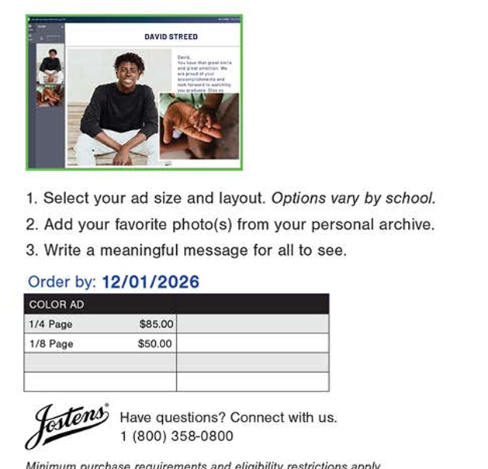
See above for link for Recognition ads.

