NoodleTools Information Sheet
- Go to www.noodletools.com and click on “Log In”.

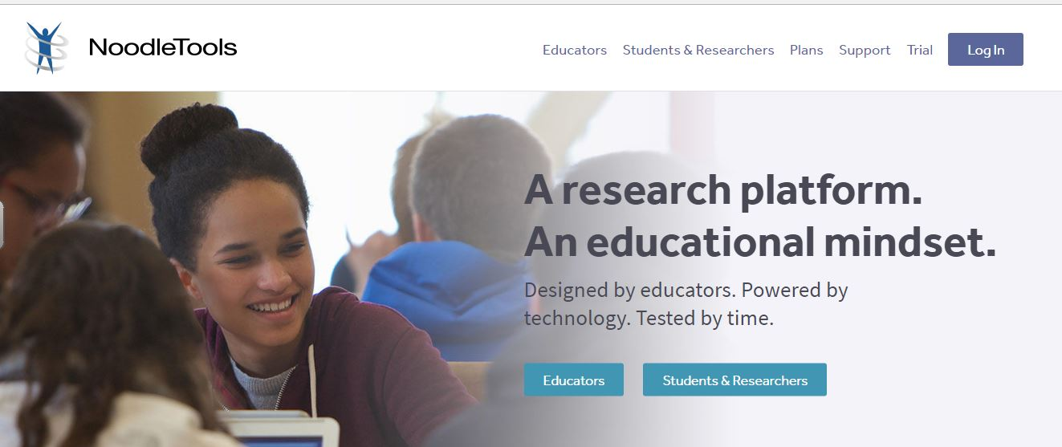
- Make sure to choose “School/University Account”
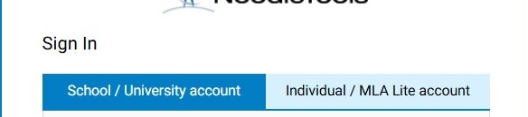
- When prompted for personal ID and password, enter the following:

Faculty Accounts
Personal ID: uc email address
Password: ucteacher
Student Accounts (Grades 11-12)
Personal ID: uc email address
Password: uc20XX (Graduation Year)

Example:
Personal ID: ssmith@unioncatholic.org
Password: uc2027
Student Accounts (Grades 9, 10 and Transfers)
Personal ID: uc email address
Password: uc20XXuc (Graduation Year)

Example:
Personal ID: nturner@unioncatholic.org
Password: uc2029uc
Note: If you are logging in for the first time or have not logged in for awhile, you may be prompted to “revalidate” your account provide the school/library ID and password which is
ID: unioncatholic
Password: vikings

- Noodletools uses your UC email address as your Personal ID. Make sure to use your UC email address (not your personal email). Noodletools will prompt you to verify your email address.

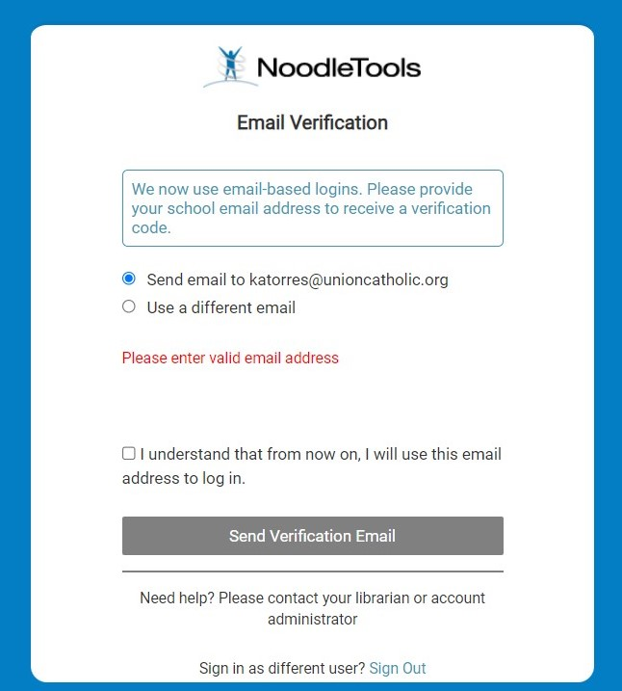

- Note: If you are logging in for the first time or have not logged in for awhile, you may be prompted to “revalidate” your account provide the school/library ID and password which is
ID: unioncatholic
Password: vikings
Those logging in for the first time will also need to complete their profile information. Fill in appropriate information.
Email: (use unioncatholic.org email address)
Graduation Year: 20XX
Initials: XX
Last 4 digits of phone: XXXX (you can use 1600)

Once you login, you will be taken to the “Project Page”
Click "New Project" to begin a new assignment.
(Or select a project to continue working on it.)
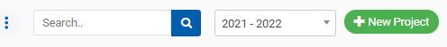

There are 3 parts to creating a new project.
- Project title: Choose something easy to recognize. The class, title or topic of the paper are good options.
- Citation style: Choose MLA or APA- if you are not sure, ask your teacher! (Note: You can change your project to another style after you start.)
- Citation level: Use the default setting of Advanced. 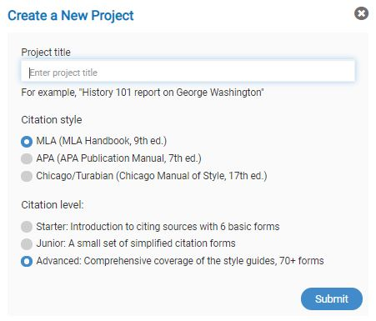
Once you have created a “project”, you can add sources.
Choose “Sources” from menu when the project is open.
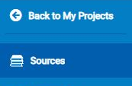

On the Sources screen top menu bar– click "New Source" button
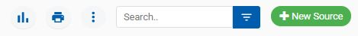

Begin adding a new source by identifying where you found the source.
- The NoodleTools pop-up menu "Where is it?" asks you to "click the option above that describes how you accessed this source."
- Choose "Database", "Website", "Print or in-hand", "Viewed/heard live", "File, app, e-book", or "Other".
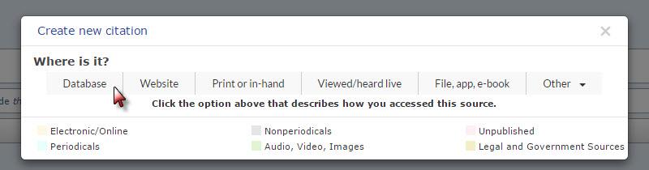

NoodleTools next prompts you to select the source type. From the list of sources under "What is it?" select the option that best describes your source.
- Ask your teacher for help identifying the source type if you have a problem.
Note: If you are citing an AI tool, you need to select “Website” then “AI Response/Output”. See below.
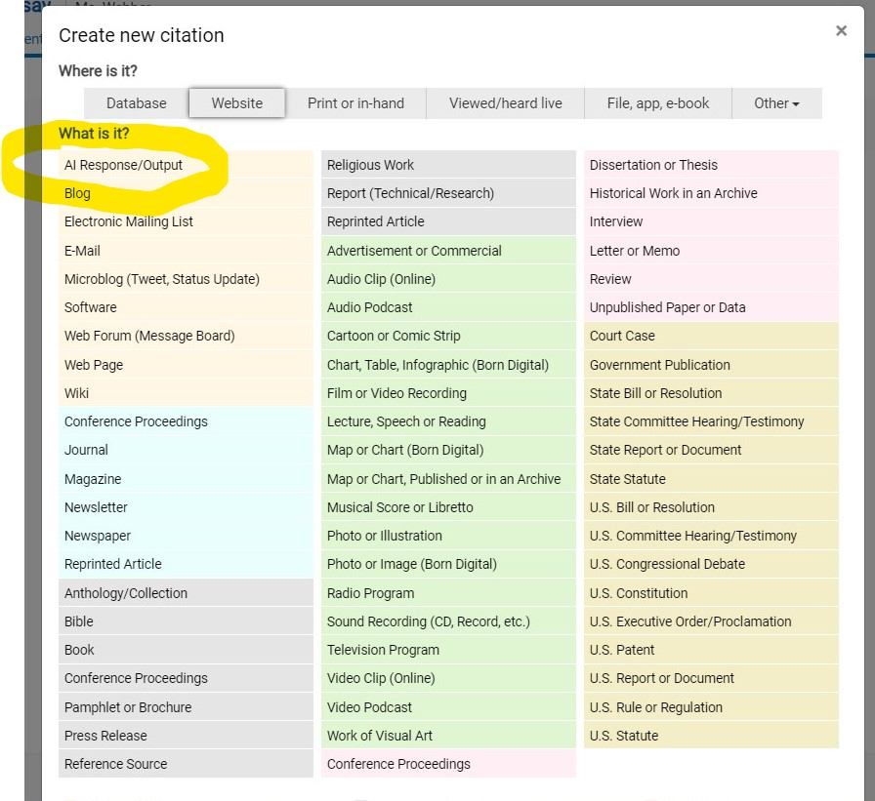

After you select what type of source you have, Noodletools will prompt you to fill in source information (such as URL and date). After you complete the information, click “Save” and Noodletools will generate a citation for your source.
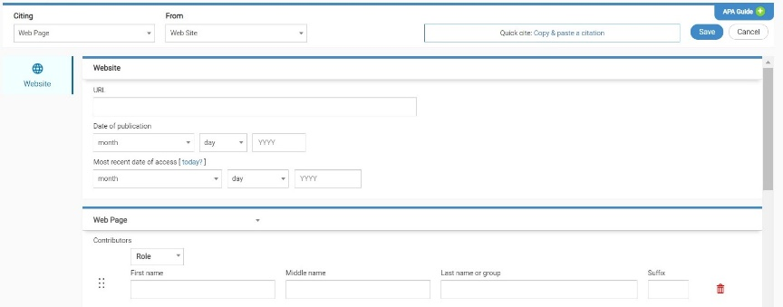
QUESTIONS? Email Ms. Webber- kwebber@unioncatholic.org

