THOMPSON MIDDLE SCHOOL
Partnership Agreement
Handbook
2026-2027

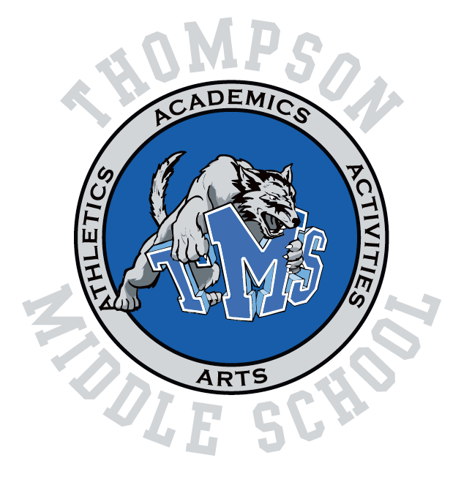
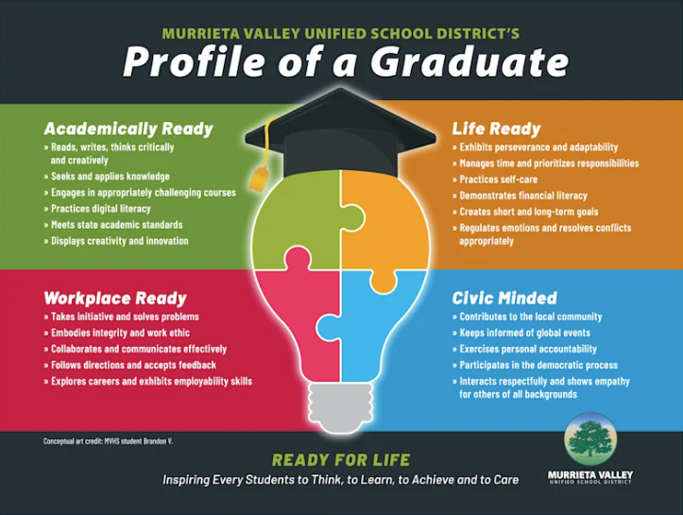

Thompson Middle School
24040 Hayes Avenue, Murrieta, CA 92562
Phone: 951-696-1410 Fax: 951-304-1692
Website: https://www.murrieta.k12.ca.us/thompson

Thompson Mission Statement:
To inspire every student to Think, to Learn, to Achieve, to Care with P.R.I.D.E.

Thompson Vision:
Academic and Personal Excellence for All.

Murrieta Valley Unified School District Board of Education
Dr. Ward Andrus
Eleanor Briggs
Elliot Emmer
Nicolas Pardue
Christine Schmidt
Nancy Young

Thompson Middle School Administration
Principal – Rod DeLeon
Assistant Principal – Julie Moeller
Assistant Principal – Nick Ibbetson
Site Secretary- Valerie Schmidt

6th Grade Counselor – Jessica Deszcz
7th Grade Counselor – Elijah Anderson
8th Grade Counselor – Cassandra Larson

School Communication
Our Thompson Middle School administrative team will send a weekly newsletter to our community to keep families informed of upcoming student and family events, collaboration opportunities, and other information relevant to our school community. Teachers will use Parent Square to communicate with parents. Families may contact our office for information by dialing 951-696-1410. A calendar of events can be viewed on our district website.

Social Media
Follow us on Instagram at Thompson.middle.school and like us on Facebook to stay up to date!

Schoolwide PRIDE Expectations

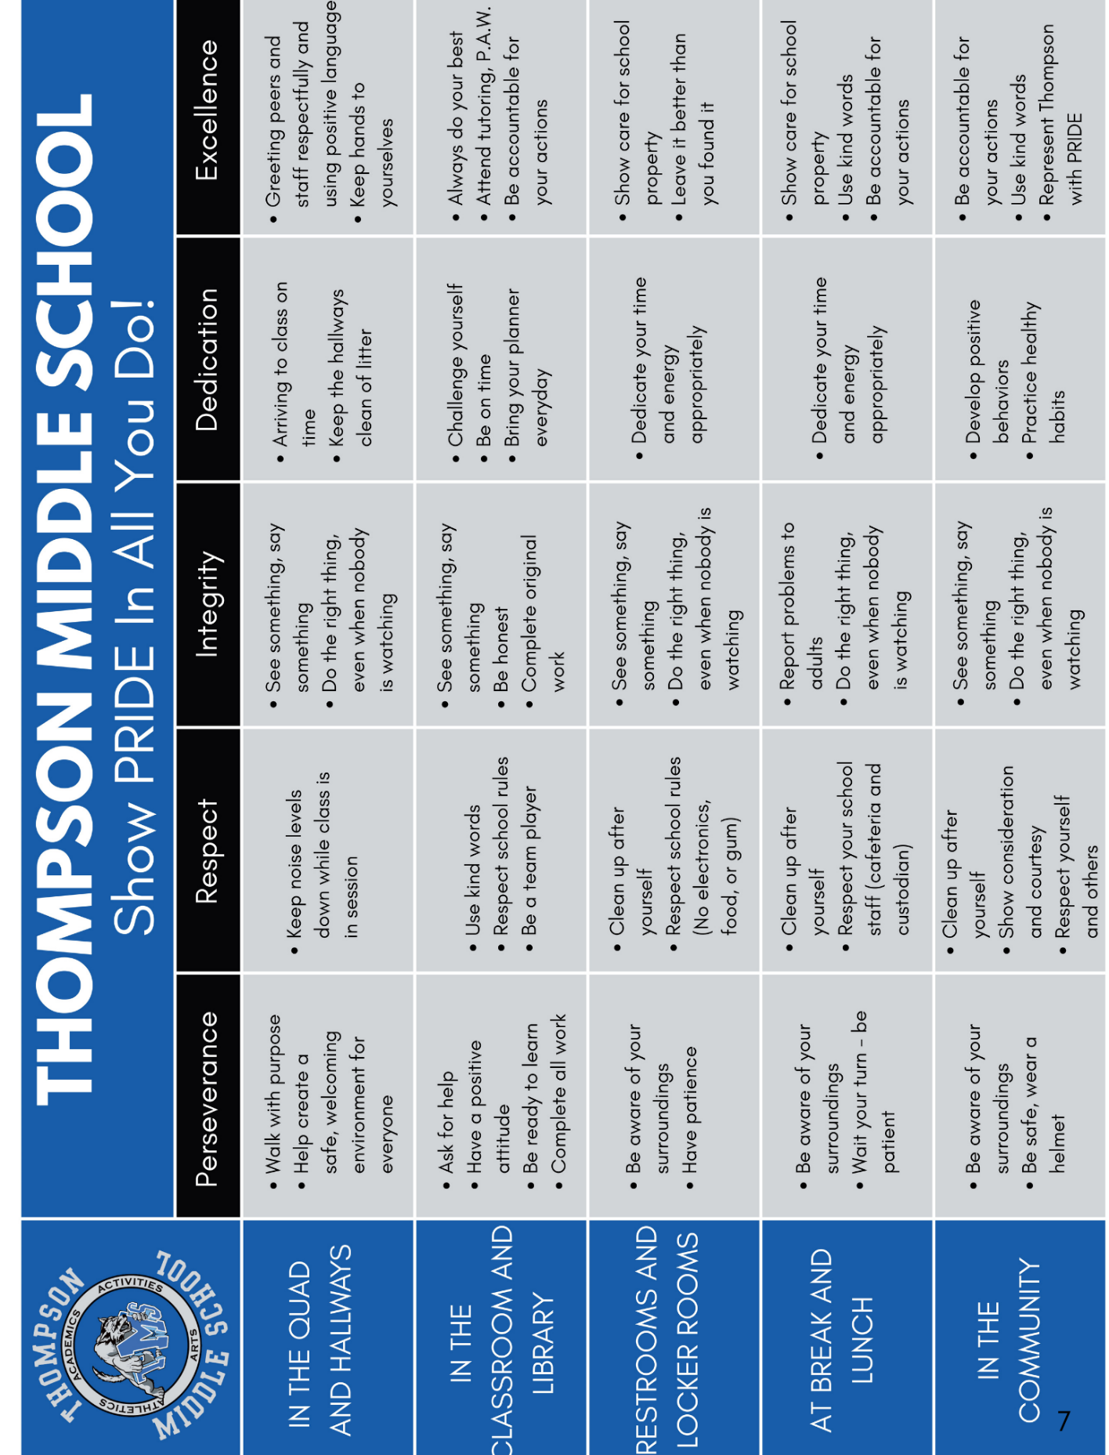

Positive Behavior System of Support
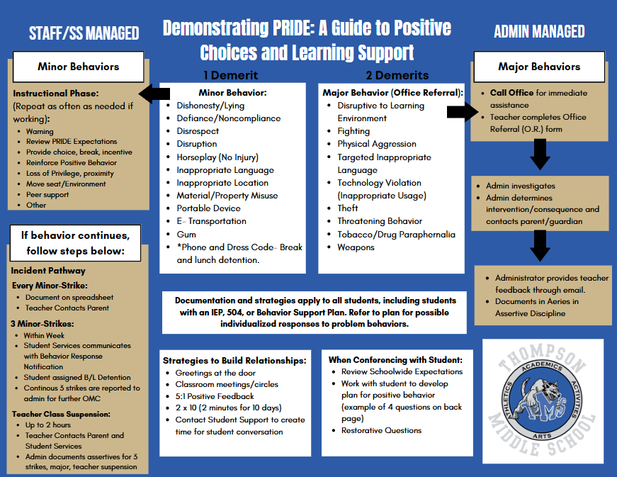

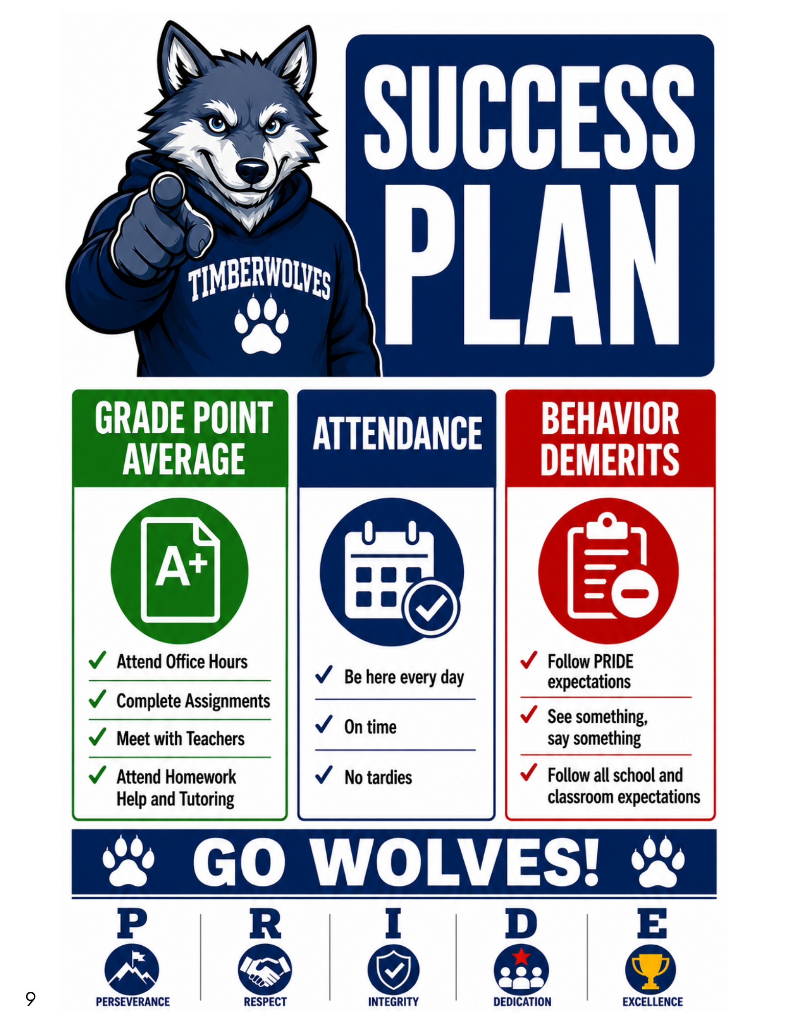

No-Go List
Students that are not meeting all academic, behavior, and attendance expectations will be placed on the No-Go list. Students will not be allowed to participate or attend any TMS extra-curricular activities, field trips, and before or after school events, including Murrieta Valley High School events. Students on the No-Go list will be placed on a Success Plan and will meet with school administration throughout the year.
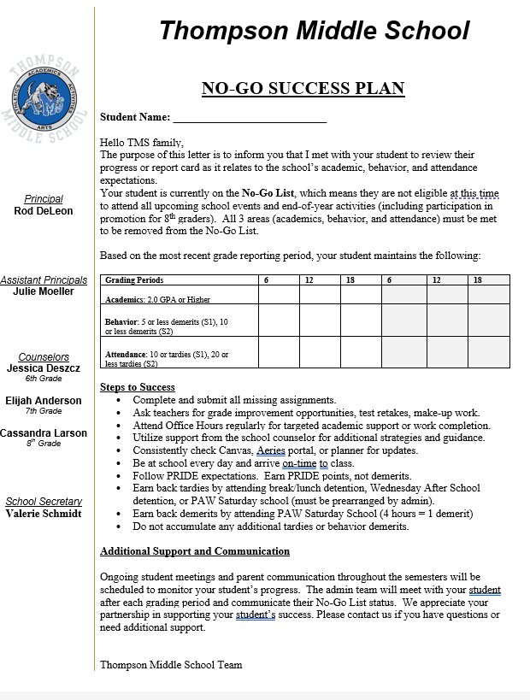

Extra-curricular Activities, Intramurals, Competitions, Field Trips
Students participating in school events must meet all academic, behavior, and attendance criteria. School administration determines final approval. Students on the No-Go list will not be able to participate.
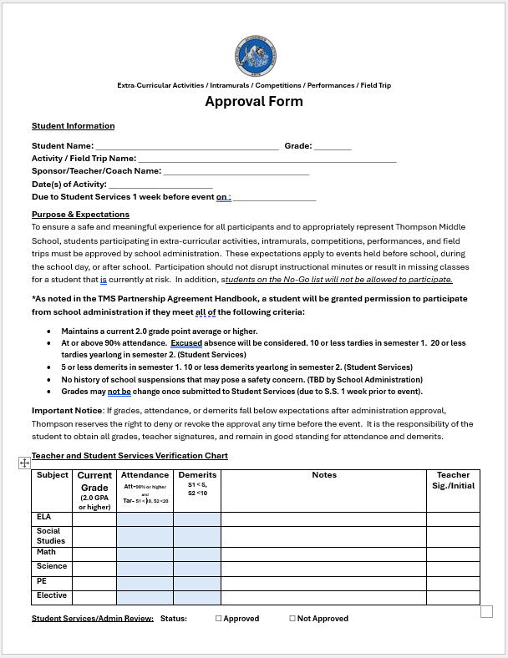

Campus Map

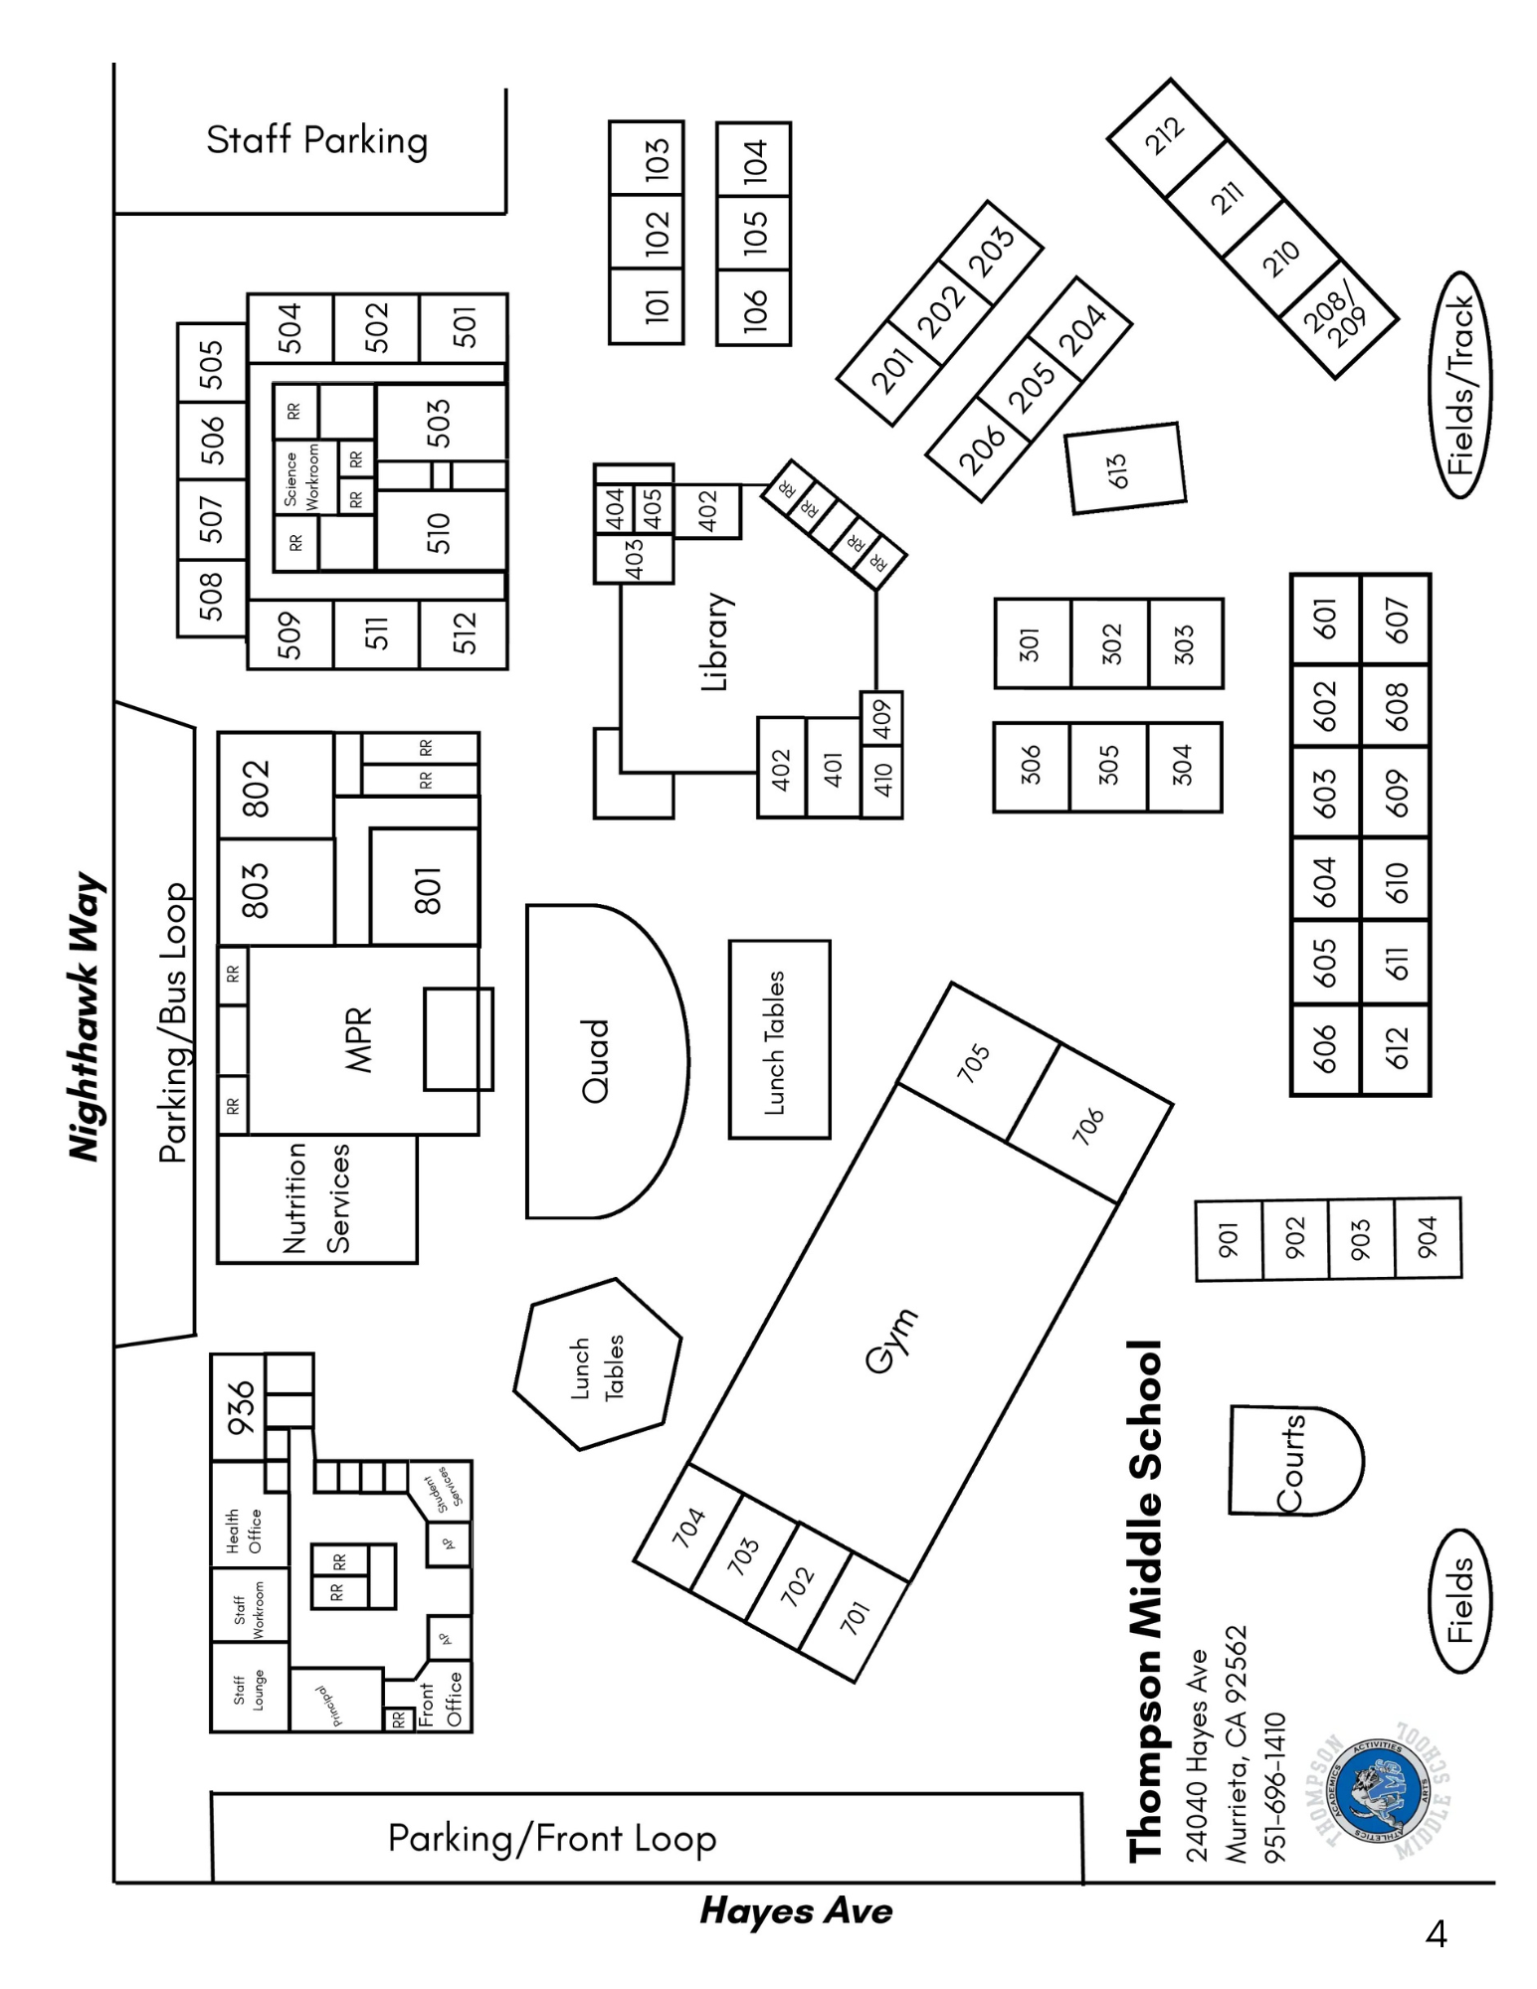

MVUSD School Year Calendar

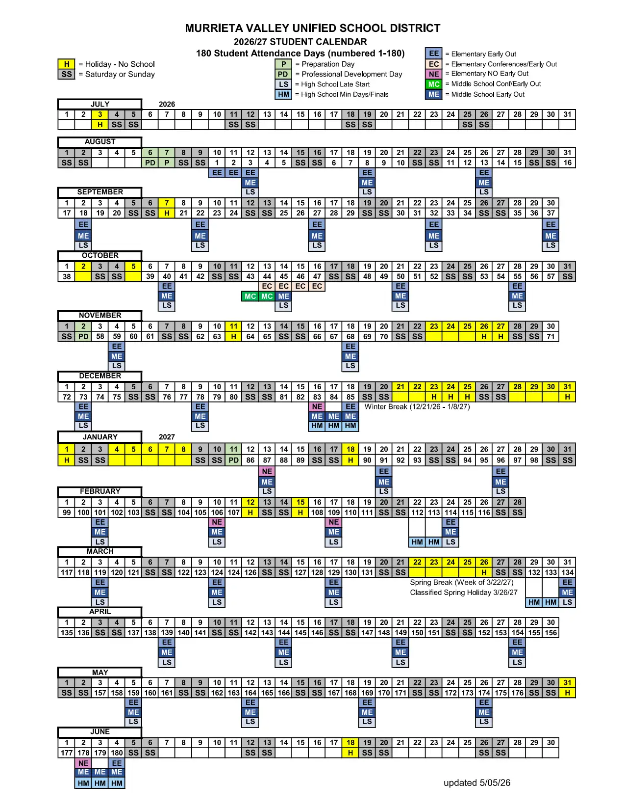

Thompson Middle School Bell Schedules 2026-2027

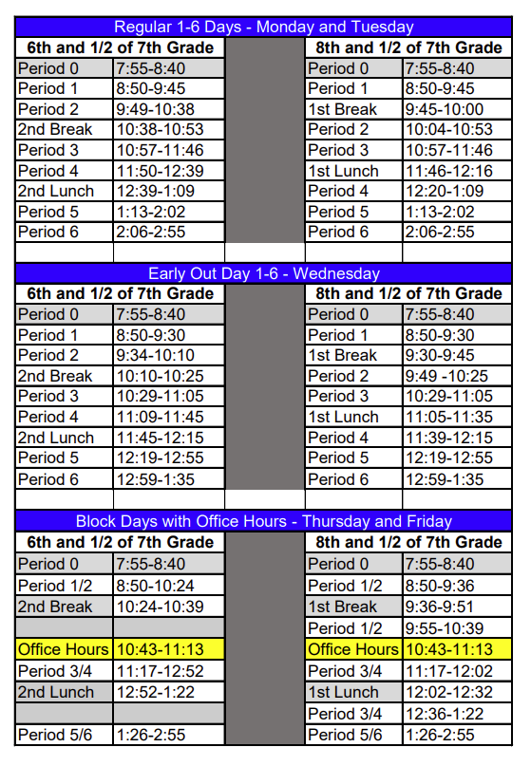

Thompson Middle School
Parent Involvement Manual
Philosophy: Thompson is dedicated to the advancement of each and every student. The learning achievement of all learners is a priority. To successfully achieve this goal, a partnership between the school and parent/caregiver is strongly encouraged and fostered.
Parent/Family Involvement: Direct family involvement is more important to student success than family income or the education level of the parent. Parental participation improves student learning and therefore, student long-term outcomes. We welcome and highly encourage parental involvement. There are many opportunities to take on an active role in your learner’s education. From attending school sponsored events to participating in our committees, please do not hesitate to contact us about these opportunities.
Visiting the Campus: For security and safety reasons, all visitors to Thompson Middle School MUST register in the office at the beginning of ANY visit, no matter how brief. You may arrange to visit during class time by contacting your learner’s teacher or our administrative team. Please schedule conferences either before or after school. Children who are not enrolled at Thompson Middle School are NOT PERMITTED TO VISIT or attend Thompson Middle School functions due to safety and liability considerations.
Parent Observation Policy: In order to minimize disruption to the teaching/learning environment, please adhere to these guidelines:
- Parents are required to schedule observation appointments through the classroom teacher at least twenty-four (24) hours in advance. It is helpful for the teacher to know the purpose of the visit so the time and length of the visit can be arranged.
- Please report to the office at the time of your arrival. Sign in and receive a guest badge. This is required by the district and by Thompson Middle School.
- The office staff will notify the teacher when the parent arrives.
- Please be aware that conferences are not available while the teacher is teaching a class with other students. Conferences must be scheduled for another time.

Scheduling Conferences: Both before and after school conferences with teachers can be scheduled to help meet the needs of parents’ work schedules. The time and locations of special events will be arranged in advance, and parents will be notified prior to such events.
- The quickest and most efficient form of communication with teachers is through email. Phone calls will be answered in a timely fashion. Please be aware, teachers cannot be expected to answer their phones during class time.
- Teachers will answer parent communication within 24 hours, if possible.
- If parents wish to have continual and ongoing communication, please email or call the teacher weekly. Teachers are not expected to initiate weekly emails or calls.
- The school website www.murrieta.k12.ca.us/thompson provides important information for both parents and students. Check our school website regularly to stay up to date.
Resolution Process: The purpose of establishing resolution process guidelines is to facilitate communication within our Thompson Middle School community. It is important for parents to communicate their concerns, questions, and desires about the educational process and our school. By using the steps outlined below, we can work together to address concerns which may arise:
1. The parent meets with the teacher to explain their concerns and reach a resolution. A plan of action may be needed. Please schedule a follow-up either by phone, note, e-mail, or in person.
2. If the concern is not resolved, then it is appropriate to contact a school counselor. The counselor will schedule a meeting with the parents and the teacher. The concern and actions taken will be reviewed. A new plan of action will be developed and carried out. Another meeting may be scheduled to check progress.
3. If the concern persists after the counselor and teacher have attempted resolution, then parents may contact their student’s Administrator.
Parents as Partners in Education: The strongest support for learning occurs at home. This can be achieved by helping your learner with setting goals. Taking your child’s education seriously helps them understand the importance of their education. We ask that parents ensure their learner’s success through supporting the following:
- Regular attendance, including prompt arrival and not leaving early.
- Establish a time for homework, daily. Try and review the homework with them.
- Support school policies, including dress codes and behavior expectations.
- Communicate regularly with your learner’s teachers and the school.
Parents as Models: Parents have a tremendous impact on children’s behavior. What they observe in adults becomes a standard of behavior. Both students and the school benefit from active participation by families. Active participation can be in the form of:
- Asking your child open ended questions about their day at school (this should be done daily)
- Volunteering, even for a single event, at the school
- Donations
- Communication with your learner’s educators on a regular basis
Parent Behavior: We firmly believe in maintaining a positive and harmonious atmosphere that fosters learning, growth, and mutual respect. It is essential that all members of our community, including parents, adhere to certain codes of conduct and rules of civility.
It is expected that communication in all forms, and at all times, whether verbal, non-verbal, or written (including email), will be conducted in a professional and courteous manner. Parents on campus are expected to model appropriate behavior at all times, even during events taking place outside of school hours. It is especially important that parents model the problem-solving process--that is, concerns you may have addressed with the classroom teacher and administration. At no time will parents/guardians on campus interact with children other than their own in matters of behavior and/or discipline. If there is an issue with another child, please contact the school staff immediately. Do not attempt to resolve the issue yourself.
- Dress: Parents should follow dress guidelines as described in the student/district dress code.
- Language: Parents on campus are expected to model the use of appropriate language at all times. This extends to slogans, advertising, and sayings on clothing and/or accessories.
- Tobacco products should not be used or carried onto school property, including the parking lot. Glass bottles/containers are not allowed.
PTSA (Parent/Teacher/Student Association): The Thompson Middle School PTSA is an important school and community organization. The PTSA is involved in many activities that benefit our students, staff, and surrounding community. Red Ribbon Week, Fundraisers, Reflections, assemblies and other special events are organized/sponsored by the PTSA. The PTSA is always in need of volunteers. Please become a member and volunteer!
Together, Thompson Middle School Parents/Caregivers, Teachers, Staff, and our community can make a positive difference in students’ lives.

Thompson Middle School
Parent and Community Support
School Site Council: Elected members represent students, staff, parents, and the community. The School Site Council monitors the site plan and expenditures of the Single Plan for Student Achievement budget (SPSA). Elections are held each year to replace parents and teachers who have concluded their two-year terms.
Parent Advisory Committees: Our parent advisory committees are comprised of parents/guardians of students. These committees are dedicated to ensuring that members have access to the school’s and district administration and a voice in the education of their children. These committees meet four times a year.
- AAPAC - African American Parent Advisory Committee
- ELAC - English Learners Advisory Committee
- LPAC - Latino Parent Advisory Committee
Wolf Watch: Join our program as a way to provide positive role models for our students. This is one way that our parents and guardians can volunteer on site to provide engagement and connection opportunities while creating a greater sense of safety for our learning community. For questions, please contact the front office.

Thompson Middle School
Student Services and Policies

Attendance Policies: Call the TMS Attendance line at 951-696-1410 and press 1 to report an absence for your student. Please leave the first and last name of the student, their grade, the date, and reason for the absence, as well as your name and relationship to the student and a phone number where you can be reached. This line is available 24 hours a day, 7 days a week.
- Students returning to school after an absence must submit a written or verbal explanation from the parent/guardian stating the student’s name, grade level, date of absence, and reason for absence on the first day back to class.
- If the absence is due to a medical appointment, please submit a doctor’s note.
- We ask that you make every attempt to make appointments after school hours for your child.
- If a student is absent for more than 10 days in one school year due to illness, a doctor’s note will be required to excuse the absence.
- Students absent without a valid excuse for more than three days in one school year shall be classified as truant.
- Habitual absences/truancies may result in a School Attendance Review Team (SART) meeting or meeting with an administrator and family referral to the Student Attendance Review Board (SARB).
- It is the student’s responsibility to make arrangements for make-up work. The student will need to make up any work missed during the absence, within a reasonable time determined by the teacher, based on the nature of the work missed.
- If a final exam is missed for an excused absence, the course grade will be submitted with a zero for the final exam. It is the student’s responsibility to arrange a time for a make-up assessment immediately upon their return to school. Exams may not be taken early.
- Parents calling to request missed work may do so once the student is absent for three (3) days. Teachers must be given 24-hour notice.
- Students may not be on campus for after-hours events on the same school day as any uncleared or unexcused absence.
- Only approved contacts, as specified on the Emergency Card, will be allowed to access the child. All contacts must be over 18 years old, and must have a photo I.D.
Academic Honesty Policy: Any alleged violation of this policy will be investigated thoroughly, and appropriate disciplinary measures will be taken consistent with Board policy. Situational discretion applies.

FOR FIRST OFFENSE, THE FOLLOWING WILL OCCUR:
1. Teacher notifies the parent.
2. Loss of all credits for the assignment or test with no make-up permitted.
3. Possible conference with student, parent, teacher and Assistant Principal
4. Possible Saturday School will be assigned by Assistant Principal.

FOR THE SECOND OFFENSE, THE FOLLOWING WILL OCCUR:
1. Teacher makes a referral to the Assistant Principal and notifies the parent.
2. Loss of all credits for the assignment or test with no make-up permitted.
3. Saturday School
4. Possible Conference with student, parent, teacher, and Assistant Principal.

FOR THIRD OFFENSE, PROGRESSIVE DISCIPLINE WILL OCCUR.
AERIES: Aeries allows parents and students to check on course grades and see what homework is due or missing. Please note that Aeries may be used in tandem with Canvas to capture this information. Teachers will communicate which platform they are using for this purpose. It is imperative that both parents and students understand where to locate this information. Parents can activate an account with a verification code and password. This information will be sent home at the beginning of the school year.
Associated Student Body (ASB): Students participate in a Leadership/Student Government class that is part of their academic schedule. This allows them to explore the various leadership roles that help govern our school, make connections, and develop a strong sense of belonging. ASB hosts Thompson Middle School dances, lunch time activities, assemblies, pep rallies and other special events.
Behavior Policies and Expectations: At TMS, we implement supportive, evidence-based practices and a Multi-Tiered System of Support (MTSS) to help our students develop and thrive holistically. Responsibility, self-discipline, and mutual respect for others are important components of each student's education. It is the student's responsibility to follow the expectations of our school, treat others as they would want to be treated, and to not interfere with the learning, safety, and well-being of themselves and others. At minimum, we expect students to adhere to the following to maintain a productive learning environment:
- Respectfulness: Courtesy and respect to self, others, and personal and school property is expected.
- Physically or verbally aggressive behavior, profanity, and calling others by names other than their given name or self-selected nickname is unacceptable.
- Responsible: Students are expected to be truthful at all times and to exercise integrity. Students will not be involved with lying (verbally, in writing, or over the telephone), forgery, fraud, misrepresentation, cheating, or copying others’ work, or misuse of school documents.
- Public Display of Affection: Students may only display affection for one another by holding hands. There will be possible progressive discipline implemented for public display of affection beyond holding hands.
Behavior: Detention Policy: Students may be assigned detention by teachers and/or administration. Other school personnel can recommend students for detention through teachers and/or administration.
- After-School Detention: families will receive communication from the school when a student is assigned an after-school detention.
- Lunch and Break Detention: students will serve their detention during their break and/or lunch. Families will be contacted by Student Services.
- Transportation to/from school is the responsibility of the parents/guardians.
- Students who fail to show up for detention will be assigned two detentions.
- Failure to show for detentions will result in referral to administrator, parent contact, and possible Saturday School.
- Please see Parent Behavior Notification below.

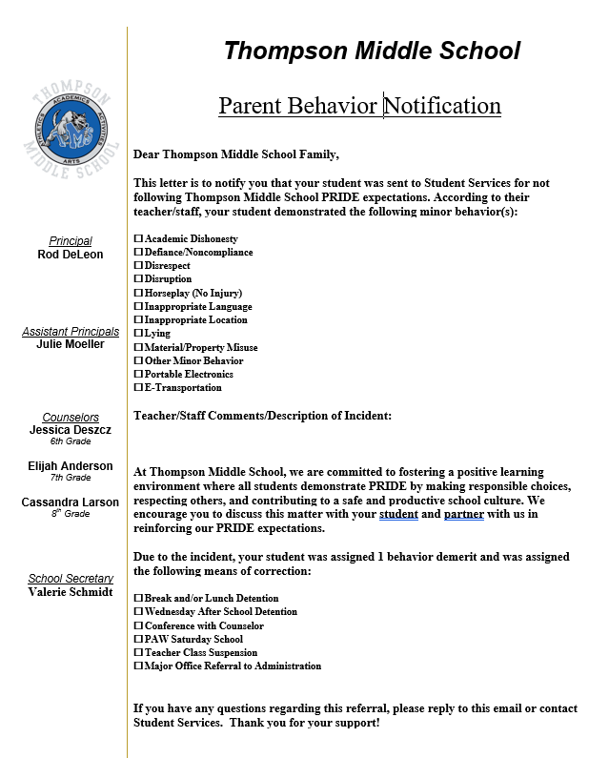
Behavior: Due Process: A student's right to due process will be adhered to and respected; students will know the reason for disciplinary actions. Due process begins in the classroom. The PRIDE Expectations Matrix and Positive Behavior System of Support are posted in classrooms and other common areas within our campus. Students may receive several warnings and classroom consequences prior to being sent to the office. Students may be assigned break, lunch, or after-school detention by a teacher or administrator. Students may also be assigned Saturday School and/or be suspended by an administrator.
- Students are subject to search if the administration has information about that student that indicates a search is necessary (i.e. drugs, weapons, stolen property, etc.)

Behavior: Loss of Activities: Students not meeting academic, behavior, and attendance expectations will be subject to the loss of extracurricular activities and privileges in addition to receiving possible disciplinary action. These students will be placed on a "No Go" list and assigned a Success Plan to be monitored by school administration.
Behavior: Referrals: A record will be kept on all students who visit administrators regarding Disciplinary Referrals. All incidents may be documented in our student information system, Aeries, and will become part of the student’s record.
Behavior: Tardies: We establish a firm tardy policy when students arrive late to class because doing so causes a disruption to the learning environment not only for themselves, but also for other students and staff. It is imperative that students arrive at school and every class on time. Teachers will send students to the Attendance office to obtain re-admittance to class ONLY when attendance for that period has already been entered in the automated computer attendance program. Eighth grade students may lose the privilege of participating in the end of the year activities if they receive twenty (20) cumulative tardies during the school year. This includes tardies to their 1st period class. Tardies will be addressed with the following consequences:
- Tardies 1-3 = Warning
- Tardy 4 = Parent Communication/Conference
- Tardies 10+ = Detention (every 5th tardy) and placed on the No-Go List for semester 1.
- Tardies 20+= Detention (every 5th tardy) and placement on No-Go List for semester 2.
Bicycles and Skateboard Racks: Bicycles of all types, skateboards, and scooters are to be walked on all areas of the school campus. Students are required to secure their bicycles, skateboards, and scooters in the bicycle rack with their own lock, and it must be locked at all times. Failure to do so will result in the following progressive disciplinary actions:
- First incident: the student will receive a warning.
- Second incident: the student will receive a warning.
- Third incident: the student will be restricted from parking their bike on campus grounds, including the bike rack, for one week.
- Fourth incident: the student will be restricted from parking their bike on campus grounds, including the bike rack, for one month.
- Fifth incident: the student will be restricted from parking their bike on campus grounds, including the bike rack, for the remainder of the semester and will be placed on the No-Go list for campus activities due to defiance.
TMS will not be held responsible for any damaged or stolen bicycles, skateboards, or scooters. Locks, combinations, or keys are required and should not be shared with other students. Bicycles, skateboards, or scooters without locks will be stored in the bike rack, not the office, at the student’s own risk.
Students are also expected to obey California’s Helmet Law. Please make sure your child is equipped with a helmet if riding a bicycle, skateboard, or scooter to school. Students who do not have the proper headgear may not be able to take their bicycle, skateboard, or scooter home. The bike rack will remain locked from the beginning to the end of the school day. At the end of each school day, students are expected to walk their bicycles, skateboards and scooters down the exit area toward Hayes Avenue and Nighthawk Way before getting on them.
Bicycles, skateboards or scooters left in the bike rack for after school activities need to be picked up before the close of the after-school program. Bicycles and skateboards must never be left unattended in the racks after hours.
All riders must sign and submit a Parking Permit Agreement (PPA) and complete the online E-Bicycle/E-Scooter Safety Course and Presentation Application (ESCP) in order to ride to and from school. Upon completion, all riders will be given a sticker to acknowledge the completion and submission of the PPA and ESCP.
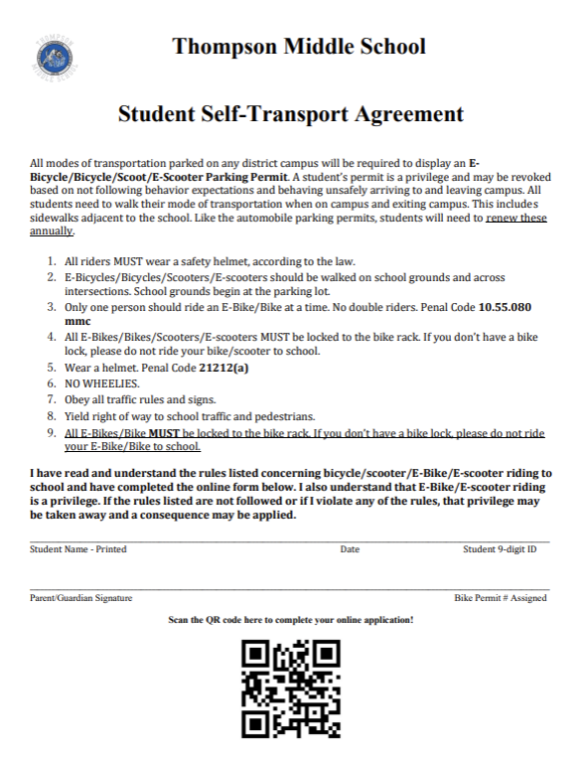

Bullying/Harassment: Bullying or harassment of any kind will not be tolerated at Thompson Middle School. Students will face disciplinary consequences upon the first offense.
What is Bullying?
Bullying is an act of repeated aggressive behavior in order to intentionally hurt another person, physically or mentally. Bullying is characterized by an individual behaving in a certain way to gain power over another person. Bullying can also be defined as when a person is "exposed, repeatedly and over time, to negative actions on the part of one or more other persons." A negative action is defined as "when a person intentionally inflicts injury or discomfort upon another person, through physical contact, through words or in other ways".
The U.S. National Center for Education Statistics suggests that bullying can be classified into two categories:
Direct Bullying
- Direct bullying is a repeated act that involves a great deal of physical aggression, such as shoving and poking, throwing things, slapping, choking, punching and kicking, beating, stabbing, pulling hair, scratching, biting, scraping, and pinching. Direct bullying can also be threatening, challenging or calling someone names directly to their face.
Indirect Bullying
- Indirect bullying is characterized by attempting to socially isolate the victim. This isolation is achieved through a wide variety of techniques, including spreading gossip, refusing to socialize with the victim, bullying other people who wish to socialize with the victim, and criticizing the victim’s manner of dress and other socially-significant markers (including the victim’s race, religion, disability, sex, or sexual preference, etc.) Other forms of indirect bullying which are more subtle and more likely to be verbal, such as name calling, the silent treatment, arguing others into submission, manipulation, gossip/false gossip, lies, rumors, false rumors, staring, giggling, laughing at the victim, saying certain words that trigger a reaction from a past event, and mocking.
For the school to determine if an action will be defined as bullying the action must have four elements:
1. Be an act of aggression
2. The act must be done to INTENTIONALLY hurt another person
3. The act must be done more than once
4. There needs to be an imbalance of power either socially, in numbers, or physically
NOTE: Even if the act is not determined to be bullying, if it is a negative act, it will still be dealt with by the school as a discipline issue.
What is not considered Bullying?
According to Ronit Baras of the Family Matters project, when talking about bullying, it is very important for parents (and teachers and kids) to understand what bullying is not. Many times, a single act or behavior is out of proportion, but it is not considered bullying. Some people think that bullying is any aggressive behavior and although such behaviors are a source of concern and need attention, it is important to separate them from bullying. As defined earlier, bullying is recurring and deliberate abuse of power.
Not Bullying List
1. Not liking someone - It is very natural that people do not like everyone around them, and as unpleasant as it may be to know someone does not like you, verbal and non-verbal messages of "I don't like you" are not acts of bullying.
2. Being excluded - Again, it is very natural for people to gather around a group of friends, and we cannot be friends with everyone, so it is acceptable that when kids have a party or play a game, they will include their friends and exclude others. It is very important to remind kids they do the same thing sometimes too, and although exclusion is unpleasant, it is not an act of bullying.
3. Accidentally bumping into someone - When people bump into others, the reaction depends mostly on the bumped person's mood. If they have had a bad day, they think it was an act of aggressive behavior, but if they are in a good mood, they smile back and attract an apology. This is also relevant for playing sports. For example, when kids throw the ball at each other, they hit someone on the head. It is very important for teachers and parents to explain that some accidents happen without any bad intention, and it is important not to create a big conflict, because it was not an act of bullying.
4. Making other kids play games a certain way - Again, this is very natural behavior. Wanting things to be done our way is normal and is not an act of bullying. To make sure kids do not fall into considering it an aggressive or "bossy" behavior, we need to teach them assertiveness. If your child comes home and complains that "Jane" is very bossy and she always wants things to be done her way, you can share that everyone wants their own way and that Jane is miserable because she is not flexible. She will suffer in life for insisting that things be done her way. Again, although it is not fun or pleasant, this is not bullying.
5. A single act of telling a joke about someone - Making fun of other people is not fun for them, but the difference between having a sense of humor and making fun of someone is very fine. It is important to teach kids (and grownups) that things they say as jokes should also be amusing for others. If not, they should stop. Unless it happens over and over again and is done deliberately to hurt someone, telling jokes about people is not bullying.
6. Arguments - Arguments are just heated disagreements between two (or more) people (or groups). It is natural that people have different interests and disagree on many things. Think about it...most of us have disagreements with ourselves, so it is very understandable to have disagreements with others. The argument itself is not a form of bullying, although some people turn arguments into bullying, because they want to win the argument so much. They use every means to get what they want and find a weakness in the other person, abuse knowledge or trust they have gained, and use it against the other person. It is very important to distinguish between natural disagreements and bullying during an argument.
7. Expression of unpleasant thoughts or feelings regarding others - Communication requires at least two players. Although it may be unpleasant to hear what someone thinks about you, it is not a form of bullying, but a very natural thing. In every communication, there are disagreements and some forms of judgment about each other's attitude and behavior. If someone says to you, "I think this was not a nice gesture" or "You insulted me when you said this", this is not Bullying, but an expression of thoughts and feelings.
8. Isolated acts of harassment, aggressive behavior, intimidation or meanness - The definition of bullying states that there is repetition in the behavior. Bullying is a conscious, repeated, hostile, aggressive behavior of an individual or a group abusing their position with the intention to harm others or gain real or perceived power. Therefore, anything that happens once is not an act of bullying. All the behaviors above are unpleasant and may need to be addressed, but they are not treated as bullying.
What to do if you are being bullied -
Now that we know that Bullying is a “repeated aggressive behavior that takes place over time,” what actions should you and/or your child take if being bullied?
- Tell a parent - Too many times students are taught to handle things themselves. Being bullied may be a new experience for your child that you as a parent have more life experience to help him/her deal with. As a parent, it is important that you pay attention to what your child is telling you and find out if things are happening more than once.
- Tell a trusted adult at school (teacher, counselor, administrator). The number one reason bullying occurs at school is because the school does not know about it. If the school does not know about it, they cannot stop it.
- Work with your school – Remember your school wants to stop bullying as much as you do. Work with them as a team and devise solutions together.
Canvas: Canvas is our learning management system that allows students to access materials and assignments throughout the year. Canvas supports online learning, while allowing teachers to post grades, information and assignments online. Canvas may be used in tandem with Aeries for the documentation of student progress. Teachers will communicate which platform they post ongoing grades and homework completion reporting on. Parent Canvas accounts are available to help monitor student progress and work. Account information can be obtained in Student Services.
Cellphones/Electronics: The district recognizes that many families desire their students to carry cell phones, smart watches and glasses for safety and emergency use. The district supports and allows for the possession of cell phones for those reasons. Although board policy allows possession of cell phones, it also gives the authority to school administration to restrict their use. Our TMS educators believe that cell phones significantly interfere with the learning and community building process within the school day. To optimize our learning environment for all, students are expected to adhere to the following:
- Phones must be turned off and put away (in backpacks or storage, not in clothing pockets) while on campus.
- Phones must not be used during the school day including instructional (class) time, break, and lunch. Phones must be turned off and put away while on campus.
- Smart watches and Smart glasses are not permitted on campus.
- The use of any camera on campus is prohibited, unless part of a class assignment or approved school activity, without the advanced permission of the principal. This includes the use of cell phones for the purpose of taking or transmitting photos or videos.
- Phones can be turned on after dismissal when students have exited and off campus.
- Electronic games are not allowed on campus (with the exception of use in E-Sports).
- AirPods/Earbuds/Beats/Headphones are not permitted on campus.
- Students will have access to school phones if needed and may request to use them in Student Services.
- Parents may leave messages for students at the front office.
- No student shall be prohibited from possessing or using a cell phone that is determined by a licensed physician or surgeon to be essential for the student’s health and the use of which is limited to health-related purposes. The school administration may require proper documentation in order to authorize such use.
Failure to comply with the above may result in confiscation of the device and further progressive school discipline. Phones will be returned to a parent. Thank you for helping us keep our campus safe.
Consequences:
First Offense: Students will be escorted to Student Services where the device will be safely secured. The student may pick up the device at the end of the day. 1 behavior demerit will be assigned. Student may also serve a break and lunch detention.
Second Offense: Student will be escorted to Student Services where the device will be safely secured. The parent must come in to pick up the device at the end of the day from the main office receptionist. 1 demerit will be assigned. Student may serve multiple break and lunch detentions.
Third Offense: Student will be escorted to Student Services where the device will be safely secured. The parent must come in to pick up the device at the end of the day from the main office receptionist. 1 demerit will be assigned. Student may serve multiple break and lunch detentions.
Fourth Offense and beyond: Student will be escorted to Student Services where the device will be safely secured. The parent must come in to pick up the device at the end of the day from the main office receptionist. The student will receive progressive discipline, which may include: multiple days of detention, Saturday School, and/or placement on the no go list. 1 demerit will be assigned.
Closed Campus: Thompson Middle School has a closed campus policy. This means that no student is to leave the school grounds on their own accord during the regular school day for any reason. Students may not enter campus before 8:15 a.m. unless they are assigned zero period. All students will remain on campus during regular school hours. Students needing to leave school during the school day must check out through the Attendance office and have an authorized adult physically sign them out. Students may not remain on the school campus after 3:00 p.m. unless it is for a specific after-school activity and the required permission form is on file in the school office and with the supervising teacher.
Clubs: Thompson Middle School provides a wide variety of extracurricular activities for our students. Clubs are available before and after school and during lunch. Clubs vary depending on availability, staffing, and student interest.
Communication: TMS adheres to an open communication policy. At TMS, no one will be able to address the individual needs of your child better than the classroom teacher. When concerns arise, we strongly suggest that parents make an effort to first contact the teacher. Please note our teachers will make an effort to return calls or e-mails within a 24-hour period. In some cases, more time may be required.
A complete directory of Thompson Middle School staff email addresses is available on the TMS web site: www.murrieta.k12.ca.us/thompson
- Parent Conferences: A teacher or parent may initiate a Parent/Teacher Conference. The parties involved will make arrangements to meet at a mutually convenient time during the teacher’s prep period (7:55-8:40 a.m.). District scheduled conferences occur on minimum days in the Fall.
Deliveries Balloons, flowers, etc. are not allowed in the classroom and will not be delivered to the student. Students who have these items on campus may pick up the items from the front office when they leave for home. Lunches, books, homework, clothing, etc. will not be delivered to students. The front office receptionist will not be able to accept drop-offs. Under no circumstance will food delivery services be accepted on campus for students (i.e. Door Dash, Uber Eats, Grubhub, etc.).
Dress Code: At Thompson Middle School we show P.R.I.D.E. in all that we do: Perseverance, Respect, Integrity, Dedication, and Excellence.
Part of showing that we have P.R.I.D.E. is by following the MVUSD DRESS AND GROOMING GUIDELINES:
1. Students must wear clothing including both a shirt with pants or skirt, or the equivalent (for example dresses, leggings, or shorts) and shoes.
2. When the body is standing straight, clothing must cover the chest, back, torso, stomach, and lower extremities from armpit to mid-thigh (at no time may any part of a student’s buttocks be exposed). Tops must have a strap.
3. Clothing must cover all undergarments. No underwear or undergarments may be visible at any time. Clothing may not be see-through.
4. Clothing must be suitable for all scheduled classroom activities including physical education, science labs, shop classes, field trips and other activities where unique hazards or specialized attire or safety gear is required. Bare feet are not permitted at any time.
5. Attire and/or grooming depicting or advocating violence, weapons, criminal activity, gang-related activity (including clothes, accessories, or colors identified by MPD as gang- affiliate), use of tobacco, alcohol or drugs, pornography, foul language, hate speech, or clothing that could be considered dangerous or that could be used as a weapon are prohibited.
If my attire does not meet the MVUSD DRESS AND GROOMING GUIDELINES, I will be asked to change my attire to meet these guidelines. I understand that having P.R.I.D.E. means being dressed appropriately for my studies at Thompson Middle School.
My options after an Attire Intervention are:
- Call home for a change of clothing. While waiting for the change of clothing, I will be sent to class with alternate attire provided by the school until my change of clothing arrives. Change of clothing can only be dropped off during a student's break or lunch period. Parents must call ahead to inform the front office of said drop off before their students break or lunch time to arrange for their student to be there. All drop-offs must be handed directly to your student; the receptionist will not hold any clothing items from parents for the student to pick up later.
- Borrow a change of clothing for the day. I will return my change of clothing at the end of the day and receive my original items back.
- All dress code violations may warrant break and lunch detentions. 1 demerit will be assigned for each dress code violation.
- I will return all borrowed dress code clothing to the office. Failure to return borrowed clothing will result in a $15 fine for each item not returned applied to by student account.
Emergencies: Telephone numbers are necessary for us to act efficiently in the event of an emergency. Please include a relative’s or neighbor’s telephone number in case of an emergency. We request that you notify us immediately about changes of address, email, or telephone numbers. Important: Please list all telephone numbers and e-mail addresses where parents can be contacted during the school day.
Food Policy: Food and beverages will be served and eaten in the lunch area only. Gum is not permitted on campus at any time. Glass containers, nuts or seeds in the shell and eating or drinking in classrooms is strictly prohibited. Water bottles and container are allowed.
Grade Reports: Report Cards are posted on Aeries at the end of each eighteen-week semester. Progress Reports are posted on Aeries approximately every six (6) weeks, in each semester. They provide information on your child's progress from each teacher. Please contact Student Services for sign-up information and an access code for Aeries if you do not already have one. If a hard copy of the report card is needed, please request it through Student Services.
Gum on Campus: Gum chewing on campus is not permitted. Careless disposal of gum creates sanitation and cleaning challenges as well as costly repairs. Gum packs may be confiscated requiring parent pick-up at Student Services. Disciplinary action such as demerits and/or detention may be implemented.
Hall Passes: Students not in the classroom during class time are required to have a pass at all times. Students must obtain a pass from their teacher and check out through 5-star before coming to the office. Remember to be polite and patient in the office areas.
Health Services: A school nurse and/or Health Technician will be present on campus at all times. Students must obtain a pass to visit the Health Office. Students must have an emergency card on file in the office in case of accidents. Parents will be notified of accident situations and are responsible for transporting students except in cases of extreme emergency. It is critical that we be able to reach you or one of your designated contacts. Therefore, you must notify the Health Office of any phone number changes immediately.
Health Services – Medications: California Education Code (Section 49423) states that when a school district employee gives a medication to a student, it must be in accordance with the written direction of a physician along with written permission of the child's parent or legal guardian. These authorizations must be renewed whenever the prescription changes or within 12 months of the signed authorization form. The prescription label on the container is not acceptable as a physician's written direction. This includes all medications including over the counter medications.
- All medications will be stored in the Health Office. Students are not allowed to have medication in their possession at school, walking to and from school, or on the school bus. This practice provides for the safety of all students on campus. The only exception to this policy is if the student’s wellbeing is in jeopardy and the medication, such as an inhaler for asthma, is carried on his/her person.
- The appropriate release forms can be obtained from the school. Medications must be provided to the school in the container in which it was purchased or filled. Prescription medications must be prescribed to whom it will be administered with the prescription label attached. School personnel cannot give medication brought to school in a plastic bag, plastic ware, or any other repackaging. Out-of-date medication will not be given. An adult must bring the medication to school along with the completed authorization form.
- If you anticipate a visit to your child’s physician or dentist and expect that medication may be prescribed, or the dosage changed, please contact the school Health Office for the appropriate forms.
Homework: Homework is defined as an assignment in a subject area that has been taught and learned sufficiently so that the student does the work correctly rather than reinforcing errors or incorrect work. Homework is completed outside of class time. However, teachers may use their discretion to start homework in class to ensure accuracy.
When questions arise, students are encouraged to contact each individual teacher regarding the posting of homework.
- Goals of Homework – Extend or reinforce classroom learning, aid in the mastery of skills, teach students to budget time and use time wisely, involve parents/guardians in the education of their child, but not require the parent/guardian to provide initial instruction, provide opportunities for parent/child interaction, and enable a student to make up work missed due to excused absences, not including suspensions.
- Types of Assignments – The goals of homework, as defined in the District homework philosophy, indicate that multiple kinds of assignments should be used; these are described as follows: Creative activities, cultural enrichment, drill and practice as well as problem solving activities, makeup assignments and revision, test preparation, reading, projects, family discussion topics, review or remediation, extension of learning to new applications, extended reading, and independent research/reports.
- Make-up Homework Policy – When a student is absent from school, it is his/her responsibility to contact teachers upon returning to school regarding make-up work. The time allotted for making up missed work will vary depending on the circumstances surrounding the absence, the actual time out of school, and the teacher’s classroom policy. Each student will make arrangements with his/her teachers for turning in work. Students need to check Canvas and/or Aeries for missing assignments. When uncertain, the student is encouraged to contact the teacher directly. The make-up policy for missing assignments when a student is not absent is at the discretion of the individual teacher. Generally, late work may be turned in during the unit/chapter of study with a penalty such as a partial grade. Please read individual teacher guidelines for their specific homework policy.
- Assignments may be fixed/corrected at the discretion of the teacher. Students are encouraged to fix/redo assignments when the opportunity arises.

Identification Cards: I.D. Cards will be issued to all students enrolled at Thompson Middle School. Students are required to present this card when requested to do so by any school official, upon admission to a school function (i.e., dances), when checking out material from the library. Do not LOAN or GIVE this card to anyone. It will be confiscated. Replacement of I.D. cards, whether stolen or lost, will be replaced at a nominal fee (payment in advance to TMS Pack Shack).
Library/Textbooks: It is very important that all students follow all library policies on returning library and textbooks. Books checked out through the library should be returned in the same condition as when borrowed. Failure to return books in a timely manner will result in disciplinary action such as after-school detention and loss of extra-curricular activities. Students must show their Student Identification Card to check out a book from the library. NO I.D. CARD = NO BOOK.
Library/Textbook Fines: Books checked out to a student must be the identical book returned (i.e., barcodes must match). Even if a student returns a book, if it does not have the correct barcode as originally issued to them, the student is still responsible for finding and returning the originally issued with the correct barcode or pay for the book. Eighth graders must return and/or pay for all library books and textbooks checked out in their names. This includes all books from grades 6 through 8. Failure to do so will result in the student being unable to receive a class schedule, books, P.E. uniform, ASB card, etc. at MMHS, MVHS or VMHS or have student records forwarded to the new high schools. Sixth and Seventh graders who advance to seventh and eighth will not be issued textbooks or library books if all previous year's books have not been returned. A record of current library checkouts can be viewed by parents and students in Aeries.
Lost and Found: Items left in a classroom will be turned into Student Services. Items not claimed within a reasonable time period will be donated to charity. Please put your student’s last name on personal belongings so items can be easily returned. A notice will be sent out to parents and students prior to each charity donation.
Notice of Consequence: The Board of Education and staff of MVUSD believe in safe schools. The district supports a policy of safe schools and will enforce consequences upon students involved with controlled substances, possession of a firearm, or brandishing a knife at another person. Any offense involving drugs, alcohol, dangerous objects, and all sexual assaults and batteries will be reported to the proper legal authority.
EXPULSION IS MANDATED UPON THE FIRST OFFENSE FOR VIOLATION OF THE PROVISIONS OF EDUCATION CODE SECTION 48915 C (1), (2), (3), AND (4) WHICH ARE:
1. Possessing, selling, or otherwise furnishing a firearm.
2. Brandishing a knife at another person.
3. Unlawfully selling controlled substances.
4. Committing or attempting to commit a sexual assault.
Under certain circumstances expulsion can be recommended on a first offense for any violation of Education Code 48900, including but not limited to:
1. Using, possessing, selling, furnishing, or being under the influence of any controlled substance (illegal drugs or alcoholic beverage) or intoxicant of any kind. [Ed Code 48900 (c)].
2. Possessing, selling, or otherwise furnishing any firearm, knife, explosive, or other dangerous object. [Ed Code 48900(b)}.
These regulations apply to students in the following situations: On school grounds (this includes the parking lot, as well as vehicles on school property), going to or from school, and on lunch break (on or off campus).
Restroom Privileges: Due to the importance of instructional time, students should make every effort to use the restroom before school, during breaks, at lunch, and during passing periods. (Teachers may grant or deny restroom privileges at their discretion). Students will sign in and out using 5 Star Students for restroom and hall pass purposes.
Safety: Students must walk at all times on campus and not run unless otherwise instructed.
- Students are required by law to wear a helmet for their safety if riding on their bicycle, skateboard or scooter.
- Earthquake Procedures: The procedures used in case of an earthquake will vary depending on the severity and frequency with which the tremors occur.
- Fire Drills: Thompson Middle School conducts regularly scheduled fire drills. Evacuation instructions are posted in classrooms.
- Lockdown Drills: Thompson Middle School conducts regularly scheduled lockdown drills.
School Sponsored Events: School events sponsored by TMS are subject to the following requirements:
- I.D. Cards must be presented in order to gain admission.
- Only Thompson students may attend. Guests from other schools are not allowed. Faculty members and chaperones have full authority to admit, refuse admission to, or remove any student from an event without refund. School rules and dress codes apply at all times. Students are expected to be courteous, friendly, and polite. Students who do not display appropriate behaviors will be asked to leave. Parents will be contacted and required to pick student up. Until such time as they arrive, the student will remain with the administrator in charge. All events will be scheduled at the discretion of the Principal, ASB Advisor, and Student Government. Any student suspended/expelled, with excessive tardies, on the No-Go list, or who has lost privileges for any other reason may not attend any school event during the time of their consequence.
Sexual Harassment: If a student has been proven to have caused sexual harassment, he/she will be suspended from school and possibly recommended for expulsion. Sexual harassment is based upon the impact on the victim, not the intentions of the perpetrator.
Sexual harassment is unwelcome sexual advances, requests for sexual favors, or other verbal/physical conduct of a sexual nature.
Uninvited behavior that makes being in the school offensive, negative, unfriendly and/or intimidating and leads to a hostile environment that makes learning difficult.
“This for That/Something for Something Else” is another form of harassment. Examples: The manager at the fast-food place in which you work says that you will be fired if you do not engage in certain behaviors with him/her; Someone blocking the door and refusing to let you through unless you agree to certain behaviors.
Flirting | vs | Sexual Harassment
Welcomed behavior |  | Unwelcome behavior
Leaves you feeling positive |  | Leaves you feeling negative
Respectful |  | Disrespectful
Flattering |  | Unpleasant
Enjoyable |  | Illegal
*SEXUAL HARASSMENT OFTEN GOES UNREPORTED. REPORTING IS THE ONLY WAY TO GET HELP
WHAT CAN BE DONE? TAKE ACTION!
- ASSERT YOURSELF: Tell the harasser to stop the behavior. Tell him or her aloud or in writing what behaviors you find offensive.
- CALL FOR HELP: Ask for the help of someone you trust - your friends, parents, or a person in authority. Tell them about your problem. Enlist friends as witnesses.
- TAKE NOTES: Keep a detailed, written record of what was said and done to share with the person who investigates your complaint.
- INFORM AUTHORITIES: Report offensive behavior to a teacher, counselor, or principal. Give details and provide witnesses. This action may stop this behavior.
- OPEN A CASE: File a complaint with your counselor or administrator against the person who is harassing you.
- NEVER GIVE IN: If you are not satisfied with the results of the complaint, continue to take action and get help from your principal.

Student Drop off/Pick Up: Students are to be dropped off and picked up in the Nighthawk loop, as well as the Hayes loop. Our driveway gate on Nighthawk will be closed; please do not turn around or drop off students at this lower gate. This creates a very dangerous situation for students on the sidewalk. Areas for student pick-up are clearly marked. Please do not pick up your child at Ralph’s shopping center or in neighboring streets.
Student Recognition: Thompson Middle School implements celebrations to recognize students who have achieved high levels of academic performance, such as Honor Roll for students that have a 3.5-4.0 GPA. Thompson also recognizes students for P.R.I.D.E at luncheons throughout the school year.
Technology/Computers: Thompson Middle School is very fortunate to have such a high level of technology on campus. Students are expected to adhere to MVUSD’s Student Responsible Use of Technology expectations which are reviewed during the annual registration confirmation process. Students are expected to use computers, the Internet, and other technologies for educational purposes only. Students are also expected to report those who may be using computers and other technologies in ways not related to their positive learning and educational experience. Students who do not use computers or other technologies for educational purposes will be denied access to them. Willingly searching and viewing inappropriate materials on the computer will result in a discipline consequence.
Transportation: District-provided transportation is a privilege, not a right. It is important that students conduct themselves in an orderly manner at the bus stop and on the bus. Students may only ride on their assigned bus. The bus driver has complete authority over any circumstance arising on the bus.
- Bikes, scooters, and skateboards will be stored and locked in the appropriate racks. Students are required to wear helmets when riding their bike, scooter, or skateboard to and from school. Running will be reserved for the P.E. playing areas. Skateboards, scooters, bikes, hoverboards, and rollerblades are not permitted to be ridden on campus at any time.
Visitors: Parents, guardians, and community members are encouraged to visit TMS. Students from other schools may not visit during their vacation periods. All visitors are required to check in with the school office upon entering campus. All visitors are required to present photo identification when checking in. Visitors are required to sign both in and out, and to wear a badge during the visit. Those wishing to visit classrooms must have prior approval from the teacher; 24-hour notice is required. Visitors may remain in the school, as long as they observe the school rules.
Volunteers: Thompson Middle School encourages parents, guardians, and community members to become involved at our school. Volunteers are required to complete a Volunteer Registration form that can be found in the front office. Volunteers who have contact with students, in an enclosed area, for four (4) hours or more per week are required to have a TB skin test. PLEASE DO NOT LET THIS PREVENT YOU FROM COMING TO OUR SCHOOL AND HELPING. Any donation of your time is greatly appreciated.

The following activities are prohibited on school grounds except as authorized, regulated, or directed by school site administration.
(1) Loitering in or around the school campus
(2) Operating any Cycle or Motorized Vehicle
(3) Skateboards, Roller Blades, Roller Skating
(4) Golfing
(5) Possessing Alcohol, Drugs, Weapons or Explosive Devices
(6) Operating Motorized Toys - (such as remote control planes, rockets, cars, drones, etc.)
(7) Bringing or Allowing Animals on campus
(8) Riding Horses on school grounds
(9) Smoking on school premises
(10) Electronic signaling devices
(11) Note: All Visitors must check in with front office and secure visitor’s pass
Persons violating the spirit or letter of this policy shall be referred to the Murrieta Valley Unified School District and/or the Murrieta Police Department. Such persons shall be subject to the appropriate consequences and/or fines.
MVUSD Policy 5144.1a
California Education Code 48900
California Penal Code Section 626.6 Section 653g

