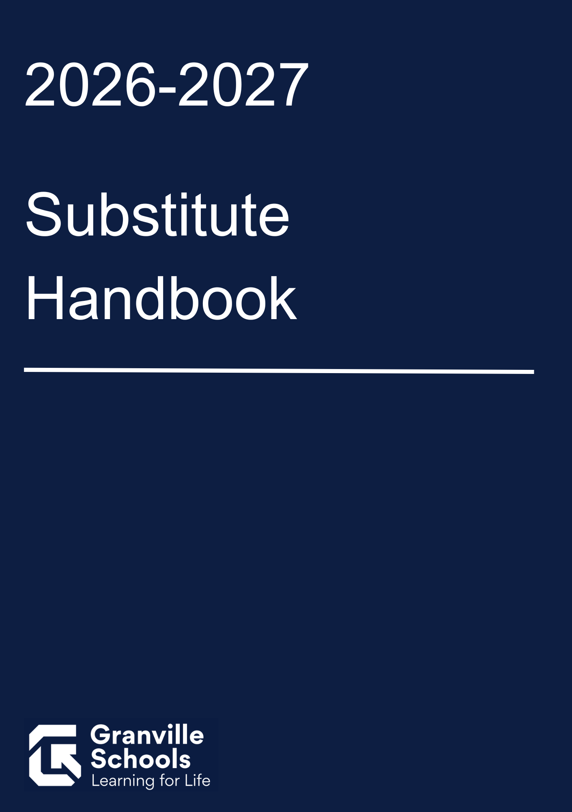



NONDISCRIMINATION AND EQUAL EMPLOYMENT OPPORTUNITY
The Board of Education does not discriminate on the basis of race, color, national origin, sex (including sexual orientation and gender identity), disability, age, religion, military status, ancestry, or any other legally protected category, in its programs and activities, including employment opportunities.
Revised (7/15/2024) Board Approved (07/2024), Revised (12/11/2024)(Revised 7/9/2025)(Revised 7/8/2026)

It is a pleasure to welcome you to the Granville Exempted Village School District as a substitute for Granville Elementary, Intermediate, Middle and High Schools.
The services you provide as a substitute are invaluable and essential to meeting the continued educational needs of our students. By agreeing to serve as a substitute, you accept the responsibility to abide by the policies, rules and regulations of the Granville Exempted Village School District as part of every assignment that is accepted.

Please read this handbook to become acquainted with the operation of the schools in our district.
Contact Information
General HR questions can be directed to Marie Kreger 740-587-8109 or mkreger@granvilleschools.org.

Questions about your SmartFind Express account can be directed to Marie Kreger at
740-587-8109 or mkreger@granvilleschools.org.

Questions regarding substitute assignments should be directed toward the individual buildings of each assignment

Payroll and Employee Access Center questions can be directed to Jaime Nesbit at
740-587-8119 or jnesbit@granvilleschools.org

Detailed information and specific questions regarding the hiring process can be directed to Brian Petrie, Director of Human Resources at 740-587- 8114 or bpetrie@granvilleschools.org.

Required Credential and Public School Works Training
In advance of being hired as a substitute by the Board, the candidate shall possess the appropriate license for their assignment through the State Board of Education.

Candidates with a valid professional teaching license are not required to hold a separate substitute teaching license

All substitutes hired by the District are considered temporary, at-will employees. All employees must complete assigned online training through Public School Works. Substitutes must complete all required training by September 30 of each school year. Substitutes hired after September 1 of any school year must complete the training series within 30 days of employment. This is an annual requirement. Compensation for the completed training will be $60.00 annually. (9/2024)

Safety and Security Plan
Each teaching staff member should provide the location of the school’s crisis folder.

Prior to the school day, the substitute shall review the contents of this folder to become familiar with specific information and protocols for the school and class including but not limited to:
- Lockdown Procedures
- Fire Procedures
- Severe Weather Procedures
- Evacuation Procedures

If you have any questions regarding emergency procedures, please speak with the building principal.

SMARTFIND EXPRESS
SmartFind Express is an automated substitute placement and management system provided by PowerSchool for K-12 school districts. SmartFind Express is the substitute calling system the Granville Exempted Village uses to place substitutes in the classroom. For a basic overview of the SmartFind Express Substitute Portal, select this link: GEVSD Substitute User Guide for SmartFind Express Mobile App.pdf

Attendance and Workday
Substitutes are required to arrive on time and remain in the building until the end of the workday (as listed in SmartFind Express) for that assignment. Arriving late or leaving early from an assignment could result in removal from the SmartFind Express system.

The substitute workday for teachers is 7 hours and 45 minutes including a 30 minute unpaid lunch break. Substitutes should remain on campus during the lunch period but will not have student supervisory responsibilities.

Appearance
All substitutes are expected to dress professionally. The dress is "Business Casual". It is generally easier to define what is not acceptable when defining work attire for employees. The following items are considered unacceptable for the school environment:
- Jeans
- T-shirts
- Sandals or other open-toed shoes

When considering professional dress, attire should in no way be distracting to the learning environment.
Substitutes who are scheduled to work in Physical Education Assignments are permitted to wear athletic attire, but should bring a change of clothes if the assignment changes after they have arrived at school.

Per Diem Rates (as of July 1, 2026)
To streamline the hiring process of future substitutes for the Granville School District all substitutes will be hired as teacher/aide/secretary.
All jobs that become available on SmartFind Express will be offered to you. If you choose to accept a substitute position as a teacher, you will be paid substitute teacher pay. If you accept a substitute position as an aide, you will receive substitute aide pay. If you accept an assignment as a substitute secretary, you will be paid substitute secretary pay. As a substitute, pay is based on the position you are covering, not the licensure that you hold.

Granville Exempted Village Schools per diem rates are as follows:
Nurse Substitute Full Day $145.63/day
Bus Driver Substitute $24.57/hour
Teacher Substitute Full day $145.63/day
Teacher Substitute Half day $72.82/day
Educational/Office/Clinic Aide $16.60 /hour
Secretary Substitute $19.20/hour

Long Term Substitute Teaching Assignment
As a long term substitute teacher, your pay for the first 20 days will be $145.63 per day. After 20 consecutive days of subbing in the same assignment, you may receive a pay increase to the daily rate of $255.49 If you miss any portion of a day within the first 20 days, your consecutive days start over at day 1. When you have reached 20 consecutive days please email Jaime Nesbit, Payroll Specialist (jnesbit@granvilleschools.org) to let her know. It is your responsibility to inform her of your 20th day in order for your pay to be raised.

Other Local Benefits for Long Term Substitutes including Medical Benefits
After 60 (non-consecutive) days of long-term employment in the same assignment, you are eligible to earn sick leave. In addition, if you begin your long-term assignment before April 1, you will be granted 1 personal day. If you begin after April 1, you are not granted any personal days. When you have reached 60 days please email Jaime Nesbit, Payroll Specialist (jnesbit@granvilleschools.org) to let her know. It is your responsibility to inform her of your 60th day so you can discuss sick leave.
Building Substitutes or Substitutes who serve 60 consecutive days in the same assignment are eligible for Medical Benefits through the District. The Open Enrollment period for these benefits will begin on the 61st day of work in the same assignment for long term substitutes and for, and the substitute will have 30 days to enroll. Coverage will begin on the first day of the month after the open enrollment period ends.
Example:
61st day of service – November 3rd
Enrollment Period – November 4th – December 3rd
Benefit Coverage Begins – January 1st

State Teacher Retirement System and School Employees Retirement System (STRS & SERS)

Licensed teachers are required to become members of the State Teacher Retirement System (STRS). Additional details regarding STRS are on the web at www.strsoh.org. Individuals who do not possess a teaching license are required to become members of the School Employees Retirement System (SERS). All required forms are included in the Granville Exempted Village Schools Payroll packet. Please reach out to Jaime Nesbit at jnesbit@granvilleschools.org regarding any questions.

Canceling Assignments
Substitutes may cancel jobs they have accepted if done prior to the cutoff time as listed for each building. Substitutes do not have the option to cancel jobs they have accepted if the cutoff time has passed.

If the substitute needs to cancel a job assignment after the cutoff time frame, the district SmartFind Express administrator must be contacted and the building secretary needs to be informed. The contact information can be found on the Granville Exempted Village Schools Building information page. A reason must be given to the SMARTFIND administrator as to why the job needs to be canceled. At the discretion of the Granville Administration, the SmartFind Express Administrator may deny the request and mark in the SmartFind Express system that particular day as a non-work day.

Lesson Plans, Academic Freedom and Controversial Topics

It is the duty of the substitute teacher to follow the lesson plan as provided by the teacher. If you are unable to locate plans, please contact the office immediately for further instruction. Creating or developing activities outside of the instructional goals of the lesson plans must be approved by the administrator in advance. Creation of activities and/or materials outside of the specific lesson plan are prohibited and constitute grounds for removal from the substitute pool.

Viewpoint Neutrality and the Parents’ Bill of Rights

All school staff members are expected to remain viewpoint neutral while working as an agent of the school district with the understanding that students, staff, and community members should not be informed or staff members' views on controversial topics either directly or indirectly during the course of their work or instruction in the district. While staff members do retain certain 1st Amendment rights as citizens, statements regarding controversial topics can often be a distraction to the learning environment whether those statements are made inside or outside of the classroom. Statements and conduct that create a distraction from the learning environment may be grounds for removal of a substitute from the pool.

In 2025, the Ohio Legislature codified Ohio Revised Code Section 3313.473, which states at its core, “A parent has a fundamental right to make decisions concerning the upbringing, education, and care of the parent's child.” Otherwise referred to as the Parents’ Bill of Rights, the bill’s primary components are as follows:

From Bricker Graydon Parents’ Bill of Rights Frequently Asked Questions June 23, 2025:

- Sexuality Content in Instruction: Districts are prohibited from including “sexuality content” in instruction in grades K-3. For grades 4-12, districts must ensure that sexuality content is age and developmentally appropriate and must provide a parent the opportunity to review content before instruction is provided and an opportunity to opt-out.
  - What is “sexuality content”?
HB 8 defines "sexuality content" as “any oral or written instruction, presentation, image, or description of sexual concepts or gender ideology provided in a classroom setting.”
  - Does HB 8 prohibit teachers from posting certain messages, flags and posters in their classrooms?

Because “sexuality content” could be determined by the recipient or observer of the message, speech, or image, staff members should exercise great care in the display of images, flags, and posters as they may be considered a form of instruction that is not incidental and thus subject to the provisions of HB 8.

For substitutes in particular, it is important to notify the building principal of any information related to an interaction with a student that may initiate the requirements of the bill as outlined above.

- Prompt Notification to Parents in Certain Circumstances: Districts are required to promptly notify parents of a substantial change in a student’s services, monitoring related to the student's mental, emotional, or physical health or well-being or the school's ability to provide a safe and supportive learning environment for the student.

For substitutes in particular, it is important to notify the building principal of any information related to an interaction with a student that may initiate the requirements of the bill as outlined above.

- Prohibited Conduct: District staff are prohibited from: 1) directly or indirectly encouraging a student to withhold information from a parent concerning the student’s mental, emotional, or physical health or well-being; and 2) discouraging or prohibiting parent notification of and involvement in decisions affecting the student’s mental, emotional or physical health or well-being.

For substitutes in particular, it is important to notify the building principal of any information related to an interaction with a student that may initiate the requirements of the bill as outlined above.

- Notification Requirement and Consent for Services: Districts are required to notify parents of physical, mental and behavioral health care services and the option to withhold consent or decline services.

For substitutes in particular, it is important to notify the building principal of any information related to an interaction with a student that may initiate the requirements of the bill as outlined above.

- Parent Concern Procedure: Districts are required to develop a “parent concern” procedure.

For substitutes in particular, it is important to notify the building principal of any information related to an interaction with a student that may initiate the requirements of the bill as outlined above.

Staff Ethics, Political Expression and Campaigning on behalf of an individual or issue
All school staff members are prohibited from using their position to campaign for or against an individual or ballot initiative or using their position to attempt to incur financial gain. This includes both direct and indirect methods of communication for or against an individual candidate or ballot initiative. The following are a list of behaviors that are expressly prohibited while working as a substitute as a part of a district program or activity
- Wearing any form of accessory or apparel that represents a political cause, action, or candidate.
- Discussing a political campaign related to upcoming election or ballot issue with students unless it is included in an approved lesson plan provided by the staff member that the substitute is replacing.
- Distributing information, literature, or any other material promoting a business, political campaign, or issue.

Exclusion

SmartFind Express has a built-in survey that can be utilized and a ranking system for the employees to evaluate the substitute's performance. If there is a violation that needs to be reported immediately, the building administrator will be informed.
If a substitute does not fulfill his/her job duties and district expectations, there is a substitute evaluation form within SmartFind Express.
The form is filled out by the teacher and will report any infractions to the principal. All violations will be reported to the district office and exclusion from the classroom will be accomplished from the administrator of SmartFind Express at the direction of the GEVSD Administration.
Substitutes can be excluded from a building due to offenses they committed during the course of the day. Administrators reserve the right to exclude substitutes from an individual teacher's classroom, grade level, or the entire building. Substitutes who are excluded from two settings may result in being excluded from the entire district.
Depending on the nature of the offense, a substitute may be excluded from the entire district immediately.
Exclusion from the SmartFind Express system may result from offenses including but not limited to the following:
•Job Shopping.
• Accessing the SmartFind Express system during the workday (phone, computer, Jobulator, etc).
• Using computers during work time for any purpose other than the classes being taught.
• Answering cell phones during class time.
• Leaving the building during work hours without permission from the building principal.
• Leaving the classroom you are responsible for unattended.
• Behaving inappropriately towards students and/or staff members.
• Deviating from or modifying content presented in the lesson plans
• Incorporating controversial topics in instruction that are not part of an approved lesson plan.
• Violating student confidentiality regulations and laws by sharing protected information with an individual other than those that have a direct instructional relationship or responsibility with the students

Parking
We ask that you park in the employee's spot for which you are subbing. However, if the person you are subbing for is at school that day, you will need to park in a visitor's spot. Parking assignments for each building can now be found in SmartFind Express.

Job Shopping
When a substitute accepts a job in the SmartFind Express system, it is expected that they will report for that assignment. Choosing to cancel an assignment in order to accept another assignment is considered job shopping and is not an acceptable practice.
Please be advised that if you are found job shopping within the SmartFind Express system, you may be excluded as a substitute from a building, several buildings, the district or the SmartFind Express system as a whole. This statement should be considered the first warning.

SmartFind Express Account Responsibility

The SmartFind System uses Granville Digital Identity District Credentials for sign in through a Single Sign On. If you are having difficulty accessing your account, please contact our Technology Department.
Substitutes in the SmartFind Express system are prohibited from accessing the SmartFind Express system to look for available jobs while currently working an assignment within the district. This statement covers all hours of the day associated with the job assignment.

Each substitute’s SmartFind Express password and ID are their responsibility and should not be shared with anyone (ie. spouse, friends, parents, etc.). Passwords and ID's are not permitted to be used by anyone other than the hired substitute employee to access the account information to log on the system to obtain assignments.

Please be advised that if the employee's account shows activity during working hours, the substitute may be excluded from a building, several buildings, the district or the SmartFind Express system. This statement should be considered the first warning.

School Delay/Closing Information and District Websites
If the Granville Exempted Village Schools are on a delay, report for your job assignment at the appropriate time after the delay. If the Granville Exempted Village Schools are closed, do not report to work.
In case of inclement weather please check on the following sources for school closing updates:

https://granvilleschools.sfe.powerschool.com/homeAction.do
www.qranvilleschools.org
Local radio stations Local television stations
Facebook

The Granville Exempted Village Schools also subscribes to a service (School Messenger) that will contact you by telephone to inform you of any changes in the status of the Granville Schools during inclement weather.

Substitutes are paid for a full day when the district has up to a 2-hour delay, but are not paid on days when schools are closed. Payment for a full day assignment is applicable to those individuals scheduled to work a full day prior to any form of early release being announced.

Evaluation
A building principal, under whom you serve, may observe and evaluate a substitute's work performance to determine whether or not to re-employ the substitute. A feedback mechanism is available in SmartFind Express for both substitutes and teachers to complete an assessment from their viewpoint for each job assignment completed. Please log into SmartFind Express to complete this assessment after each assignment.

Continued Employment
Substitute teachers are employed on a day-to-day basis by the school district. There is no contractual agreement for employment between a substitute teacher and the School Board beyond the day's assignment for which the substitute is called and for which he/she agrees to work.

Please note: Feedback from building principals and classroom teachers regarding your classroom performance may serve as a factor in future substitute employment decisions.

School District and Building Contact Information
Granville Exempted Village Schools District Office
130 N. Granger Street
Granville, Ohio 43023
Brian Petrie Director of Human Resources
Email: bpetrie@granvilleschools.org
740-587-8114

Granville Elementary School
310 N. Granger Street
Granville, Ohio 43023
740-587-8102
Principal- Travis Morris
Secretary- Brennan Kellett
Start time: 8:10am End time: 3:55pm
Cut off time: 1 hour before an assignment starts

Granville Intermediate School
2025 Burg Street
Granville, Ohio 43023
740-587-8103
Principal- Tracie Lees
Secretary- Janine McCullough
Start time: 8:00am
End time: 3:45pm
Cut off time: 1 hour before an assignment starts

Granville Middle School
210 New Burg Street
Granville, Ohio 43023
740-587-8104
Principal- Lisa Ormond
Secretary- Jody Overholt
Start time: 7:15am
End time: 3:00pm
Cut off time: 1 hour before an assignment starts

Granville High School
248 New Burg Street
Granville, Ohio 43023
740-587-8105
Principal- Scott Hinton
Secretary- Lori Browning
Start time: 7:20am
End time: 3:05pm -Cut off time: 1 hour before an assignment star
Sub Expectations
- Arrive early to the building and be in the classroom before the students.
- Familiarize yourself with the school's safety and emergency plans and procedures.
- Keep all information regarding students confidential
- Be positive, enthusiastic, flexible and respectful to all students in words and actions.
- Keep a Sense of humor and expect to be challenged.
- Report any accident/injuries to the office immediately.
- Park in the appropriate parking lot/space (ask a building secretary).
- Report to the building secretary upon arrival.
- Familiarize yourself with the school- obtain a map.
- Inquire about lunch/recess duty, end of day duties.
- Familiarize yourself with crisis plan and fire drill information.
- Write your name on the board.
- Consult with neighboring teachers with questions.
- Organize materials to be used during the day.
- Check equipment that will be used to ensure it is working properly.
- Begin class and have activities ready as soon as students arrive.
- Check procedure for reporting attendance and lunch counts.
- FOLLOW THE TEACHER'S LESSON PLANS AS CLOSELY AS POSSIBLE.
- Supplement with other activities only after assigned work is done.
- Inquire about school rules concerning hall/restroom pass.
- Collect the students work- Organize, label & secure with paperclip/rubber band
- Leave a detailed note for the teacher including completion of the lesson, list of absent students, and incidents you want to share with the classroom teacher.
- Return the room to the condition it was in when you arrived.
- Stay until the end of the school day. Refer to the start/end times for each school on SmartFind Express.
- Stop in the office to clock out, if necessary.
- Do not distribute treats/candy.
- Do not rearrange the teacher's desk.
- Do not leave students unattended.
- Do not dispense medication to students. Please send the student to the nurse.
- Do not use corporal punishment, touch a student or physically threaten them.
- Do not order a disruptive student from the room. Request assistance from the front office.
- Do not allow an ill student to go to the nurse alone. Ask another student to escort the ill child to the office.
- Do not keep students after class or after school.
- Do not let any student leave class/school early unless the office requests you to do so.
PLEASE REMEMBER!!!
WHENEVER YOU ARE SUBSTITUTE TEACHING AND ARE UNSURE OF WHAT ACTION TO TAKE, ERROR ON THE SIDE OF CAUTION. CONTACT A TEACHER, BUILDING SECRETARY OR BUILDING PRINCIPAL FOR GUIDANCE.

