A Peek at our Week
Mrs. Bird
Monday, September 14 – Friday, September 18, 2026
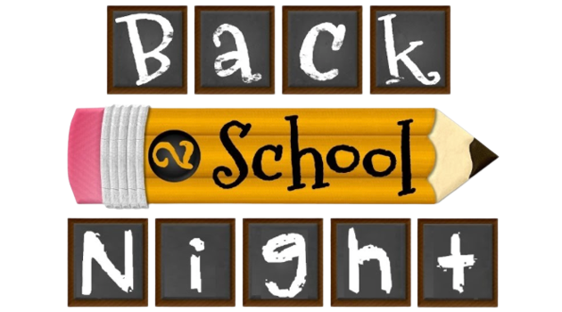
*Back to School Night is this Thursday, September 17th! I look forward to meeting you!
*Picture Day is Monday, September 21st!
WORD WALL WORDS: flock, blend, they, one, said
Please practice reading and spelling these words each night!
Homework Schedule
Monday  *Spanish & Health/Gym* | Tuesday  *STEAM& Health/Gym* | Wednesday  *Art* | Thursday  *Health/Gym* | Friday  *Music & Health/Gym*  Library Visit Biweekly
Math: Additional Practice 1.4  Reading: Log | Math: Additional Practice 1.5  Reading: Log | Math: Additional Practice 1.6  Reading: Log | Math: Additional Practice 1.7  Reading: Log | Have a wonderful weekend!
Taking a Closer Look…
- Math: We will continue Topic 1 on strategies to fluently add and subtract within 20.
- Social Studies: We will continue our first unit on communities. We will create a trifold poster to illustrate urban, suburban, and rural communities.
- Reader’s Workshop: We will practice what “good readers do” when actively reading a book. Students will pay close attention to the characters, setting, problem, and solution in their books.
- Writer’s Workshop: We will launch our first writing unit called, Making Small Moments Big. Students will begin the process of writing personal narrative “small moment” stories.
- Fundations: We will complete Unit 1 in our Fundations program. We will practice when to use C, K, or CK in words. We will also learn about closed syllables. Our first test is scheduled for Friday!

**Remember to have sneakers for gym class!**

