Canford Sports Centre - LeisureHub User Manual
Webpage: https://sportscentre.canford.com/book/identity/login?signin=d8342742a1d2009f5c7e6eda2c83b913

Registration
Members and non-members need to register to use LeisureHub for online bookings and a variety of other online functionality.
People who already have a membership with us, will need to register with the same email address that they have listed in their membership account, for the account to match and be created.
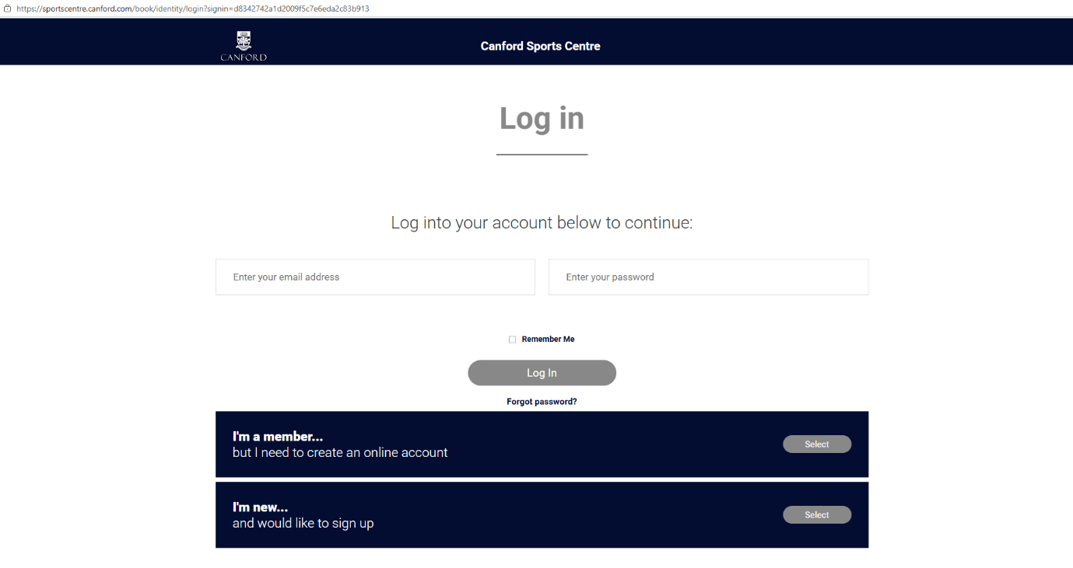
From the login page, existing registered Leisure Hub users can login or retrieve a forgotten password.
Non-registered users have two register options:
- I’m a member… but I need to create an online account – This option is for existing members who do not have a LeisureHub account. This will link their new LeisureHub account to the existing Canford Sports Centre membership record.
- The information you provide for LeisureHub will be used to match your existing Canford Sports Centre membership account. Only if you enter the information exactly as it is in your membership account will you be able to link your newly registered LeisureHub account.
- I’m new… and would like to sign up – This option is for customers who are non-members and new to Canford Sports Centre. This option will create a LeisureHub account that will enable online booking.
Activation emails will be automatically sent to the customer – and you must click on the activation link within 24 hours to activate your LeisureHub account
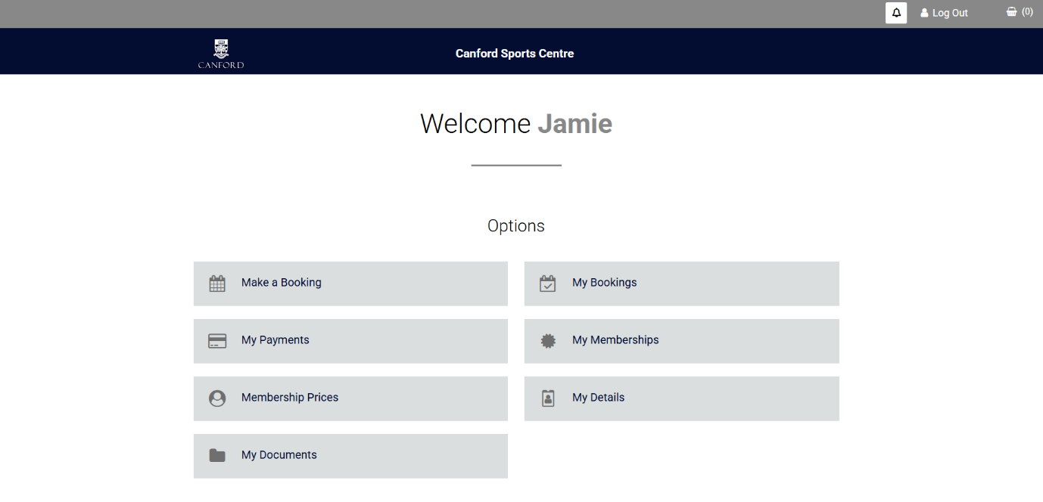
My LeisureHub Homepage
- Make a Booking – this is where you can book sessions and classes
- My Bookings – see historical and future bookings made
- My Payments – see receipts from previous bookings and payments
- My memberships – information on current and historical memberships
- Membership prices – all available memberships that can be purchased online
- My details – view and edit personal details i.e. address
- My documents – information on terms and conditions for memberships and bookings

Online Booking
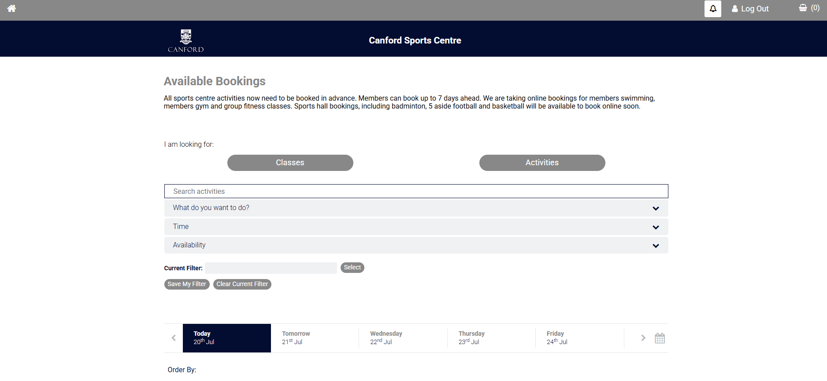
There are various search filters that can be used to identify specific sessions; this includes activity type, date and time.

Bookable sessions are then shown with detail of location, time, duration, spaces and cost. There is also an ‘I’ button that gives more information about each session.
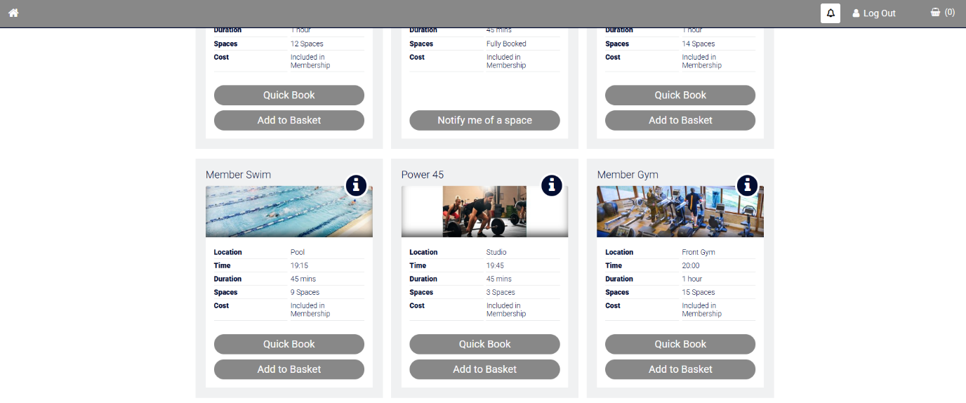
You can then select your activity to book:
- If a session is full you can choose to be notified on when a space becomes available. This will notify all people that select this and that space will be filled on a first come first serve basis.
- Add basket allows you to add multiple activities to your basket, to book at the same time.
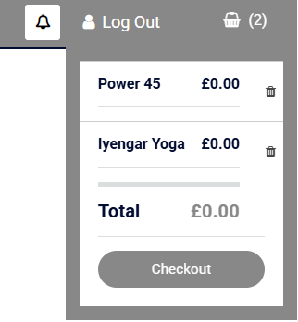
Add to basket:

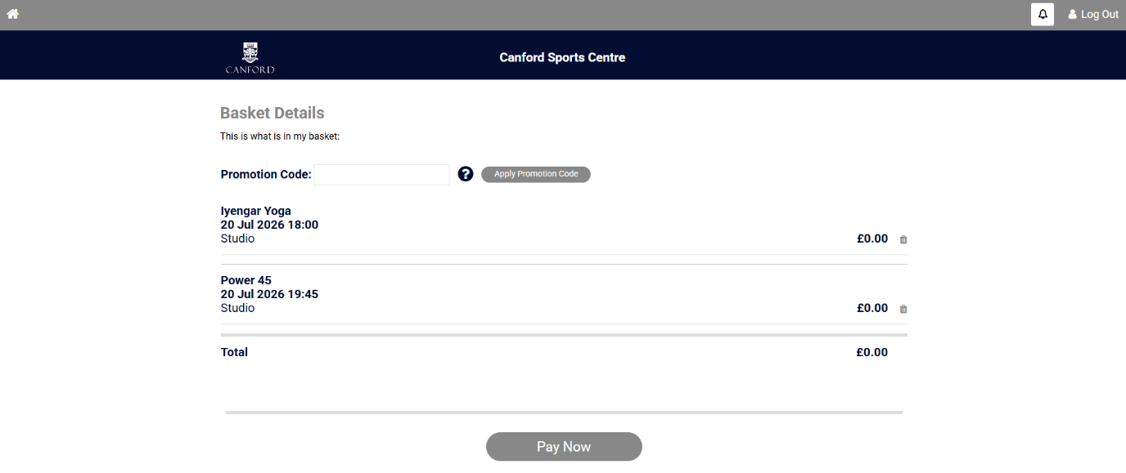
Once in the basket, you can then checkout
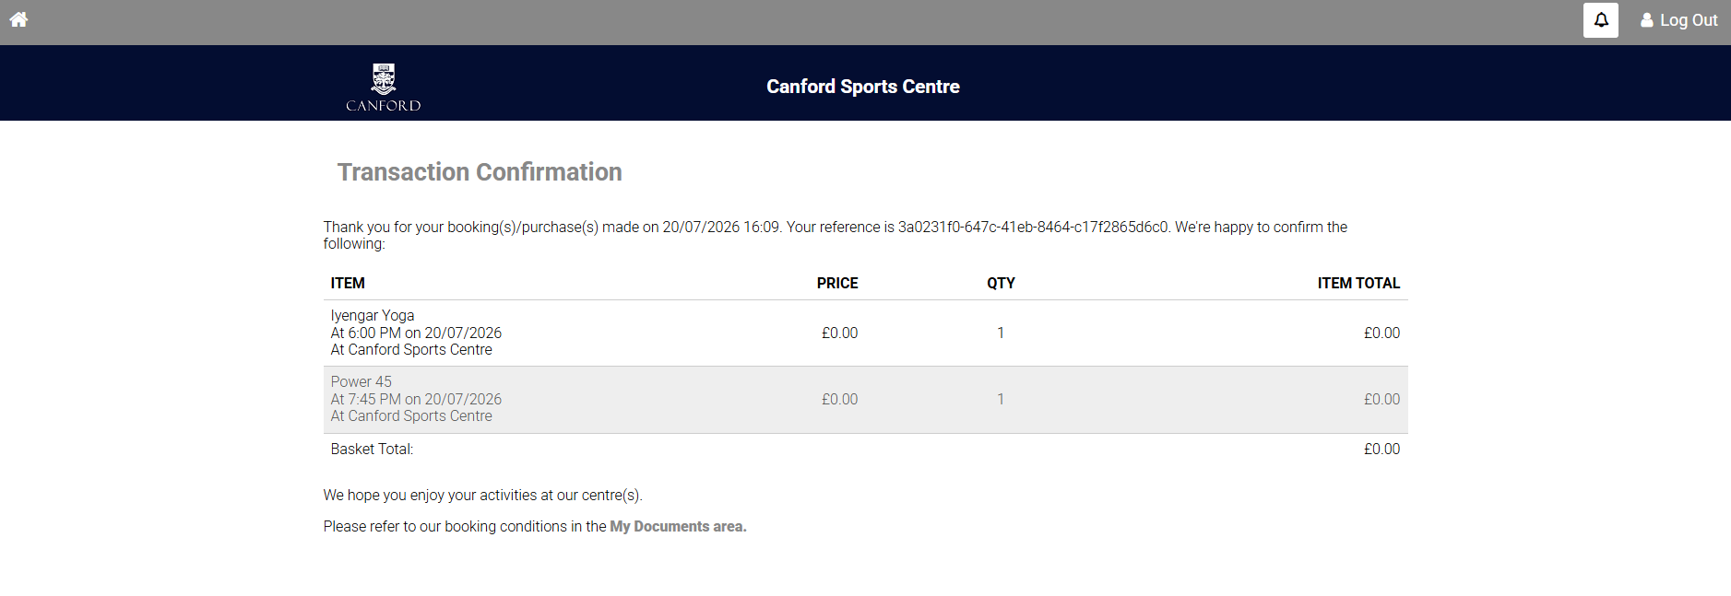
Click ‘pay now’ and this will take you into the payment portal. Some sessions will require payment if they are not included in a membership or for non-members. For sessions that are included in a user’s membership, the checkout process is complete after this.
For bookings with no payment attached, clicking ‘pay now’ will confirm your booking and take you to the ‘transaction conformation’ page. This is confirmation of the booking being completed and will confirm the date and time of the booking.
If a booking requires payment, clicking ‘pay now’ will result in a further step before confirmation show below:
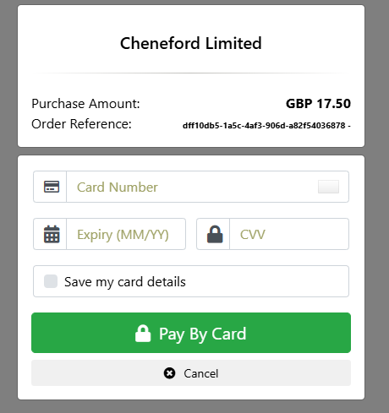
Enter your card details into the relevant boxes and select ‘pay by card’ to complete the transaction. This will then take you to the ‘transaction confirmation’ page shown previously.

Quick Booking
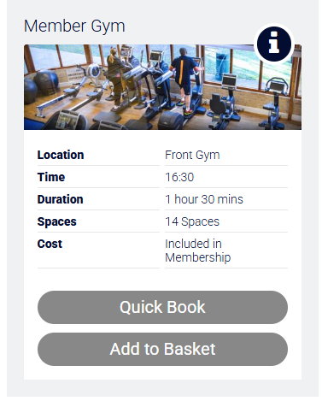
A ‘Quick Book’ button will become available if the activity is included in your membership and free to book and is not already in your basket. Using the ‘Quick Book’ button will allow members to book a zero-cost session without going through the checkout process.

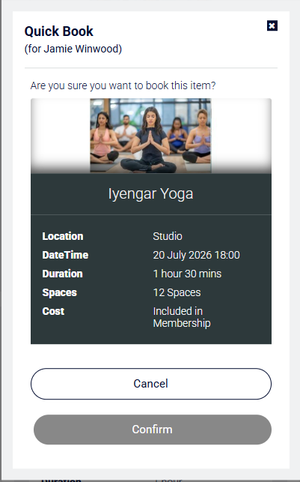
The ‘Quick Book’ button will only appear to members that are logged into the LeisureHub and have the required membership level for the session to be zero-cost.
Clicking ‘Quick Book’ will launch this popup.
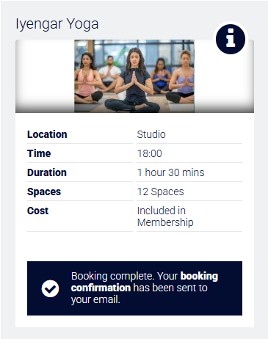
The booking terms and conditions will need to be agreed to before the member can confirm the booking. The terms and conditions will only appear if the member hasn’t already previously accepted the current active terms and conditions. If in a scenario where the person hasn’t already accepted the latest version of the terms and conditions, they will appear and can be reviewed.

Selecting ‘Confirm’ will book the activity for the member. A conformation message will appear on the activity tile, and an email will be sent to the member’s email address

Rebook or cancelling bookings
Go to ‘My Bookings’ on your LeisureHub home page, see below the options to rebook or cancel previously booked sessions.
