MECHS SIT TEAM MEETING Agenda/ Minutes
August 31, 2026 3:30 - 4:30 p.m.
In attendance: Erin Long, Eric Blackman, Josiah Johnston, Carrie Lee Hoffman, Melissa Sluder, Courtney Filiss, Tenoch Palafox, Ella Hoffman, Ami Conate, Sophia Sluder
Not Present: Mackenzie Moylan, Aiden Potter, Ace Carter
Regular Business:
- Welcome and introductions; thank you for serving–students, parents, and staff!
- What is SIT? What is SIP?
  - SIT: School Improvement Team–Stakeholders in the school who help principal make decisions about how to best serve students.
  - SIP: School Improvement Plan. Establishes goals that are worked toward school-wide –shared at this meeting. 
Q: What is the School Improvement Team?
A: School Improvement Teams are required by North Carolina law to develop school improvement plans. The team is comprised of the principal of each school, representatives of the assistant principals, instructional personnel, instructional support personnel, and teacher assistants assigned to the school building, and parents of children enrolled in the school. The representatives are elected by their respective groups. The General Assembly of North Carolina views parental involvement as a critical component of school success and positive student achievement. It is the intent of NC that parents, along with teachers, have a substantial role in developing school improvement plans. [NC General Statutes �115C-105.27]. Madison County Schools encourage and endorse shared decision making as evident in our mission statement, Core Values and various policy directives. You are all important stake holders; we serve as a sounding board for school improvement ideas and the school improvement plan. Confidentiality and Bylaws- Reminder that we occasionally work with personally identifying information, test scores, etc. that should not be shared outside of these meetings!
- Set dates for SIT Meetings for the year: 4th Mondays each month. Next meeting is 9/28
  - Q: What if a meeting gets snowed out? A: We will meet the following week if possible
- PD/PLC Calendar– Theme: One Drop of Water–The Ripple Effect, Global Resilient Leaders
Instructional coaching and dates to remember:
  - Sept 23rd–required work day Morning: MECHS PLC/ PD–Global Leaders (led by GL Committee) & WNC Resilience Project Update (Johnston/ Long) and Afternoon PLCs – Content Areas/ Global Leader Hub coursework
  - Year-long – Resilience Training by OpenWay Learning (Johnston, Long, Young) and Global Leaders Committee Meetings (Participate/ GearUp)
    - Global Leaders Professional Development: 100% participation! All staff will get on the Participate Learning Hub and complete coursework, receive badges, and engage in monthly planning period PLCs with Blackman and Young. April 16, 2027 is the deadline for all HUB work/ badges/ stipends.
- Global Leaders Community Night/ Open House– (Oct. 13, 3:00 - 5:00pm) Community partners/ agencies will have tables to share information about services and volunteer needs.
  - Report card pickup. Food by GearUp. Volunteer hours for students. We need to advertise and invite community/ businesses (Young/ Global Committee)
- Clubs- Start September 18 Friday Activity/ Club Schedule 9:30 - 10:15 a.m.
- Homecoming–9/11 and Spirit Days 9/4 - 9/11
  - Friday 9/4 Super Heroes and Villains
  - Tuesday 9/8 Student/ Teacher Swap
  - Wednesday 9/9 Country Club v Country
  - Thursday 9/10 Decades Day
  - Friday 9/11 Red, White and Blue HOMECOMING! There is a dance at MHS after the game–tickets on sale at MHS
- NHS (Long) We had our first meeting Friday 8/28. Elections will be held at the next meeting on 9/11.
- Student Government (Wallin, Harrison, McGuire) Elections were held on 8/28
  - Brayden Walker (President), Gianna Hill (VP)
- Service Opportunities–many!
  - Community Collaboration! CHC (Sarah, Anna, Julie, Erin), Teens of Mad Co (TMC–Aine), PAGE (Maia), Interact (Rotary), MHS Carpentry (Mr. Sams), Bonners Scholar (Nick)
    - TMC is heading a team for the Great Litter Sweep Sept 12 - 26, big push on last day 9/26! The team will share any $ won for our agencies ;). See Aine Brown if you have questions.
    - 1st CHC Youth Advisory Council (YAC) Meeting is 9/24 at MECHS; will discuss litter sweep & other projects then; everyone is invited. BIG End of Year Community Field Day is being planned. Future meetings at CHC last Thursdays of each month
    - Sat., 9/19 and Sat, 10/3 Neighbors Helping Neighbors (Anna) Service Days with CHC.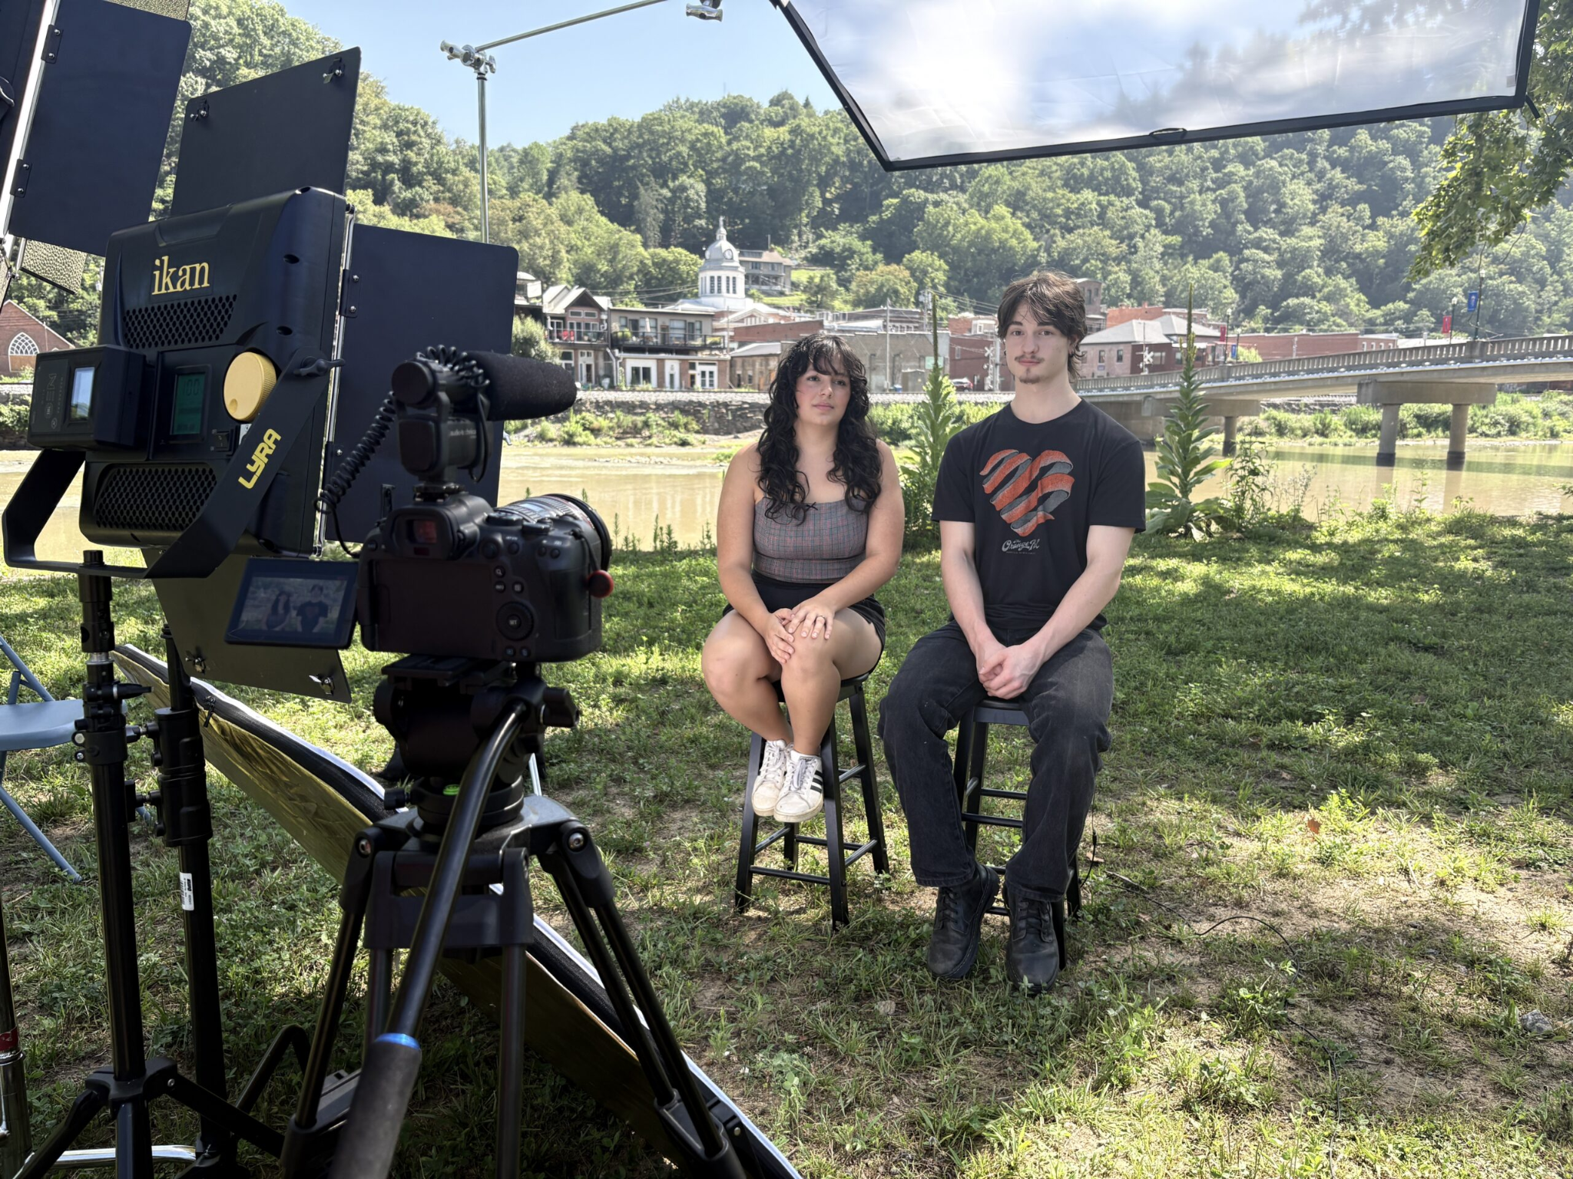 Youth Advisory Council MEHCS Students Community Voices – Oral History/ Documentary featuring our Aine and Matthew L.
  - 9/25 Imagination Library donation drive/ share freshmen Dolly Essays (NHS/ Student Gov’t/ Freshmen)
  - If $ donations involved, speak to Mr. Blackman ahead of time.
  - FFA 5 K on 10/10–support MHS
  - 10/31 Halloween– NHS
    - sophs/ junior–MMS and seniors–downtown
  - NHS– community involvement and Student Government — school functions
    - These groups do a lot for our school/ community; they plan to work on projects in harmony
  - Future Idea: Campus Garden
Ideas for spreading the word about volunteer opportunities:
  - Newsletter?
  - MECHS Webpage (Ryan)
  - MECHS FB/Instagram (Julie and Amanda)
  - Community board upstairs at MECHS
  - Student Gov’t at MECHS insta page (Brayden, Student Body President)
  - NHS page (Officers TBD)
    - Remind students that this gets them service hours for graduation
- Trailblazer Trips (Johnston)
  - River snorkeling 9/11
  - Camping 9/12
- Extra credit Romeo and Juliet Montford Park Players in Asheville (September evenings) – with a vampire twist– no bus is going from MECHS, but ENG teachers offering extra credit if students take a selfie at the play.
  - ENG teachers will be at the play on Friday night, 9/18. Students must have their own transportation and parent permission; it is not a school-sponsored trip.
- Pre-ACT Date (sophomores only): October 15. Still a regular school day for all other MECHS students. The date and schedule will correspond with MHS schedule to accommodate dual-enrolled students.
  - Upstairs teachers will administer the test. Downstairs teachers will maintain a quiet school atmosphere with student work and Global Leader activities during the pre-ACT.
  - ACT Prep coming soon throughout the school / Boot Camps– different content areas will share the load with brief warm ups. Thanks to GearUp for the materials!
- Attendance–
  - Celebrating our kids: previously done awards for attendance and A/B Honor Roll. But we need a detailed study/ campaign (NHS, Student Gov., GL project?); what do other schools do that have good attendance?
  - Can be tied into Global Leadership–future employers look for folks who SHOW UP consistently and don’t check out early.

CLOSING DISCUSSIONS, PROPOSALS, DECISIONS and “HOMEWORK”:

  - Growth and A level school is the goal–we plan to exceed growth this year!

Meeting Adjourned 4:17pm
Next meeting is 9/28 @ 3:30 p.m.

