

Set Up Procedures for Student Meal Magic Lunch Card

(Best done on a computer for setup)

- Click on link: https://fscdubourg.familyportal.cloud/
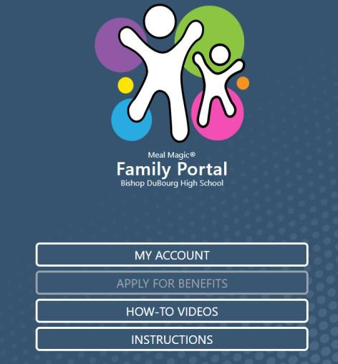
- Click on “My Account”.
Returning Students
You should only have to update your Passphrase. If that does not work, please refer to the step-by-step procedures.
- Then click on “I need to Register as a Family Portal User”.
- Type in the email address connected to the Meal Magic account.
  - This will be a parent’s email address.
  - Only one parent’s email address was provided, so if one parents does not work, try the second parent’s email address. It must match what the school has on file.
- Click “Next” at the bottom.
- You will be taken to the “Terms of Use” page.
- Read and click “Accept” at the bottom.
- You will be taken to the “Privacy Policy” page.
- Read and click “Accept” at the bottom.
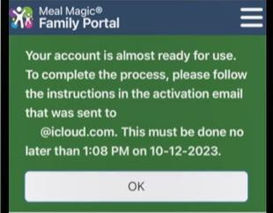
- At this point, you will get a message that says an activation email was sent to you.

- Click “Accept”.
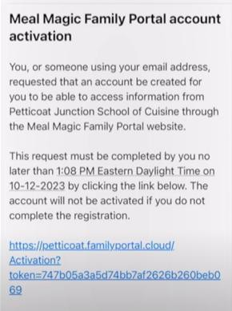
- Open your email and you will see an email similar to the one below.
NOTE: You should see the email in your inbox right away.
- Click the link in the email.
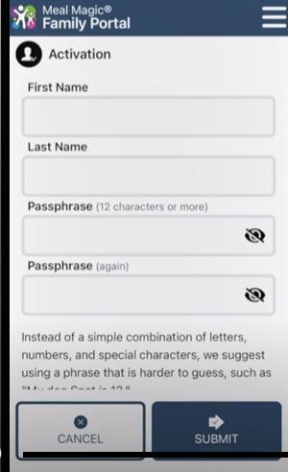
- You will be redirected back to Meal Magic and you will get a screen like this.
- Enter your name (Parent Name).
- Create a PASSPHRASE and confirm it again.
- Click “Submit”.
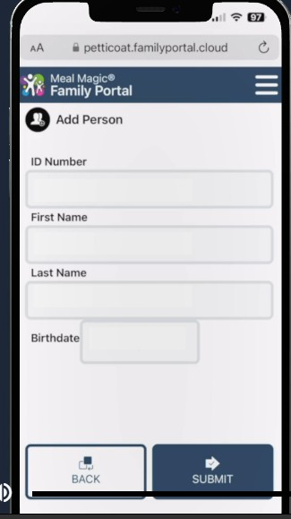
- You will now add your STUDENT information on a screen like below.
- Your STUDENT ID number is a combination of the Food Service Consultant identifier and also your student’s ID number.
  - For Bishop DuBourg, the Food Service Consultant identifier number is 102.
  - If you do not know your student’s ID number, it is located on “Family Access” under “Student Info” and is shown as “Other ID” (under the student photo).
  - Combine the two numbers. For example: 102300099.
  - Enter the student first and last name.
  - Enter the student’s birthdate.
  - Click “Submit”.
NOTE: The students name must match what is showing in Skyward (Family Access). If your name is hyphenated in Family Access (Smith-Jones), it must be the same way on Meal Magic.
- You should now see your student’s name. If you have multiple children at Bishop DuBourg, simply click on “Add Person” and repeat STEP 17.
- You can now add money to your student’s lunch account two ways.
  - First Way
    - Click on “Deposit”
    - Enter the amount you want to deposit
    - Click “Checkout”
    - Click on “Credit Card” and enter the payment information (Meal Magic charges a fee for adding money via a credit card)
    - Click “Pay”
  - Second Way
    - Bring in cash or check and put in envelope found in the main office and it will be given to the cafeteria that morning.
- Click on “Notifications”.
- Here you can set a notification to email you when your child’s lunch balance falls below a certain level.
If you have questions, you may reach out to:
Katrina Brazil – Cafeteria Supervisor – 102manager@foodserv.org
Kate Hageman – Student Account Specialist – kate@foodserv.org

