

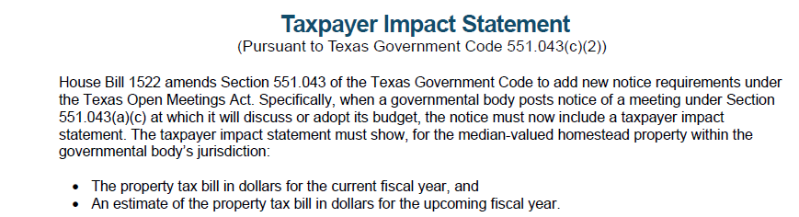
This requirement is intended to increase transparency by allowing taxpayers to see how proposed budgets
may directly affect their property tax bills.

