How do I pay student fees in the Givebacks app?
Paying student fees is quick and easy through the Givebacks App. Whether your email address is already associated with a student or not, this guide walks you through each step.
If your email address is already associated with a Student:
Step 1: Open the Email Invitation from Givebacks
• You’ll receive an email from Givebacks letting you know you’ve been invited to access student fees.
• Tap "Pay Now" in the email.
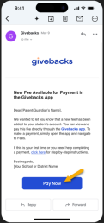
• You’ll be directed to your phone’s app store to download the Givebacks App.
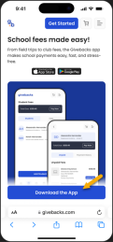
Step 2: Download and Launch the App
• Tap Download or Install in the app store.
• Once the download is complete, open the Givebacks App. 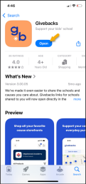
Step 3: Create or Confirm Your Account
• The app will recognize your email since it is already on file with the school.
• Choose to Create Account (if new to Givebacks) or Sign In (if you've used Givebacks before).
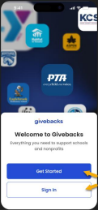
• Confirm or set your password and tap Continue.
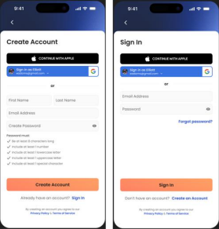
Step 4: Access the “You’re Already Connected” Screen
• After a Welcome Screen, you’ll land on a “You’re already connected" screen showing the organizations you are connected to.
• Select the “Visit the fees page” button to access your student fees. 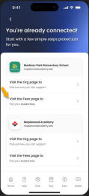
• If you don't see your organization presented, select “Explore More Actions” to find another organization. You'll be prompted with a few questions to help us better guide your app experience.
Step 5: Select Your Student Profile
You’ll be shown the student(s) associated with your email.
• Tap your child’s name to view their profile and fee details.
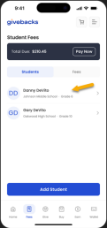
Step 6: Pay Your Fees
You’ll see a list of fees assigned to your student—such as device insurance, club dues, or class fees.
• Tap Add to Cart on any fee item you'd like to pay.
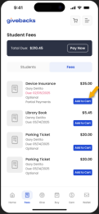
• Once ready, proceed to checkout. Follow the prompts to enter payment details and complete your transaction.
Step 7: Confirmation
You’ll receive a confirmation of your payment both in the app and by email. You can always return to the Fees screen to view your fee history and Wallet Tab to access receipts.
If your email address is not yet associated with a Student account:
If you didn’t provide your email address to your school or it isn’t recognized by Givebacks, don’t worry — you can still pay student fees by selecting your organization and manually adding your student.
Step 1: Download and Launch the Givebacks App
• Download the Givebacks App from the App Store or Google Play. • Open the app once installed.
Step 2: Create an Account or Sign In
• Choose Create Account if you're new to Givebacks.
• If you already have an account, click Sign In and enter your email and password.
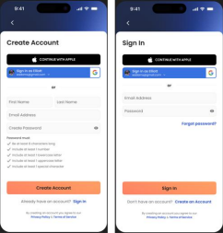
Step 3: Tell us Why You're Here & Select Your Organization
After signing in, you’ll be prompted to tell Givebacks what you’re trying to accomplish.
• You can select from a list of actions that you wish to complete in the app. This will help us personalize your onboarding.
• Select all that apply.
• Click Continue.
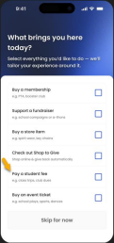
Next, you’ll be asked to choose the specific causes or schools you support. • Browse or search by name or location.
• Select your school or organization by clicking Follow & Continue. 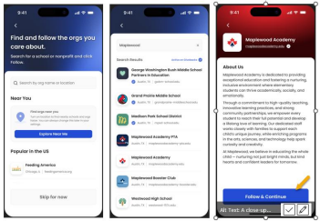• Add another organization or click Start Supporting to finish onboarding.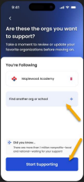
Step 4: Navigate to the Student Fees Section
• From the “Your Personalized Start” screen, tap the Fees tab or look for the Visit Fees Page.
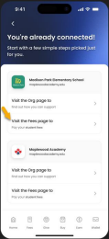
• If your account isn’t linked to any students yet, you’ll see an option to Add Student.
Step 5: Add Your Student
To pay fees, you must link your student account.
• Click Add Student.
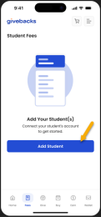
• Fill in the student’s:
o First Name
o Last Name
o Student ID (provided by the school) • Click Add Student.
If the information matches a record from the school, you’ll see a success message: “Student Added.” Once added, the student’s fees will automatically appear under their name.
Step 6: Pay Your Fees
• Select the student and review their listed fees.
• Tap Add to Cart next to each item you'd like to pay.
• Proceed to checkout and enter your payment details.
Step 7: Confirmation
After completing payment, you’ll receive:
• An in-app confirmation screen
• An email receipt
• Access to purchase history from the Wallet or Fees tab
Questions? Click the "?" icon to contact Givebacks Support.

