 | September 1 | September 2 | September 3 | September 4
 | Chicken Nuggets  & Fresh Voyageurs Bread  French Fries  Fruit Choice & Milk Choice | Chicken Nuggets  & Voyageurs Bread  French Fries  Fruit Choice & Milk Choice | Grilled Cheese  Tomato Soup  Fruit Choice  Milk Choice | Happy September Birthdays!  Pizza  Broccoli  Fruit & Milk Choice  Cookie
September 7 | September 8 | September 9 | September 10 | September 11
No School Today | Tacos with Meat & Cheese  Refried Beans & Salsa  Fruit Choice  Milk Choice | Chicken Patty on a Bun  Mixed Veggies  Fruit Choice  Milk Choice | Pancakes & Scrambled Eggs  Tater Tots  Fruit Choice  Milk Choice | Bosco Sticks with Sauce  Carrots  Fruit & Milk Choice  Mini Rice Krispies
September 14 | September 15 | September 16 | September 17 | September 18
Domino’s Pizza  Green Beans  Fruit Choice  Milk Choice | Popcorn Chicken  & Fresh Voyageurs Bread  Mashed Potatoes & Gravy  Fruit Choice & Milk Choice | Chicken Alfredo  Broccoli  Fruit Choice  Milk Choice | Soft Pretzel & Cheese Curds  Carrots  Fruit & Milk Choice  Ice Cream Cup | Chicken Wings  & Fresh Voyageurs Bread  Baked Beans  Fruit Choice & Milk Choice
September 21 | September 22 | September 23 | September 24 | September 25
Mini Corn Dogs  Carrots  Fruit Choice  Milk Choice | Nachos with Meat & Cheese  Corn & Salsa  Fruit Choice  Milk Choice | Local Hamburger on a Bun  Broccoli  Fruit Choice  Milk Choice | Waffles & Scrambled Eggs  Tater Tots  Fruit Choice  Milk Choice | No School Today
September 28 | September 29 | September 30 | 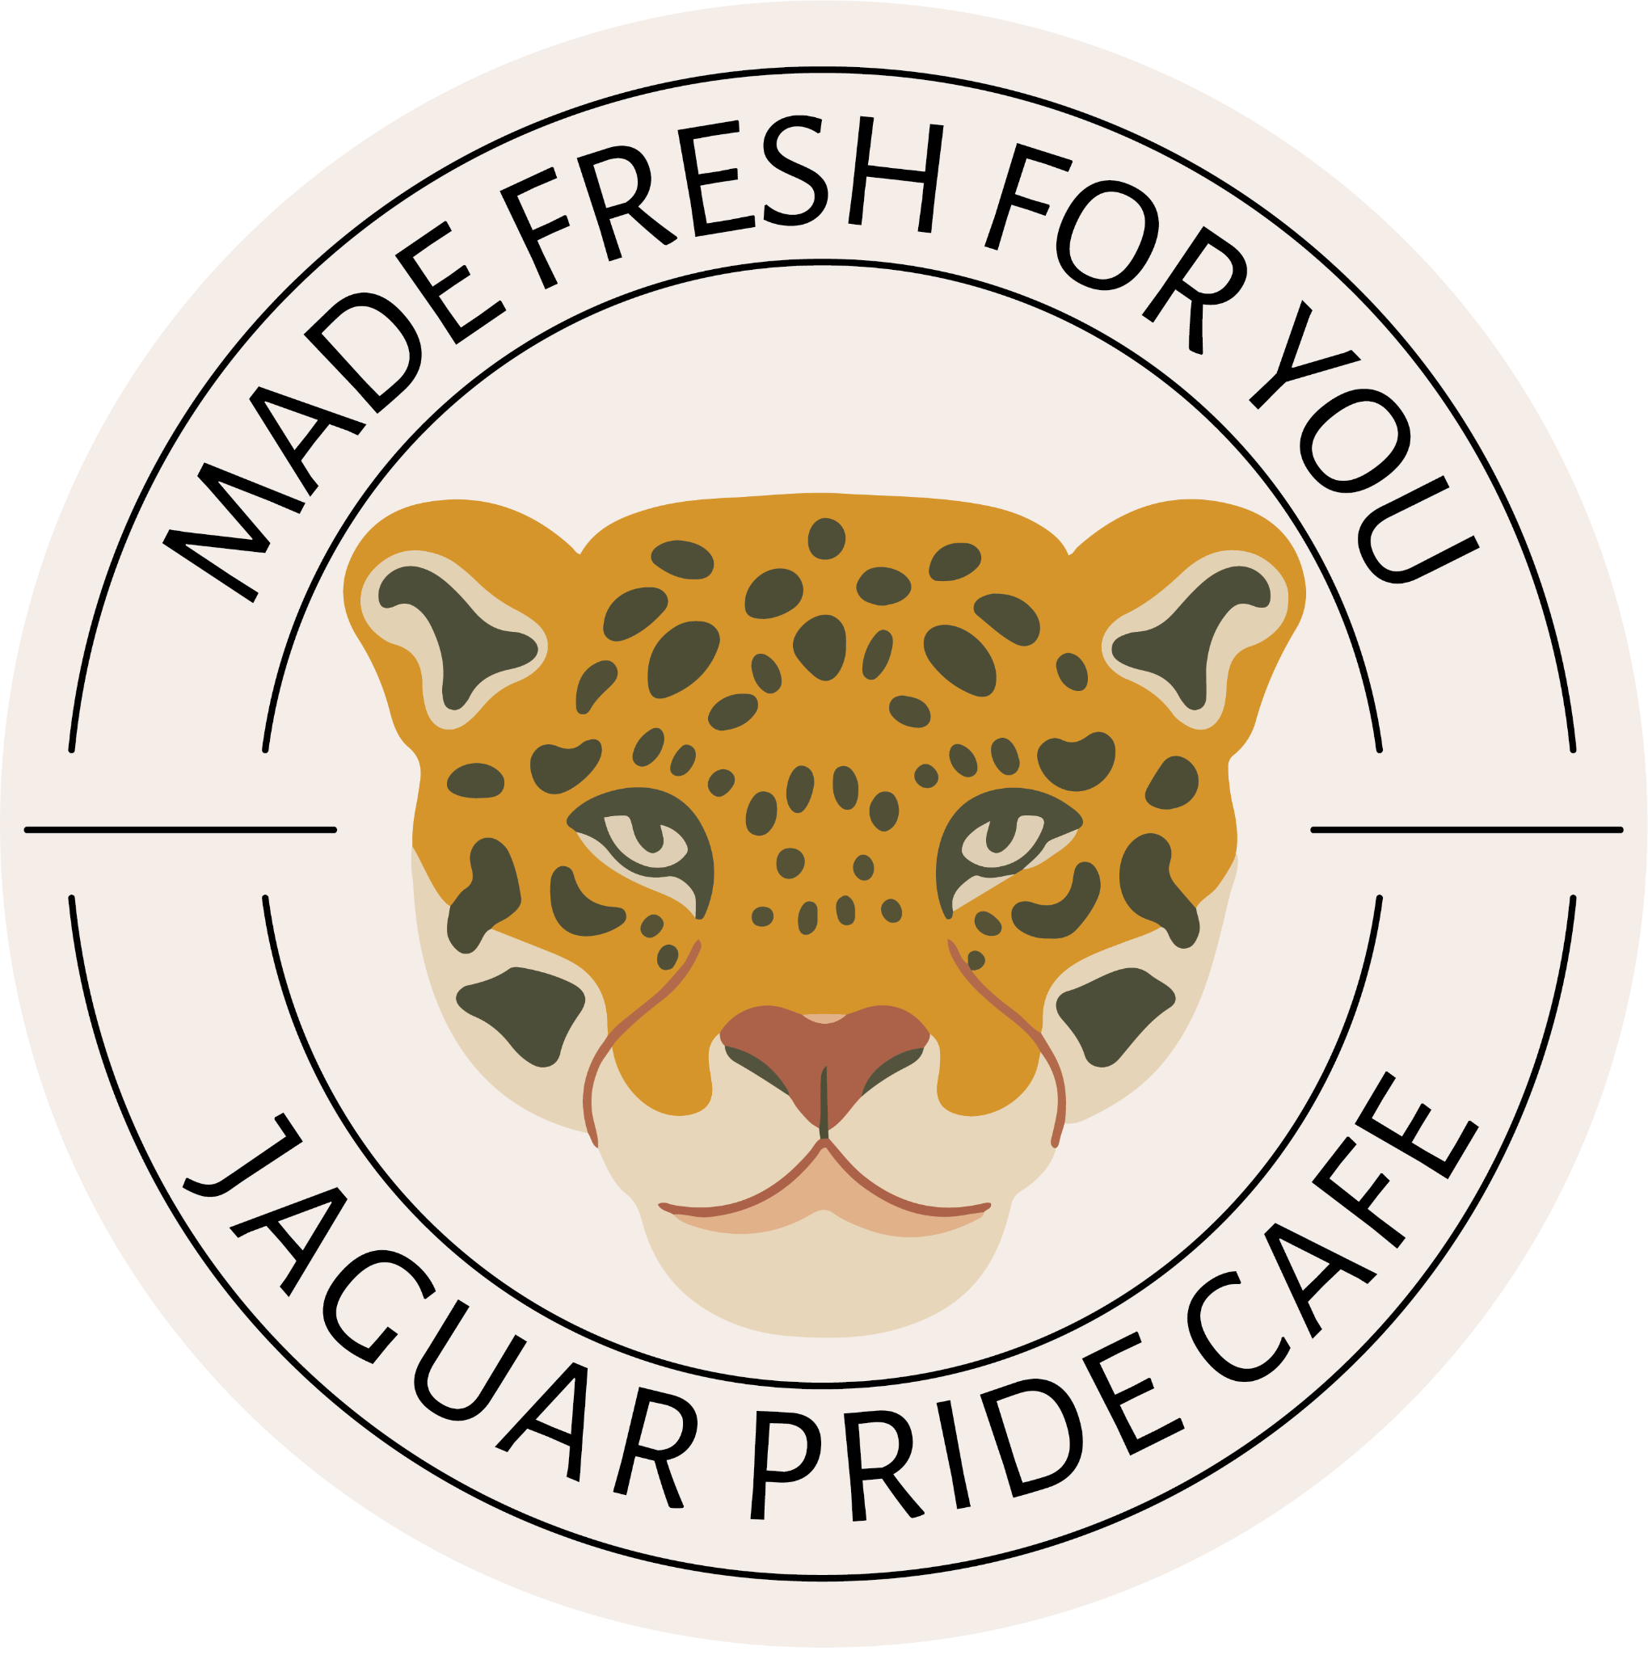 | Lunch Prices:  Full Paid - $3.25  Reduced - $0.00  Free - $0.00
Mandarin Orange Chicken  Brown Rice & Broccoli  Fruit Choice  Milk Choice | Hot Dog on a Bun  French Fries  Fruit Choice  Milk Choice | Homemade Lasagna  Broccoli  Fruit Choice  Milk Choice

