 | September 1 | September 2 | September 3 | September 4
 | Cereal & String Cheese  Fruit Choice  Milk Choice | Cereal & String Cheese  Fruit Choice  Milk Choice | Mini Bagels  Fruit Choice  Milk Choice | Soft Nature Valley Bar  Fruit Choice  Milk Choice
September 7 | September 8 | September 9 | September 10 | September 11
No School Today | NutriGrain Bar  & String Cheese  Fruit Choice  Milk Choice | Muffin  Fruit Choice  Milk Choice | Breakfast Bread  Fruit Choice  Milk Choice | Scooby Doo Grahams  & Yogurt  Fruit Choice  Milk Choice
September 14 | September 15 | September 16 | September 17 | September 18
Cereal & String Cheese  Fruit Choice  Milk Choice | Cereal Muffin  Fruit Choice  Milk Choice | Breakfast Bread  Fruit Choice  Milk Choice | Mini Bagels  Fruit Choice  Milk Choice | Soft Nature Valley Bar  Fruit Choice  Milk Choice
September 21 | September 22 | September 23 | September 24 | September 25
NutriGrain Bar  String Cheese  Fruit Choice  Milk Choice | Whole Grain Bagel  Cream Cheese  Fruit Choice  Milk Choice | Muffin  Fruit Choice  Milk Choice | Breakfast Bread  Fruit Choice  Milk Choice | No School Today
September 28 | September 29 | September 30 | 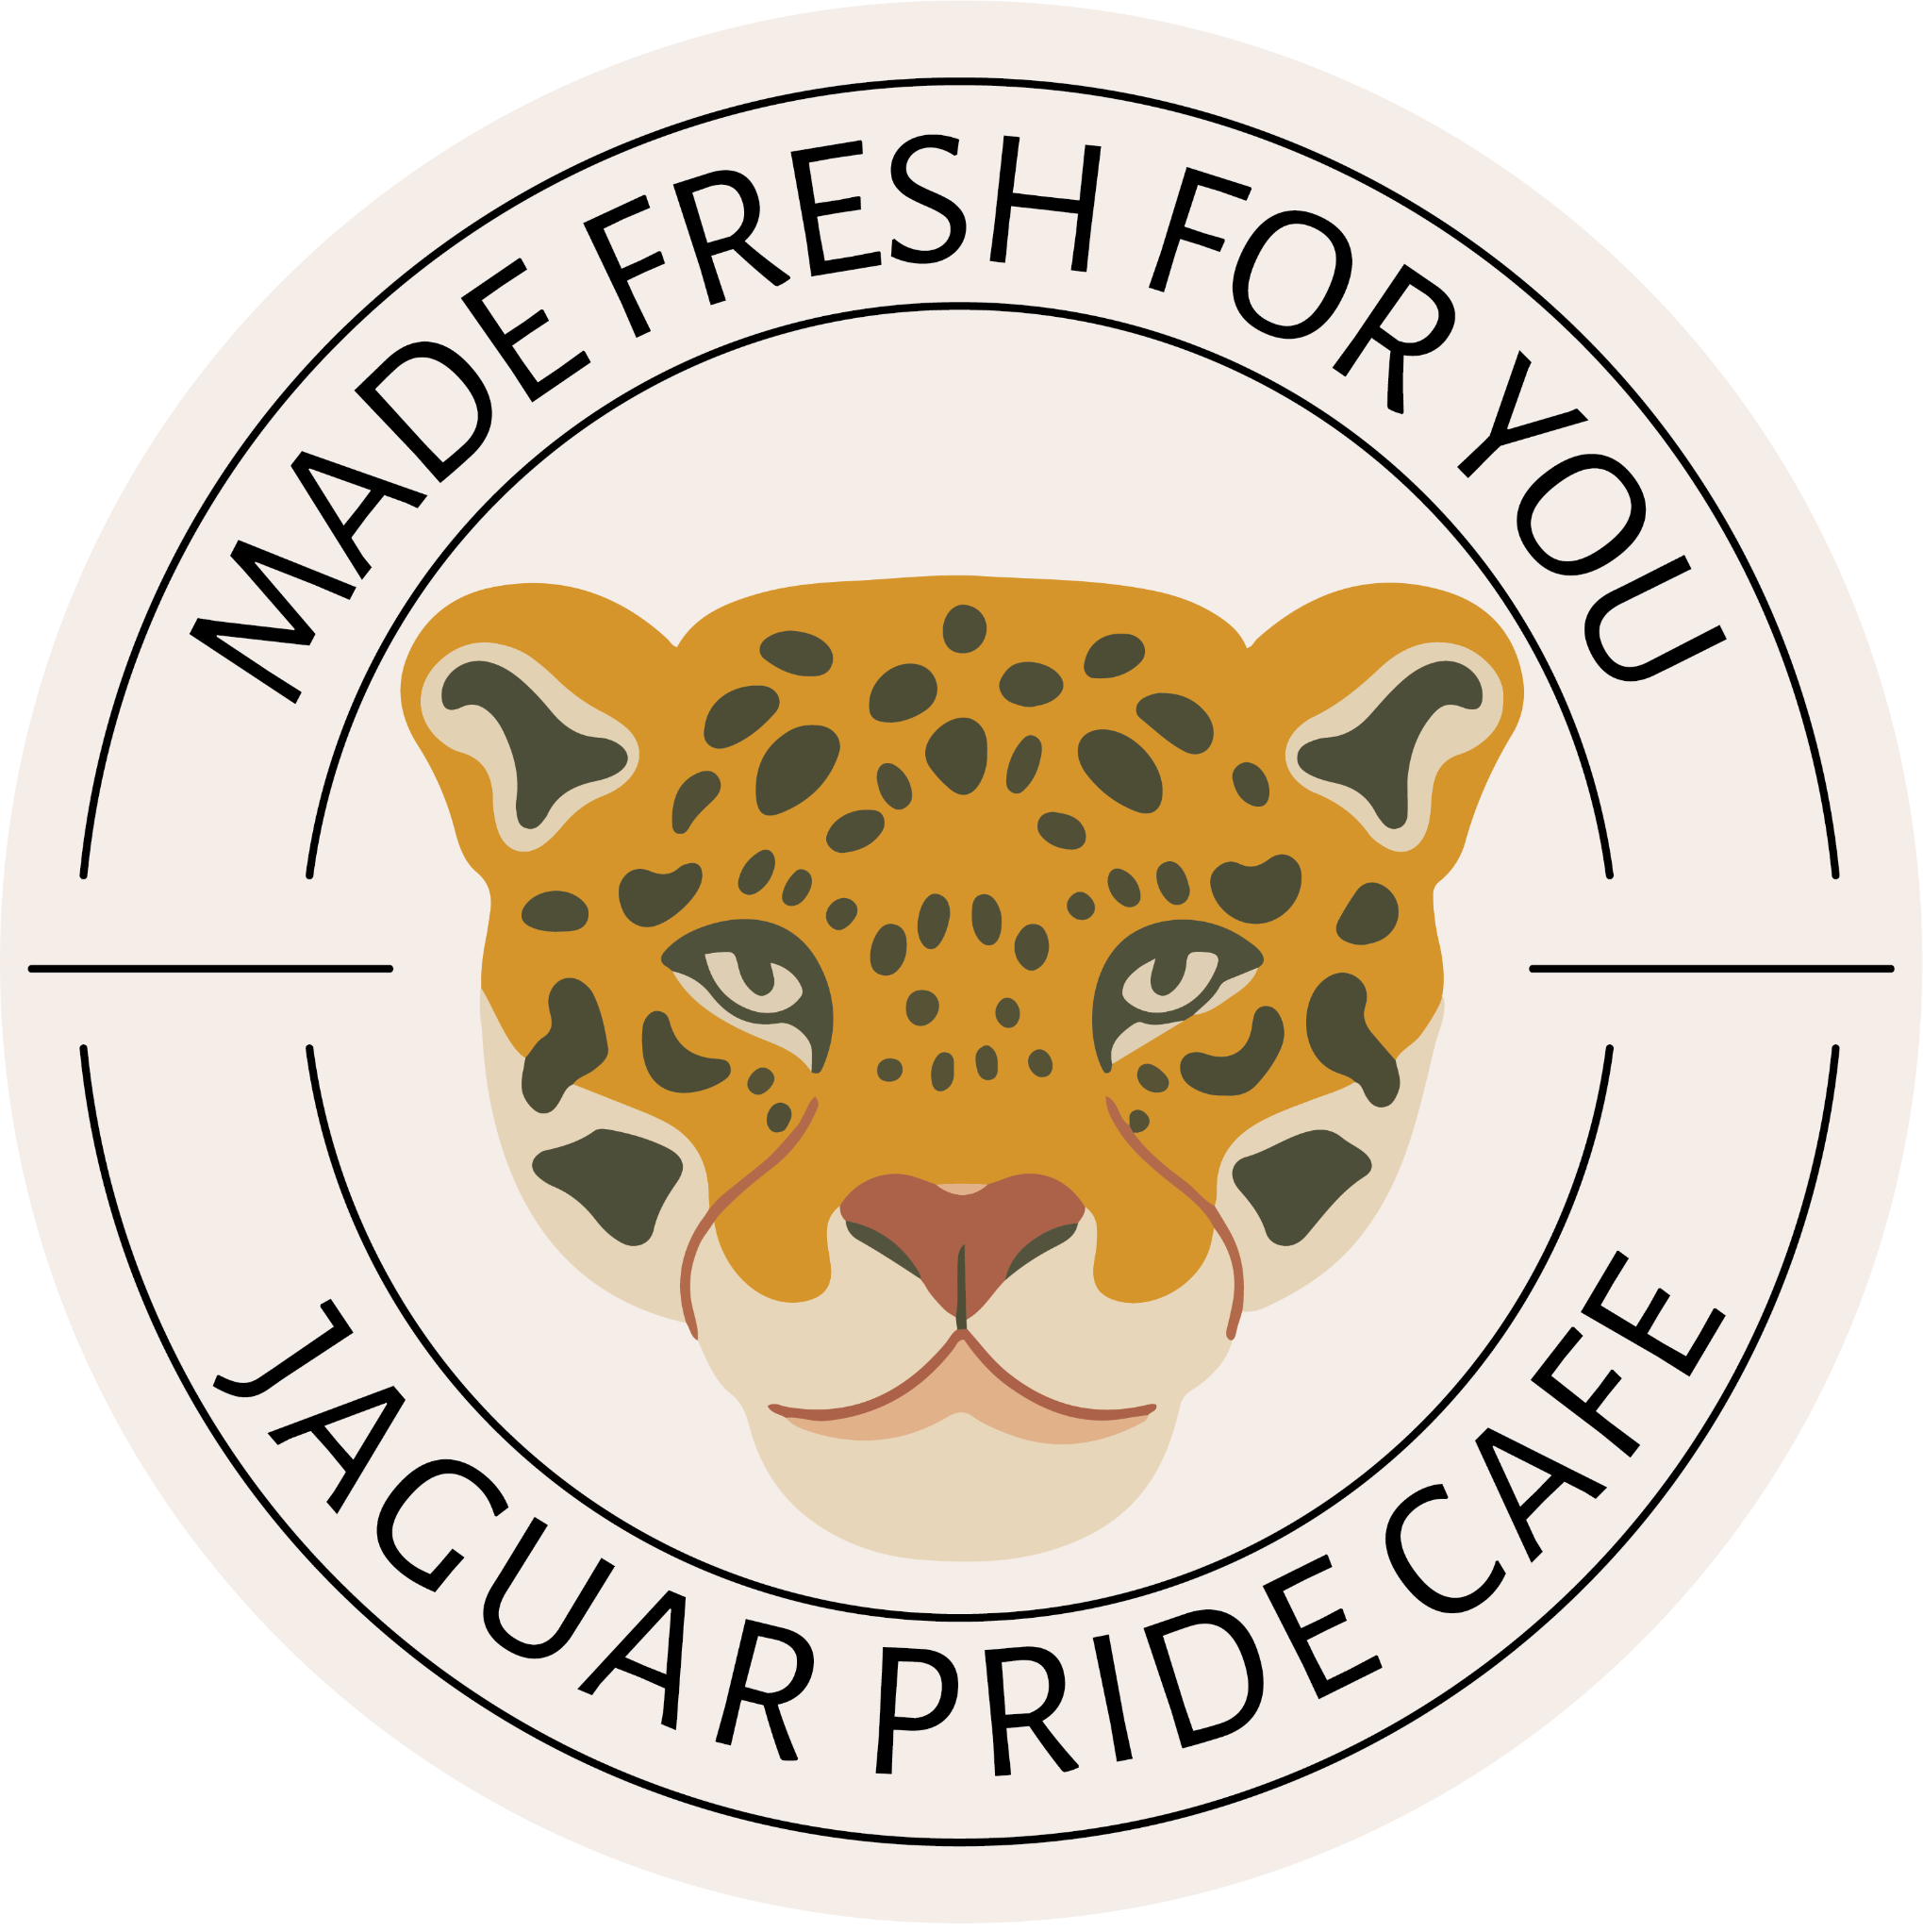 | Breakfast Free for Everyone!
Cereal & String Cheese  Fruit Choice  Milk Choice | Cereal Muffin  Fruit Choice  Milk Choice | Breakfast Bread  Fruit Choice  Milk Choice |  | Breakfast Free for Everyone!

