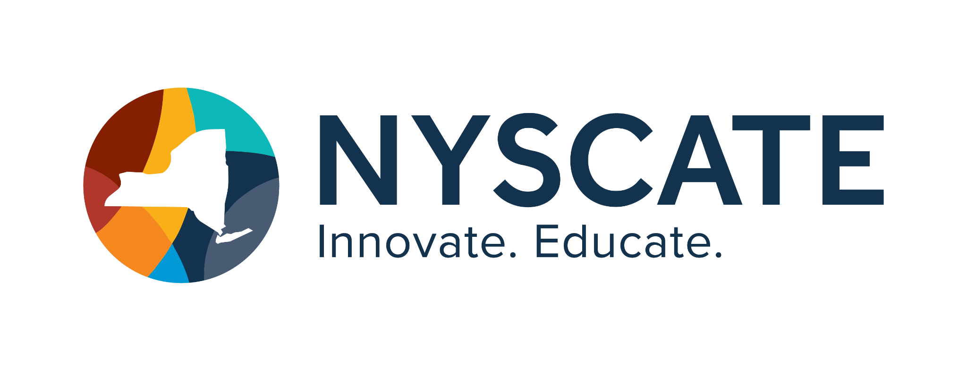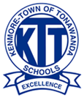
Project Template

Smart Start Cohort 25/2

Summary of Resource
- Subject(s): Social Studies
- Topic or Unit of Study: Colonial Period
- Lesson Title: Which Colony is the Best Colony?
- Grade/Level: 7th Grade
- Duration of Lesson: 4-5 Days

Implementation

Standards Addressed
7-8.CT.2 Collect and use digital data in a computational artifact.
7-8.CT.3 Refine and visualize a data set in order to persuade an audience

Justiﬁcation
By completing this project students will gain a better understanding of using digital resources for research, How to incorporate that research into a digital artifact and ultimately creating something persuasive based on the research collected. This will be a paired assignment.
Working in collaboration helps with communication skills, time management and accountability too all things middle schoolers need to accomplish.

Personal Reﬂection
I really like the idea of this assignment and want to utilize this next year in my classroom. I do like having my students collaborate on assignments together. They really need an opportunity to interact with each other in positive ways. Another key for this assignment is the research aspect. We all recognize there is a ton of information out there on the internet, unfortunately not all of it is accurate, not all of it is quality either- so working with kids to establish how to find reliable credible sources is a critical skill in the modern world. Finally the biggest thing I'm looking to accomplish through this activity is giving them creative license to make something from the information they have learned. Alternate assessment strategies instead of the traditional paper/ digital test to evaluate knowledge. This gives students more leeway and creative ability to show what they know. It will be a fun and engaging idea for them to work on, and thus give them more satisfaction while learning all the while. I’ll give them the template and the rubric and offer support and guidance but leave the details to each group and allow them the opportunity to design their own presentation in the way they see as more effective and fun.

