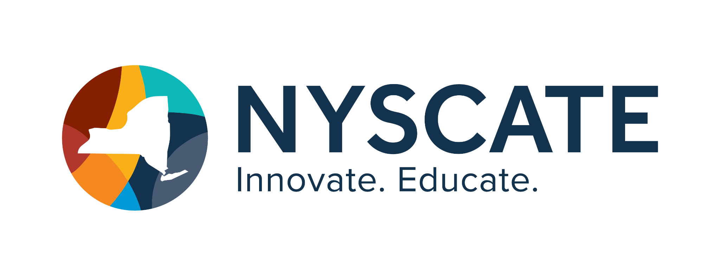
Project Template

Smart Start Cohort 25/26

Summary of Resource
- Subject(s): Science
- Topic or Unit of Study: Phases of Matter
- Lesson Title: Phase Change Choice Board
- Grade/Level: 6
- Duration of Lesson: 2 class periods (approx. 90 min.)

Implementation
Link to Original Resource: Phase Change Choice Board

Standards Addressed 4-6.CT.1
4-6.CT.3
4-6.CT.7
4-6.DL.2

Justiﬁcation
The activities to be completed on the choice board incorporate these standards. One example of the activities includes a SIM in which students control outputs by what they input into the system. Other activities include commenting in a public space with classmates sharing their insights from a video clip, using media to use distinguish understanding,

Personal Reﬂection
Digital citizenship and the standards courses help to familiarize me with the standards themselves with speciﬁc examples and explanations. It also recognizes and conﬁrms standards that I regularly implement. The courses I completed on Choice Boards and Escape Rooms were highly interesting and useful, and also provide an opportunity to meet standards and explain them,

