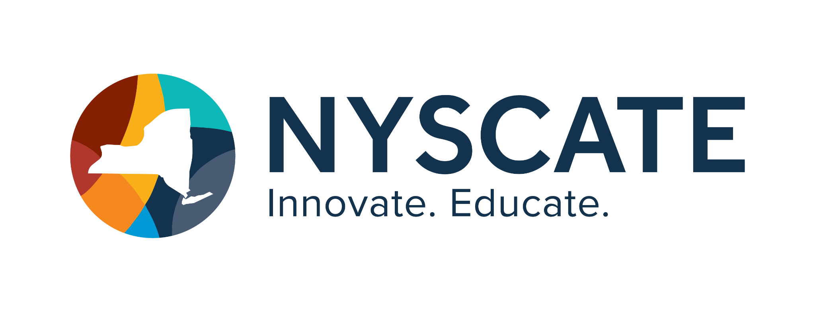
Project Template

Smart Start Cohort 25/26

Summary of Resource
- Subject(s): Cybersecurity
- Topic or Unit of Study: Risks and Safeguards
- Lesson Title: Help! I’m Trapped In My Computer!!!
- Grade/Level: 5th Grade
- Duration of Lesson: 20 minutes

Implementation

Link to Original Resource:

Standards Addressed
Tip: List the CS&DF Standards that the resource will help to address
4-6.CY.1 - Explain why diﬀerent types of information might need to be protected. 4-6.CY.2 - Describe common safeguards for protecting personal information.

Justiﬁcation
Tip: How will this resource be used to integrate the standards.
This resource can be used in a number of ways to integrate the standards. This resource is a fun, engaging and interactive activity that can be used to teach the CS & DF standards for Cybersecurity: Risks and Safeguards. It is an escape room that tells a story of a boy trapped in a

computer and you have to answer 10 questions on cybersecurity correctly in order to help the boy escape the computer. The teacher could use this activity separately or as part of a unit on computer and online safety. The questions that are asked cover topics that are directly addressed in the 4-6.CY.1 and 4-6.CY.2 standards. Some of the concepts include: the digital footprint, keeping your software safe, online safety, phishing, malware and suspicious emails and what to do in diﬀerent situations to protect yourself and be safe.

Personal Reﬂection
Tip: How have these courses helped you to better understand the CS&DF standards and apply them in your classroom.
The courses that I have taken through this grant have provided me with a huge amount of information on computer science and digital literacy. I went from a little understanding of the standards to a much better understanding. I know where to ﬁnd them and information about them. I have read all of them and can generate an example for each one. I can now come up with projects and activities for my classroom that incorporate technology and the standards into my lessons for my students. I am feeling much more conﬁdent and comfortable in my knowledge and usage of technology because of the courses that I have taken. I have now made 2 escape rooms incorporating the standards and have used them in my classroom already. I am excited to make more of these and proud of myself for being able to do so. My students are asking for more of them and they loved the ones I made. I am also using the social emotional learning and digital ﬂuency concepts in my classroom as well. We have already had multiple conversations about digital literacy and cybersecurity, including identity theft. The students are very knowledgeable about many of these topics and we have had many interesting discussions. Thank you for this opportunity. I plan on continuing this progress in the future with my students. There will always be more to do and learn about because of the ever changing nature of technology in education and I am up for the challenge.

