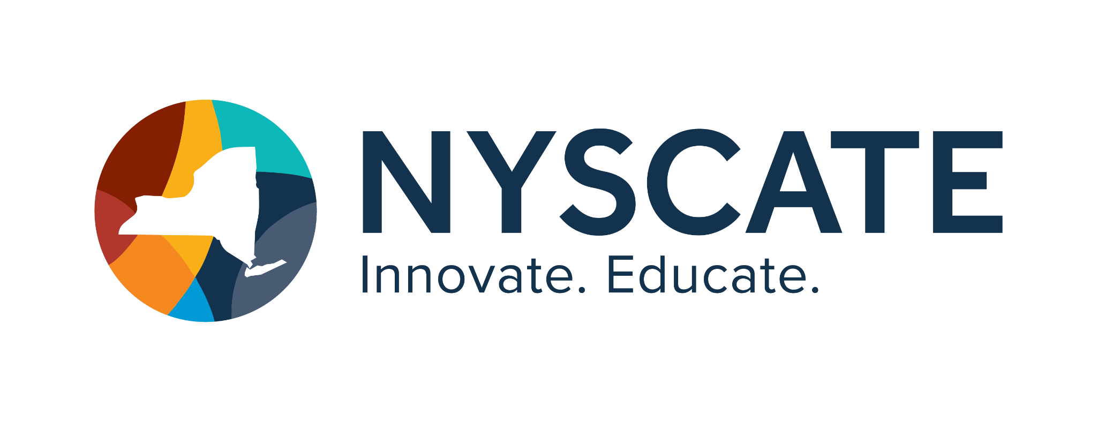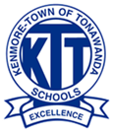
Project Template

Smart Start Cohort 25/26

Summary of Resource
- Subject(s): Mariana Trench anchoring phenomenon and Plate tectonics
- Topic or Unit of Study: Plate tectonics
- Lesson Title: Digital Notebook Anchoring Phenomenon
- Grade/Level: 9th / 10th
- Duration of Lesson: Anchoring Phenomenon - 40 min (Total 3 lessons in Digital Notebook)

Implementation

Link to Original Resource:
https://docs.google.com/presentation/d/1-BQOMVQgahb0IsbTDNaiL-gQiSarY4PjOlxIP5CvT0w/edi t?usp=sharing

Standards Addressed
HS-ESS1-5.
Evaluate evidence of the past and current movements of continental and oceanic crust and the theory of plate tectonics to explain the ages of crustal
rocks. [Clarification Statement: Emphasis is on the ability of plate tectonics to explain the ages of crustal rocks. Examples include evidence of the ages of oceanic crust increasing with distance from mid-ocean ridges (a result of plate spreading) and the ages of North American continental crust decreasing with distance away from a central ancient core of the continental plate (a result of past plate interactions).]
9-12.DL.2: Students communicate and collaborate (synchronously and asynchronously) with others using digital tools, supporting individual learning and the learning of others

9-12.DL.4: Students show evidence of independently having created, revised, and published digital artifacts using advanced digital tools.

Justiﬁcation
A digital notebook ﬁts these standards really well because it lets students show their thinking as it develops, not just turn in a ﬁnal answer. For HS-ESS1-5, students use the notebook to collect maps, diagrams, and models of plate tectonics and crust ages, then annotate them to spot patterns—like oceanic crust getting older the farther it is from mid-ocean ridges or continental crust changing in age as you move away from an ancient core. Students explain these patterns in their own words using short reﬂections or claim-evidence-reasoning entries, showing how plate tectonics explains the ages of crustal rocks.
The notebook also supports 9–12.DL.2 because students can easily share their work, comment on each other’s pages, and give feedback using digital tools. They can compare observations, ask questions, or help clarify explanations, either during class or outside of class to collaborate and grow their understanding.
For 9–12.DL.4, the digital notebook shows clear evidence of creation and revision.
Students build pages over time, revise explanations, improve annotations, and organize their ideas into a polished ﬁnal notebook. By the end of the unit, the notebook acts as a published digital artifact that demonstrates both their understanding of plate tectonics and their ability to use advanced digital tools eﬀectively.

Personal Reﬂection
These courses I took have helped me better understand the CS&DF standards by showing how they can be meaningfully applied in a science classroom, not just discussed in theory. Through the coursework, I learned how to design science lessons that value students’ cultural backgrounds, lived experiences, and local knowledge as assets in making sense of scientiﬁc concepts. Especially learning how to do things with my ELL students but also make it fun through the concept of an escape room.
The courses and presentations also emphasized equitable science practices such as collaborative investigations, student discourse, and multiple ways for students to demonstrate understanding so all learners can access rigorous science content. Overall, these courses/ presentations have strengthened my ability to align science instruction with the CS&DF standards by creating an inclusive, inquiry-based classroom where students see themselves as scientists and feel empowered to ask questions, analyze evidence, and connect science learning to their own lives and communities. Which is especially important with the amount of digital work we integrate in our classrooms now, and the dangers of the online network.
.

