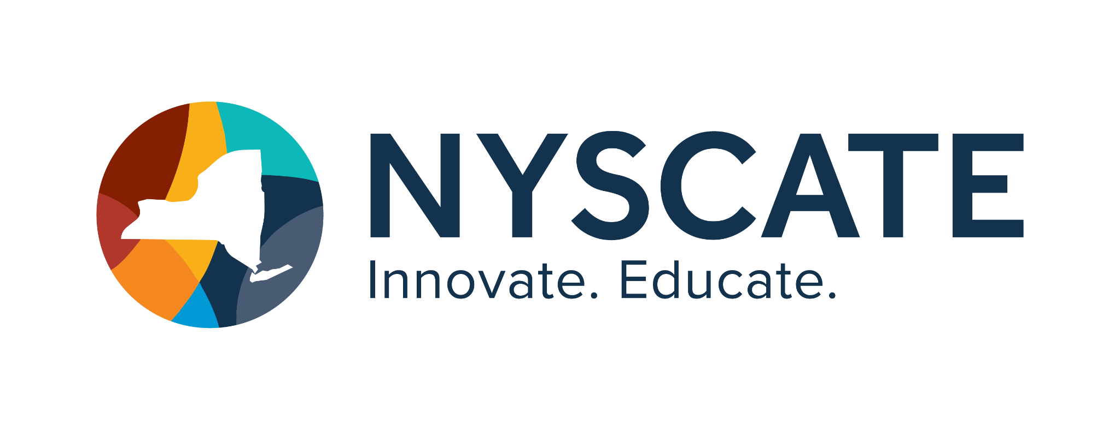
Project Template

Smart Start Cohort 25/26

Summary of Resource
- Subject(s): Social Studies/CS&DF
- Topic or Unit of Study: Holidays
- Lesson Title: Exploring Diﬀerent Holidays
- Grade/Level: Kindergarten
- Duration of Lesson: 45-60 minutes

Implementation

Link to Original Resource:
Choice Board:
https://docs.google.com/presentation/d/e/2PACX-1vSaMvsyqlFZlVC_NF47w_-dLcePRefTliSyojFD MJdM3oeH-arKvChyck-O-20-hS7_5dvtyzJ_5SxB/pub?start=false&loop=false&delayms=3000

SeeSaw Activity:
https://app.seesaw.me/pages/shared_activity?prompt_id=prompt.024230ce-0aa5-434f-ae5f-25e 998752237&share_token=U-rw27EYRjqJszKF3nuRWA

Standards Addressed
Social Studies Standard: K.3 Symbols and traditions help develop a shared culture and identity within the United States.
K.3b The study of American symbols, holidays, and celebrations helps to develop a shared sense of history, community, and culture.
CS&DF Standard: K-1.DL.4 Use at least one digital tool to create a digital artifact.

Justiﬁcation
I made a virtual choice board where the students will choose one of the holidays to learn more about. They have to click on 2 links (the star and heart) and then they may choose to click on at least one other picture on their slide. The links are various videos, games, and read aloud articles about the speciﬁc holiday they have chosen. Once they have time to click on the links in the choice board (20-30 minutes), they will have to answer a question on SeeSaw. This question will ask them to state 1 thing they learned about the holiday they chose or 1 interesting fact they learned. The students will be asked to audio record their fact and asked to write/draw the holiday they chose. Once all of the students submitted their assignment, together as a class, we will look at their answers on the board and have a class discussion.
This lesson will be completed at the beginning of the school year to be able to explicitly teach how to use the audio record feature of Seesaw and how to submit/navigate SeeSaw assignments. These students will have never used this platform before and will need explicit instructions in order to create this digital artifact that will then be shared with the class. Their submission will be shared to the class journal where all students will have access to see.
Lesson progression
- Getting on Seesaw
- Showing the students how to get to their assignments
- Showing students how to click on a link within the assignment
- Having students explore the google choice board and making sure they click on the must do’s and at least one of the other picture on their slide
- Going over how to draw on Seesaw
- Show students how to audio record their answer on Seesaw
- Showing how to submit their work
- Class discussion- showing everyone’s picture and audio recordings Learning Intention: We are learning to use a digital tool to make a digital artifact. Success Criteria: I can make a drawing on SeeSaw with an audio recording.

Personal Reﬂection
These courses have opened my mind to various other technologies and ideas to incorporate into my everyday lessons within my classroom. Before taking these courses, I didn’t even know there
were standards for CS&DF. Learning about these standards opened my eyes to a world of possible lesson integrations that I have already been doing. I have found that a lot of these standards would integrate well with lessons I have already been completing in my classroom. I have found that a lot of the social studies lessons that I am currently teaching about our community can be extended so the CS&DF standards are covered. There are also other lessons in our math curriculum and reading curriculum that would address the CS&DF standards. While taking these courses my mind was constantly churning and thinking about speciﬁc lessons I could add to in order to address the CS&DF standards. Learning and taking these courses allowed me to gain knowledge around these standards and allowed me to have more ideas on how to incorporate them into my lessons. I have found that there are so many diﬀerent possibilities in order to teach my students about digital ﬂuency. I think that it is so important to incorporate these ideas into my classroom because the world is ever changing and students need to be exposed to and taught how to use their devices and digital tools correctly before they have misconceptions. Just like any other subject we teach in school, digital ﬂuency will be something that needs to be addressed every day going forward.

