How to use your menu. | Southfield Public Schools

See what's on the menu
- Visit your new menus URL at: Southfield Public Schools - School Nutrition And Fitness
- Click into the menu you'd like to view to open the interactive monthly calendar.
- Click the magnifying glass on any day to view all items served.

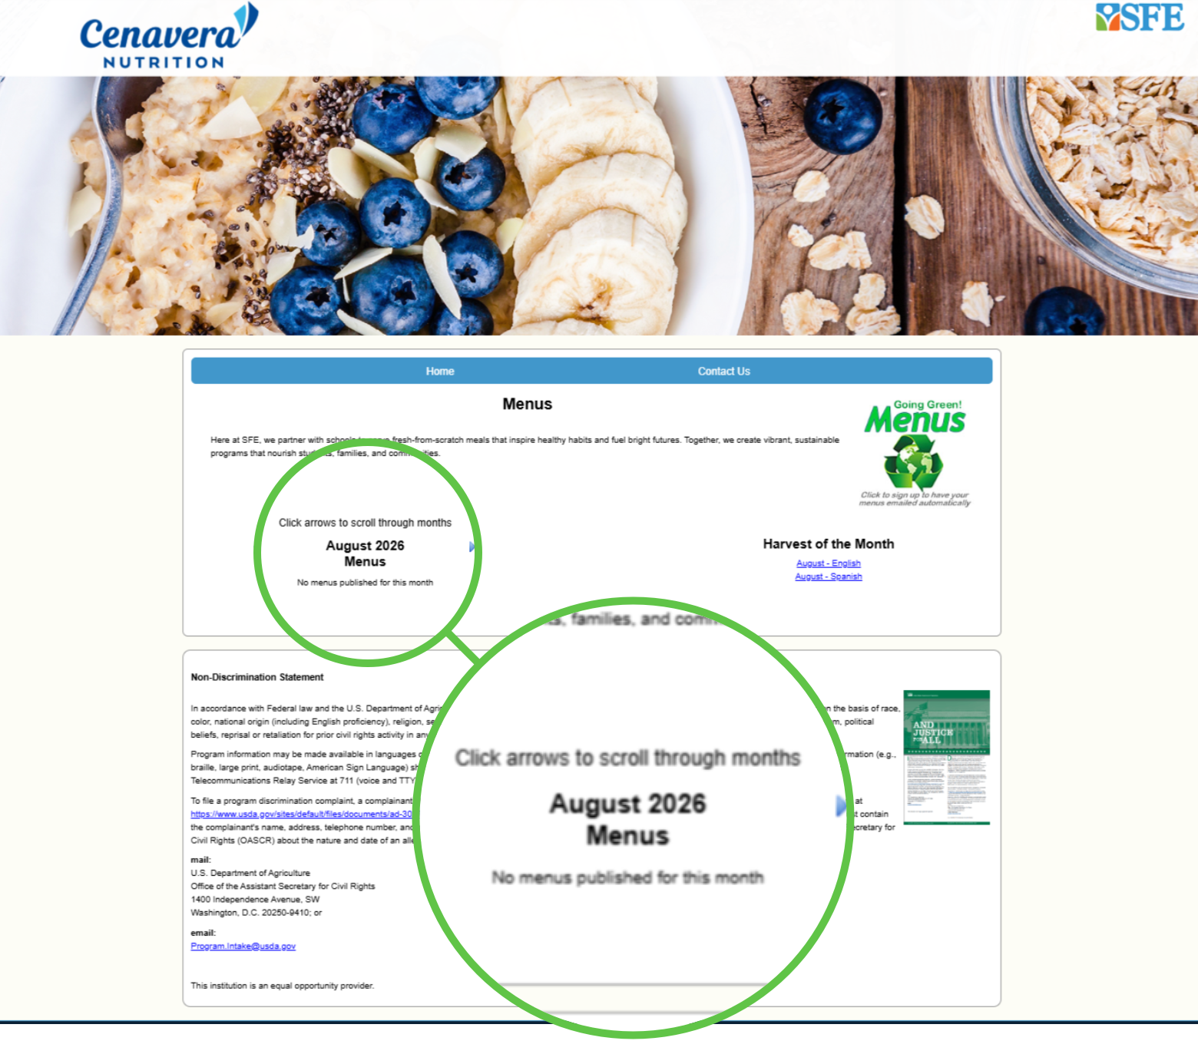 | 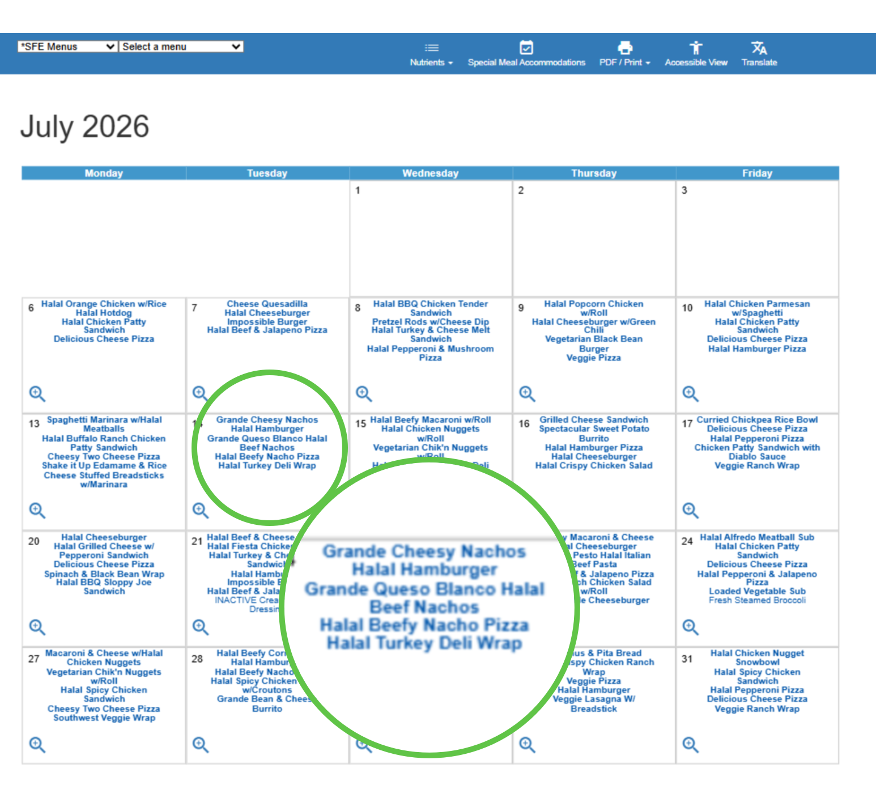
Start using your new interactive menu
by downloading the app.
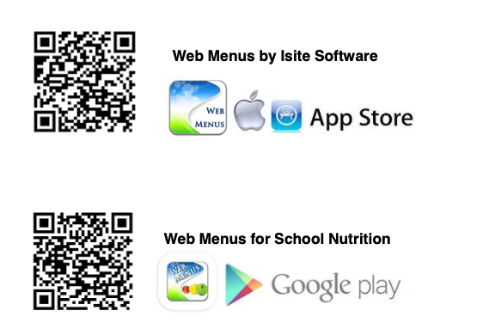

Switch to a different menu. | Southfield Public Schools

Switch to a different menu
- Use the dropdown in the upper-left corner to select a different grade group.
- Use the second dropdown to choose a specific school site, then use the third dropdown to select menu you'd like to view.
- The calendar automatically updates to display your new selection.

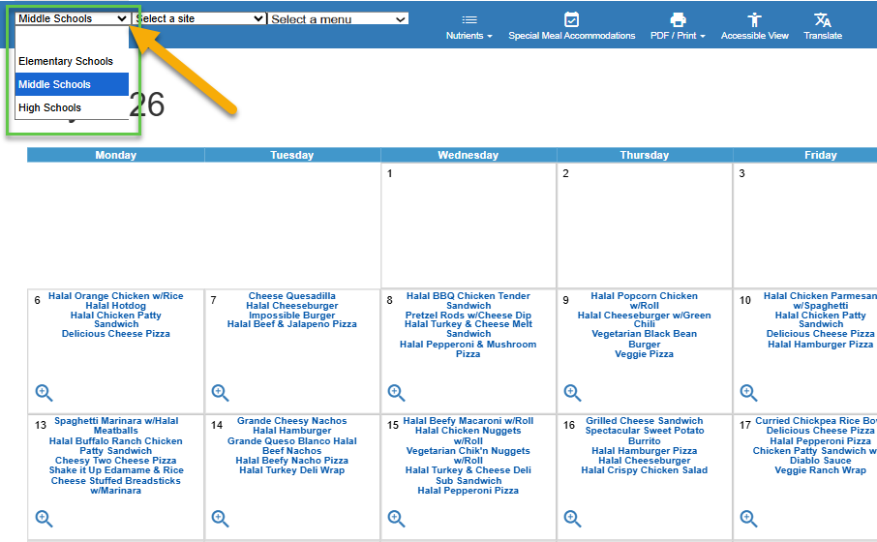

How to view nutrition info. | Southfield Public Schools

See nutrition facts at a glance
Hover over any food item to instantly view its nutrition facts, allergen icons, and rating.

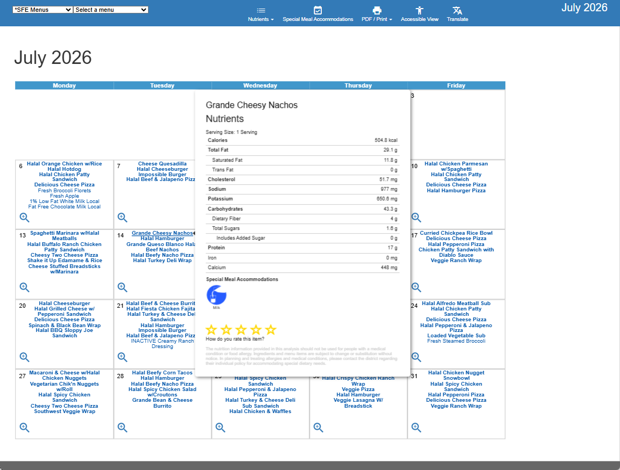

How to use the Nutrients menu. | Southfield Public Schools

Use the Nutrients menu
- Click the Nutrients dropdown in the top navigation.
- Select Carb Count for portion sizes and carbs by day, or Nutrition Report Card for a full breakdown.
- Check items to see combined totals and hover over any icon to see its full name.

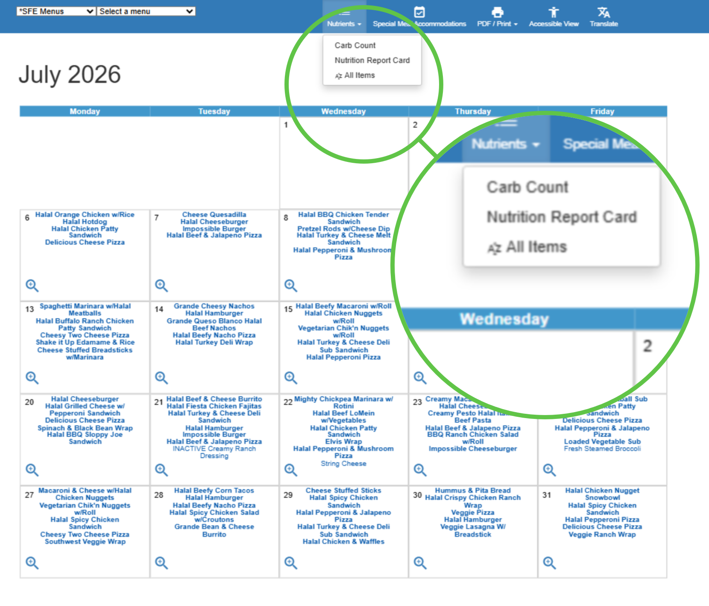 | 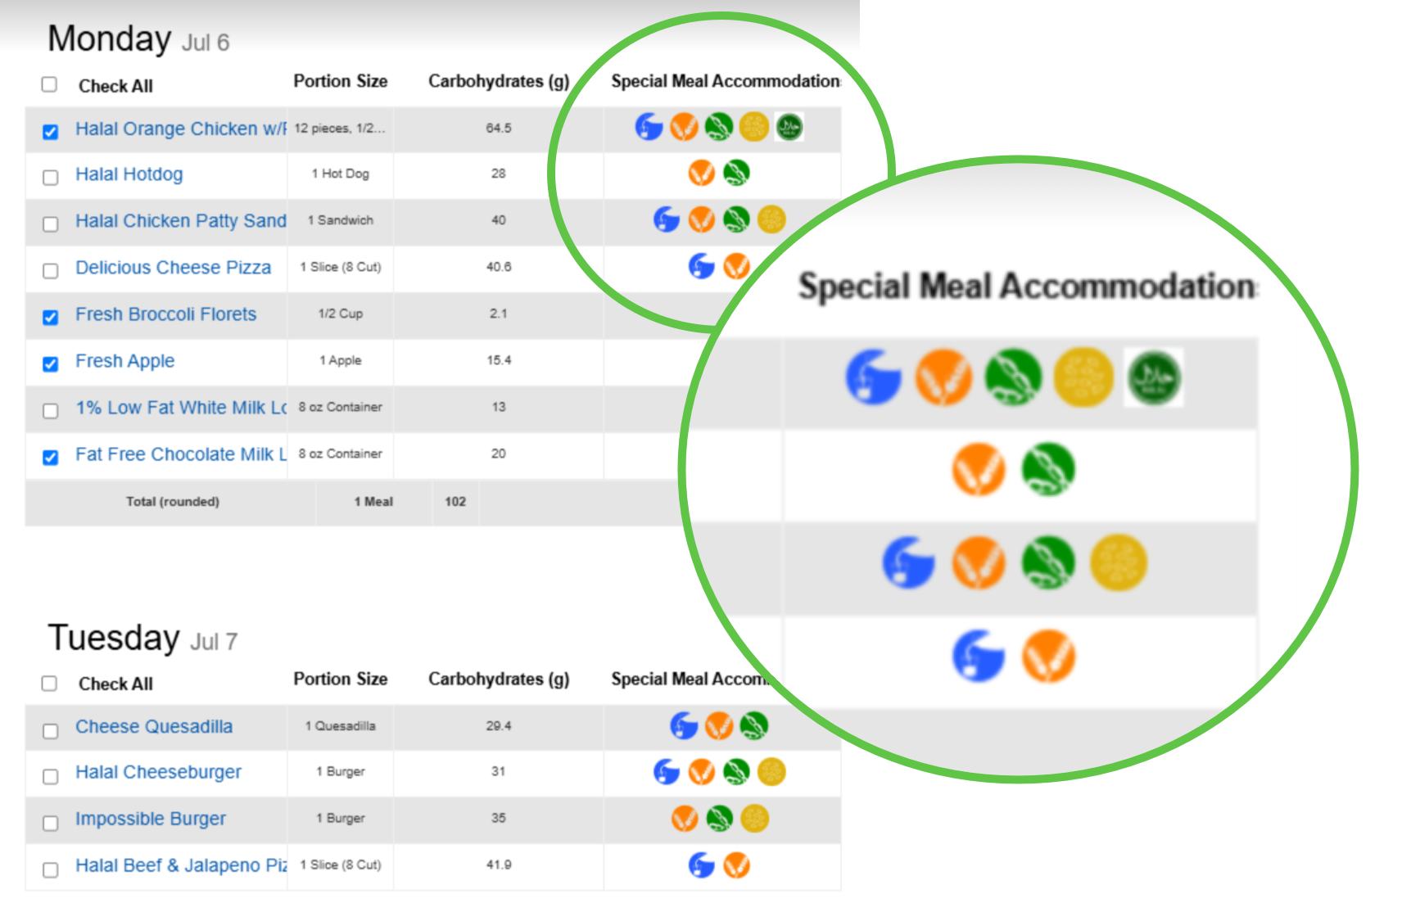

How to filter by allergen. | Southfield Public Schools

Filter by allergen
- Click Special Meal Accommodations in the top navigation.
- Select the allergens you'd like to identify, then close the window.
- Items with a selected allergen show with a red strikethrough

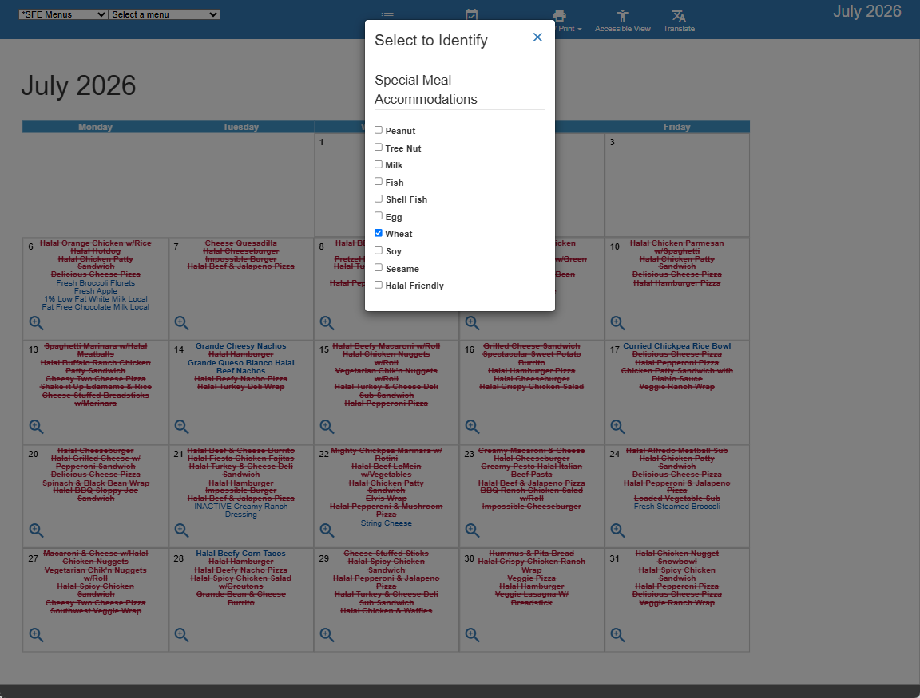 | 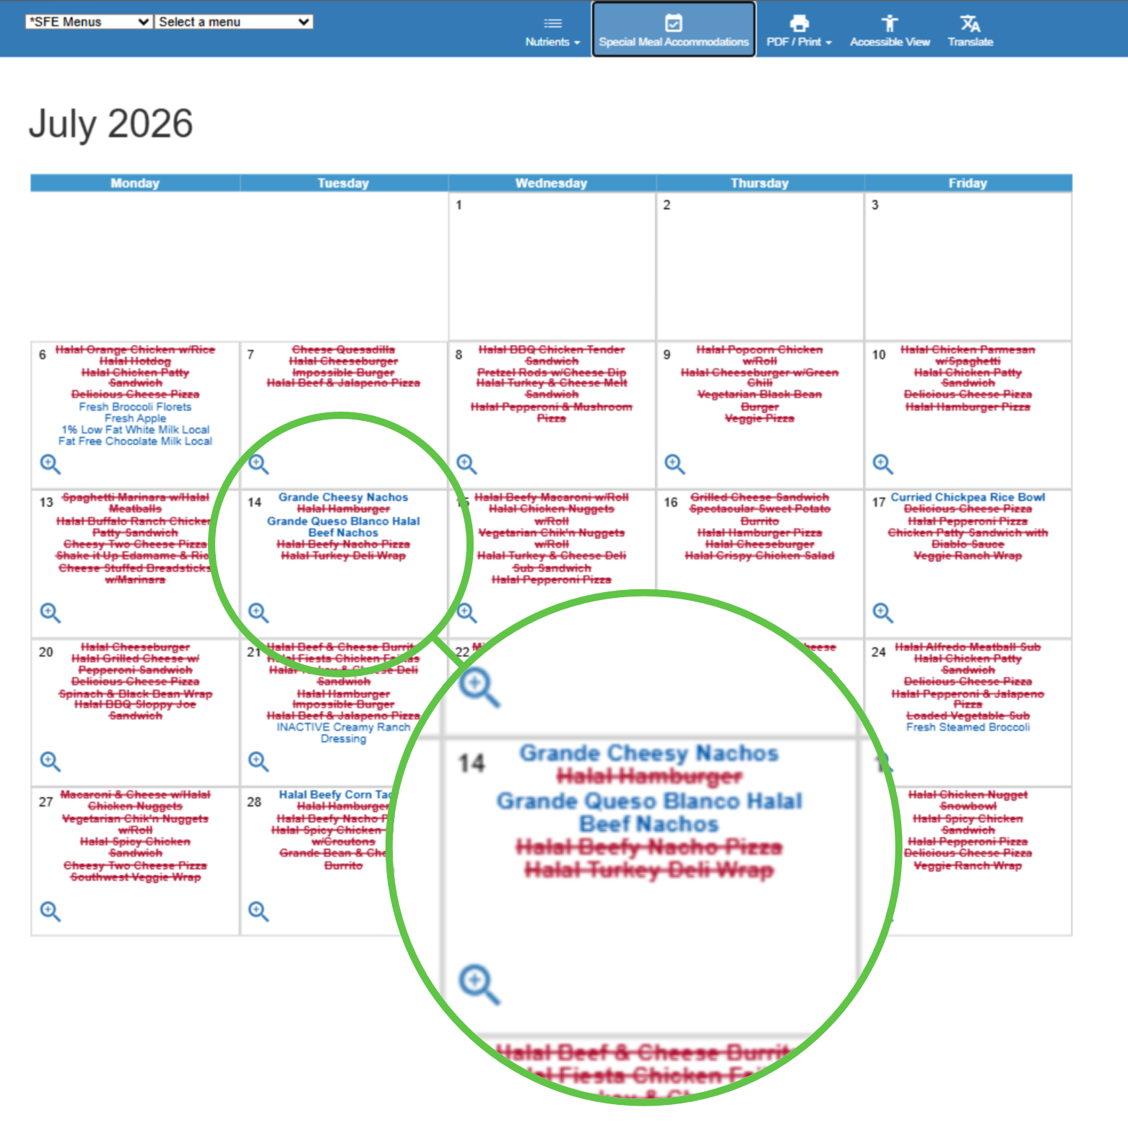

How to translate & print. | Southfield Public Schools

Translate into another language  - Click Translate in the top navigation.  - Choose your preferred language from the dropdown list.  - View your translated menu items immediately — no need to leave the page.  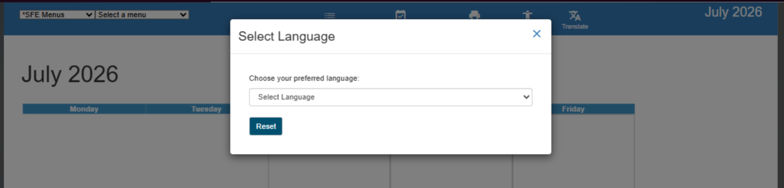 | Print a menu  - Click PDF / Print in the top navigation.  - Choose Calendar With Images or Calendar Without Images.  - Your menu downloads as a PDF — ready to print or save.  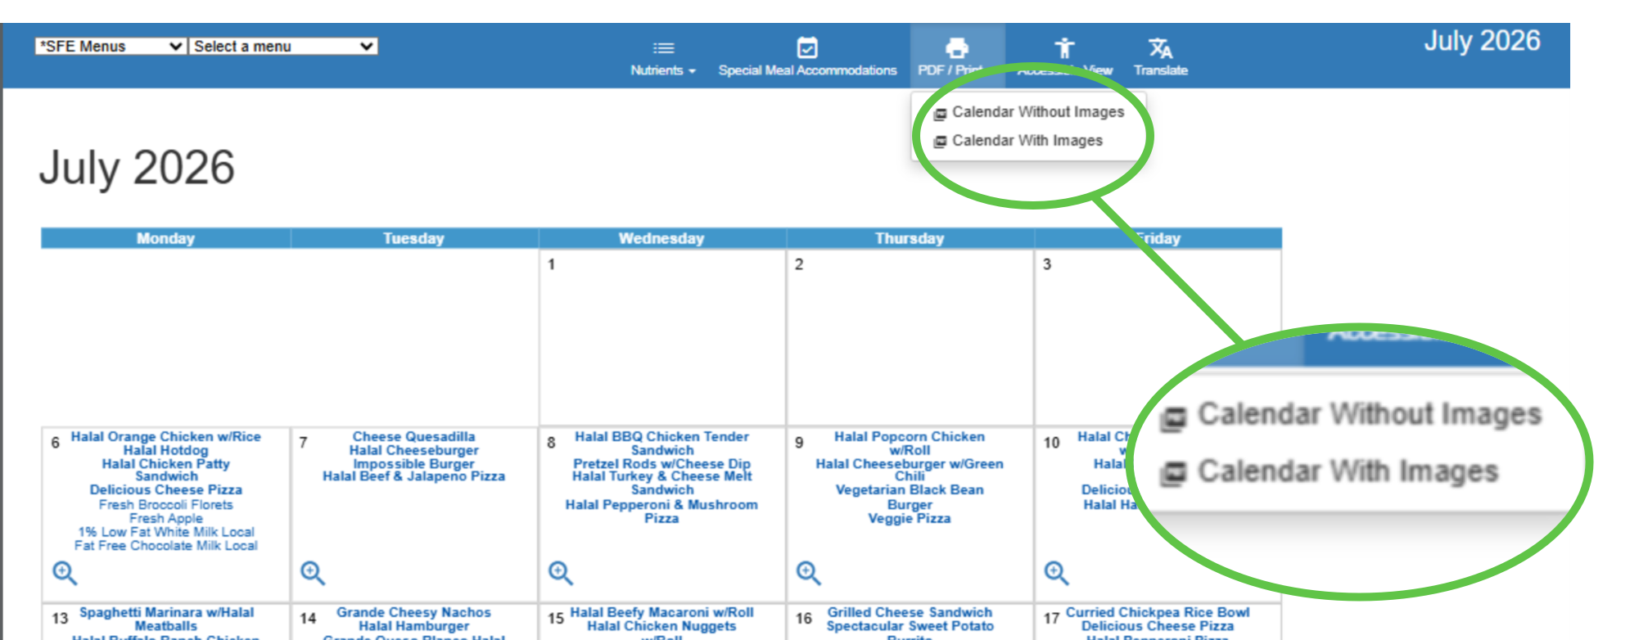

Start using your new interactive menu
by downloading the app.

