2026-27

South Adams
Course Titles and Descriptions

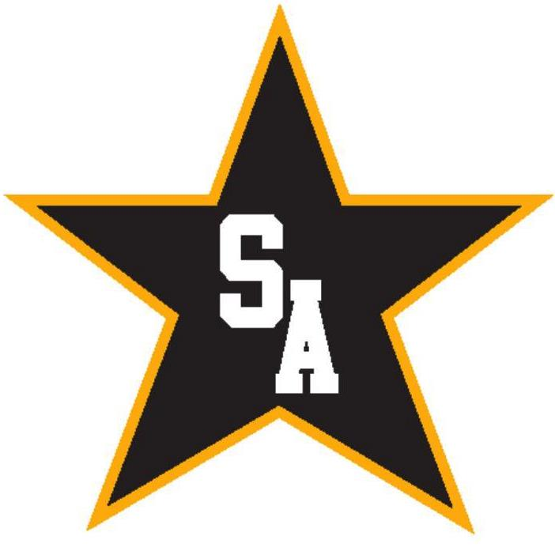
TABLE OF CONTENTS

General Information 4
State graduation and diploma requirements 6
SA Graduation Pathways 7
New Indiana Diploma 8-9
Scheduling Procedures 10
Graduation Information 11
Dual Credit Courses and Certifications at South Adams 13

Course Descriptions
Advanced Non-CTE for College Credit 15
Advanced Placement (AP) 16
English/Language Arts 18
Fine Arts 20
Health and Wellness 25
Mathematics 26
Multidisciplinary 29
Physical Education 33
Science 34
Social Studies 36
World Language 39
Career and Technical Education (CTE)
Advanced Manufacturing 42
- Precision Machining 42
- Welding Technology 44
Agricultural Education 45
- Ag Mechanical and Engineering 46
- Agriscience 47
Architecture & Construction 48
- Construction Trades 48

Arts, AV, Tech, and Communication 49
- Radio & Television Broadcasting 49
- Fashion & Textiles 49
Business Management, Marketing,
Finance, & Entrepreneurship 50
- Business Administration 50
- Marketing and Sales 51
- CTE and WBL Courses 51
Foundational Career Technical Education 53
Education and Training 56
- Education Careers 53
Health Sciences 57
- Biomedical Sciences 57
- Healthcare Specialist 58
Hospitality and Human Services 60
- Culinary Arts 60
Information Technology 61
- Software Development 61
Public Safety 63
- Fire and Rescue 63
- Criminal Justice 63
Science, Technology, Engineering, & Math (STEM) 65
- Engineering 44
Transportation 67

Automotive Services Technology 67

GENERAL INFORMATION

To: Parents and Students

The information on the following pages has been prepared to assist you in the course selection process.

This handbook is a tool to help students and parents select courses for high school and a resource to assist students and parents with understanding the graduation requirements for each diploma track.

If you have questions about specific courses or departments, talk to a teacher in that area or the department chairperson. Department contacts are listed below:

AGRICULTURAL EDUCATION – Ms. Barnes

AUTO SERVICE TECHNOLOGY – Mr. Bush

BUSINESS EDUCATION– Mr. Moser

COMPUTER SCIENCE - Mr. McKinley

FINE ARTS – INSTRUMENTAL – Mrs. Schwinn

FINE ARTS – VISUAL – Mrs. Hargrove

FINE ARTS – VOCAL – Mrs. Thomson

FIRE & RESCUE - Mr. Heiser

FOREIGN LANGUAGE –

HEALTH & PE – Mrs. Buckingham

LANGUAGE ARTS – Mr. Sprunger

MATHEMATICS – Mr. McKean

PRECISION MACHINING – Mr. Dailey

PROJECT LEAD THE WAY – Mrs. Calhoun

SOCIAL STUDIES – Mr. O’Dell

SCIENCE – Mr. Roby

WORK BASED LEARNING – Mr. Moser

Students, teachers, counselors and parents work together to choose courses that match student’s individual career goals and meet their individual diploma track requirements.

SCHEDULE CHANGES: FAMILIES ARE ENCOURAGED TO CAREFULLY SELECT COURSES FOR THE 2026-2027 SCHOOL YEAR. SCHEDULING WILL TAKE PLACE IN FEBRUARY & MARCH. SCHEDULE VERIFICATIONS ARE TARGETED TO BE AVAILABLE TO STUDENTS BY EARLY MAY. THE DEADLINE FOR SCHEDULE CHANGES WILL BE MAY 22, 2026.

CLASS DROP: Students may be able to drop or add a course during the first 5 days of the semester. Students who wish to drop a course need to meet with their counselor to discuss other course options. Students must complete a drop/add form.

REMEMBER: May 22, 2026 – IS THE LAST DAY FOR SCHEDULE CHANGES!

Complete information about graduation requirements in Indiana are available at https://www.in.gov/doe/students/graduation-pathways/

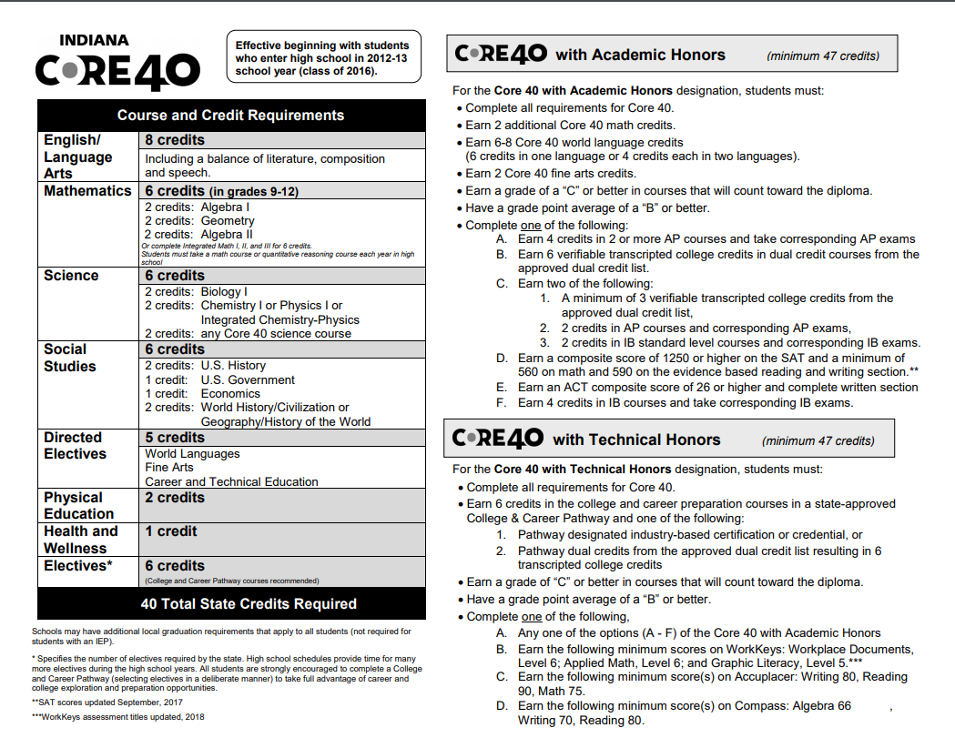

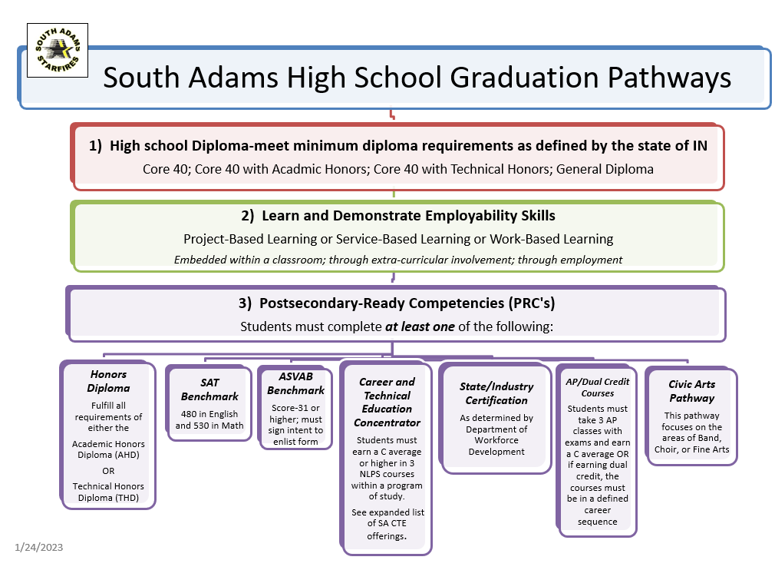

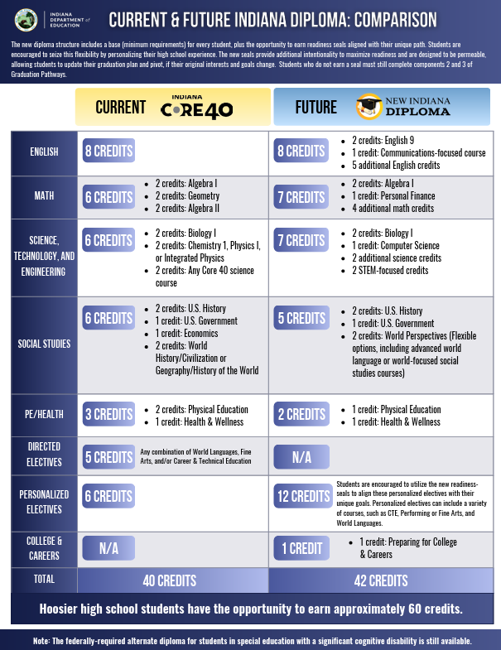

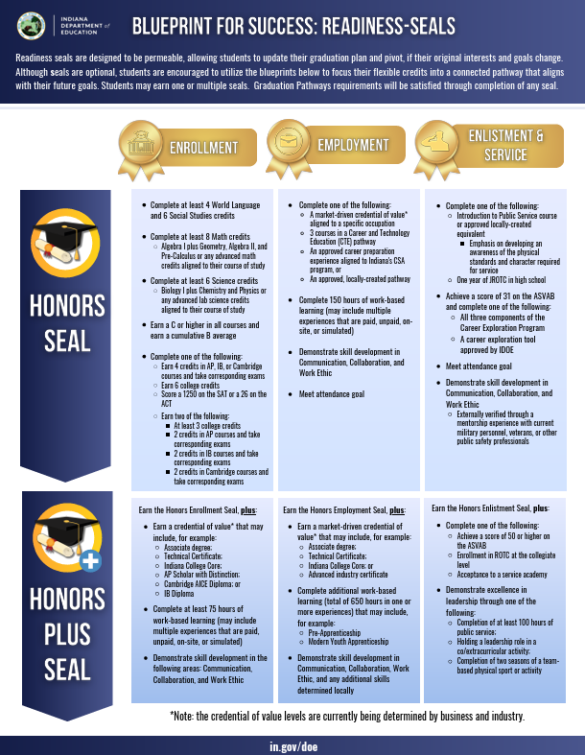

Scheduling Procedures

Beginning with the ninth grade, all credits earned will count toward graduation. Students completing high school courses as 8th graders in 2025-26 will receive credit and their grade will be on their high school transcript unless they choose to retake the course as a 9th grader.

A CREDIT is earned when a student passes a class (one semester) with an A, B, C or D.

A PREREQUISITE is a required course one must take in order to be eligible to take another course.

Example: Spanish I is a prerequisite to Spanish II.

WHEN SCHEDULING CLASSES

Each student should consider course descriptions carefully. Required courses should be considered first, then electives to complete his/her schedule. Courses need to connect to students’ graduation pathway and diploma track.

Each student will meet with their counselor to submit their course request. After this, schedule changes will be made on an “as needed” basis. May 22, 2026 is the last day for schedule changes for the 2026-27 school year. Changes after this point may not be granted.

Attendance, behavior, and tardy records will be considered for enrollment in CTE programs.

GRADUATION INFORMATION

DIPLOMA TYPES - All students are informed about the diploma choices available to them. Current

diploma types are: Core 40, Core 40 w/Technical Honors, Core 40 w/Academic Honors, General and Alternative Diploma. Most colleges and universities are requiring that a student have a minimum of the Core 40 diploma. Any student/family that wants to pursue a General Diploma and withdraw from the Core 40 requirements must meet with the principal and school counselor and sign the designated form indicating a desire to opt out of pursuing the Core 40 diploma.

EARLY GRADUATION - Students who wish to graduate at the end of the first semester of their senior year must declare their intention by December 1st of their junior year or before the first day of school their senior year. Students must have passed ALL Graduation Assessments, must be Core 40 or Core 40 with honors or achieve a General Diploma with CTE Concentration. Students who are early grads will need to be approved to take an Area 18 class; students will work through their counselor for approval. To be eligible for senior awards and/or recognition, a senior must be a student in good standing.

If graduation is desired at the end of the junior year, a request for early graduation under Indiana Code (511 IAC 6-7-4) must be submitted to the principal. Students who wish to graduate in 3 years must meet with their school counselor and principal to create an approved plan.

MINIMUM GRADUATION REQUIREMENTS - In order to graduate from South Adams Schools, students must complete at least 40 credits of high school work with a combination of required core classes and electives for a General Diploma or CORE 40 Diploma. Students wishing to graduate with a CORE 40/Technical Honors or Core 40/Academic Honors Diploma must achieve 47 credits.

PARTICIPATION IN GRADUATION EXERCISES – to participate in South

Adams High School Commencement exercises individuals must meet the

following requirements:

• Must have earned all required credits.

• Must be in good standing for attendance and discipline and all book rental must be paid in full.

• Full Time Students - must pass 5 of 7 classes in their final term.

• Modified day & early graduate students - must pass all classes in the final term.

• Must attend commencement practice.

GRADE CLASSIFICATION - Status is reclassified after each school year and based on original graduation cohort and credits.

Freshman – 0-10 credits Junior – 22-32 credits

Sophomore – 11-21 credits Senior – 33 or more credits

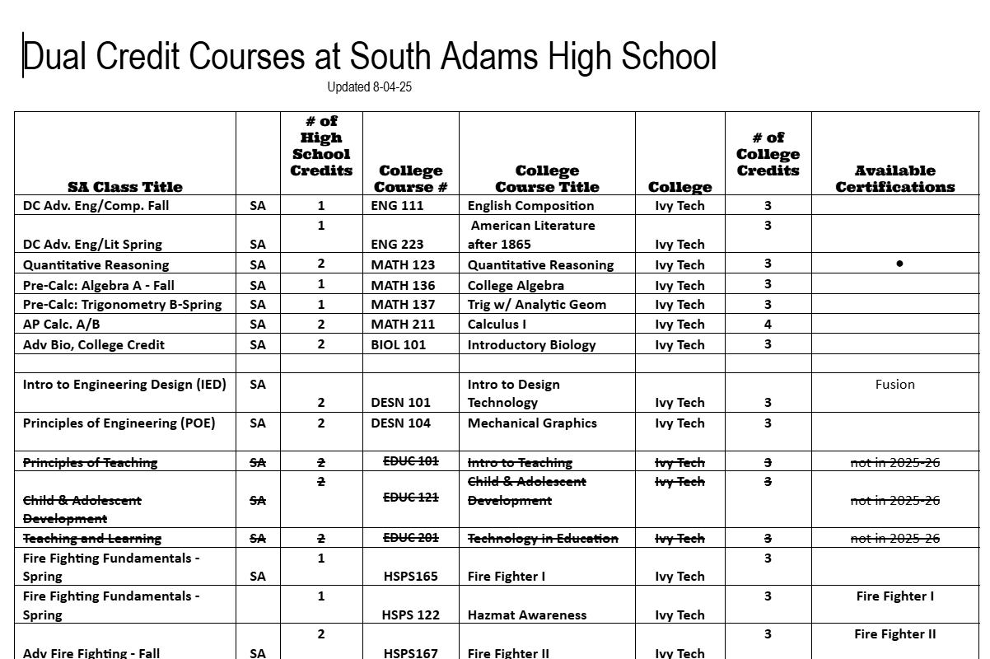

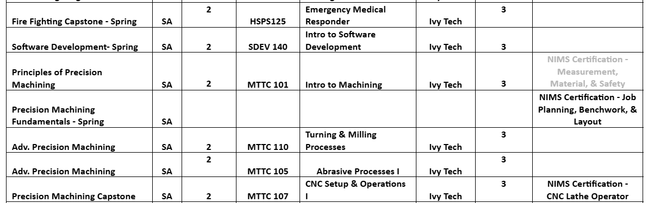

High School CTD Companion Summary Document
The High School CTD Companion Summary document accompanies the CTD during the 2026-2027 school year. It notes course-specific information (e.g., codes and titles, course durations, available credits, recommended and required course prerequisites, dual credit designations) and illustrates which course(s) support a variety of Graduation Pathways. All diploma requirements will be reflected until the current requirements (i.e., Core 40, Academic Honors Diploma and Technical Honors Diploma) sunset for the class of 2028.
Indiana’s Alternate Diploma
The Indiana Alternate Diploma is an available course of study (for student cohorts beginning with the 2018-2019 school year) for students with an Individualized Education Program (IEP) who have been removed from a diploma path as determined by their case conference committees. The Indiana Alternate Diploma provides increased access to the general education curriculum by providing flexibility in earning either credits or applied units in general education or special education classes. The Alternate Diploma can be earned through any combination of applied units and credits. Review IDOE’s Graduation Pathways webpage for more information.
Applied Courses
The courses outlined in this document and denoted with an “(A)” (e.g., “1002 English 9 (A)”) are eligible to serve as “applied” courses for students pursuing an alternate diploma. Educators are encouraged to establish connections between the designated course description and Indiana’s Content Connectors to provide opportunities for real-world application and content relevancy for hands-on learners striving for learning targets at each grade level. Applied courses enable students with a broad spectrum of ability levels to access a variety of course content. Instructional methods, accommodations, and modifications will vary based on the needs of the student (e.g., students with IEPs) and are determined locally.
Laboratory Courses
A laboratory course, identified by (L) in the course title, is one in which a “minimum of twenty-five percent (25%) of the total instructional time is devoted to laboratory activities.” Laboratory activities are those activities in which individual students use appropriate procedures and equipment in accomplishing that learning task.
Honors Courses
Schools may designate a course as “Honors” when the course content is significantly more rigorous than the state-approved course. Honors-level courses must be correlated to a current, approved Indiana course code, have defined criteria for student admission to the course, as well as clear expectations of student outcomes.

Advanced Courses: Non-CTE for College Credit

Advanced Courses for College Credit covers (1) any college-level course offered for credit by an accredited post-secondary institution through an approved agreement with a secondary school, or (2) any other post-secondary course offered for dual credit under the provisions of 511 IAC 6-10. The intent of these courses is to allow schools to award high school credit to students for taking college courses with content that is more advanced than state-approved high school courses.
Dual credit is the term given to courses in which high school students have the opportunity to earn both high school and college credits. Dual credit courses are taught by high school faculty, adjunct college faculty, or college faculty either at the high school or the college/university. This may also include online courses or distance education taught by college faculty. Dual credit is offered by both state and independent (e.g., private, regionally accredited) colleges and universities.
Indiana law requires each Indiana high school to offer a minimum of two dual credit courses.
According to the Indiana Commission for Higher Education’s Policy on Dual Credit Courses Taught in High Schools by High School Faculty, all post-secondary institutions shall generate transcripts for all students who complete advanced courses for dual credit. In order to apply these dual credits toward an Honors Diploma Award, both the secondary and the post- secondary institutions must transcript the credit.
Dual credit courses provide opportunities for qualified students to earn college credit from accredited institutions while attending high school.
1124 Advanced English/Language Arts, College Credit (ADV ENG CC)
Advanced English/Language Arts, College Credit, is an advanced course based on the Indiana Academic Standards for English/Language Arts in grades 11 and 12. This course title covers any English language and composition advanced course offered for credit by an accredited post-secondary institution through an adjunct agreement with a secondary school.
3090 Advanced Science, College Credit DC Biology
(ADV SCI CC)
Advanced Science, College Credit is a title that covers (1) any science course offered for credit by an accredited post-secondary institution through an adjunct agreement with a secondary school, or (2) any other post-secondary science course offered for dual credit under the provisions of 511 IAC 6-10.

Advanced Placement (AP) Courses

1058 AP English Literature and Composition (LIT/COMP AP)
AP English Literature and Composition is a course based on the content established and copyrighted by the College Board. The course is not intended to be used as a dual credit course. The course focuses on reading, analyzing, and writing about imaginative literature (fiction, poetry, drama) from various periods. Students engage in close reading and critical analysis of imaginative literature to deepen their understanding of the ways writers use language to provide both meaning and pleasure. As they read, students consider a work's structure, style, and themes, as well as its use of figurative language, imagery, and symbolism. Writing assignments include expository, analytical, and argumentative essays that require students to analyze and interpret literary works.

1562 AP United States History (US HIST AP)
AP United States History is a course based on the content established and copyrighted by the College Board. The course is not intended to be used as a dual credit course. In AP United States History, students investigate significant events, individuals, developments, and processes from approximately 1491 to the present. Students develop and use the same skills and methods employed by historians: analyzing primary and secondary sources; developing historical arguments; making historical connections; and utilizing reasoning about comparison, causation, and continuity and change. The course also provides eight themes that students explore throughout the course in order to make connections among historical developments in different times and places: American and national identity; work, exchange, and technology; geography and the environment; migration and settlement; politics and power; America in the world; American and regional culture; and social structures.

1612 AP World History Modern (WLD HST MAP)
AP Human Geography is a course based on the content established and copyrighted by the College Board. The course is not intended to be used as a dual credit course. The AP Human Geography course is equivalent to an introductory college-level course in human geography. AP Human Geography introduces students to the systematic study of patterns and processes that have shaped human understanding, use, and alteration of Earth’s surface. Students employ spatial concepts and landscape analysis to examine socio-economic organization and its environmental consequences. They also learn about the methods and tools geographers use in their research and applications. The curriculum reflects the goals of the National Geography Standards (2012).

2562 AP Calculus AB (CALC AB AP)
AP Calculus AB is a course based on the content established and copyrighted by the College Board. The course is not intended to be used as a dual credit course. AP Calculus AB focuses on students' understanding of calculus concepts and provides experience with methods and applications. The course emphasizes modeling change, approximation and limits, and analysis of functions. The course requires students to use definitions and theorems to build arguments and justify conclusions. AP Calculus AB features a multirepresentational approach to calculus, with concepts, results, and problems expressed geographically, numerically, analytically, and verbally. A sustained emphasis on clear communication of methods, reasoning, justifications, and conclusions is essential. Technology should be used in the course to reinforce relationships among functions, to confirm written work, to implement experimentation, and to assist in interpreting results.

2570 AP Statistics (AP STAT)
AP Statistics is a course based on the content established and copyrighted by the College Board. The course is not intended to be used as a dual credit course. The AP Statistics course introduces students to the major concepts and tools for collecting, analyzing, and drawing conclusions from data. There are four themes evident in the content, skills, and assessment in the AP Statistics course: exploring data, sampling and experimentation, probability and simulation, and statistical inference. Students use technology, investigations, problem solving, and writing as they build conceptual understanding.

3080 AP Physics 1: Algebra-Based (L)
(PHYS 1 AP)
AP Physics 1 is a course based on the content established and copyrighted by the College Board. The course is not intended to be used as a dual credit course. AP Physics 1: Algebra-based is an
algebra-based, introductory college-level physics course. Students cultivate their understanding of physics through inquiry-based investigations as they explore these topics: kinematics, dynamics, circular motion and gravitation, energy, momentum, simple harmonic motion, torque and rotational motion. This course requires that 25 percent of instructional time be spent in hands-on laboratory work, with an emphasis on inquiry-based investigations that provide students with opportunities to demonstrate the foundational physics principles and apply the science practices.
skills which are transferable to any future career path. Cambridge Advanced Biology (A Level) is ideal for learners who want to study biology or a wide variety of related subjects at university, or to follow a career in science.

English/Language Arts Courses

1002 English 9 (A)
(ENG 9)
English 9, an integrated English course based on the Indiana Academic Standards for English/Language Arts in Grades 9-10, is a study of language, literature, composition, and oral communication, focusing on literature within an appropriate complexity for this grade level. Students use literary interpretation, analysis, comparisons, and evaluation to read and respond to representative works of historical or cultural significance in classic and contemporary literature balanced with nonfiction. Students write responses to literature; expository (informative); narrative, and argumentative compositions; and sustained research assignments. Students deliver grade-appropriate oral presentations with attention to audience and purpose and access, analyze, and evaluate online information.

1004 English 10 (A)
(ENG 10)
English 10, an integrated English course based on the Indiana Academic Standards for English/Language Arts in Grades 9- 10, is a study of language, literature, composition, and oral communication, focusing on literature with an appropriate complexity for this grade level. Students use literary interpretation, analysis, comparisons, and evaluation to read and respond to representative works of historical or cultural significance in classic and contemporary literature balanced with nonfiction. Students write responses to literature; expository (informative); and argumentative compositions; and sustained research assignments. Students deliver grade-appropriate oral presentations with attention to audience and purpose and access, analyze, and evaluate online information.

1006 English 11 (A)
(ENG 11)
English 11, an integrated English course based on the Indiana Academic Standards for English/Language Arts in Grades 11-12, is a study of language, literature, composition, and oral communication focusing on literature with an appropriate complexity for this grade level. Students use literary interpretation, analysis, comparisons, and evaluation to read and respond to representative works of historical or cultural significance appropriate in classic and contemporary literature balanced with nonfiction. Students write narratives, responses to literature, academic essays (e.g. analytical, argumentative, informative), and more sustained research assignments incorporating visual information in the form of pictures, graphs, charts and tables. Students write and deliver grade-appropriate multimedia presentations and access, analyze, and evaluate online information.

1008 English 12 (A)
(ENG 12)
English 12, an integrated English course based on the Indiana Academic Standards for English/Language Arts for Grades 11- 12, is a study of language, literature, composition, and oral communication focusing on an exploration of perspective across a wide variety of genres. Students use literary interpretation, analysis, comparisons, and evaluation to read and respond to representative works of historical or cultural significance in classic and contemporary literature balanced with nonfiction. Students write narratives, responses to literature, academic essays (e.g. analytical, argumentative, informative), and more sustained research assignments incorporating visual information in the form of pictures, graphs, charts, and tables. Students write and deliver grade-appropriate multimedia presentations and access, analyze, and evaluate online information.

1012 English as a New Language (English/Language Arts) (A) (ENL)
English as a New Language (English/Language Arts), an integrated English course based on the WIDA English Language Development (ELD) Standards, is the study of language, literature, composition and oral communication for English learners (ELs) so that they improve their proficiency in listening, speaking, reading, writing and comprehension of standard English. Students study English vocabulary used in fictional texts and content-area texts, speak and write English so that they can function within the regular school setting and an English-speaking society, and deliver oral presentations appropriate to their respective levels of English proficiency. This coursework addresses Indiana's Academic Standards for English/Language Arts (ELA) and is based on the general ELA curriculum and each student's Individualized Learning Plan.

1076 Speech (A) (SPEECH)
Speech, a course based on the Indiana Academic Standards for English/Language Arts, is the study and application of the basic principles and techniques of effective oral communication. Students deliver focused and coherent speeches that convey clear messages, using gestures, tone, and vocabulary appropriate to the audience and purpose. Students deliver different types of oral and multimedia presentations, including viewpoint, instructional, demonstration, informative, persuasive, and impromptu. Students use the same Standard English conventions for oral speech that they use in their writing.

1078 Advanced Speech and Communication (ADV SPEECH)
Advanced Speech and Communication, a course based on the Indiana Academic Standards for English/Language Arts and emphasizing the communication and collaboration standards, is the study and application of skills in listening, oral interpretation, media communications, research methods, and oral debate. Students deliver different types of oral and multimedia presentations, including speeches to inform, to motivate, to entertain, and to persuade through the use of impromptu, extemporaneous, memorized, or manuscript delivery.

1086 Student Media (A) (STDNT MEDIA)
Student Media, a course based on the High School Journalism Standards and the Student Media Standards, is the continuation of the study of Journalism. Students demonstrate their ability to do journalistic writing and design for high school media, including school newspapers, yearbooks, and a variety of other media formats. Students follow the ethical principles and legal boundaries that guide scholastic journalism. Students express themselves publicly with meaning and clarity for the purpose of informing, entertaining, or persuading. Students work on high school media staffs so that they may prepare themselves for career paths in journalism, communications, writing, or related fields.

Fine Arts Courses

4000 Introduction to Two-Dimensional Art (L) (A) (2D ART)
Introduction to Two-Dimensional Art is a course based on the Indiana Academic Standards for Visual Art. Students taking this course engage in sequential learning experiences that encompass art history, art criticism, aesthetics, production, and integrated studies and lead to the creation of portfolio quality works. Students explore historical and cultural background and connections; analyze, interpret, theorize, and make informed judgments about artwork and the nature of art; create two-dimensional works of art, reflect upon the outcomes, and revise their work; relate art to other disciplines and discover opportunities for integration; and incorporate literacy and presentational skills. They identify ways to utilize and support art museums, galleries, studios, and community resources.

4002 Introduction to Three-Dimensional Art (L) (A) (3D ART)
Introduction to Three-Dimensional Art is a course based on the Indiana Academic Standards for Visual Art. Students taking this course engage in sequential learning experiences that encompass art history, art criticism, aesthetics, production, and integrated studies and lead to the creation of portfolio quality works. Students explore historical and cultural background and connections; analyze, interpret, theorize, and make informed judgments about artwork and the nature of art; create three-dimensional works of art, reflect upon the outcomes, and revise their work; relate art to other disciplines and discover opportunities for integration; and incorporate literacy and presentational skills. They identify ways to utilize and support art museums, galleries, studios, and community resources.

4004 Advanced Two-Dimensional Art (L) (ADV 2D ART)
Advanced Two-Dimensional Art is a course based on the Indiana Academic Standards for Visual Art. Students in this course build on the sequential learning experiences of Introduction to Two-Dimensional Art that encompass art history, art criticism, aesthetics, and production and lead to the creation of portfolio quality works. Students explore historical and cultural background and connections; analyze, interpret, theorize, and make informed judgments about artwork and the nature of art; create
two-dimensional works of art, reflect upon the outcomes, and revise their work; relate art to other
disciplines and discover opportunities for integration; and incorporate literacy and presentational skills. They identify ways to utilize and support art museums, galleries, studios, and community resources.

4006 Advanced Three-Dimensional Art (L) (ADV 3D ART)
Advanced Three-Dimensional Art is a course based on the Indiana Academic Standards for Visual Art. Students in this course build on the sequential learning experiences of Introduction to
Three-Dimensional Art that encompass art history, art criticism, aesthetics, and production and lead to the creation of portfolio quality works. Students explore historical and cultural background and connections; analyze, interpret, theorize, and make informed judgments about artwork and the nature of art; create three-dimensional works of art, reflect upon the outcomes, and revise their work; relate art to other disciplines and discover opportunities for integration; and incorporate literacy and presentational skills. They identify ways to utilize and support art museums, galleries, studios, and community resources.

4020 Advanced Art History (ADV ART HST)
Advanced Art History is a course based on the Indiana Academic Standards for Visual Art. Students in this course engage in sequential learning experiences that encompass art history, art criticism, aesthetics, and production. They build on knowledge and skills developed in Art History. Students continue to study works of art and artifacts from world cultures, engage in historically relevant studio activities; utilize research skills to discover social, political, economic, technological, environmental, and historical trends and connections; analyze, interpret, theorize, and make informed judgments about artwork and the nature of art; relate art to other disciplines and discover opportunities for integration; and incorporate literacy and presentational skills. They utilize the resources of art museums, galleries, and studios, and identify art-related careers.

4024 Art History (A) (ART HIST)
Art History is a course based on the Indiana Academic Standards for Visual Art. Students taking Art History engage in sequential learning experiences that encompass art history, art criticism, aesthetics, and production. Students study works of art and artifacts from world cultures, engage in historically relevant studio activities; utilize research skills to discover social, political, economic, technological, environmental, and historical trends and connections; analyze, interpret, theorize, and make informed judgments about artwork and the nature of art; relate art to other disciplines and discover opportunities for integration; and incorporate literacy and presentational skills. Students utilize the resources of art museums, galleries, and studios, and identify art-related careers.

4046 Fiber Arts (L) (A) (FBR ARTS)
Fiber Arts is a course based on the Indiana Academic Standards for Visual Art. Students in fiber arts engage in sequential learning experiences that encompass art history, art criticism, aesthetics, and production and lead to the creation of portfolio quality works. Students create fiber art works utilizing processes such as loom and off-loom construction, dyeing, coiling, and stitchery. They reflect upon and refine their work; explore cultural and historical connections; analyze, interpret, theorize, and make
informed judgments about artwork and the nature of art; relate art to other disciplines and discover opportunities for integration; and incorporate literacy and presentational skills. Students utilize the resources of art museums, galleries, and studios, and identify art-related careers.

4060 Drawing (L) (A) (DRAWING)
Drawing is a course based on the Indiana Academic Standards for Visual Art. Students in drawing engage in sequential learning experiences that encompass art history, art criticism, aesthetics, and production and lead to the creation of portfolio quality works. Students create drawings utilizing processes such as sketching, rendering, contour, gesture, and perspective drawing and use a variety of media such as pencil, chalk, pastels, charcoal, and pen and ink. They reflect upon and refine their work; explore cultural and historical connections; analyze, interpret, theorize, and make informed judgments about artwork and the nature of art; relate art to other disciplines and discover opportunities for integration; and incorporate literacy and presentational skills. Students utilize the resources of art museums, galleries, and studios, and identify art-related careers.

4064 Painting (L) (A) (PAINTING)
Painting is a course based on the Indiana Academic Standards for Visual Art. Students taking painting engage in sequential learning experiences that encompass art history, art criticism, aesthetics, and production that lead to the creation of portfolio quality works. Students create abstract and realistic paintings, using a variety of materials such as mixed media, watercolor, oil, and acrylics as well as techniques such as stippling, gouache, wash, and impasto. They reflect upon and refine their work; explore cultural and historical connections; analyze, interpret, theorize, and make informed judgments about artwork and the nature of art; relate art to other disciplines and discover opportunities for integration; and incorporate literacy and presentational skills. Students utilize the resources of art museums, galleries, and studios, and identify art- related careers.

4160 Beginning Concert Band (L) (A) (BEG BAND)
Beginning Concert Band is based on the Indiana Academic Standards for High School Instrumental Music. Students taking this course are provided with a balanced comprehensive study of music through the concert band, which develops skills in the psychomotor, cognitive, and affective domains. Ensemble and solo activities are designed to develop elements of musicianship including tone production, technical skills, intonation, music reading skills, listening skills, analyzing music, studying historically significant styles of literature, and integration of other applicable disciplines. Experiences include improvising, conducting, playing by ear, and sight-reading. Students develop the ability to understand and convey the composer's intent in performance of music. Time outside of the school day may be scheduled for rehearsals and performances. A limited number of public performances may serve as a culmination of daily rehearsal and musical goals. Students are required to participate in performance opportunities outside of the school day that support and extend learning in the classroom.

4168 Intermediate Concert Band (L) (INT BAND)
Intermediate Concert Band is based on the Indiana Academic Standards for High School Instrumental Music. This course includes a balanced comprehensive study of music that develops skills in the psychomotor, cognitive, and affective domains. Ensemble and solo activities are designed to develop elements of musicianship including tone production, technical skills, intonation, music reading skills, listening skills, analyzing music, studying historically significant styles of literature, and integration of other applicable disciplines. Students study a varied repertoire of developmentally appropriate concert band literature and develop the ability to understand and convey the composer's intent in performance of music. Time outside of the school day may be scheduled for rehearsals and performances. A limited number of public performances may serve as a culmination of daily rehearsal and musical goals.
Students are required to participate in performance opportunities outside of the school day that support and extend learning in the classroom.

4170 Advanced Concert Band (L) (ADV BAND)
Advanced Concert Band is based on the Indiana Academic Standards for High School Instrumental Music. This course provides students with a balanced comprehensive study of music through the concert band, which develops skills in the psychomotor, cognitive, and affective domains. Ensemble and solo activities are designed to develop elements of musicianship including tone production, technical skills, intonation, music reading skills, listening skills, analyzing music, studying historically significant styles of literature, and integration of other applicable disciplines. Experiences include improvising, conducting, playing by ear, and sight-reading. Students develop the ability to understand and convey the composer's intent in performance of music. Time outside of the school day may be scheduled for rehearsals and performances. A limited number of public performances may serve as a culmination of daily rehearsal and musical goals. Students are required to participate in performance opportunities outside of the school day that support and extend learning in the classroom.

4182 Beginning Chorus (L) (A) (BEG CHOR)
Beginning Chorus is based on the Indiana Academic Standards for High School Choral Music. Students taking Beginning Chorus develop musicianship and specific performance skills through ensemble and solo singing. This class includes the study of quality repertoire in the diverse styles of choral literature appropriate in difficulty and range for the students. Chorus classes provide opportunities for performing, creating, and responding to music. Students develop the ability to understand and convey the composer's intent in performance of music. Time outside of the school day may be scheduled for rehearsals and performances. A limited number of public performances may serve as a culmination of daily rehearsal and musical goals. Students are required to participate in performance opportunities outside of the school day that support and extend learning in the classroom.

4186 Intermediate Chorus (L) (INT CHOR)
Intermediate Chorus is based on the Indiana Academic Standards for High School Choral Music. Students taking Intermediate Chorus develop musicianship and specific performance skills through ensemble and solo singing. This class includes the study of quality repertoire in the diverse styles of choral literature appropriate in difficulty and range for the students. Chorus classes provide opportunities for performing, creating, and responding to music. Students develop the ability to understand and convey the composer's intent in performance of music. Time outside of the school day may be scheduled for rehearsals and performances. A limited number of public performances may serve as a culmination of daily rehearsal and musical goals. Students are required to participate in performance opportunities outside of the school day that support and extend learning in the classroom.

4188 Advanced Chorus (L) (ADV CHOR)
Advanced Chorus is based on the Indiana Academic Standards for High School Choral Music. Students taking Advanced Chorus develop musicianship and specific performance skills through ensemble and solo singing. This class includes the study of quality repertoire in the diverse styles of choral literature appropriate in difficulty and range for the students. Chorus classes provide opportunities for performing, creating, and responding to music. Students develop the ability to understand and convey the composer's intent in performance of music. Time outside of the school day may be scheduled for rehearsals and performances. A limited number of public performances may serve as a culmination of daily rehearsal and musical goals. Students are required to participate in performance opportunities outside of the school day that support and extend learning in the classroom.

4202 Electronic Music (L)
(ELEC MUS)
Electronic Music is based on the Indiana Academic Standards for High School Music Technology. Students taking this course are provided with a wide variety of activities and experiences to develop skills in using electronic media and current technology to perform, create, and respond to music.

4206 Music History and Appreciation (A) (MUS HIST)
Music History and Appreciation is based on the Indiana Academic Standards for Music and standards for this specific course. Students receive instruction designed to explore music and major musical styles and periods through understanding music in relation to both Western and Non-Western history and culture. Activities include analyzing and describing music; evaluating music and music performances; and understanding relationships between music and the other arts, as well as disciplines outside of the arts.

4244 Technical Theater (L) (TECH THTR)
Technical Theatre is based on the Indiana Academic Standards for Theatre. Students enrolled in Technical Theatre actively engage in the process of designing, building, managing, and implementing the technical aspects of a production. These activities should incorporate elements of theatre history, culture, analysis, response, creative process, and integrated studies. Additionally, students explore career opportunities in the theatre, attend and critique theatrical productions, and recognize the responsibilities and the importance of individual theatre patrons in their community

Health and Wellness Courses

3506 Health and Wellness Education (A) (HLTH & WELL)
Health and Wellness is a course based on Indiana’s Academic Standards for Health and Wellness and provides the basis to help students adopt and maintain healthy behaviors. Health education should contribute directly to a student’s ability to successfully practice behaviors that protect and promote health and avoid or reduce health risks. Through a variety of instructional strategies, students practice
the development of functional health information (essential concepts); determine personal values that support healthy behaviors; develop group norms that value a healthy lifestyle; develop the essential skills necessary to adopt, practice, and maintain health-enhancing behaviors. This course includes the application of priority areas in a planned, sequential, comprehensive health education curriculum.
Priority areas include: promoting personal health and wellness, physical activity, and healthy eating; promoting safety and preventing unintentional injury and violence; promoting mental and emotional health, a tobacco- free lifestyle and an alcohol- and other drug-free lifestyle; and promoting human development and family health. This course provides students with the knowledge and skills of health and wellness core concepts, analyzing influences, accessing information, interpersonal communication, decision-making and goal-setting skills, health-enhancing behaviors, and health and wellness advocacy skills.

Mathematics Courses

2520 Algebra I (A) (ALG I)
Algebra I formalizes and extends the mathematics students learned in the middle grades. The Indiana Academic Standards for Algebra I consist of five domains: Number Systems, Expressions, and Functions; Linear Equations, Inequalities, and Functions; Systems of Linear Equations and Inequalities; Quadratic and Exponential Equations and Functions; and Data Analysis & Statistics. These critical areas deepen and extend understanding of linear and exponential relationships by contrasting them with each other and by applying linear models to data that exhibit a linear trend. Students will also engage in methods for analyzing, solving, and using quadratic functions. The eight Process Standards for Mathematics apply throughout the course. Together with the content standards, the Process Standards prescribe that students experience mathematics as a coherent, useful, and logical subject that makes use of their ability to make sense of problem situations.

2522 Algebra II (A) (ALG II)
Algebra II builds on work with linear, quadratic, and exponential functions and allows for students to extend their repertoire of functions to include polynomial, rational, and radical functions. Students work closely with the expressions that define the functions and continue to expand and hone their abilities to model situations and to solve equations, including solving quadratic equations over the set of complex numbers and solving exponential equations using the properties of logarithms. The Indiana Academic Standards for Algebra II consist of six domains: Arithmetic and Structure of Expressions, Equations, and Functions; Function Families; Modeling with Functions and Data; Modeling with Advanced Algebra; Modeling with Data and Statistics; and Modeling with Quantities. The eight Process Standards for Mathematics apply throughout the course. Together with the content standards, the Process Standards prescribe that students experience mathematics as a coherent, useful, and logical subject that makes use of their ability to make sense of problem situations.

2524 Analytical Algebra II (ANA ALG)
Analytical Algebra II builds on previous work with linear, quadratic and exponential functions and extends to include polynomial, rational, and radical functions. Data analysis, statistics, and probability content should be included throughout the course, as students collect and use univariate and bivariate data to create and interpret mathematical models. The Indiana Academic Standards for Analytical Algebra II consist of six domains: Arithmetic and Structure of Expressions, Equations, and Functions; Function Families; Modeling with Functions and Data; Modeling with Advanced Algebra; Modeling with Data and Statistics; and Modeling with Quantities. Additionally, Analytical Algebra II should focus on the application of mathematics in various disciplines including business, finance, science, CTE, and social sciences using technology to model real-world problems with various functions, using and translating between multiple representations. The eight Process Standards for Mathematics apply throughout the course. Together with the content standards, the Process Standards prescribe that students experience mathematics as a coherent, useful, and logical subject that makes use of their ability to make sense of problem situations. The essential standards for Analytical Algebra II are different from those noted for Algebra II, which may support students in a variety of STEM-related and non-STEM post-secondary pursuits.

2527 Calculus (CALC)
Calculus expands a student’s knowledge of topics like functions, graphs, limits, derivatives, and integrals. Additionally, students will review algebra and functions, modeling, trigonometry, etc. Calculus is made up of five strands: Limits and Continuity; Differentiation; Applications of Derivatives; Integrals; and Applications of Integrals. The eight Process Standards for Mathematics apply throughout the course. Together with the content standards, the Process Standards prescribe that students experience mathematics as a coherent, useful, and logical subject that makes use of their ability to make sense of problem situations.

2532 Geometry (A) (GEOM)
Geometry formalizes and extends students’ geometric experiences from the middle grades. Students explore more complex geometric situations and deepen their explanations of geometric relationships, moving towards formal mathematical arguments. The Indiana Academic Standards for Geometry consist of five domains: Geometry Foundations, Triangles, Quadrilaterals and Other Polygons, Circles, and Transformations & Three-Dimensional Solids. Together with the content standards, the Process Standards prescribe that students experience mathematics as a coherent, useful, and logical subject that makes use of their ability to make sense of problem situations.

2550 Quantitative Reasoning (A) (QUANT REAS)
Quantitative Reasoning is a mathematics course focused on the study of numeracy, ratio and proportional reasoning, modeling, probabilistic reasoning to assess risk, and statistics. Students build knowledge of and confidence with basic mathematical/analytical concepts and operations required for problem solving, decision making, and economic productivity in real-world applications and prepare for an increasingly information-based society in which the ability to use and critically evaluate information, especially numerical information, is essential. Technology, such as computers and graphing calculators, should be used frequently. This higher-level mathematics course is designed to align with college-level quantitative reasoning courses for dual secondary/college credit. The eight Process Standards for Mathematics apply throughout the course. Together with the content standards, the Process Standards prescribe that students experience mathematics as a coherent, useful, and logical subject that makes use of their ability to make sense of problem situations.

2564 Pre-Calculus: Algebra (PRECAL AL)
Pre-Calculus: Algebra extends the foundations of algebra and functions developed in previous courses to new functions, including exponential and logarithmic functions, and to sequences and series. The course provides students with the skills and understandings that are necessary for advanced manipulation of angles and measurement. Pre-Calculus: Algebra is made up of five strands: Functions; Quadratic, Polynomial, and Rational Equations and Functions; Exponential and Logarithmic Functions; Sequences and Series; and Conics. The course is designed for students who expect math to be a major component of their future college and career experiences, and as such it is designed to provide students with strong foundations for calculus and other higher-level math courses. The eight Process Standards for Mathematics apply throughout the course. Together with the content standards, the Process Standards prescribe that students experience mathematics as a coherent, useful, and logical subject that makes use of their ability to make sense of problem situations.

2566 Pre-Calculus: Trigonometry (PRECAL TRIG)
Pre-Calculus: Trigonometry provides students with the skills and understandings that are necessary for advanced manipulation of angles and measurement. Trigonometry provides the foundation for common periodic functions that are encountered in many disciplines, including music, engineering, medicine, finance, and nearly all other STEM disciplines. Trigonometry consists of six strands: Unit Circle; Triangles; Periodic Functions; Identities; Polar Coordinates and Complex Numbers; and Vectors.
Students will advance their understanding of imaginary numbers through an investigation of complex numbers and polar coordinates. A strong understanding of complex and imaginary numbers is a necessity for fields such as engineering and computer programming. The eight Process Standards for Mathematics apply throughout the course. Together with the content standards, the Process Standards prescribe that students experience mathematics as a coherent, useful, and logical subject that makes use of their ability to make sense of problem situations.

Multidisciplinary Courses

0500 Basic Skills Development (A) (BAS SKLS)
Basic Skills Development is a multidisciplinary course that provides students continuing opportunities to develop basic skills including: (1) reading, (2) writing, (3) listening, (4) speaking, (5) mathematical computation, (6) note taking, (7) study and organizational skills, and (8) problem-solving skills, which are essential for high school course work achievement. Determination of the skills to be emphasized in this course is based on Indiana’s standards, individual school corporation general curriculum plans, and the student’s Individualized Education Programs (IEP) or other individualized plans. Skills selected for developmental work provide students with the ability to continue to learn in a range of different life situations.

0502 Cadet Teaching Experience (A) (CADET TCHG)
This elective course provides students in grades eleven (11) or twelve (12) organized exploratory teaching experiences in grades kindergarten (K) through grade nine (9). All teaching experiences should be preplanned by the high school Cadet Teaching Experience teacher-trainer and the cooperating teacher(s) who are supervising prospective teachers and providing them with pre-training experiences in one or more classes. This course provides a balance of class work relating to:
(1) classroom organization, (2) classroom management, (3) the curriculum and instructional process,
(4) observations of teaching, and (5) instructional experiences. Study topics and background reading provide the cadets with information concerning the teaching profession and the nature of the cadet teachers’ assignments. Evaluation is based upon the cadet teachers’ cooperation, day-to-day practical performance, and class work including the cadets’ potential ability to teach. The total workload of the Cadet Teaching course is comparable to those for other subjects in the high school curriculum.

0516 Junior Reserve Officer Training Corps (JR ROTC)
This course is designed to develop: (1) citizenship and patriotism, (2) self-discipline, (3) physical fitness, (4) reliance and leadership, and (5) the skills used in decision making, communications, and problem-solving. The course content and experiences enable the students to understand the role of the military in support of national objectives and to become familiar with basic military knowledge, gender equity issues, benefits, and requirements. Topics to be included in the course are: (1) military history,
(2) ROTC in the military, (3) substance abuse, (4) map reading, (5) marksmanship and firearm safety,
(6) military drill, (7) field activities, (8) reserve components, and (9) first aid and hygiene. Opportunities are provided to explore the qualities and traits of courage, self-sacrifice, and integrity. Junior Reserve Officer Training Corps programs must be approved by and meet the requirements of the appropriate military organization.

0522 Career Information and Exploration (A) (CARR INFO)
Career Information and Exploration provides students with opportunities to learn about themselves and about various traditional and nontraditional occupations and careers. Students also gain an awareness of the type of occupational preparation or training needed for various occupations and careers.
Students develop skills in: (1) employability, (2) understanding the economic process, and (3) career decision making and planning. Opportunities are provided for students to observe and participate in various job situations through opportunities such as field trips, internships, mock interviews, and guest speakers. Resume development experience and career- related testing are also provided to students.

0530 Career Exploration Internship (A) (CARR EXP)
The Career Exploration Internship course is a paid or unpaid work experience in the public or private sector that provides for workplace learning in an area of student career interests. Unlike the work-based Learning capstone course in which students gain expertise in a specific occupation, the career exploration internship is intended to expose students to broad aspects of a particular industry or career cluster area by rotating through a variety of work sites or departments. In addition to their workplace learning activities, students participate in 1) regularly scheduled meetings with their classroom teacher, or 2) a regularly scheduled seminar with the teacher for the purpose of helping students make the connection between academic learning and their work-related experiences. Specific instructional standards tied to the career cluster or pathway and learning objectives for the internship must be written to clarify the expectations of all parties – the student, parent, employer, and instructor.

0532 College-Entrance Preparation (A) (COL-ENT PREP)
College-Entrance Preparation utilizes individual student score reports from the PSAT or other formative assessments to prepare students for college readiness assessments such as Indiana’s Graduation Qualifying Exam, the SAT. Based on individual student score reports, students should receive targeted instruction to strengthen their foundations in critical reading, writing, and mathematics. Being “college ready” means being prepared for any post-secondary education or training experience, including readiness for study at two-year and four-year institutions leading to a post-secondary credential (i.e., a certificate, license, associate or bachelor's degree). A college-ready student has the necessary English and mathematics skills to qualify for and succeed in entry-level, credit-bearing college courses without the need for remedial coursework.

0539 Service Based Learning (SBL)
Service-based learning integrates meaningful service to enrich and apply academic knowledge, teach civic and personal responsibility (and other employability skills), and strengthen communities. SBL can be classified by three core indicators: (1) Integrating academic study with service experience, (2) Reflecting larger social, economic, and societal issues, and (3) Collaborative efforts between students, schools, and community partners.

0543 Work-Based Learning Level 1: Employability Skills Development (WBL Lvl 1)
The Work Based Learning Level 1 course may be used to capture and track Career Relevant Learning Experiences that develop career readiness competencies and employability skills. Career Relevant Learning includes the universe of business and career connected experiences and opportunities that allow K-12 and postsecondary students to engage in meaningful conversations around careers and the world of work. This level includes activities that can occur in workplaces or school-based enterprises and involve an employer assigning a student meaningful job tasks to develop his or her skills, knowledge, and readiness for work. Career Relevant Learning includes the universe of business and career connected experiences and opportunities that allow K-12 and postsecondary students to engage in meaningful conversations around careers and the world of work. This level includes paid or non-paid experiential activities that can occur in workplaces or school-based enterprises and involve an employer assigning a student meaningful job tasks to develop his or her skills, knowledge, and readiness for work (e.g., Governor’s Work Ethic Certificate, student entrepreneurial experience, supervised agricultural experience, school-based enterprise, or employability skills co-op or part-time job).

0544 Work-Based Learning Level 2: Internship
(WBL Lvl 2)
The Work Based Learning Level 2 may be used to capture experiences that meet the newly adopted definition of WBL. Work-based Learning is defined as: Sustained interactions between participants (adults/youth) and professionals in real or simulated workplace settings that foster in-depth, firsthand experiences with the tasks required in a given career field, intentionally aligned and evaluated with course/training competencies, while offering participants the opportunity to gain intentional career outcomes. Internships and workplace simulations provide access or advancement in a career field that can serve as the culminating course or event in a student’s chosen career pathway. Through WBL, students have the opportunity to apply the concepts, skills, and dispositions learned in previous pathway coursework in real world workplace settings. Internships may take a variety of forms but can be generally categorized as paid or non-paid workplace simulations, academic or technical internships (i.e., career exploration internships, cadet teaching, health occupations explorations, WBL Capstone, NLPS Capstone, and clinical/practicums).

0545 Work-Based Learning Level 3: Modern Youth Apprenticeship/Pre-Apprenticeship (WBL Lvl 3)
The Work Based Learning Level 3 may be used to capture experiences that meet the newly adopted definition of WBL. Work-based Learning is defined as: Sustained interactions between participants (adults/youth) and professionals in real or simulated workplace settings that foster in-depth, firsthand experiences with the tasks required in a given career field, intentionally aligned and evaluated with course/training competencies, while offering participants the opportunity to gain intentional career outcomes. Modern Youth Apprenticeships are work-based learning programs designed for high school students. They generally incorporate the key elements of the standard apprenticeship model, including paid workplace experience and related technical instruction. Modern youth apprenticeships must result in postsecondary credit and/or industry recognized credentials. Modern youth apprenticeship is a structured, work based learning program with an aligned, competency based education and training plan agreed to by the student, school, and employer that may also include Pre-Apprenticeship

programs. Pre-apprenticeship must be articulated with a registered apprenticeship program and include at least two semesters of related academic instruction eligible for secondary academic credit.

0546 Work-Based Learning Level 4: Federal Registered Apprenticeship (WBL Lvl 4)
The Work Based Learning Level 4 may be used to capture experiences that meet the newly adopted definition of WBL. Work-based Learning is defined as: Sustained interactions between participants (adults/youth) and professionals in real or simulated workplace settings that foster in-depth, firsthand experiences with the tasks required in a given career field, intentionally aligned and evaluated with course/training competencies, while offering participants the opportunity to gain intentional career outcomes. Registered apprenticeships are defined as intensive work-based learning opportunities that generally last from one to six years and provide a combination of on-the-job training and formal classroom instruction. They are intended to support progressive skill acquisition and lead to postsecondary credentials and, in some cases, degrees. Paid U.S. Department of Labor Registered Apprenticeships often involve 2,000 to 10,000 on-the-job hours. Students 16 years-old or older may qualify for an apprenticeship. Per the Indiana General Assembly, any apprenticeship program must be registered under the federal National Apprenticeship Act (29 U.S.C. 50 et seq.) or another federal apprenticeship program.

0547 Project Based Learning (PBL)
Project-based learning allows students to gain knowledge and skills by working for an extended period of time to investigate and respond to an authentic, engaging and complex question, problem, or challenge. The project is framed by a meaningful problem to solve or a question to answer, at the appropriate level of challenge. Students engage in a rigorous, extended process of asking questions, finding resources, and applying information. Students often make their project work public by explaining, displaying and/or presenting it to people beyond the classroom.

3520 Driver Education (DRIVER ED)
Driver Education provides students with the knowledge needed to assist them in developing the skills, habits, and attitudes necessary to interact safely and effectively with other highway users in a wide variety of environments, situations, and conditions. This course should always provide a combination of classroom instruction and behind-the-wheel experiences in on-street environments. Whenever possible, the on-street observations and behind-the-wheel experiences should be supplemented with off street, multiple-car driving range and simulation experiences as listed in IAC 5116-6-7. The Driver Education course also provides for, but is not necessarily limited to, student learning related to: (1) driving skills, (2) traffic laws, (3) the laws of nature, (4) driving attitudes, (5) occupant protection, (6) the effect of physical and mental conditions of the driver, (7) vehicle purchase, (8) insurance and maintenance, (9) the ecology and energy efficiency of various transportation modes, (10) energy efficient driving techniques, and (11) sharing the roadway with other users, including motorcyclists and pedestrians.

Physical Education Courses

3542 Physical Education I (L) (A) (PHYS ED I)
Physical Education I focuses on instructional strategies through a planned, sequential, and comprehensive physical education curriculum which provides students with opportunities to actively participate in at least four of the following: team sports; dual sport activities; individual physical activities; outdoor pursuits; self-defense and martial arts; aquatics; gymnastics; and dance, all of which are within the framework of the skills, knowledge, and confidence needed by the student for a lifetime of healthful physical activity and fitness. Ongoing assessment includes both written and
performance-based skill evaluation. Individual assessments may be modified for individuals with disabilities, in addition to those with IEPs and 504 plans (e.g., chronic illnesses, temporary injuries, obesity). See 511 IAC 7-27-9, 7-27-11.

3544 Physical Education II (L) (A) (PHYS ED II)
Physical Education II focuses on instructional strategies through a planned, sequential, and comprehensive physical education curriculum which provides students with opportunities to actively participate in four of the following areas that were not included in Physical Education I: team sports; dual sport activities; individual physical activities; outdoor pursuits; self-defense and martial arts; aquatics; gymnastics; and dance, all of which are within the framework of the skills, knowledge and confidence needed by the student for a lifetime of healthful physical activity and fitness. Ongoing assessment includes both written and performance-based skill evaluation. Individual assessments may be modified for individuals with disabilities, in addition to those with IEPs and 504 plans (e.g., chronic illnesses, temporary injuries, obesity). See 511 IAC 7-27-9, 7-27-11.

3560 Elective Physical Education (L) (A) (ELECT PE)
Elective Physical Education, a course based on selected standards from Indiana’s Academic Standards for Physical Education, identifies what a student should know and be able to do as a result of a quality physical education program. The goal of a physically educated student is to maintain appropriate levels of cardio-respiratory endurance, muscular strength and endurance, flexibility, and body composition necessary for a healthy and productive life. Elective Physical Education promotes lifetime sport and recreational activities and provides an opportunity for an in-depth study in one or more specific areas. A minimum of two of the following activities should be included: team sports; dual sports activities; individual physical activities; outdoor pursuits; self-defense and martial arts; aquatics; gymnastics; and dance. This course includes the study of physical development concepts and principles of sport and exercise as well as opportunities to develop or refine skills and attitudes that promote lifelong fitness.
Students have the opportunity to design and develop an appropriate personal fitness program that enables them to achieve a desired level of fitness. Ongoing assessment includes both written and performance-based skill evaluation. Individual assessments may be modified for individuals with disabilities, in addition to those with IEPs and 504 plans (e.g., chronic illnesses, temporary injuries, obesity). See 511 IAC 7-27-9, 7-27-11.

Science Courses

3024 Biology I (L) (A) (BIO I)
Biology I incorporates Disciplinary Core Ideas, Science and Engineering Practices, and Crosscutting Concepts to help students gain a three dimensional understanding of Biology topics. Disciplinary Core Ideas for this course include From Molecules to Organisms, Ecosystems, Heredity and Biological Evolution. Instruction focuses on the observation of phenomena to develop an understanding of how scientific knowledge is acquired.

3026 Biology II (L) (BIO II)
Biology II is an advanced laboratory, field, and literature investigations-based course. Students enrolled in Biology II examine in greater depth the structures, functions, and processes of living organisms.
Students also analyze and describe the relationship of Earth’s living organisms to each other and to the environment in which they live. In this course, students refine their scientific inquiry skills as they collaboratively and independently apply their knowledge of the unifying themes of biology to biological questions and problems related to personal and community issues in the life sciences.

3044 Earth and Space Science I (L) (A) (EAS SCI I)
Earth and Space Science incorporates high school Disciplinary Core Ideas, Science and Engineering Practices, and Crosscutting Concepts to help students gain a three dimensional understanding of Earth and Space Science topics. Disciplinary Core Ideas for this course include Earth's Place in the Universe, Earth's Systems, and Human Interaction with Earth's Systems. Instruction focuses on the observation of phenomena to develop an understanding of how scientific knowledge is acquired.

3064 Chemistry I (L) (A) (CHEM I)
Chemistry I incorporates Disciplinary Core Ideas, Science and Engineering Practices, and Crosscutting Concepts to help students gain a three dimensional understanding of Chemistry topics. Disciplinary Core Ideas for this course include Matter and its Interactions and Energy. Instruction focuses on the observation of phenomena to develop an understanding of how scientific knowledge is acquired.

3066 Chemistry II (L) (CHEM II)
Chemistry II is an extended laboratory, field, and literature investigations-based course. Students enrolled in Chemistry II examine the chemical reactions of matter in living and nonliving materials. Based on the unifying themes of chemistry and the application of physical and mathematical models of the interactions of matter, students use the methods of scientific inquiry to answer chemical questions and solve problems concerning personal needs and community issues related to chemistry.

3108 Integrated Chemistry-Physics (L) (A) (ICP)
Integrated Chemistry and Physics incorporates Disciplinary Core Ideas, Science and Engineering Practices, and Crosscutting Concepts to help students gain a three-dimensional understanding of Chemistry and Physics topics. Disciplinary Core Ideas for this course include Matter and its Interactions, Forces, Energy, and Waves and their Applications in Technologies for Information Transfer. Instruction focuses on the observation of phenomena to develop an understanding of how scientific knowledge is acquired.

5276 Anatomy and Physiology (A) (A & P)
Anatomy & Physiology is a course in which students investigate concepts related to Health Science, with emphasis on interdependence of systems and contributions of each system to the maintenance of a healthy body. It introduces students to the cell, which is the basic structural and functional unit of all organisms, and covers tissues, integumentary, skeletal, muscular, and nervous systems as an integrated unit. Through instruction, including laboratory activities, students apply concepts associated with Human Anatomy & Physiology. Students will understand the structure, organization and function of the various components of the healthy body in order to apply this knowledge in all health related fields.

Social Studies Courses

1512 Current Problems, Issues, and Events (A) (CPIE)
Current Problems, Issues, and Events gives students the opportunity to apply investigative and inquiry techniques to the study of significant problems or issues. Students develop competence in (1) recognizing cause and effect relationships, (2) recognizing fallacies in reasoning and propaganda devices, (3) synthesizing knowledge into useful patterns, (4) stating and testing hypotheses, and (5) generalizing based on evidence. Problems or issues selected will have contemporary historical significance and will be studied from the viewpoint of the social science disciplines. Community service programs and internships within the community may be included.

1514 Economics (A) (ECON)
Economics examines the allocation of resources and their uses for satisfying human needs and wants. The course analyzes economic reasoning and behaviors of consumers, producers, savers, investors, workers, voters, institutions, governments, and societies in making decisions. Students explain that because resources are limited, people must make choices and understand the role that supply, demand, prices, and profits play in a market economy. Key elements of the course include the study of scarcity and economic reasoning; supply and demand; market structures; the role of government; national economic performance; the role of financial institutions; economic stabilization; and trade.

1518 Indiana Studies (A) (IN STUDIES)
Indiana Studies is an integrated course that compares and contrasts state and national developments in the areas of politics, economics, history, and culture. The course uses Indiana history as a basis for understanding current policies, practices, and state legislative procedures. It also includes the study of state and national constitutions from a historical perspective and as a current foundation of government. Examination of individual leaders and their roles in a democratic society will be included, and students will examine the participation of citizens in the political process. Selections from Indiana arts and literature may also be analyzed for insights into historical events and cultural expressions.

1538 Topics in History (A) (TOP HIST)
Topics in History provides students the opportunity to study specific historical eras, events, or concepts. Development of historical research skills using primary and secondary sources is emphasized. The course focuses on one or more topics or themes related to United States or world history. Examples of topics might include: (1) twentieth- century conflict, (2) the American West, (3) the history of the United
States Constitution, and (4) democracy in history.

1540 United States Government (A)
(US GOVT)
United States Government provides a framework for understanding the purposes, principles, and practices of constitutional representative democracy in the United States. Responsible and effective participation of citizens is stressed. Students understand the nature of citizenship, politics, and governments and understand the rights and responsibilities of citizens and how these are part of local, state, and national government. Students examine how the United States Constitution protects rights and provides the structure and functions of various levels of government. Analysis of how the United States interacts with other nations and the government’s role in world affairs is included in this course. Using primary and secondary resources, students will articulate, evaluate, and defend positions on political issues. As a result, they will be able to explain the role of individuals and groups in government, politics, and civic activities and the need for civic and political engagement of citizens in the United States.
1542 United States History (A)
(US HIST)
United States History is a two-semester course that builds upon concepts developed in previous studies of U.S. History and emphasizes national development from the late nineteenth century into the twenty-first century. After reviewing fundamental themes in the early development of the nation, students are expected to identify and review significant events, persons, and movements in the early development of the nation. The course then gives major emphasis to the interaction of key events, people, and political, economic, social, and cultural influences in national developments from the late nineteenth century through the present as they relate to life in Indiana and the United States. Students are expected to trace and analyze chronological periods and examine the significant themes and concepts in U.S. History. Students develop historical thinking and research skills and use primary and secondary sources to explore topical issues and to understand the cause for changes in the nation over time.
1546 World Geography (A)
(WORLD GEO)
World Geography allows students to study the interaction of humans and their environments in a world setting. Students study global patterns of physical and cultural characteristics, including the Earth/sun relationship, atmospheric and oceanic circulation, landforms, climate, vegetation, population, economic and political structures, culture, cultural diffusion, and international and interregional connections. Using maps, geographic representations and technology such as geographic information systems (GIS),
students will examine spatial relationships, the interaction of physical and cultural characteristics of designated places, areas, or regions. Students are expected to apply knowledge of geographic concepts and uses of geography to inquiry, research, and use participatory processes. The themes of location, characteristic of place, human/environmental interaction, movement between places, and regions anchor the course content. Emphasized are elements of the National Geography Standards: The World in Spatial Terms, Places and Regions, Physical Systems, Human Systems and Environment and Society.

1548 World History and Civilization (A) (WLD HST/CVL)
World History and Civilization emphasizes events and developments in the past that greatly affected large numbers of people across broad areas and that significantly influenced peoples and places in subsequent eras. Key events related to people and places as well as transcultural interaction and exchanges are examined in this course. Students are expected to compare and contrast events and developments involving diverse peoples and civilizations in different regions of the world. They will examine examples of continuity and change, universality and particularity, and unity and diversity among various peoples and cultures from the past to the present. Students are also expected to practice and process skills of historical thinking and research and apply content knowledge to the practice of thinking and inquiry skills and processes. There will be continuous and pervasive interactions of processes and content, skills and substance, in the teaching and learning of history.

World Language Courses

2120 Spanish I
(SPAN I)
Spanish I, a course based on Indiana’s Academic Standards for World Languages, introduces students to effective strategies for beginning Spanish language learning, and to various aspects of
Spanish-speaking culture. This course encourages interpersonal communication through speaking and writing, providing opportunities to make and respond to basic requests and questions, understand and use appropriate greetings and forms of address, participate in brief guided conversations on familiar topics, and write short passages with guidance. This course also emphasizes the development of reading and listening comprehension skills, such as reading isolated words and phrases in a situational context and comprehending brief written or oral directions. Additionally, students will examine the practices, products, and perspectives of Spanish-speaking culture; recognize basic routine practices of the target culture; and recognize and use situation-appropriate non-verbal communication. This course further emphasizes making connections across content areas and the application of understanding Spanish language and culture outside of the classroom.
2122 Spanish II
(SPAN II)
Spanish II, a course based on Indiana’s Academic Standards for World Languages, builds upon effective strategies for Spanish language learning by encouraging the use of the language and cultural understanding for self-directed purposes. This course encourages interpersonal communication through speaking and writing, providing opportunities to make and respond to requests and questions in expanded contexts, participate independently in brief conversations on familiar topics, and write cohesive passages with greater independence and using appropriate formats. This course also emphasizes the development of reading and listening comprehension skills, such as using contextual clues to guess meaning and comprehending longer written or oral directions. Students will address the
presentational mode by presenting prepared material on a variety of topics, as well as reading aloud to practice appropriate pronunciation and intonation. Additionally, students will describe the practices, products, and perspectives of Spanish-speaking culture; report on basic family and social practices of the target culture; and describe contributions from the target culture. This course further emphasizes making connections across content areas and the application of understanding Spanish language and culture outside of the classroom.
2124 Spanish III
(SPAN III)
Spanish III, a course based on Indiana’s Academic Standards for World Languages, builds upon effective strategies for Spanish language learning by facilitating the use of the language and cultural understanding for self-directed purposes. This course encourages interpersonal communication through speaking and writing, providing opportunities to initiate, sustain, and close conversations; exchange detailed information in oral and written form; and write cohesive information with greater detail. This course also emphasizes the continued development of reading and listening comprehension skills, such as using cognates, synonyms, and antonyms to derive meaning from written and oral information, as well as comprehending detailed written or oral directions. Students will address the presentational mode by presenting student-created material on a variety of topics, as well as reading aloud to practice appropriate pronunciation and intonation. Additionally, students will continue to develop understanding of Spanish-speaking culture through recognition of the interrelations among the practices, products, and perspectives of the target culture; discussion of significant events in the target culture; and investigation of elements that shape cultural identity in the target culture. This course further emphasizes making connections across content areas as well the application of understanding Spanish language and culture outside of the classroom.
2140 World Language Other I
(WLD LANG OTHR I)
Other I, a course based on Indiana’s Academic Standards for World Languages, introduces students to effective strategies for beginning target language learning, and to various aspects of the target culture. This course encourages interpersonal communication through speaking and writing, providing opportunities to make and respond to basic requests and questions, understand and use appropriate greetings and forms of address, participate in brief guided conversations on familiar topics, and write short passages with guidance. This course also emphasizes the development of reading and listening comprehension skills, such as reading isolated words and phrases in a situational context and comprehending brief written or oral directions. Additionally, students will examine the practices, products, and perspectives of the target culture; recognize basic routine practices of the target culture; and recognize and use situation-appropriate non-verbal communication. This course further emphasizes making connections across content areas and the application of understanding the target language and culture outside of the classroom.

2142 World Language Other II
(WLD LANG OTHR II)
Other II, a course based on Indiana’s Academic Standards for World Languages, builds upon effective strategies for target language learning by encouraging the use of the language and cultural understanding for self-directed purposes. This course encourages interpersonal communication through speaking and writing, providing opportunities to make and respond to requests and questions in expanded contexts, participate independently in brief conversations on familiar topics, and write cohesive passages with greater independence and using appropriate formats. This course also emphasizes the development of reading and listening comprehension skills, such as using contextual clues to guess meaning and comprehending longer written or oral directions. Students will address the presentational mode by presenting prepared material on a variety of topics, as well as reading aloud to practice appropriate pronunciation and intonation. Additionally, students will describe the practices, products, and perspectives of the target culture; report on basic family and social practices of the target culture; and describe contributions from the target culture. This course further emphasizes making connections across content areas and the application of understanding the target language and culture outside of the classroom.
2144 World Language Other III
(WLD LANG OTHR III)
Other III, a course based on Indiana’s Academic Standards for World Languages, builds upon effective strategies for target language learning by facilitating the use of the language and cultural understanding for self-directed purposes. This course encourages interpersonal communication through speaking and writing, providing opportunities to initiate, sustain, and close conversations; exchange detailed information in oral and written form; and write cohesive information with greater detail. This course also emphasizes the continued development of reading and listening comprehension skills, such as using cognates, synonyms, and antonyms to derive meaning from written and oral information, as well as comprehending detailed written or oral directions. Students will address the presentational mode by presenting student-created material on a variety of topics, as well as reading aloud to practice appropriate pronunciation and intonation. Additionally, students will continue to develop understanding of the target culture through recognition of the interrelations among the practices, products, and perspectives of the target culture; discussion of significant events in the target culture; and investigation of elements that shape cultural identity in the target culture. This course further emphasizes making connections across content areas as well the application of understanding the target language and culture outside of the classroom.
2188 English as a New Language (English Language Development) (A)
(ENL)
English as a New Language, an integrated English course based on the WIDA English Language Development (ELD) Standards, is the study of language, literature, composition, and oral communication for English learners (ELs) to help them improve their proficiency in listening, speaking,
reading, writing, and comprehension of standard English. Students study English vocabulary used in fictional texts and content-area texts, speak and write English so that they can function within the regular school setting and an English-speaking society, and deliver oral presentations appropriate to their respective levels of English proficiency.

CAREER AND TECHNICAL EDUCATION (CTE)

Advanced Manufacturing

THESE COURSES ARE OFFERED AT SOUTH ADAMS HIGH SCHOOL

7109 Principles of Precision Machining
(PRIN PREC MACH)
Principles of Precision Machining provides students with a basic understanding of the processes used to produce industrial goods. Classroom instruction and labs will focus on shop safety, measurement, layout, blueprint reading, shop math, metallurgy, the use of basic hand tools, milling, turning, grinding, and sawing operations. This course prepares the student for the optional National Institute for Metalworking Skills (NIMS) Measurement, Materials, & Safety Certification, which may be required for college dual credit.

7105 Precision Machining Fundamentals
(MACH FUN)

Precision Machining Fundamentals will build a foundation in conventional milling and turning. Students will be instructed in the classroom on topics of shop safety, theory, industrial terminology, and calculations. Lab work will consist of the setup and operation of vertical and/or horizontal milling machines and engine lathes. This course prepares the student for the optional National Institute for Metalworking Skills (NIMS) Milling I Certification, which may be required for college dual credit.

7107 Advanced Precision Machining

(PREC MACH)
Advanced Precision Machining builds upon the Turning and Milling processes learned in Precision Machining Fundamentals and builds a foundation in abrasive-process machines. Students will be instructed in the classroom on topics of shop safety, theory, industrial terminology, and calculations associated with abrasives. Lab work will consist of the setup and operation of bench grinders and surface grinders. Additionally, students will be introduced to Computerized Numeric Controlled (CNC) setup, operations and programming. This course prepares the student for the optional National Institute for Metalworking Skills (NIMS) Grinding I Certification, which may be required for college dual credit.

7219 Precision Machining Capstone
(PREC MACH CAP)
The Precision Machining Capstone is an in-depth study of skills learned in Precision Machining I, with a stronger focus on CNC setup/operation/programming. Students will be introduced to two axis CNC lathe programming and three axis CNC milling machine programming. Develops the theory of programming in the classroom with applications of the program accomplished on industry-type machines. Studies terminology of coordinates, cutter paths, angle cutting, and linear and circular interpolation. Classroom activities will concentrate on precision set-up and inspection work, as well as machine shop calculations. Students will develop skills in advanced machining and measuring parts involving tighter tolerances and more complex geometry. Throughout the course there will be a continued focus on workplace safety.

Welding Technology

THESE COURSES ARE TAUGHT AT BELLMONT HIGH SCHOOL

7110 Principles of Welding Technology
(PRIN WEL TCH)

Principles of Welding Technology includes classroom and laboratory experiences that develop a variety of skills in oxy-fuel cutting and basic welding. This course is designed for individuals who intend to make a career as a Welder, Technician, Designer, Researcher, or Engineer. Emphasis is placed on safety at all times. OSHA standards and guidelines endorsed by the American Welding Society (AWS) are used. Instructional activities emphasize properties of metals, safety issues, blueprint reading, electrical principles, welding symbols, and mechanical drawing through projects and exercises that teach students how to weld and be prepared for postsecondary and career success.

7111 Shielded Metal Arc Welding
(SHLD MAW)

Shielded Metal Arc Welding involves the theory and application of the Shielded Metal Arc Welding process. Process theory will include basic electricity, power sources, electrode selection, and all aspects pertaining to equipment operation and maintenance. Laboratory welds will be performed in basic weld joints with a variety of electrodes in the flat, horizontal and vertical positions. Emphasis will be placed on developing the basic skills necessary to comply with AWS industry standards.

7101 Gas Welding Processes
(GAS WEL PRC)

Gas Welding Processes is designed to cover the operation of Gas Metal Arc Welding (MIG) equipment. This will include all settings, adjustments and maintenance needed to weld with a wire feed system. Instruction on both short-arc and spray-arc transfer methods will be covered. Tee, lap, and open groove joints will be done in all positions with solid, fluxcore, and aluminum wire. Test plates will be for progress evaluation. Schools may choose to offer the course as a comprehensive MIG Welding course or a combination of introductory MIG and TIG Welding operations.

7226 Welding Technology Capstone
(WELD TECH CAP)
The Welding Technology Capstone course builds upon the knowledge and skills developed in Welding Fundamentals, Shielded Metal Arc Welding, and Gas Metal Arc Welding by developing advanced welding skills in Gas Tungsten Arc Welding (TIG), Pipe Welding, and Fabrication. As a capstone course, students should have the opportunity to apply their knowledge and use skills through an intensive work-based learning experience.

Agricultural Education

The vision and mission of Agricultural Education is: that all people value and understand the vital role of agriculture, food, fiber, and natural resource systems in advancing personal and global well-being; and that students are prepared for successful careers and a lifetime of informed choices in agriculture.

The goals for Agricultural Science and Business students focus on providing learning experiences which will allow them to:

- demonstrate desirable work ethics and work habits.
- apply the basic agricultural competencies and the basic background knowledge in agriculture and related occupations.
- analyze entrepreneurial, business, and management skills needed by students preparing to enter agriculture and related occupations.
- expand leadership and participatory skills necessary for the development of productive and contributing citizens in our democratic society.
- gain effective social and interpersonal communication skills.
- be aware of career opportunities in agriculture and set career objectives.
- acquire job-seeking, employability, and job-retention skills.
- advance in a career through a program of continuing education and life-long learning.
- apply the basic learning skills in reading, writing, and thinking, mathematics, communicating, listening, and studying.
- recognize the interaction of agriculture with governments and economic systems at the local, state, national, and international levels.
- recognize how new technologies impact agriculture and how agriculture impacts the environment.

FFA

The FFA is the career and technical education student organization which is an integral part of the vocational program of instruction in agricultural education. The many activities of the FFA parallel the methodology of the instructional program and are directly related to the occupational goals and objectives. As an integral part of the instructional program, district and state level FFA activities provide students opportunities to demonstrate their proficiency in the knowledge, skills, and attitudes they have acquired in the agricultural science and agricultural business education program of instruction. Students shall be rewarded and recognized for their competence. Agricultural education students demonstrating a high degree of competence in state level FFA activities are highly encouraged to represent their local communities, districts, and state by participating in national FFA activities.

Instructional activities of the FFA require participation of Agricultural Science and Agricultural Business Education students as an integral part of an Agricultural Education course of instruction and, therefore, may be considered an appropriate use of the allotted instructional time; however, vocational student organization activities may not disrupt the instructional time of other academic courses.

5056 Introduction to Agriculture, Food, and Natural Resources
(INT AGFNR)

Introduction to Agriculture, Food and Natural Resources is a two-semester course that is highly recommended as a prerequisite to and as a foundation for all other agricultural classes. Through hands-on learning activities, students are encouraged to investigate areas of agriculture. Students are introduced to the following areas of agriculture: animal science, plant and soil science, food science, horticultural science, agricultural business management, natural resources, agriculture power, structure, and technology, careers in agriculture, leadership, and supervised agricultural experience. An activity and project-based approach is used along with team building to enhance the effectiveness of the student learning activities.

5228 Supervised Agricultural Experience
(SAE)

Supervised Agricultural Experience (SAE) is designed to provide students with opportunities to gain experience in the agriculture field(s) in which they are interested. Students will experience and apply what is learned in the classroom, laboratory and training site to real-life situations with a standards-based plan for learning. Students work closely with their agriculture teacher(s), parents and/or employers to get the most out of their SAE program. This course can be offered each year as well as during the summer session. Curriculum content and competencies need to be varied so that school year and summer session experiences are not duplicative.
7117 Principles of Agriculture
(PRIN AG)

Principles of Agriculture is a two-semester course that will cover the diversity of the agricultural industry and agribusiness concepts. Students will develop an understanding of the role of agriculture in the United States and globally. Students will explore Agriculture, Food, and Natural Resource (AFNR) systems related to the production of food, fiber and fuel and the associated health, safety and environmental management systems. Topics covered in the course range from animals, plants, food, natural resources, ag power, structures and technology, and agribusiness. Participation in FFA and Supervised Agricultural Experiences (SAE) will be an integral part of this course in order to develop leadership and career ready skills.

Ag Mechanical and Engineering

5088 Agriculture Power, Structure, and Technology
(AG POW)

Agriculture Power, Structure and Technology is a two semester, up to six credits, lab intensive course in which students develop an understanding of basic principles of tool selection, operation, maintenance, and management of agricultural equipment in concert with the utilization of technology. Topics covered include: safety, problem solving/troubleshooting, electricity, plumbing, concrete, carpentry, metal technology, engines, emerging technologies, leadership development, supervised agricultural experience, and career opportunities in the area of agriculture power, structure, and technology

7112 Agriculture Structures Fabrication and Design
(AG ST FAB DES)

Agricultural Structures Fabrication and Design is a two-semester course that focuses on metal work, and agricultural structures. This course will allow students to develop skills in welding and metalworking, construction, fabrication, machine components and design while incorporating the engineering design process. Students will also cover safety topics for each area while demonstrating appropriate health and safety standards.

Agri-Science - Plants or Animals

5008 Animal Science
(ANML SCI)

Animal Science is a two-semester program that provides students with an overview of the animal agriculture industry. Students participate in a large variety of activities and laboratory work including real and simulated animal science experiences and projects. All areas that the students study may be applied to both large and small animals. Topics to be covered in the course include: history and trends in animal agriculture, laws and practices relating to animal agriculture, comparative anatomy and physiology of animals, biosecurity threats and interventions relating to animal and human safety, nutrition, reproduction, careers, leadership, and supervised agricultural experiences relating to animal agriculture.

5070 Advanced Life Science, Animals (L)
(ALS ANIML)

Advanced Life Science: Animals is a two-semester course that provides students with opportunities to participate in a variety of activities including laboratory work. Students will explore concepts related to history and trends in animal agriculture as related to animal welfare, husbandry, diseases and parasites, laws and practices relating to handling, housing, environmental impact, global sustainable practices of animal agriculture, genetics, breeding practices, biotechnology uses, and comparative knowledge of anatomy and physiology of animals used in animal agriculture.

ARCHITECTURE & CONSTRUCTION

THESE COURES ARE AT BELLMONT HIGH SCHOOL

Construction Trades

7130 Principles of Construction Trades
(PRIN CON TR)

Principles of Construction Trades prepares students with the basic skills needed to continue in a
construction trade field. Topics will include an introduction to the types and uses for common hand and power tools, learn the types and basic terminology associated with construction drawings, and basic safety. Additionally, students will study the roles of individuals and companies within the construction industry and reinforce mathematical and communication skills necessary to be successful in the construction field.

7123 Construction Trades: General Carpentry
(CON TRD GC)

Construction Trades: General Carpentry builds upon the skills learned in the Principles of Construction Trades and examines the basics of framing. This includes studying the procedures for laying out and constructing floor systems, wall systems, ceiling joist and roof framing, and basic stair layout. Additionally, students will be introduced to building envelope systems.

7122 Construction Trades: Framing and Finishing
(CON TRD FR FIN)

Construction Trades: Framing and Finishing prepares students with advanced framing skills along with interior and exterior finishing techniques. Topics include roofing applications, thermal and moisture protection, exterior finishing, cold-formed steel framing, drywall installation and finishing, doors and door hardware, suspended ceilings, window, door, floor, and ceiling trim, and cabinet installation.

ARTS, AV TECH, AND COMMUNICATIONS

THESE COURSES ARE OFFERED AT JAY COUNTY HIGH SCHOOL

Radio and Television Broadcasting

7139 Principles of Broadcasting

(PRIN BROAD)

The purpose of the Principles of Broadcasting course is to provide entry-level fundamental skills for students who wish to seek or pursue opportunities in the field of broadcasting or mass media. Students will explore the technical aspects of audio and sound design for radio production and distribution, as well as, the technical aspects of video production and distribution.

7306 Audio and Video Production Essentials

(AUD VID PROD)

Audio and Video Production Essentials provides an in-depth study on audio and video production techniques for radio, television, and digital technologies. Students will learn skills necessary for audio production and on-air work used in radio and other digital formats. Additionally, experience will be gained in the development of the video production process; including skills in message development, directing, camera, video switcher, and character generator operations.

7307 Mass Media Production

Mass Media Production will focus on the study of theory and practice in the voice and visual aspects radio and television performance. In addition, this course introduces the skills used to acquire and deliver news stories in a digital media format. Students will learn how to research issues and events, interview news sources, interact with law enforcement and government officials, along with learning to write in a comprehensive news style.

7308 Radio & TV Broadcasting Capstone
(RAD TV BROAD CAP)
This course will cover a variety of domains further building on skills in video production, and broadcast industry practices specific to radio, television, and digital media. Attention will be given to cross-industry synergies, emerging technologies, and the global market for media. Students are highly encouraged to do a video newscast or radio practicum to gain real world experience. In most cases this practicum may be completed through a school-based enterprise.

Fashion and Textiles

7301 Principles of Fashion and Textiles
(PRIN FASH TEXT)
Principles of Fashion and Textiles prepares students for occupations and higher education programs of study related to the entire spectrum of careers in the fashion industry. This course builds a foundation that prepares students for all aspects of the fashion creation process. Major topics include: Basic clothing construction techniques, pattern alterations, and use of commercial patterns.

7302 Textiles, Apparel, and Merchandising
(TEXT APP MERCH)
Textiles, Apparel, and Merchandising provides a comprehensive overview of the textiles, apparel and merchandising industry specific to fashion related goods including the nature of fashion, raw materials and production, designers, retailers, and supporting services.

7303 Advanced Textiles

(ADV TEXT)
Advanced Textiles will focus on the study of textiles concerning fiber, yarn, fabric construction, and finishes which affect the selection, use, and care of textiles.

7304 Fashion and Textiles Capstone
(FASH TEXT CAP)
Fashion Textile Capstone studies the evolution of Western dress from ancient times to the twentieth century. Emphasis on representative style and change over time. Additionally, this course will focus on the Identification of physical features which affect apparel quality. Analysis of ready-to-wear apparel to identify features which produce desirable aesthetic and functional performance is also covered.

BUSINESS MANAGEMENT, MARKETING, FINANCE & ENTREPRENEURSHIP

Business and industry surveys indicate that economic survival in the 21st century will demand that students know and understand both fundamental and technical concepts of business as well as possess the ability to execute these concepts in nearly any setting. All persons, regardless of age, gender, and career aspirations, can benefit from participating in business education.

The mission of Business Technology Education in Indiana is to work cooperatively with the business community to prepare all individuals to live and work as productive citizens in a changing global society by providing essential business experiences, education, and training.
These experiences should actively engage students using instructional strategies that rely on the use of technology and practices that reflect current and emerging business procedures.
4512 Business Math
(BUS MATH)
Business Math is a course designed to prepare students for roles as entrepreneurs, producers, and business leaders by developing abilities and skills that are part of any business environment. A solid understanding of math including algebra, basic geometry, statistics, and probability provides the necessary foundation for students interested in careers in business and skilled trade areas. The content includes mathematical operations related to accounting, banking and finance, marketing, and management. Instructional strategies should include simulations, guest speakers, tours, Internet research, and business experiences.
4562 Principles of Business Management
(PRIN BUS)

Principles of Business Management examines business ownership, organization principles and problems, management, control facilities, administration, financial management, and development practices of business enterprises. This course will also emphasize the identification and practice of the appropriate use of technology to communicate and solve business problems and aid in decision making. Attention will be given to developing business communication, problem-solving, and decision-making skills using spreadsheets, word processing, data management, and presentation software.

Business Administration

5914 Marketing Fundamentals

(MRKT FUN)

Marketing Fundamentals provides a basic introduction to the scope and importance of marketing in the global economy. Emphasis is placed on oral and written communications, mathematical applications, problem-solving, and critical thinking skills as they relate to advertising/promotion/selling, distribution, financing, marketing-information management, pricing, and product/service management.

Marketing and Sales

5918 Strategic Marketing
(STRT MRKT)

Strategic Marketing builds upon the foundations of marketing and applies the functions of marketing at an advanced level. Students will study the basic principles of consumer behavior and examine the application of theories from psychology, social Psychology, and economics. The relationship between consumer behavior and marketing activities will be reviewed.

CTE and WBL Courses

4540 Personal Financial Responsibility
(PRSFINRSP)

Personal Financial Responsibility addresses the identification and management of personal financial resources to meet the financial needs and wants of the individuals and families, considering a broad range of economic, social, cultural, technological, environmental, and maintenance factors. This course helps students build skills in financial responsibility and decision making; analyze personal standards, needs, wants, and goals; identify sources of income, savings, and investing; understand banking, budgeting, record-keeping and managing risk, insurance and credit card debt. A project-based approach and applications through authentic settings such as work based observations and service-learning experiences are appropriate. Direct, concrete applications of mathematics proficiencies in projects are encouraged.

5237 CTSO Leadership Development in Action
(LEAD DEV)

Leadership Development in Action is a project-based course in which students integrate higher order thinking, communication, leadership, and management processes to conduct Career and Technical Student Organizations (CTSO) leadership projects at the local, state, or national level. Each student will create a vision statement, establish standards and goals, design and implement an action plan and timeline, reflect on accomplishments, and evaluate results.

Authentic, independent application through CTSO student-directed programs or projects, internship, community-based study, or in–depth laboratory experience is required. Research and development, interdisciplinary projects, and/or collaboration with postsecondary faculty, community agencies, or organizations are appropriate approaches. Instructor must be a current chapter advisor of an Indiana-recognized CTSO. State and national membership in an Indiana recognized CTSO is required of any student enrolled in this course. Service-learning experiences are highly recommended. Achievement of applicable Career and Technical Education (CTE), academic, and employability standards will be documented through a required student portfolio.

FOUNDATIONAL CAREER TECHNICAL EDUCATION

4565 Computing Foundations for a Digital Age
(COMPFOUND)

Computers and the internet have revolutionized the way we access and disseminate information. As technology continues to change at an ever-increasing pace, the need for students to gain a foundational understanding of computer science is clear. Computing Foundations for a Digital Age is designed to introduce students to five major topics within computer science including computing systems, networks and the internet, data and analysis, algorithms and planning, and impacts of computing. The course introduces foundational computing concepts while exploring current events and building critical thinking, collaboration, problem solving, and other important skills that are invaluable for life in a global and technologically advancing society.

5237 CTSO Leadership Development in Action
(LEAD DEV)

Leadership Development in Action is a project-based course in which students integrate higher order thinking, communication, leadership, and management processes to conduct Career and Technical Student Organizations (CTSO) leadership projects at the local, state, or national level. Each student will create a vision statement, establish standards and goals, design and implement an action plan and timeline, reflect on accomplishments, and evaluate results.

Authentic, independent application through CTSO student-directed programs or projects, internship, community-based study, or in–depth laboratory experience is required. Research and development, interdisciplinary projects, and/or collaboration with postsecondary faculty, community agencies, or organizations are appropriate approaches. Instructor must be a current chapter advisor of an Indiana-recognized CTSO. State and national membership in an Indiana recognized CTSO is required of any student enrolled in this course. Service-learning experiences are highly recommended. Achievement of applicable Career and Technical Education (CTE), academic, and employability standards will be documented through a required student portfolio.

5342 Nutrition and Wellness
(NTRN WLNS)

Nutrition and Wellness is an introductory course valuable for all students as a life foundation and
academic enrichment; it is especially relevant for students interested in careers related to
nutrition, food, and wellness. This is a nutrition class that introduces students to only the basics
of food preparation so they can become self-sufficient in accessing healthy and nutritious foods.
Major course topics include nutrition principles and applications; influences on nutrition and
wellness; food preparation, safety, and sanitation; and science, technology, and careers in
nutrition and wellness. A project-based approach that utilizes higher order thinking,
communication, leadership, management processes, and fundamentals to college and career
success is recommended in order to integrate these topics into the study of nutrition, food, and
wellness. Food preparation experiences are a required component. Direct, concrete
mathematics and language arts proficiencies will be applied. This course is the first in a
sequence of courses that provide a foundation for continuing and post-secondary education in
all career areas related to nutrition, food, and wellness.

Local programs have the option of offering a second version of the course that is
focused more on the fitness aspects of wellness and nutrition. This version may be
taught within the family and consumer sciences department or it may be interdisciplinary
and team taught or co-taught with a teacher licensed in physical education. Such a
course may be differentiated from the regular course offering by using a subtitle in
addition to Nutrition and Wellness. A student may earn credits for multiple versions of the
course. No waiver is required in this instance.

5394 Preparing for College and Careers

(PREP CC)
*Local graduation requirement

Preparing for College and Careers addresses the knowledge, skills, and behaviors all students need to be prepared for success in college, career, and life. The focus of the course is the impact of today’s choices on tomorrow’s possibilities. Topics to be addressed include twenty- first century life and career skills; higher order thinking, communication, leadership, and management processes; exploration of personal aptitudes, interests, values, and goals, examining multiple life roles and responsibilities as individuals and family members, planning and building employability skills, transferring school skills to life and work; and managing personal resources. This course includes reviewing the 16 national career clusters and Indiana's College and Career Pathways, in-depth investigation of one or more pathways, reviewing graduation plans, developing career plans, and developing personal and career portfolios. A project-based approach, including computer and technology applications, cooperative ventures between school and community, simulations, and real-world experiences, is recommended.

5974 Work Based Learning Capstone
(WBL)

Work Based Learning Capstone is a stand-alone course that prepares students for college and career. Work-Based Learning means sustained interactions with industry or community professionals in real workplace settings, to the extent practicable, or simulated environments at an educational institution that foster in-depth, first-hand engagement with the tasks required of a given career field, that are aligned to curriculum and instruction. Work Based Learning Capstone experiences occur in workplaces and involve an employer assigning a student meaningful job tasks to develop his or her skills, knowledge, and readiness for work. A clear partnership agreement and training plan is developed by the student, teacher, and workplace mentor/supervisor to guide the student’s work-based experiences and assist in evaluating achievement and performance. Related Instruction shall be organized and planned around the activities associated with the student’s individual job and career objectives in a pathway and shall be taught during the same semester the student is participating in the work-based experience. For a student to become employable, the related instruction should cover: (a) employability skills, and (b) specific occupational competencies.

6162 Cooperative Education
(COOP EDU)

Cooperative Education is an approach to employment training that spans all career and technical education program areas through school-based instruction and on the job training. Time allocations are a minimum of fifteen hours per week of on-the-job training and approximately five hours per week of school-based instruction, focused on employability skills development. Additionally, all state and federal laws and regulations related to student employment and cooperative education must be followed.
0530 Career Exploration Internship
(CARR EXP)

The Career Exploration Internship course is a paid or unpaid work experience in the public or private sector that provides for workplace learning in an area of student career interests. Unlike the work-based Learning capstone course in which students gain expertise in a specific occupation, the career exploration internship is intended to expose students to broad aspects of a particular industry or career cluster area by rotating through a variety of work sites or departments. In addition to their workplace learning activities, students participate in (1) regularly scheduled meetings with their classroom teacher, or (2) a regularly scheduled seminar with the teacher for the purpose of helping students make the connection between academic learning and their work-related experiences. Specific instructional standards tied to the career cluster or pathway and learning objectives for the internship must be written to clarify the expectations of all parties – the student, parent, employer, and instructor.

7156 Technical Skills Development

(TECH SKL DEV)
The Technical Skills Development course may be used to provide students with the opportunity to apply the technical knowledge and skills learned in a Concentrator A or B course through additional real world learning experiences such as lab activities, project-based learning or a work-based learning experience. Students must be co-enrolled in a Concentrator A and/or B course in order to be enrolled in the Technical Skills Development course.

5974 WBL Capstone

(WBL CAPS)
WBL Capstone is a stand-alone course that provides students the opportunity to gain expertise in a specific occupation aligned to the student’s CTE pathway. This course occurs in real or simulated workplace settings and involves an employer assigning a student meaningful job tasks to develop his or her skills, knowledge, and readiness for work. A clear partnership agreement and training plan is developed by the student, parent or guardian, school, and employer partner to guide the student’s work-based experiences and assist in evaluating achievement and performance. Related instruction shall be organized and planned around the activities associated with the student’s individual job and career objectives in a pathway and shall be taught either on-the-job or in a classroom setting during the same semester the student is participating in the work-based experience. The related instruction should cover: (a) employability skills, and (b) specific occupational competencies to help prepare the student for further education and training or employment within their career pathway.

EDUCATION AND TRAINING
Education Careers

7161 Principles of Teaching
(PRIN TEACH)

This course provides a general introduction to the field of teaching. Students will explore
educational careers, teaching preparation, and professional expectations as well as
requirements for teacher certification. Current trends and issues in education will be examined.
A minimum 20-hour classroom observation experience is required for successful completion of
this course.

7157 Child and Adolescent Development
(CHLD ADL DEV)

Child and Adolescent Development examines the physical, social, emotional, cognitive, and
moral development of the child from birth through adolescence with a focus on the middle years
through adolescence. Basic theories of child development, biological and environmental
foundations of development, and the study of children through observation and interviewing
techniques are explored. The influence of parents, peers, the school environment, culture and
the media are discussed. An observation experiences up to 20 hours may be required for
completion of this course. This course has been approved to be offered for dual credit. Students
pursuing this course for dual credit are still required to meet the minimum prerequisites for the
course and pass the course with a C or better in order for dual credit to be awarded.

7162 Teaching and Learning
(TEACH LRN)

Teaching and Learning provides students the opportunity to apply many of the concepts that
they have learned throughout the Education Professions pathway. In addition to a focus on best
practices, this course will provide an introduction to the role that technology plays in the modern
classroom. Through hands-on experience with educational software, utility packages, and
commonly used microcomputer hardware, students will analyze ways to integrate technology as
a tool for instruction, evaluation, and management.

HEALTH SCIENCES

THESE COURSES ARE TAUGHT AT BELLMONT HIGH SCHOOL.

5272 Introduction to Health Science Careers
(INTRO HS CAREERS)

Introduction to Health Science Careers is an exploratory course designed to provide students
with an opportunity to investigate all aspects of the health science industry. Students will receive
an introduction to healthcare systems and examine a variety of pathways in health science, and
reflect on their own knowledge, skills and interests, to begin to narrow the areas within health
science they want to continue exploring, in preparation for further study in Health Science I.

5276 Anatomy and Physiology (A & P)

Anatomy & Physiology is a course in which students investigate concepts related to Health
Science, with emphasis on interdependence of systems and contributions of each system to the
maintenance of a healthy body. It introduces students to the cell, which is the basic structural
and functional unit of all organisms, and covers tissues, integument, skeletal, muscular and
nervous systems as an integrated unit. Through instruction, including laboratory activities,
students apply concepts associated with Human Anatomy & Physiology. Students will
understand the structure, organization and function of the various components of the healthy
body in order to apply this knowledge in all health-related fields.

Biomedical Sciences

5218 Principles of Biomedical Sciences
(PRIN BIOMED)

Principles of the Biomedical Sciences provides an introduction to this field through “hands-on”
projects and problems. Student work involves the study of human medicine, research processes
and an introduction to bioinformatics. Students investigate the human body systems and various
health conditions including heart disease, diabetes, hypercholesterolemia, and infectious
diseases. A theme through the course is to determine the factors that led to the death of a
fictional person. After determining the factors responsible for the death, the students investigate
lifestyle choices and medical treatments that might have prolonged the person’s life. Key
biological concepts included in the curriculum are: homeostasis, metabolism, inheritance of
traits, feedback systems, and defense against disease. Engineering principles such as the
design process, feedback loops, fluid dynamics, and the relationship of structure to function will
be included where appropriate. The course is designed to provide an overview of all courses in
the Biomedical Sciences program and to lay the scientific foundation necessary for student
success in the subsequent courses. NOTE: This course aligns with the PLTW Principles of
Biomedical Sciences curriculum. Use of the PLTW Curriculum may require additional training
and membership in the PLTW network.

5216 Human Body Systems
(HUMAN SYST)

Human Body Systems is a course designed to engage students in the study of basic human
physiology and the care and maintenance required to support the complex systems. Using a
focus on human health, students will employ a variety of monitors to examine body systems
(respiratory, circulatory, and nervous) at rest and under stress, and observe the interactions
between the various body systems. Students will use appropriate software to design and build
systems to monitor body functions. NOTE: This course aligns with the PLTW Human Body
Systems curriculum. Use of the PLTW Curriculum may require additional training and
membership in the PLTW network.

5217 Medical Interventions
(MED INTERV)

Medical Interventions is a course that studies medical practices including interventions to
support humans in treating disease and maintaining health. Using a project-based learning
approach, students will investigate various medical interventions that extend and improve
quality of life, including gene therapy, pharmacology, surgery, prosthetics, rehabilitation, and
supportive care. Students will also study the design and development of various interventions.
Lessons will cover the history of organ transplants and gene therapy with additional readings
from current scientific literature addressing cutting edge developments. NOTE: This course
aligns with the PLTW Medical Interventions curriculum. Use of the PLTW Curriculum may
require additional training and membership in the PLTW network.

Pre-Nursing / Healthcare Specialist

7168 Principles of Healthcare
(PRIN HLCR)

Principles of Healthcare content includes skills common to specific health career topics such as
patient nursing care, dental care, animal care, medical laboratory, public health, and an
introduction to healthcare systems. Lab experiences are organized and planned around the
activities associated with the student’s career objectives.

5274 Medical Terminology
(MED TERMS)

Medical Terminology prepares students with language skills necessary for effective,
independent use of health and medical reference materials. It includes the study of health and
medical abbreviations, symbols, and Greek and Latin word part meanings, all taught within the
context of body systems. This course builds skills in pronouncing, spelling, and defining new
words encountered in verbal and written information in the healthcare industry. Students have
the opportunity to acquire essential skills for accurate and logical communication, and
interpretation of medical records. Emphasis is on forming a foundation of a medical vocabulary
including; appropriate and accurate meaning, spelling, and pronunciation of medical terms, and
abbreviations, signs, and symbols.

7166 Healthcare Specialist: CNA
(HC SPEC CNA)

The Healthcare Specialist: CNA prepares individuals desiring to work as nursing assistants with
the knowledge, skills and attitudes essential for providing basic care in extended care facilities,
hospitals and home health agencies under the direction of licensed nurses. The course will
introduce students to the disease process and aspects of caring for a long-term care resident
with dementia. Individuals who successfully complete this course are eligible to apply to sit for
the Indiana State Department of Health (ISDH) certification exam for nursing assistants. This
course meets the minimum standards set forth by the ISDH for Certified Nursing Assistant
training and for health care workers in long-term care facilities.

HOSPITALITY AND HUMAN SERVICES

THESE COURSES ARE TAUGHT AT JAY COUNTY HIGH SCHOOL.

Culinary Arts

7173 Principles of Culinary and Hospitality
(PRIN HOSP)

Principles of Culinary and Hospitality is designed to develop an understanding of the hospitality
industry and career opportunities, and responsibilities in the food service and lodging industry.
Introduces procedures for decision making which affects operation management, products,
labor, and revenue. Additionally, students will learn the fundamentals of food preparation, basic
principles of sanitation, service procedures, and safety practices in the food service industry
including proper operation techniques for equipment.

7171 Nutrition
(NUTR)

Nutrition students will learn the characteristics, functions and food sources of the major nutrient
groups and how to maximize nutrient retention in food preparation and storage. Students will be
made aware of nutrient needs throughout the life cycle and to apply those principles to menu
planning and food preparation. This course will engage students in hands-on learning of
nutritional concepts such as preparing nutrient dense meals or examining nutritional needs of
student athletes

7169 Culinary Arts
(CUL ARTS)

Culinary Arts teaches students how to prepare the four major stocks, the five mother sauces (in
addition to smaller sauces) and various soups. Additional emphasis is placed on the further
development of the classical cooking methods. This course will also present the fundamentals
of baking science including terminology, ingredients, weights and measures, and proper use and
care of equipment. Students will produce yeast goods, pies, cakes, cookies, and quick breads.

INFORMATION TECHNOLOGY

7183 Principles of Computing

(PRIN COMP INFO)
Principles of Computing provides students the opportunity to explore how computers can be used in a wide variety of settings. The course will begin by exploring trends of computing and the necessary skills to implement information systems. Topics include operating systems, database technology, cybersecurity, cloud implementations and other concepts associated with applying the principles of good information management to the organization. Students will also have the opportunity to utilize basic programming skills to develop scripts designed to solve problems. Students will learn about algorithms, logic development, and flowcharting.

Software Development

7253 Software Development Capstone
(SW DEV CAP)
The Software Development Capstone provides students with basic programming concepts such as sequence, iteration and decision structures, variables and constants, and functions and advances concepts such as searches, sorts, collections, dictionaries, arrays, and linked lists. This course focuses on logical program design using a modular approach involving task-oriented program functions such as methods, attributes, inheritance, exception handling, and polymorphism. Students will develop a basic understanding of the fundamental concepts involved when using the Java programming development language. This capstone course also provides fundamental and advanced concepts of the Python programming language. Students are required to demonstrate course objectives through the appropriate Oracle Java Certification exam preparation materials.
This course covers topics in C++ programming language with an emphasis on classes, advanced debugging techniques, pointers, dynamic memory allocation, and data allocation. Students will be introduced to object-oriented design and programming concepts using C++ language features. The Software Development Capstone course provides an understanding of fundamental and advanced concepts of the C# programming language. The course emphasis will be on creating industry standard programs using current programming design software.

7185 Database Development
(DATA DEV)

Website and Database Development will provide students a basic understanding of the
essential Web and Database skills and business practices that directly relate to Internet
technologies used in Web site and Database design and development. Students will learn to
develop Web sites using Hypertext Markup Language (HTML) and Cascading Style Sheets
(CSS). Additionally, students will be introduced to the basic concepts of databases including
types of databases, general database environments, database design, normalization and
development of tables, queries, reports, and applications. Students will be familiarized with the
use of ANSI Standard Structured Query Language. Students will be introduced to data concepts
such as data warehousing, data mining, and BIG Data. Students will develop a business
application using database software such as Microsoft Access.

7184 Software Development
(SOFT DEV)

Software Development introduces students to concepts and practices of programming
languages and software development. Students are introduced to algorithms and development
tools used to document/implement computer logic. Discusses the history of software
development, the different types of programming such as real time processing, web/database
applications, and different program development environments. Concepts will be applied using
different programming languages, and students will develop and test working programs in an
integrated system.

PUBLIC SAFETY
Fire and Rescue

7195 Principles of Fire and Rescue
(PRIN FIRE RES)

Principles of Fire and Rescue introduces students to the various roles that firefighters and
emergency services workers play to protect the public from the loss of life and property. They
are frequently the first emergency personnel at the scene of a traffic accident or medical
emergency and may be called upon to put out a fire, treat injuries or perform other vital
functions. This course will introduce students to the history, terminology, and basic firefighting
skills needed for a beginning firefighter. Additionally, students will develop a career plan for a
career in public safety; including areas of Fire Science, Homeland Security, and Emergency
Medical Services.

7189 Fire Fighting Fundamentals
(FIRE FGHT FUN)

Fire Fighting Fundamentals is for those students who are seeking certification as a firefighter.
This course will prepare students for the Hazardous Materials Awareness and Operations
certifications and will introduce students to NFPA 1001 which serves as the standard of
measurement for all fire fighters in North America. Students will learn the knowledge and
hands-on practical skills for managing and controlling a hazardous materials incident required
for the certifications. Furthermore, students will study how a fire behaves and will learn the basic
firefighting skills needed to extinguish a fire while protecting themselves and other firefighters.

7186 Advanced Fire Fighting
(ADV FIRE FGHT)

Advanced Fire Fighting expands upon the principles and techniques of firefighting learned in
Fire Fighting Fundamentals. Students will study fire protection systems, firefighter safety and
survival. Students will also learn what fire is, the chemical hazards of combustion, and related
by-products of fire. Additionally, students will gain a better understanding of fire department
organization, administration, operations, and basic strategies and tactics.

7229 Fire and Rescue Capstone

(FIRE RES CAP)
Fire and Rescue Capstone will prepare students to earn the EMT certification.

THE COURSES BELOW ARE TAUGHT AT BELLMONT HIGH SCHOOL.

Criminal Justice

7193 Principles of Criminal Justice
(PRIN CR JUST)

Principles of Criminal Justice covers the purposes, functions, and history of the three primary
parts of the criminal justice system: law enforcement, courts, and corrections. This course
further explores the interrelationships and responsibilities of these three primary elements of the
criminal justice system.
7191 Law Enforcement Fundamentals
(LAW ENF FUND)

Law Enforcement Fundamentals Critically examines the history and nature of the major
theoretical perspectives in criminology, and the theories found within those perspectives.
Analyzes the research support for such theories and perspectives, and the connections
between theory and criminal justice system practice within all the major components of the
criminal justice system. Demonstrates the application of specific theories to explain violent and
non-violent criminal behavior on both the micro and macro levels of analysis. Additionally, this
course will introduce fundamental law enforcement operations and organization. This includes
the evolution of law enforcement at federal, state, and local levels.

7188 Corrections and Cultural Awareness
(CRT CORR)

Corrections and Cultural Awareness emphasizes the study of American criminal justice
problems and systems in historical and cultural perspectives, as well as discussing social and
public policy factors affecting crime. Multidisciplinary and multicultural perspectives are
stressed. Additionally, this course takes a further examination of the American correctional
system; the study of administration of local, state, and federal correctional agencies. The
examination also includes the history and development of correctional policies and practices,
criminal sentencing, jails, prisons, alternative sentencing, prisoner rights, rehabilitation, and
community corrections including probation and parole. Current philosophies of corrections and
the debates surrounding the roles and effectiveness of criminal sentences, institutional
procedures, technological developments, and special populations are discussed.

7231 Criminal Justice Capstone

(CRIM JUST CAP)
The Criminal Justice Capstone course allows students to complete additional instruction to earn a postsecondary certificate and should include a work-based learning component such as job shadowing, internship, etc. once the core content is completed.

SCIENCE, TECHNOLOGY, ENGINEERING, & MATH (STEM)

7199 Engineering Essentials
(ENG ESS)

Engineering Essentials is designed as a first-exposure experience to inspire students of all
backgrounds to explore the breadth of engineering-related career opportunities. Throughout the
course, students explore global engineering challenges and sustainability goals, the impact of
engineering, and the variety of career paths available to them. Students will understand the
various disciplines within the engineering field, approach and solve problems in different ways,
use a variety of industry tools, and build an engineering mindset. NOTE: This course aligns with
the PLTW Engineering Essentials curriculum. Use of the PLTW curriculum may require
additional training and membership in the PLTW network.

Engineering

4802 Introduction to Engineering Design
(INT ENG DES)

Introduction to Engineering Design is a fundamental pre-engineering course where students become familiar with the engineering design process. Students work both individually and in teams to design solutions to a variety of problems using industry standard sketches and current 3D design and modeling software to represent and communicate solutions. Students apply their knowledge through hands-on projects and document their work with the use of an engineering notebook. Students begin with completing structured activities and move to solving open-ended projects and problems that require them to develop planning, documentation, communication, and other professional skills. Ethical issues related to professional practice and product development are also presented. NOTE: This course aligns with the PLTW Introduction to Engineering Design curriculum. Use of the PLTW curriculum may require additional training and membership in the PLTW network.
5644 Principles of Engineering
(PRNC ENG)

Principles of Engineering is a course that focuses on the process of applying engineering, technological, scientific and mathematical principles in the design, production, and operation of products, structures, and systems. This is a hands-on course designed to provide students interested in engineering careers to explore experiences related to specialized fields such as civil, mechanical, and materials engineering. Students will engage in research, development, planning, design, production, and project management to simulate a career in engineering. The topics of ethics and the impacts of engineering decisions are also addressed. Classroom activities are organized to allow students to work in teams and use modern technological processes, computers, CAD software, and production systems in developing and presenting solutions to engineering problems. Schools may use the PLTW curriculum to meet the standards for this course. NOTE: This course aligns with the PLTW Principles of Engineering curriculum. Use of the PLTW curriculum may require additional training and membership in the PLTW network.

5518 Aerospace Engineering
(AERO ENG)

Aerospace Engineering should provide students with the fundamental knowledge and experience to apply mathematical, scientific, and engineering principles to the design, development, and evolution of aircraft, space vehicles and their operating systems. Emphasis should include investigation and research on flight characteristics, analysis of aerodynamic design, and impact of this technology on the environment. Classroom instruction should provide creative thinking and problem-solving activities using software that allows students to design, test, and evaluate a variety of air and space vehicles, their systems, and launching, guidance and control procedures. NOTE: This course aligns with the PLTW Aerospace Engineering curriculum. Use of the PLTW curriculum may require additional training and membership in the PLTW network.

THIS COURSE IS TAUGHT AT ADAMS CENTRAL HIGH SCHOOL.
4818 ENVIRONMENTAL SUSTAINABILITY
(ENV SUS)
Environmental Sustainability is a specialization course that builds upon prior knowledge learned in previous engineering and science courses. Students investigate and design solutions in response to current challenges such as providing the world with clean and abundant drinking water, an adequate food supply, and renewable energy. Students are introduced to environmental issues and use the engineering design process to design, build, and test potential solutions. This course engages critical thinking and problem-solving skills as students apply and extend their knowledge through designing experiments, managing projects, conducting research, and creating presentations to communicate solutions.
5650 Civil Engineering and Architecture
(CIVIL ENG)

Civil Engineering and Architecture introduces students to the fundamental design and development aspects of civil engineering and architectural planning activities. Application and design principles will be used in conjunction with mathematical and scientific knowledge. Computer software programs should allow students opportunities to design, simulate, and evaluate the construction of buildings and communities. During the planning and design phases, instructional emphasis should be placed on related transportation, water resource, and environmental issues. Activities should include the preparation of cost estimates as well as a review of regulatory procedures that would affect the project design. NOTE: This course aligns with the PLTW Civil Engineering and Architecture curriculum. Use of the PLTW Curriculum may require additional training and membership in the PLTW network.

TRANSPORTATION

THESE COURSES ARE TAUGHT AT SOUTH ADAMS HIGH SCHOOL.

Automotive Service Technology

Automotive Service prepares students for the Automotive and Light Truck Industries. Classroom learning and hands-on experience provide the job entry skills needed for virtually every mechanical industry worldwide, including but not limited to: Automotive, Heavy Truck, Agriculture, Heavy Equipment and Powersports.

Auto Service is a task-oriented project based hands-on class, with classroom activities intended to reinforce skills and safety used in today’s high paying, high security careers.

7213 Principles of Automotive Services
(PRIN AUTO SER)

This course gives students an overview of the operating and general maintenance systems of the modern automobile. Students will be introduced to the safety and operation of equipment and tools used in the automotive industry. Students will study the maintenance and light repair of automotive systems. Also, this course gives students an overview of the electrical operating systems of the modern automobile. Students will be introduced to the safety and operation of equipment and tools used in the electrical diagnosis and repair in the automotive electrical industry. Students will study the fundamentals of electricity and automotive electronics.

7205 Brake Systems
(BRK SYS)

This course gives students an in-depth study of vehicle electrical systems. Students will study the fundamentals of electricity and automotive electronics in various automotive systems. Additionally, it teaches theory, service and repair of automotive braking systems. This course provides an overview of various mechanical brake systems used on today’s automobiles. This course will emphasize professional diagnosis and repair methods for brake systems.

7212 Steering and Suspensions
(STEER SUSP)

This course will study driveline theory and in-car service procedures. Theory and overhaul procedures related to the driveshaft and axle assemblies for front and rear wheel drive vehicles are included as well. Additionally, this course teaches theory, service and repair of automotive steering and suspension systems. It provides an overview of various mechanical, power, and electrical steering and suspension systems used on today’s automobiles and will emphasize professional diagnosis and repair methods for steering and suspension systems.

7375 Automotive Service Capstone
(AUTO SRV CAP)

This course further explores important skills and competencies within the Automotive Service
Technology Pathway. Students will be exposed to an in-depth study of vehicle electrical
systems. Students will study the fundamentals of electricity and automotive electronics in
various automotive systems. Students will understand other topics such as Engine Repair,
Climate Control, and Driveline Service. Additionally, Co-Op and Internship opportunities will be
available for students.

