KAMIAKIN MIDDLE SCHOOL HANDBOOK
Motto: We come here to grow!
Mission: Together we create an environment where each student feels that they belong, makes academic and social progress, feels safe to make mistakes, and engages with their learning with confidence.
The KaMS Way: We are Kind and Accepting. We Make Progress. We value Safety. We are KaMS!

School Website: Kamiakin Middle School (lwsd.org)
School Hours: 7:50 am- 2:25 pm (Wednesday: 7:50 am-12:40 pm)
School Colors: Maroon & Gold Mascot: Cougar
Address: 14111 132nd Ave Ne Kirkland, WA 98034
Main phone: (425) 936-2400
Attendance line: (425) 936-2401 Email: KAMSAttend@lwsd.org Notify office within 48 hours of absences
Transportation: (425) 936-1120 Email: busroutes@lwsd.org
Nutrition services: (425) 936-1393 Email: NutritionServ@lwsd.org
LWSD Students & Families: Students & Families - Lake Washington School District

Table of Contents
A Quick KaMS Reference for Families 2
Communication 3
Safety and Well Being 5
Attendance 12
Resources 14
Academics 15
KaMS Policies for Electronic Devices 17
Athletics 19

A Quick KaMS Reference for Families
General Supplies: 1 box of 24 pencils, 2 erasers, 2 pencil sharpeners, 1 box of colored pencils, 3 graph composition notebooks (1 for math, 1 for science, 1 for STEM or other, elective class-Spiral bound notebooks are OK) 2 composition notebooks (regular lined), small calculator, headphones that connect to laptop (with built in microphones preferred).

School-to-Home Communication via ParentSquare or Email: All teachers can be contacted through ParentSquare. Messages on ParentSquare can be set up to automatically translate any message into the language of your choice. You can access ParentSquare here.
Check ParentSquare regularly. All schoolwide communication will come from ParentSquare.
You can also email any staff member you need to contact. A full list of email addresses can be found on the school website.

Skyward - Parent Access: Skyward is the system our district uses to post grades. Please verify and access all student and family information via Skyward (Parent Access) on the Lake Washington School District website (www.lwsd.org).

ASB (All Student Body): At the beginning of the year, it is a good idea to purchase an ASB card. This will allow the student to participate in sports, clubs, school dances and other activities. The price of the card is $30. If you qualify for Free/reduced lunch, then this fee can be waved. The procedures for waiving the fee are linked here.
School Lunch: Families will need to pay for School Lunch unless they qualify and have completed the application process for Free and Reduced Lunch at www.myschoolapps.com and consent to share eligibility information on the application in Skyward.
Adding money to a lunch account: There are different ways to add money to a student’s lunch account:
Parents are encouraged to sign up on MySchoolBucks.com to easily update student lunch accounts, monitor student eating choices, and preview menus. Or you can contact nutritionserv@lwsd.org ; 425-936-1393 to update a lunch account or get additional information.
Send cash or a check made payable to LWSD to the school kitchen with your child’s name attached. Students can bring checks or cash to the KaMS kitchen in the morning before school, or during lunchtime.

Free and Reduced Information: Families who are eligible for free and reduced meals and have fees waived for ASB cards, sports participation and other extracurricular activities. For more information, please visit the LWSD.org website-Breakfast and Lunch Menus - Lake Washington School District (lwsd.org). Families that previously qualified for free or reduced-priced meal benefits will need to reapply to continue receiving district-supported fee reductions and benefits. Benefits and reduced fees available to families who qualify for free and reduced meals may include: PEBT, ASB cards, athletic fees and other extracurricular non-credit activities. To apply please visit https://www.myschoolapps.com Note: Children of parents who qualify for Basic Food, formerly known as food stamps, are automatically enrolled in the free lunch program. For more information, go to www.foodhelp.wa.gov.
If you need help, please contact your counselor: Melissa Pierson (A-L) or Liz Biell (M-Z). https://www.lwsd.org/students-families/breakfast-and-lunch-menus

Pantry Packs: Hopelink is an organization that provides free snacks and meal options for the weekends. Students can pick up pantry-packs from the counseling office on Friday afternoons. Talk to a counselor for more information.

Communication
Communication is the most vital link in our school community. This is accomplished in a variety of ways.
ParentSquare is the preferred way to communicate with teachers and staff members. If students or parents have a question, concern or commentary, they should reach out directly to the teacher.
You can also contact teachers through email. All staff emails can be found on our website. Phone calls during working hours to teachers will be sent to their email for follow-up at a later time.
Families will receive regular ParentSquare communication from our Principal, Elise Lamont. Please check ParentSquare regularly as there will often be important all school updates shared on a weekly basis.
School Letters/Notices: Additional information deemed necessary by the district, or our school will be mailed, emailed or hand carried to the home of each student.
Email: All teacher e-mails can be found on our school website. Communicating with staff via email follows this pattern in most cases: First initial of the first name + last name@lwsd.org
For example: Elise Lamont would be elamont@lwsd.org
Check your email regularly. Schoolwide communication will come from ParentSquare.
Principal: Elise LaMont | elamont@lwsd.org
Attendance Office Professional: Melissa Swanger | KAMSAttend@lwsd.org
Health Secretary: Jessica Hrcek | jhrcek@lwsd.org
Registrar: Sheetal Kulkarni | skulkarni@lwsd.org
Counselor (A-L): Melissa Pierson | mpierson@lwsd.org
Associate Principal (A-L): Stacey Conley | sconley@lwsd.org
Counselor (M-Z): Liz Biell | ebiell@lwsd.org
Associate Principal (M-Z): Jo Richards | jrichards@lwsd.org
Dean of Students: Morgan Douglas | mordouglas@lwsd.org
School Safety and Prevention Specialist: Lele Te’o | lteo@lwsd.org
AP Office Professional/ASB: Jen Lacey | jlacey@lwsd.org
Office Manager: Kelly Wilkinson | kwilkinson@lwsd.org
Community Engagement at KaMS: Jessica Williams | jwilliams@lwsd.org
Community in Schools at KaMS: Cyrus Malapajo | c-cmalapajo@lwsd.org
ASB/Leadership Advisor: Tyler Paris | tparis@lwsd.org
Athletic Director: Neil Kells | nkells@lwsd.org

Websites:
Platform | Purpose | Description
School Website: | Resources | The school website is a great tool that will allow you to look up teachers emails, announcements and a copy of this handbook are just some of the things that you can find here.
ParentSquare: | Communication | ParentSquare is a tool used to communicate with families. The district and school will use this tool. The link to set up your account is found here.
Skyward Access: | Grades  Records  Attendance | The Lake Washington School District has a system which allows students and parents/guardians to access student records including grades and attendance via the internet. By registering for Parent Access, families will have access to general student information, attendance, grades, lunch account balances and volunteer applications. One log-in links parents to all students in their family. Additional district publications are available by personal request to the District Administration offices at 425-702-3200.
Counseling
Counselors are here to support students with a variety of needs, resources and guidance! Stop by the counseling center or click on the button on the KaMS website to make an appointment to see your counselors. Counseling - Kamiakin Middle School
Counselors…
• Provide support on academic concerns
• Support on issues relating to the health of students
• Support on bullying/harassment issues
• Support on friendship issues
• Conflict resolution
• Small group guidance
• Scheduling assistance
• Accessing resources to support student attendance including clothing, food, school supplies, and future scholarships
Students whose last name begins with A – L are supported by Ms. Pierson: mpierson@lwsd.org
Students whose name begins with M – Z are supported by Ms. Biell: ebiell@lwsd.org.
If there is an emergency safety concern, please notify a teacher or any other staff member right away.
Youth Eastside Services provides behavioral health services, counseling, and school-based services.
Community in Schools (CIS) provides resources and support for students and families, addressing the unique needs of students to ensure they have equal opportunities to reach their full potential. Cyrus Malapajo can be reached at c-cmalapajo@lwsd.org.

Safety and Well Being
At Kamiakin, we teach students to live by the KaMS way, all day.
- The K in KaMS stands for Kind.
- The A in KaMS stands for Accepting.
- The M in KaMS stands for Makes Progress.
- The S in KaMS stands for Safe.
This is what we teach at the beginning of the year to support a positive learning environment. Teachers recognize students who are demonstrating these behaviors using KaMS Tickets.

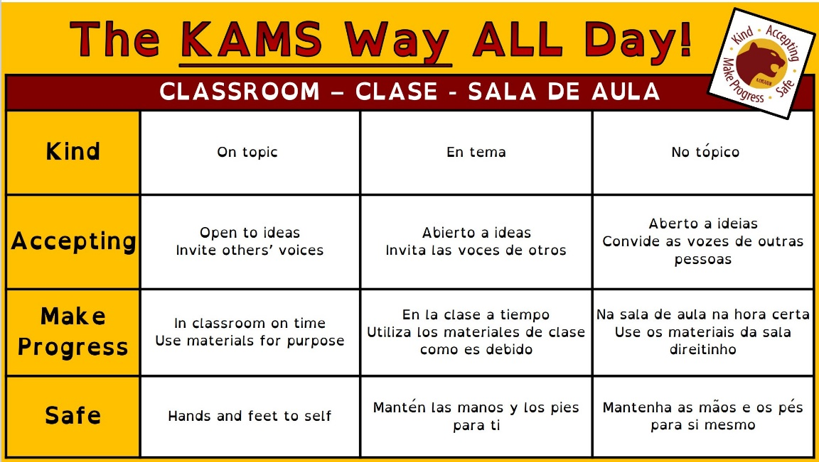
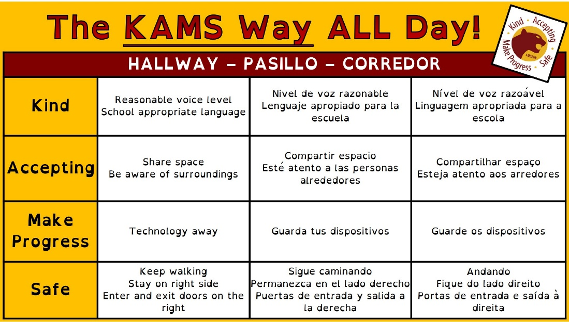

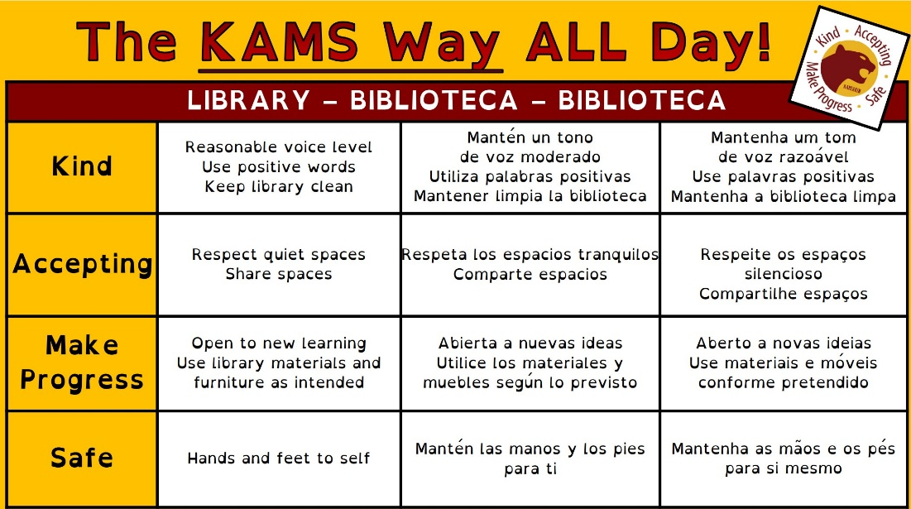
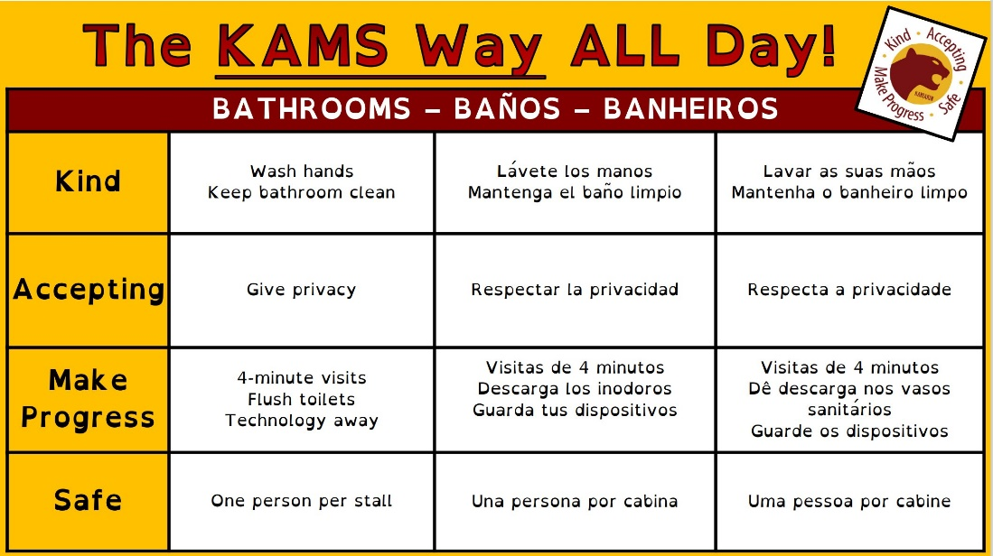

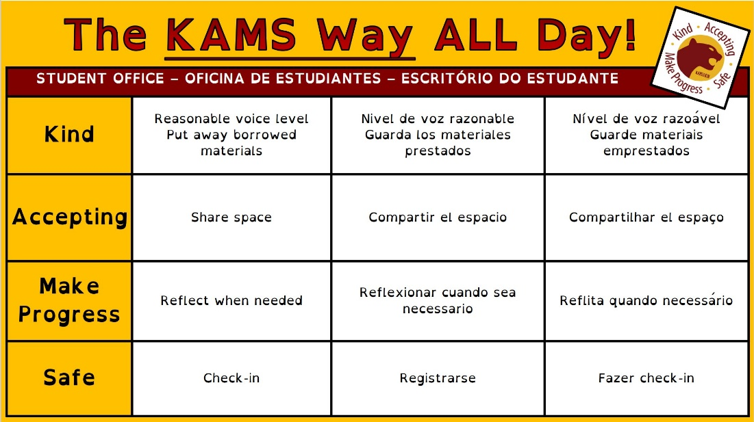
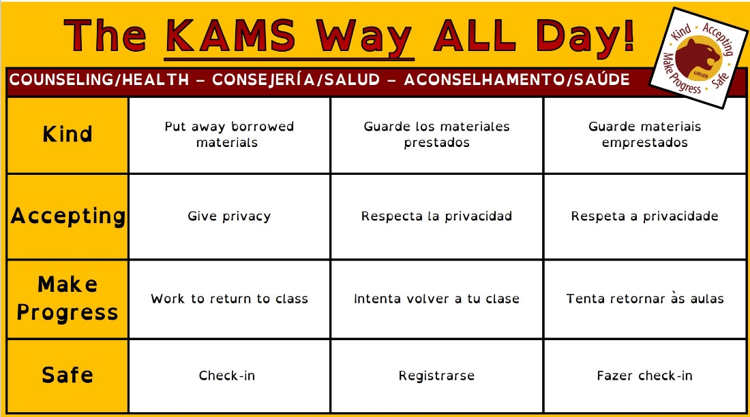

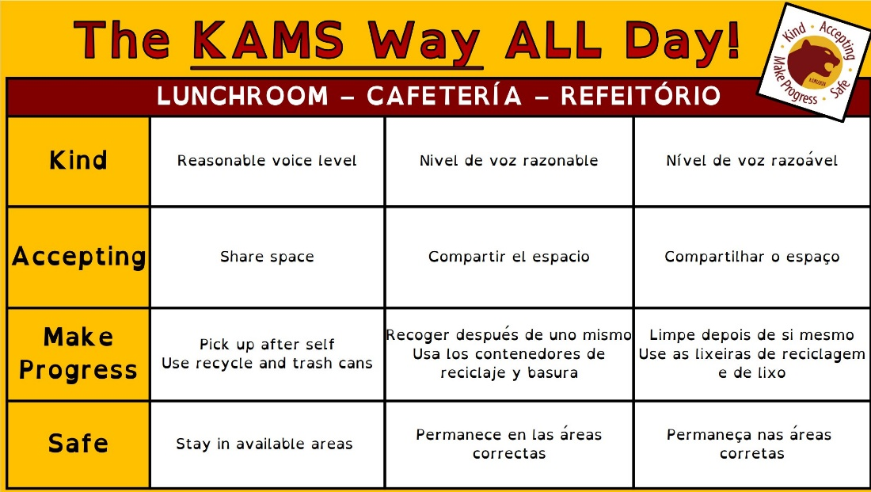
Please see the district policies:
Student Rights and Responsibilities (lwsd.org)
Preventing Harassment, Bullying and Intimidation
Reporting Concerns: At KaMS Safety is very important and we expect that all KaMS community members be upstanders by reporting any unsafe behavior to an adult at school that they trust such as a teacher, administrator, counselor, or other staff member. Students can come to the Student Office, Main Office and ask to speak to anyone available about safety concerns. Parents/guardians should email or call the principal or other administrators with concerns.
Lele Te’o is Kamiakin’s School safety and prevention specialist. He is another great resource to talk to if you have any concerns about safety on campus or any other security related concerns.
Anyone who is a bystander and does not report, could be considered a contributor to unsafe behavior. Videoing unsafe/unkind behavior without reporting is considered contributing to the likelihood that this behavior continues and could disrupt the learning environment.
LWSD Anti-Bullying Rules:
1. We will not bully others or engage in bully type behavior
2. We will be kind to others
3. We will try to help other students who are bullied.
4. We will try to include students who are left out.
5. If we know that someone is being bullied, we will tell an adult at school and an adult at home.

Safe Schools Alert is our district’s tip reporting system that allows students, staff, and parents to submit safety concerns to our school district in different ways. It is always best, if possible, to contact KaMS main office directly and ask for a school administrator to report any safety concerns immediately. 425-936-2400
You can also use Safe Schools Alert:
Phone: (425) 529-5763
Email: 1342@alert1.us Web: http://1342.alert1.us Text: Text your tip to (425) 529- 5763

Safety Procedures are practiced and reviewed regularly to prepare for emergency situations during the year in a variety of ways listed below. To prepare for emergency situations, students should memorize their parent/guardian contact information. Families should create detailed family emergency/communication plans. Parents and Guardians should make sure all contact information, emergency contacts, names of who is allowed to pick up your child, health information, etc. is up-to-date at school in Skyward.
School Safety - Lake Washington School District

Earthquake:
- Drop, cover, hold under a table or desk or against and inside wall – not a doorway – until the shaking stops.
- Stay calm. After the shaking stops, check yourself and others for injuries.
- Listen for instructions. Evacuate the building if safe to do so.
- Report to assembly area with your class and begin attendance process.

Evacuate:
- Evacuation maps are posted in all classrooms and throughout the building.
- Followed designated evacuation plan, unless hazards exist – use alternate route with nearest exit.
- Take emergency backpack/bucket to assembly location.
- Assist anyone that has injuries or special needs.
- Ensure all building occupants have exited and are safe.
- Account for all occupants.

Fire:
- Activate the nearest fire alarm pull station and call 9-1-1.
- Evacuate building following evacuation procedures.
- Do not re-enter building until authorized by emergency response personnel.

Hold:
- All students, staff and visitors stay in classroom.
- Bring anyone in hallways into classrooms to ensure hallways are clear.
- Close and lock doors and continue regular classroom instruction.
- Once “All Clear” is given, return to regular operations.

Lockdown:
- Implement ALICE, as needed, at any time.
- Lock all doors.
- Close lockdown shades and exterior blinds.
- Move away from doors and windows.
- Locate classroom emergency kit and have ready.
- Listen for communication of next steps.
- Once locked down, never open the door. Wait for law enforcement to enter room.

Secure:
- Ensure all outside doors are locked.
- Close exterior blinds.
- Continue with regular indoor activities.
- Listen for communication of next steps.

Shelter:
- Close doors and windows, following building plan.
- Shut off fans in classrooms and close vents.
- Remain in place until told it is safe to leave.
Suspicious Object:
- Do not touch or disturb material/object.
- Move away from the site of hazard/object to a safe location.
- Call 9-1-1.
- Notify Administrator.
- Be prepared to evacuate.
- Follow instructions provided over intercom or other appropriate district communication method.

Suspicious Person:
- Do not let any suspicious person into a locked building or room.
- Do not physically confront the person.
- Begin positioning yourself to the nearest exit.
- Call 9-1-1.
- Notify building administrator and provide information about the person and their direction of travel.

What Should Families/Parents Do in the Event of a (non-drill) Campus Lockdown?
The campus will go into lockdown if there is a potential or immediate threat to students. Working with authorities, the school will send vital messaging through our parent communication systems to keep families apprised.
- Not all lockdowns indicate an actual emergency; upon the lifting of a lockdown, we will do our best to maintain a school environment as normal as possible. However, some families may still choose to pick up their student.
- If you receive information that the campus is in a lockdown, please do not attempt to immediately enter the campus for both your students’ and your own personal safety.
- Working with authorities, the school will send vital messaging through our parent communication systems to keep families apprised.
- When the lockdown is rescinded, we will be available to release students to parent/guardians listed in student emergency contact files.
- Parents and guardians must have photo identification and be listed on a student’s emergency file for the student to be released; parents should follow signage to access student reunification points.
More information regarding Kamiakin’s emergency plan and information for parents is on www.lwsd.org The district website also provides real-time emergency and weather information. At school, in case of emergency, call 911 immediately if there is no adult nearby that can do it!
Parents and other visitors to KaMS are very welcome at school. We have a Family and Community Engagement Center where families can meet. All visitors to Kamiakin are required to report to the main office upon arrival. All adults within the building must visually display an employee or guest badge. Students who do not attend Kamiakin are not permitted as guests during the school day.
Campus Movement: Student safety is of primary importance. Students should only leave classrooms, lunchrooms or other assigned spaces with permission from staff.
Please walk in the halls and cafeteria, stay to the right in halls and lines and follow the KaMS Way to ensure that all students feel safe and comfortable. Students should practice situational awareness, give physical space to others, walk and notice surroundings before they act.
Student’s using the bathroom during class must sign out and should go straight to the closest bathroom to meet their needs and then return to class and sign back in. Students should not socialize in the bathroom. Only one student is allowed in a bathroom stall at a time. If more than one student is in a bathroom stall together, they may be subject to search and disciplinary action. Teachers may become concerned and notify the office if students are out of class for a bathroom break for longer than average.
If students have other needs during class, they should tell the teacher where they would like to go. These places could include the: Health Center, Counseling Center, Main Office, Student Office, Library or Family/Community Center. Any break /trip to these locations longer than average may result in the teacher contacting the office to check on their safety.
Leaving Campus After Dismissal: Once school has released for the day all students should leave campus unless they are taking part in a school sanctioned activity. Students should leave campus unless they already have a prearranged after school activity to participate in. There is no adult supervision outside of arranged school activities.
Dress Code: Dressing in a manner that is not conducive to the educational environment. A student’s dress or appearance may not present a health or safety hazard or create material and substantial disruption of the educational process at the school. Student dress shall not be gang related, nor may it promote illegal activities or activities that violate school regulations.

Attendance
At Kamiakin, daily attendance is valued. Students are reminded that “attendance matters” and so do they. We like to see them at school. Students who attend regularly have more opportunities to participate, be recognized, and grow with their school community.
Because regular attendance is both an expectation and a critical component of school success there are laws that schools are required to take. These include:
- Parents will be notified in writing or by phone after one unexcused absence in a month.
- A parent conference will be initiated after three unexcused absences in a month in order to improve the students’ attendance.
- The parent and school must enter into a contract to improve the student’s attendance after five unexcused absences in a month, or the case may be referred to a Community Truancy Board,
- The school district may file truancy petitions with the juvenile court after seven unexcused absences in a month, or ten unexcused absences in an academic year.
Under Washington state’s truancy law RCW 28A.225.030, the school/district are required to take specific actions when students are truant.
Vacations or other non-illness-related absences or early dismissals should be avoided and pre-arranged through the attendance office. Please see complete attendance information, attendance policy and state attendance law on the LWSD Website: Attendance Matters to Academic Performance.
When a student is absent or tardy, their parent or guardian needs to call the attendance voicemail for excusal at 425-936-2401 or email KAMSAttend@lwsd.org within 48 hours of the absence. Any unreported absence will be deemed an unexcused absence. If the student has missed more than half of a class period, the record will reflect an absence rather than a tardy.
Procedure for Reporting a Full Day Absence: A parent or guardian may excuse their student’s absence by:
- Calling the attendance voicemail at 425-936-2401 before 8:00 AM or emailing at KAMSAttend@lwsd.org or use ParentSquare to message KaMS Attendance.
- Sending a written note with their student. The student is to report to the Attendance Office before school to turn in a written excuse.
- Teachers cannot excuse a student’s absence. This must be coordinated with the front office.
All absences and late arrivals need to be called or emailed in within 48 hours of the absence to be excused.
Pre-Arranged Absences: Missing school for two or more days in advance should prompt students to get a Pre-Arranged Absence form from the main office prior to the dates they will be out of school. The Attendance Professional in the main office and the students’ teachers should be made aware of these types of absences in advance. The parent/guardian must sign this form. Pre-arranged absences for family vacations must be approved by the principal in advance to be excused. Sporting events require a form for even 1 day.
Procedure for Early Dismissal: All students must have a pass from the Attendance Office to have an early dismissal. To obtain a pass the student must present a note from a parent/guardian to the Attendance Office before the start of the school day. Parents may also call the main office to arrange early dismissal.
Make-up Assignments: In the case of an absence from class due to an illness, appointment, or school related event, it is the responsibility of the student to contact the teacher to make arrangements for missed work. In the case of an extended illness, please allow two days for materials to be prepared, and on some occasions, assignments may not be available prior to absences. Each teacher is responsible for setting guidelines as to when the make-up assignments are due. Students have 24 hours upon returning to school to make arrangements with teachers about make-up assignments due dates. Check Canvas if possible.

EXCESSIVE ABSENCES OR TARDIES
Tardy/Late Arrival: Students are expected to arrive at school on time and demonstrate the ability to get to each class within the four-minute passing time. Students who arrive after 7:50 AM are considered tardy.
Unexcused Tardy – To School or To Class: Students are expected to be in the classroom on time. The following are the Kamiakin responses for tardies per quarter per class:
On-Time Attendance Plan
All tardies recorded in Skyward will automatically send an email alert home.
The focus of this system is to build relationships with students and families and collaborate to support students. We want to provide instruction about the importance of their on-time attendance.
- Admin team will monitor tardies on a regular basis
  - Skyward data will be pulled to view total tardies per quarter.
  - Students with 6 or more tardies across all classes will get support from the admin team. Supports usually include: parent communication and a lunch workshop to reflect.
  - Students with 10 or more tardies overall will be supported with an on-time attendance plan developed collaboratively with students and families.
  - Admin team will be responsible for assigning consequences for all tardy related incidents.
  - Tardy count will reset each quarter.
- Teachers will accurately mark attendance and tardies in all classes.
  - Tardy Definition: Students are considered tardy if they are not in the classroom or learning environment by the bell.
  - Use the same restorative process for communicating and supporting students as we have done in the past.
    - 1st and 2nd tardies, notice and seek to understand with student; brainstorm possible solutions/needs. Build relationship capital with student. Reinforce the importance of the first part of class.
    - 3rd and 4th tardies, collaborate with families. Inform student and family of pattern of attendance and discuss interventions. Seek input from families. Bcc alpha specific admin to inform.
    - The purpose in any communication around tardies is to support the student in on-time attendance. Teacher conversations should be about building connections and two-way communication and expressing why the beginning of class is essential to academic success.
    - If tardies continue beyond 4, teachers will include admin on parent communication.

Resources
Health Room/Medication: If a student has sustained a minor injury at school, basic first aid, such as a band-aid, ice pack, and minor wound cleaning with soap and water is available in the health room. The health room is intended to help students return to class quickly or serve as a care facility until they are picked up to go home. Students are only permitted to stay in the health room for a short time unless there is a serious injury or illness that requires parent/guardian assistance. There are specific guidelines for medication at school. The LWSD medication policy can be found on page A14 of Student Rights and Responsibilities. The Health Forms on Skyward should be updated regularly by parents/guardians. In addition, if a student needs rescue medications they must be at school in order for them to be at the school.
Lost and Found items are kept in the cafeteria. Books, notebooks and all items with names in them are returned to the student. Valuable items such as phones, air pods, purses, jewelry, etc., are kept in a safe place in the student office. To help identify personal property, we urge you to put your name or initials on everything you might bring to school. We may donate all lost and found items that are not collected at the end of the semester.
KaMS Family and Community Center: A place to meet other families from the community or to talk with our Community in Schools Representative, Cyrus Malapajo, or our Family and Community Engagement School liaison, Jessica Williams.
Medical Transportation Services: To schedules free transportation to non-emergency medical appointments covered under Medicaid, call Hopelink at (800) 923-7433 or visit https://www.hopelink.org/need-help/transportation.
Additional Resources: We can connect you with a variety of resources to meet your needs. If your family needs help with school supplies, finding medical or housing resources, finding mental health counseling, college prep resources or anything else, please reach out to school counselors and or Cyrus and Jessica. We are here to help you find the support you need for school success!
Liz Biell: ebiell@lwsd.org
Melissa Pierson: mpierson@lwsd.org
Cyrus Malapajo: c-cmalapajo@lwsd.org
Jessica Williams: jwilliams@lwsd.org

Academics
Academic progress is an important part of the KaMS Way. Here are some reminders about how to meet and exceed expectations academically as we strive to make academic progress this year.
Skyward is a great tool for students and families to stay informed about the students’ grades in each class. If you do not know how to log into the family access portion of the grades, please follow the instructions that are linked here. This is also available on the district website under the “HELP” tab at the top right of the screen.
The school year is divided into four terms. Report cards are issued after each term. The end of each semester (two terms) is the final grade for student transcripts and for credit. Middle school courses that are represented on High School transcripts include: Algebra, Geometry, World Language and WA State History.
Grades are meant to communicate what a child knows and is able to do in relation to our content standards. At the middle school level, letter grades are assigned that represent students’ overall proficiency in relation to standards for the subject. These letter grades are based on a body of evidence, based on student work. Since the electronic grade book uses a numerical measuring system, a district-wide scale has been agreed upon for middle school to convert a final numerical percentage to a letter grade. This grading scale is already in Skyward.

Grading Scale for Kamiakin Middle School:
A grades typically mean that students are performing above standard level.
B+
B grades typically mean that the student is at standard.
B-
C+
C grades typically mean that the student is approaching standard.
C-
D+
D grades typically mean that a student is at risk in this subject area.
N means Not Passing. This means that there is not enough evidence for a grade to be assigned. The N grade replaced the F grade. N grades do not meet credit requirements.

Additional/Modified Grading Scales
In addition to this grading scale, there are some other grading scales that may be used for individual students. These are S/N (Satisfactory/No Credit) grading scales and a P/N (Pass/No Credit) grading scale. An Individualized Education Plan, 504, or other team meeting with parents and teachers will determine that one of these grading scales is appropriate for individual students. Definitions of S, P, and N are defined in LWSD policy as:
• S: Satisfactory- student has not met course requirements but has met objectives commensurate with ability. Parents, students, teacher, counselor, and principal should all be consulted in determining whether an "S" grade should be given.
• P: Passing- meets minimum requirements for credit.
*Please check the class syllabus to determine what percentage aligns with letter grades in each class.
Standards Based Grading: Some teachers at Kamiakin use Standards based grading. Below is an example of a Standards based grading scale. Regardless of scale, all ending grades will be entered into Skyward on a typical grading scale.
1 – Beginning/ Novice: | 2 – Developing/ Partial Mastery: | 3 – Proficient/ Meets Standard: | 4 – Advanced/ Exemplary:
The student demonstrates little understanding of the standard and cannot apply the skill independently | The student shows partial understanding and can perform some aspects of the standard with support | The student demonstrates full mastery of the standard and can apply the skill independently | The student exceeds expectations, showing deep understanding or applying the skill in complex ways

Academic Honesty: Students are taught expectations regarding academic honesty by teachers and during our review of Acceptable Use Policy. Plagiarism, cheating, and representing others’ intellectual property or AI generated work as your own will result in consequences. Students will also be required to redo the assignment or assessment.
Cougar Time/Flex Time:
Flex is a period of time 4 times per week when students can get the help and support that they need at school. Students have time on Wednesdays in Cougar Time to sign up and plan for their learning for the week.
Students and Teachers use the Flexi-sched system kams.flexisched.net to request attendance. Students are expected to attend Flex with one of their current teachers that they would like more time to get academic support or enrichment in this class. In some cases, Flex with a certain teacher is open to students who are not in their current class. This is communicated by the teacher that is offering the Flex (example: Club meetings 2X a month).
Cougar Time is a period of time on Wednesdays for students to receive Social Emotional Learning and School Support. Students can get support from each other and from their teacher during this time. Sometimes Cougar Time will have specific Social Emotional lessons, Digital Citizenship lessons, Student Leadership Activities, and will be presented with schoolwide procedures and policies that will further enhance the Kamiakin community.
Sometimes during Cougar Time, we will also have opportunities for Pride Leaders to support our sixth graders. Pride Leaders lead relationship building activities and help 6th graders adjust to being in middle school.

KaMS Policies for Electronic Devices
Devices: Cell phones and personal devices (examples include but are not limited to: smart watches, air pods, smart glasses) have continually become more important to our daily routines every year. Cell phones are a great tool to help us communicate with people when we are out of the house.
While at school, cell phones and air pods should be placed in a backpack and should stay there until the end of the school day. If you need to get into contact with your parents or guardians, you can use a school phone in the front office.
In order to maintain a safe and productive learning environment, all devices must stay off and not be used during the school day. Students should not have their phones in their hands or their desks and should not take them with them to the bathroom. Phones are best in backpacks during the day unless given prior permission by a teacher for a specific reason.

Kamiakin Middle School
Cell Phone and Electronic Device Policy & Procedures 2026-2027
KaMS Way is: “Away for the Day”

To maintain a safe, focused, and productive learning environment, students must keep all personal electronic devices stowed away from 7:50 a.m. until the dismissal bell at 2:25 p.m. This includes cell phones, smart watches, earbuds, headphones, AirPods, smart glasses, and similar devices.

Best Practice: Electronic devices should be turned off and stored in a zipped backpack pocket throughout the school day.

Schoolwide Instruction and Student Expectations

Instruction & Ongoing Review
During the first week of school, all students will receive schoolwide instruction regarding the electronic device policy and procedures. This instruction serves as the official reminder and establishes expectations for all students. At the beginning of each quarter, staff will review the policy and reteach expectations to ensure students understand and follow school procedures.
During the first week of school, each class period, teachers will:
- Review the electronic device policy.
- Remind students that electronic devices must remain in backpacks.
Family Communication
Every incident will be documented, and families will be notified of each incident. Confiscated devices will be stored securely in the office for the remainder of the school day.

If a Device Is Used During the School Day
1st Incident
- Reminder of expectations
- Device put on staff member desk and picked up at end of day in student office
- Communication Home
2nd Incident
- Reminder of expectations
- Device put on staff member desk and picked up at end of day in student office
- Communication Home
3rd Incident
- Device put on staff member desk and picked up at end of day in student office
- Communication Home
- Parent/guardian picks up phone at the end of the day
Additional Incidents
- Family contacted
- Support plan developed with student and family
Exceptions
Exceptions may be made for:
- Students with accommodations documented in a health plan.
- Teacher-directed instructional activities when electronic devices are specifically authorized by administration for educational purposes.

Commitment to Learning
Our goal at Kamiakin is to create a learning environment where all students can remain engaged, minimize distractions, build positive habits, and be fully present in their academic and social experiences.

We come here to grow.

Acceptable Use Policy/Laptop use:
Students agree to follow the AUP and the Student and Staff AUP Procedure when they sign into their laptop.
Students are expected to use their laptops only for academic and school related purposes. All computer use history is saved and can be reviewed by LWSD. This includes and is not limited to emails, Teams chats, and browsing history.
Students with off-task laptop behavior will receive a classroom consequence and may be referred to administration.
Acceptable Use Policy (AUP). Student and Staff AUP Policy (Formerly IIAB & GBD): Electronic Resources and Internet Safety (2022)
Student and Staff AUP Procedure (Formerly IIAB-R and GBD-R): Procedure Electronic Resources and Internet Safety (2022P)

Athletics
Clubs and Sports Information
ASB Membership is required for participation in all clubs/sports. This fee is waived if you qualify for Free & Reduced Lunch. Talk to a counselor with eligibility questions. They are here to help you get signed up today!
Middle School Athletic Program
Middle School Athletics Interscholastic Sports are competitive and are designed for athletes who already know the sport. These athletes will compete against other schools in our district. Seasons run for approximately 8 weeks. Intramural Sessions are designed for building skills and connecting with peers and these athletes will be competing only against other Kamiakin students. These sessions run for approximately two weeks each.
Registration for Fall Interscholastic Sports and Tryouts open approximately one month before the seasons start. Registration for Intramural Sessions will open closer to the given session. Registration information, online payment and fee waiver forms are found here: https://www.lwsd.org/programs-and-services/athletics. Payments for Intramural Sessions and non-tryout Interscholastic Sports may be done at the time of registration. Payments for cut (tryout required) Interscholastic Sports will be open to students who have made the team(s) after tryouts are complete and teams have been determined.
All Student athletes MUST have an ASB Membership as well as a valid physical exam. The Physical Clearance Form is valid for 2 years. https://resources.finalsite.net/images/v1707321623/lwsdorg/fdh1n6tmo7tdzrar1iqy/PPE-Medical-Eligibility-Form-rev.pdf
Sports Fees are:
- $125 per Interscholastic sport or $35 per Intramural session
- $35 ASB Card (annual membership required for sports)
- Students qualifying for Free/Reduced meals may be eligible for ASB and sports fee waivers. How to Waive Extra-Curricular Fees - Lake Washington School District.
Season and session information can be found here: Athletics - Kamiakin Middle School

Kamiakin Clubs and Interest Groups:
Many different clubs and interest groups are offered at the school. These groups can meet before and after school and sometimes during specific Flex times throughout the month. Check here for the most updated list. https://kams.lwsd.org/activities-athletics/clubs-activities-and-interest-groups

