A Peek at our Week
Mrs. Bird
Monday, August 31 – Friday, September 4, 2026
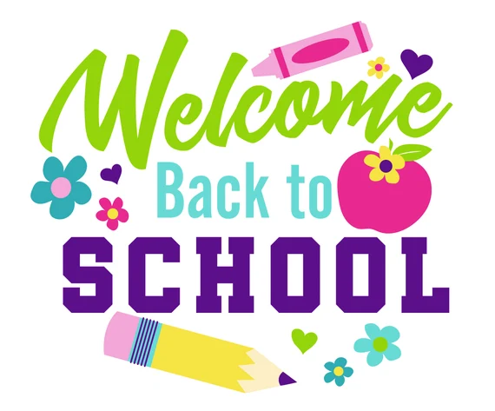
Welcome! This is our first weekly letter of the 2026-2027 school year. A Peek at our Week will be sent home at the beginning of each week to keep you informed about what we are learning, along with upcoming events! A Peek at our Week letters will also be posted on our class website. Our class website can be found at:
https://www.stillwaterschool.net/classes/mrs-bird/mrs-birds-website
On Friday, September 4th, students will dismiss at 12:40. Lunch will not be served. Please bring a small lunch or snack to school.
Homework Schedule
Monday  *Spanish & Health/Gym* | Tuesday  *STEAM& Health/Gym* | Wednesday  *Art* | Thursday  *Health/Gym* | 12:40 DISMISSAL  Friday  *Music & Health/Gym*  Library Visit Biweekly
No School | No School | Math: No HW  Reading: No HW | Math: No HW  Reading: No HW | Have a wonderful weekend!
Taking a Closer Look…
- Math: We will be taking our beginning of the year math assessment. We will also begin to learn our math routines.
- Social Studies: We will be discussing good habits, rules, and expectations in school.
- Reader’s Workshop: We will be enjoying some read aloud stories together.
- Writer’s Workshop: We will practice good writing habits for Writer’s Workshop while we work on our All About Me posters!
- Fundations: We will begin our orientation to Level 2 Fundations! Students will review drill sounds, good writing position, and how to tap out words.

**Remember to have sneakers for gym class!**

