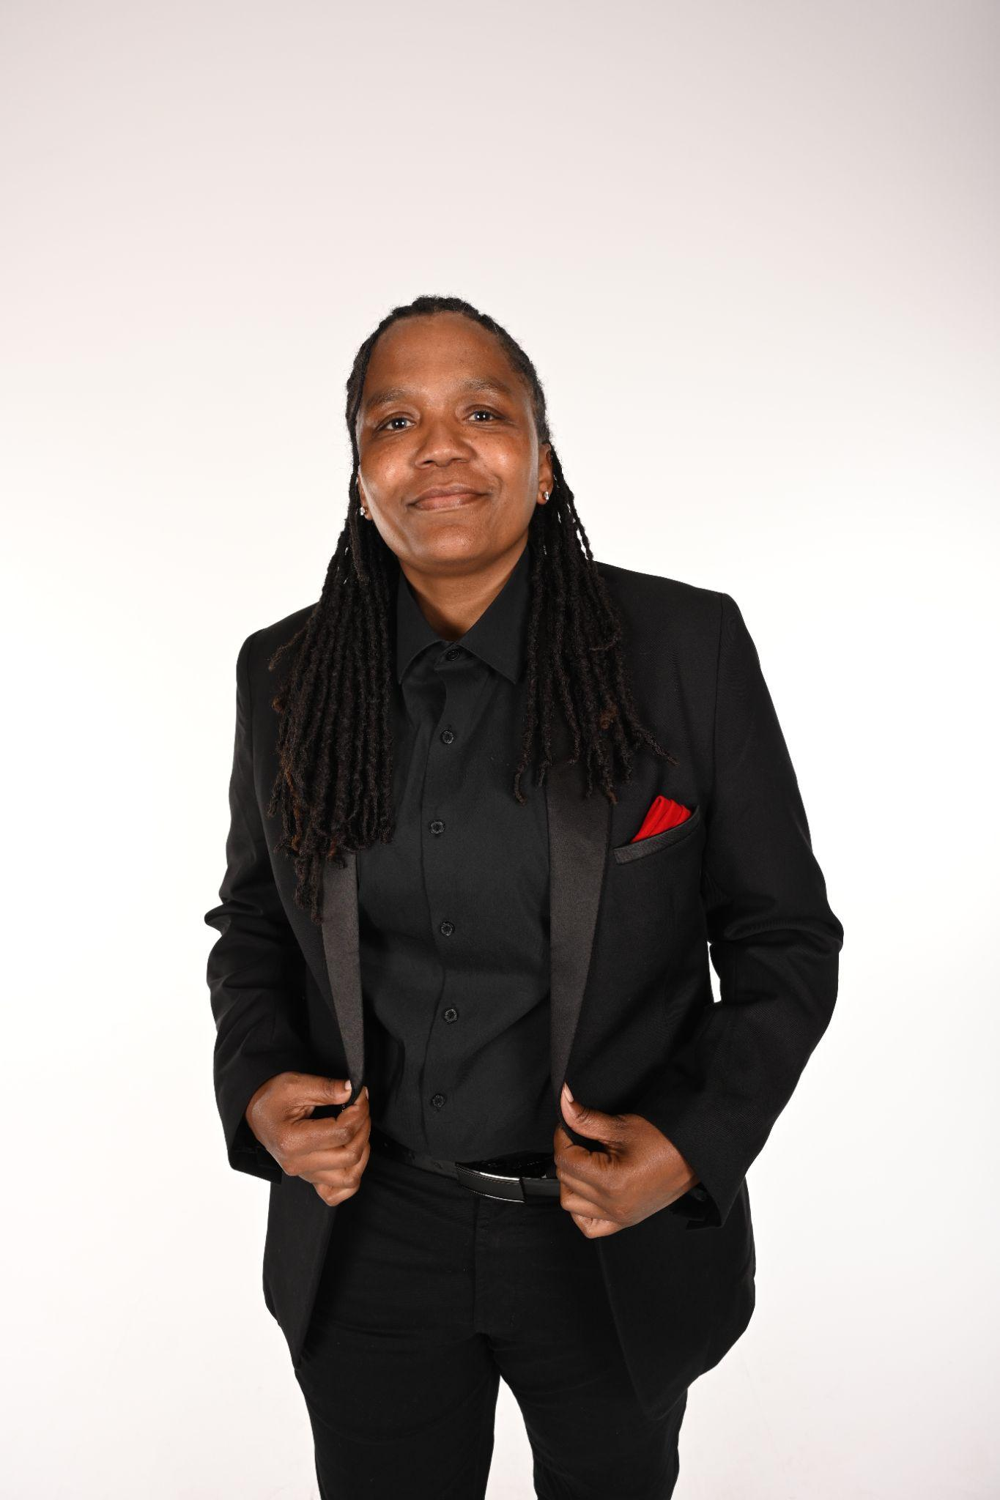

Tori Williams is a passionate physical educator at Dutchtown Middle School, where she teaches grades 6-8. In the gym, she creates a welcoming, student-centered environment that emphasizes physical literacy, community, and social responsibility. With nearly twenty years of experience in education and athletics, Williams sees physical education not just as a subject but as a way to help students develop confidence, empathy, and lifelong wellness habits. Williams' academic journey mirrors her dedication to growth and excellence. She earned a Bachelor of Arts in Sports and Fitness Administration from Brewton-Parker College in 2006, followed by a Master of Arts in Physical Education Teaching and Coaching from Augusta State University in 2010. Always seeking to deepen her expertise, she also completed an Educational Specialist degree in Physical Education at Jacksonville State University in 2021 and recently earned a Master of Science in Sports Management from the same institution in 2024. At Dutchtown Middle School, Williams turns the gym into a space where students learn through collaboration, creativity, and exploration. Her innovative approach including student-led game design and inclusive tactical challenges ensures that every student, regardless of athletic background or ability, feels valued, included, and empowered to succeed.

