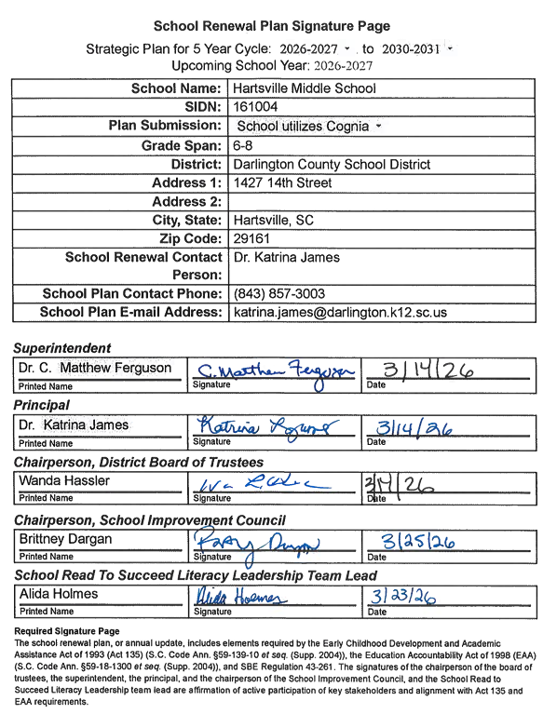

School Renewal Plan Signature Page

Strategic Plan for 5 Year Cycle: 2026-2027. to 2030-2031
Upcoming School Year: 2026-2027

School Name: | Hartsville Middle School
SIDN: | 161004
Plan Submission: | School utilizes Cognia
Grade Span: | 6-8
District: | Darlington County School District
Address 1: | 1427 14th Street
Address 2:
City, State: | Hartsville, SC
Zip Code: | 29550
School Renewal Contact Person: | Dr. Katrina James
School Plan Contact Phone: | (843) 857-3003
School Plan E-mail Address: | katrina.james@darlington.k12.sc.us

Superintendent
Dr. C. Matthew Ferguson  Printed Name | Signature | Date

Principal
Dr. Katrina James  Printed Name | Signature | Date

Chairperson, District Board of Trustees
Wanda Hassler  Printed Name | Signature | Date

Chairperson, School Improvement Council
Britney Dargan  Printed Name | Signature | Date

School Read To Succeed Literacy Leadership Team Lead
Alida Holmes  Printed Name | Signature | Date

Required Signature Page
The school renewal plan, or annual update, includes elements required by the Early Childhood Development and Academic Assistance Act of 1993 (Act 135) (S.C. Code Ann. §59-139-10 et seq. (Supp. 2004)), the Education Accountability Act of 1998 (EAA) (S.C. Code Ann. §59-18-1300 et seq. (Supp. 2004)), and SBE Regulation 43-261. The signatures of the chairperson of the board of trustees, the superintendent, the principal, and the chairperson of the School Improvement Council, and the School Read to Succeed Literacy Leadership team lead are affirmation of active participation of key stakeholders and alignment with Act 135 and EAA requirements.

Assurances for the School Renewal Plans
The assurance pages following this page have been completed and the district superintendent’s and school principal’s signature below attests that the school/district complies with all applicable assurances requirements including ACT 135 assurance pages.
Assurances for School Renewal Plans

Assurances checked below, along with the signature page signed by the superintendent and school principal, attest that the school complies with all applicable regulatory and statutory requirements listed.

Early Childhood Development and Academic Assistance Act (Act 135) Assurances
(S.C. Code Ann §59-139-10 et seq. (Supp. 2004))
N/A | Academic Assistance, PreK–3  The school makes special efforts to assist children in PreK–3 who demonstrate a need for extra or alternative instructional attention (e.g., after-school homework help centers, individual tutoring, and group remediation).
Yes | Academic Assistance, Grades 4–12  The school makes special efforts to assist children in grades 4–12 who demonstrate a need for extra or alternative instructional attention (e.g., after-school homework help centers, individual tutoring, and group remediation).
Yes | Parent Involvement  The school encourages and assists parents in becoming more involved in their children’s education. Some examples of parental involvement initiatives include making special efforts to meet with parents at times more convenient for them; providing parents with their child’s individual test results and an interpretation of the results; providing parents with information on the district’s curriculum and assessment program; providing frequent, two way communication between home and school; providing parents an opportunity to participate on decision making groups; designating space in schools for parents to access educational resource materials; including parent involvement expectations as part of the principal’s and superintendent’s evaluations; and providing parents with information pertaining to expectations held for them by the school system, such as ensuring attendance and punctuality of their children.
Yes | Staff Development  The school provides staff development training for teachers and administrators in the teaching techniques and strategies needed to implement the school/district plan for the improvement of student academic performance. The staff development program reflects requirements of Act 135, the EAA, and the National Staff Development Council’s revised Standards for Staff Development.
Yes | Technology  The school integrates technology into professional development, curriculum development, and classroom instruction to improve teaching and learning.
Yes | Innovation  The school uses innovation funds for innovative activities to improve student learning and accelerate the performance of all students.
Yes | Collaboration  The school (regardless of the grades served) collaborates with health and human services agencies (e.g., county health departments, social services departments, mental health departments, First Steps, and the family court system).
Yes | Developmental Screening  The school ensures that the young child receives all services necessary for growth and development. Instruments are used to assess physical, social, emotional, linguistic, and cognitive developmental levels. This program normally is appropriate at primary and elementary schools, although screening efforts could take place at any location.
N/A | Half-Day Child Development  The school provides half-day child development programs for four-year-olds (some districts fund full-day programs). The programs usually function at primary and elementary schools. However, they may be housed at locations with other grade levels or completely separate from schools.
N/A | Developmentally Appropriate Curriculum for PreK–3  The school ensures that the scope and sequence of the curriculum for PreK–3 are appropriate for the maturation levels of students. Instructional practices accommodate individual differences in maturation level and take into account the student's social and cultural context.
Yes | Parenting and Family Literacy  The school provides a four component program that integrates all of the following activities: interactive literacy activities between parents and their children (Interactive Literacy Activities); training for parents regarding how to be the primary teachers for their children and how to be full partners in the education of their children (parenting skills for adults, parent education); parent literacy training that leads to economic self-sufficiency (adult education); and an age-appropriate education to prepare children  for success in school and life experiences (early childhood education). Family Literacy is not grade specific, but is generally most appropriate for parents of children at the primary and elementary school levels and below as well as for secondary school students who are parents. Family Literacy program goals are to strengthen parental involvement in the learning process of preschool children ages birth through five years; to promote school readiness of preschool children; to offer parents special opportunities to improve their literacy skills and education; to provide parents a chance to recover from dropping out of school; and to identify potential developmental delays in preschool children by offering developmental screening.
Yes | Recruitment  The district makes special and intensive efforts to recruit and give priority to serving those parents or guardians of children, ages birth through five years, who are considered at-risk of school failure. “At-risk children are defined as those whose school readiness is jeopardized by any of, but not limited to, the following personal or family situation(s): parent without a high school graduation or equivalency, poverty, limited English proficiency, significant developmental delays, instability or inadequate basic capacity within the home and/or family, poor health (physical, mental, emotional) and/or child abuse and neglect.
Yes | Coordination of Act 135 Initiatives with Other Federal, State, and District Programs  The district ensures as much program effectiveness as possible by developing a district-wide/school-wide coordinated effort among all programs and funding. Act 135 initiatives are coordinated with programs such as Head Start, First Steps, Title I, and programs for students with disabilities.

Stakeholder Involvement for School Renewal Plan

List the name of persons who were involved in the development of the School Renewal Plan. A participant for each numbered position is required.
 | Position | Name
1. | Principal | Dr. Katrina James
2. | Teacher | Renata Brister
3. | Parent/Guardian | Britney Dargan
4. | Community Member | Christopher Morgan
5. | Paraprofessional | Ginger King
6. | School Improvement Council Member | Katena McDonald
7. | Read to Succeed Reading Coach | Alida Holmes
8. | School Read to Succeed Literacy Leadership Team Lead | Alida Holmes
9. | School Read to Succeed Literacy Leadership Team Member | Shalecka McKithen

Comprehensive Needs Assessment Data

Per SBE Regulation 43-261, the annual needs assessment will provide focus for planning teams to set priorities for the plan. The comprehensive needs assessment must identify targeted areas of discrepancy between the desired performance levels and the current status as indicated by available data. Any discrepancies in the following areas identified by the school and district report cards must be included in the plan: (1) achievement, (2) achievement by subgroups, (3) graduation rates, (4) attendance, (5) discipline, (6) teacher/administrator quality and professional growth, and (7) other priority areas.
Measurable performance goals, written in five-year increments, shall be developed to address the major discrepancies identified in the needs assessment, as reported in the district and school report cards.

i-Ready Diagnostic Growth Analysis Fall 2025–Winter 2025 Academic Overview

ELA (Reading) Overview
Median Progress Toward Typical Growth: 128% (How much progress a group of students (class, grade, school, or district) has made compared to the amount of growth i-Ready expects them to make in a school year.)
Current On Grade Level (Mid/Above + Early On): 35%
Gap to 50% Goal: 15 percentage points
Overall Insight: Strong growth across grades, but proficiency levels remain below target.

ELA Grade-Level Performance
Grade 6: 111% median growth | 53% met typical growth | 48% improved placement
Grade 7: 125% median growth | 56% met typical growth | 50% improved placement
Grade 8: 156% median growth | 62% met typical growth | 58% improved placement

ELA Priorities
- Intensify foundational literacy support in Grade 6.
- Move students one grade level below into an on-grade-level band.
- Maintain strong practices in Grades 7–8.
- Continue focus on vocabulary and comprehension development.

Math Overview
Median Progress Toward Typical Growth: 93% (How much progress a group of students (class, grade, school, or district) has made compared to the amount of growth i-Ready expects them to make in a school year.)
Current On Grade Level (Mid/Above + Early On): 32%
Gap to 50% Goal: 18 percentage points
Overall Insight: Both growth and proficiency need improvement, especially in Grade 6.

Math Grade-Level Performance
Grade 6: 62% median growth | 37% met typical growth | 41% improved placement
Grade 7: 83% median growth | 48% met typical growth | 44% improved placement
Grade 8: 150% median growth | 63% met typical growth | 60% improved placement

Math Priorities
- Urgent focus on Grade 6 foundational skills.
- Strengthen Tier 1 math instruction in Grades 6–8.
- Implement structured intervention blocks.
- Increase progress monitoring and data cycles.

Cross-Subject Key Insights
- Grade 8 growth is a strength in both subjects.
- Grade 6 is the primary leverage point for improvement.
- Moving students one grade level below into an on-grade-level band is the fastest path to 50%.
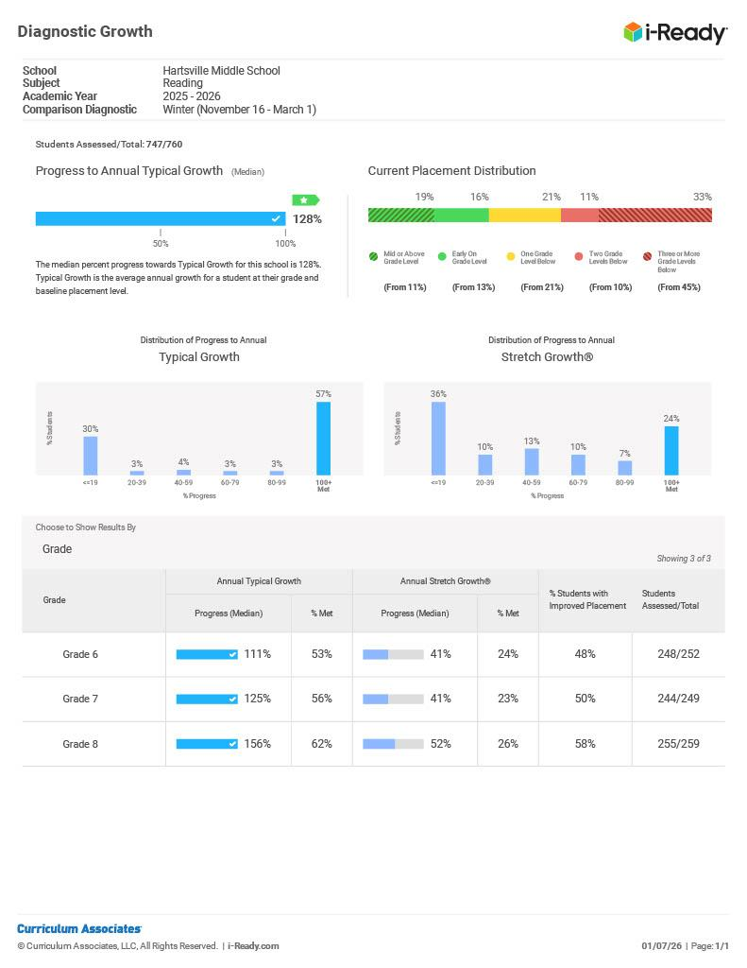
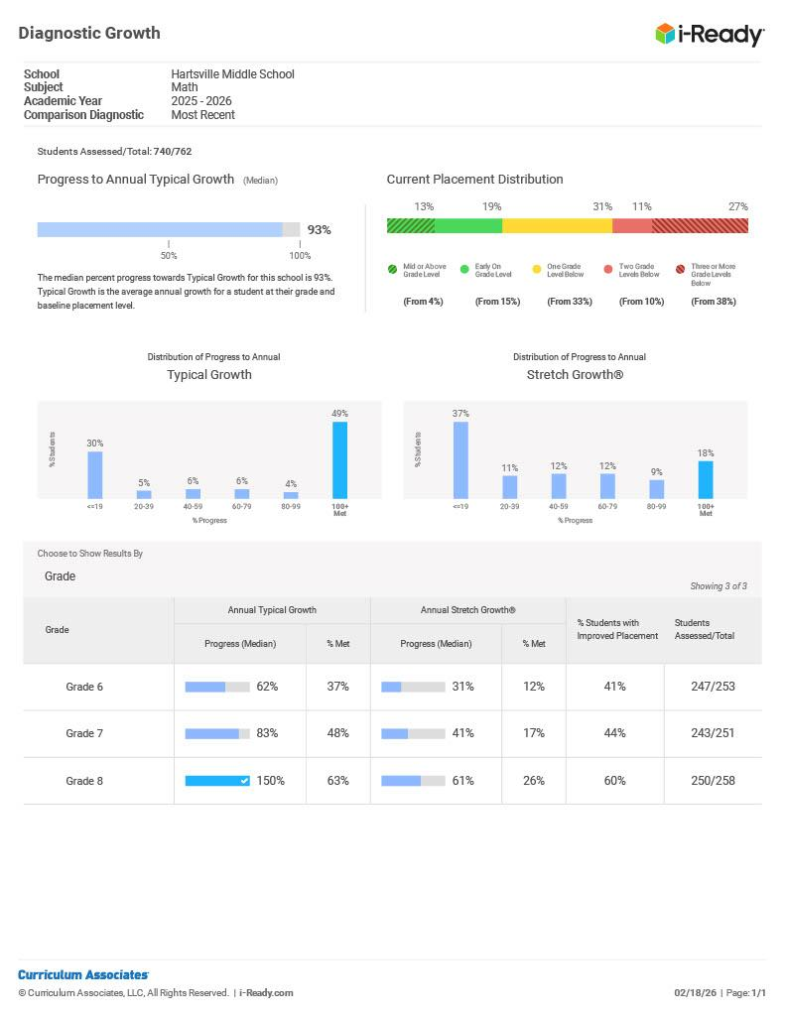

Math EOY Projections
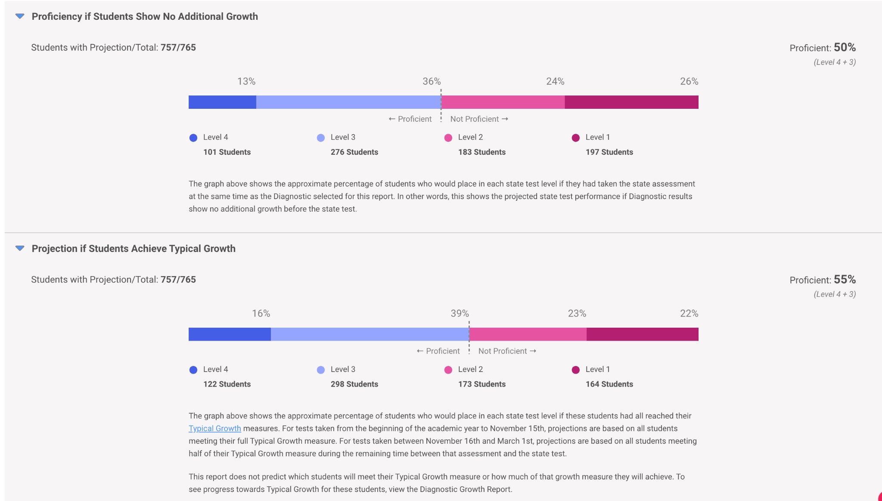
Reading EOY Projections

Science Overview
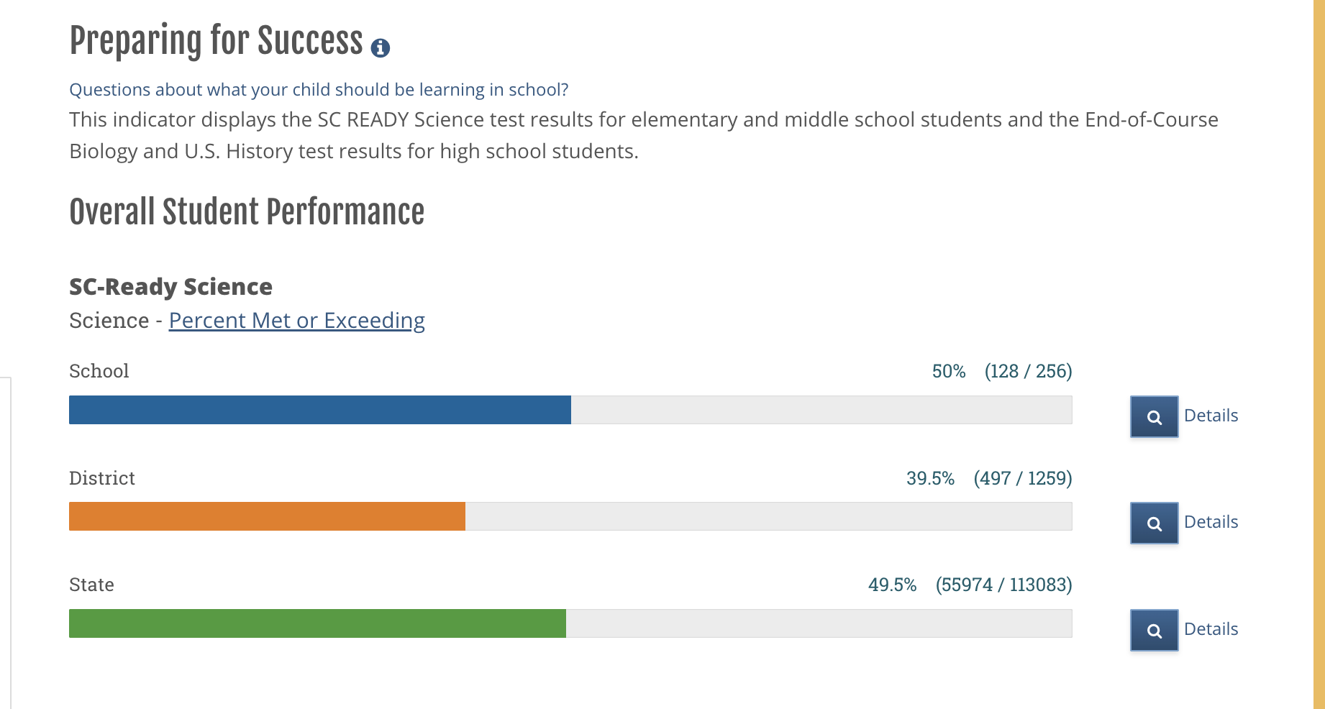
While HMS Grade 6 Science demonstrates positive indicators relative to the district, the current performance levels are not sufficient to ensure that all students meet the Profile of the South Carolina Graduate. The DCSD goal is for 75% of students to meet or exceed grade level expectations. . Strategic focus must be placed on targeted instructional improvement and intervention systems to move a greater percentage of students into proficiency and beyond.
However, despite these strengths, the data reveals a concerning distribution of students in the lower performance levels. Approximately one-third of students fall into the “Does Not Meet Expectations” category, which, while slightly lower than the district, remains significant and comparable to the state. This indicates that a substantial group of students lacks foundational understanding of grade-level science standards and will require intensive, targeted instructional support.
- HMS Grade 6 shows a mixed profile:
  - Stronger than district in top performance (Exceeds)
  - Slightly stronger or comparable to state in Meets
  - Weaker than both in the critical “Approaches” band
  - Higher-than-desired “Does Not Meet”, though slightly better than district
Teacher/Administrator Quality
Hartsville Middle School is staffed by a dedicated team of educators with an emphasis on professional development and building capacity to strengthen Tier 1 instruction by using HQIM and data to appropriately maintain focus. Currently, HMS is experiencing persistent vacancies in Mathematics and a staffing gap, with approximately 10% of full-time equivalent (FTE) teaching positions filled by educators who are not fully certified. Most are in alternative certification programs and need to pass the subject area PRAXIS test. These staffing challenges impact instructional continuity and overall student achievement.
Certified teachers participate in weekly grade-level PLC and department meetings. Once per month, department meetings are held for lateral planning among grade levels. All district middle schools have participated in collaboration opportunities.
The leadership team includes a principal and three assistant principals with a combined 65 years of experience in education. The number of years in educational leadership ranges from 2 to 15. Strong instructional leadership is noted, but staff are concerned about student behavior in classrooms and hallways.
Recognizing the importance of professional growth and its role in driving student achievement, we aim to increase access to job-embedded personal learning opportunities. Teachers participate in district personnel development. We have also implemented a system of walk-through observations, feedback cycles, and data conferences to strengthen instructional leadership and reflective practice. Teachers have been placed in “Tiers” to prioritize support. Teachers have been issued a Learning Passport that allows them to earn stamps for Coaching Connections, Collaboration Journey, and Classroom Showcases.
School Climate
Hartville Middle School has improved the school climate through a variety of initiatives. Scores on the school report card have increased over the past three years.
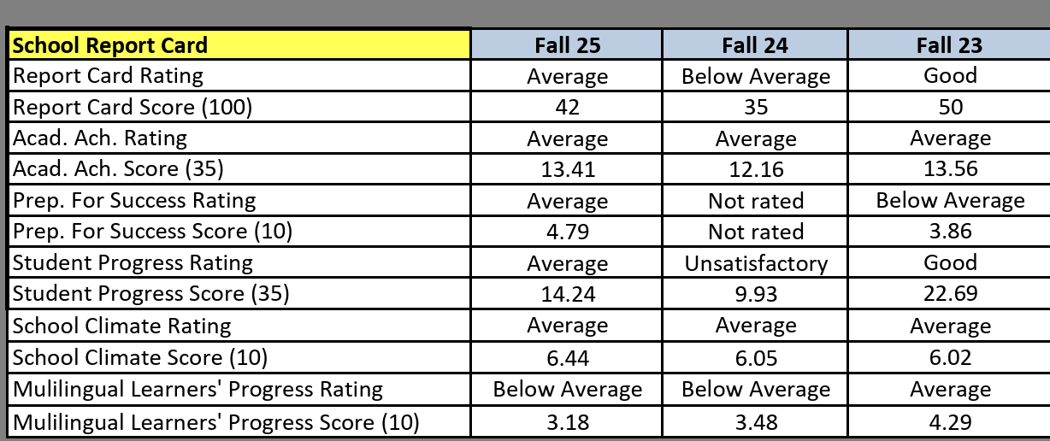
Student Surveys Results (Spring 2025):
- 82% of students agree/mostly agree with feeling safe at school
- 82.5% of students agree/mostly agree that students and teachers get along well
- 68% of students agree/mostly agree that classes are interesting and fun
Student Survey Results (Fall 2025 Panorama):
- 39% of students responded favorably to questions related to engagement, questions related to how attentive and invested students are in class.
- 46% of students responded favorably to questions about school climate, including perceptions of the school's overall social and learning climate.
- 73% of students responded favorably to questions related to how well they manage their emotions, thoughts, and behaviors in different situations.
Behavioral Data:
- Major discipline referrals increased 8% from the previous year. This was due to increased enforcement and a change in the reporting system.
- Chronic absenteeism affected 25.5% of students last year, with the highest rate among 8th graders. As of February, the chronic absenteeism rate is 17.8%.
Teacher Perceptions:
- 85.5% of teachers agree that the administration has high expectations for them.
- 71% of teachers agree that they are supported by the administration
- 58% of teachers agree that the school leadership makes a substantial effort to address teacher concerns.
- 64.5% of teachers agree that there are relevant professional opportunities offered to teachers at my school.
- 25.8% of teachers agree that students behave well in their class.
At Hartsville Middle School, we recognize the importance of incorporating the characteristics of a successful middle school. To strengthen our learning environment, we plan to:
- Ensure every student's academic and personal development is guided by an adult advocate through a daily Advisory period
- Health, wellness, and social-emotional competence are supported in curricula, school-wide programs, and related policies.
- Policies and practices are student-centered
- The school environment is welcoming, inclusive, and affirming for all.
- The school collaborates with the community and business partners.
- Educators are specifically prepared to teach young adolescents and possess a depth of understanding in the content areas they teach.
- Health, wellness, and social-emotional competence are supported in curricula, school-wide programs, and related policies.

Executive Summary of Needs Assessment Data Findings

Directions: | In the appropriate boxes, use school data to identify areas in need of improvement. Required areas to be addressed: Student Achievement, Teacher/Administrator Quality, and School Climate.

Student Achievement, including sub-groups
Early Childhood/Primary (PK-2):
Elementary/Middle (3-8):
Hartsville Middle School is a rural middle school. The total enrollment across grades 6 through 8 is 790 students, with a balanced gender distribution of 48.4% male and 51.6% female. Enrollment is evenly distributed across grade levels, with approximately 32.3% of students in grade 6, 33.4% in grade 7, and 34.3% in grade 8, reflecting steady cohort growth across the middle grades.

The student population is predominantly White (52.5%) and Black or African American (43.5%), together representing more than 96% of total enrollment. Both groups demonstrate near gender parity, with slightly higher female representation overall.

We have 38 students classified as MLL, 62 with 504s, and 137 with Special Education IEPs.

Fifteen of our students are enrolled in DCSD360, our district’s virtual school.

Reading Performance Baselines:
- SCREADY Spring 2025 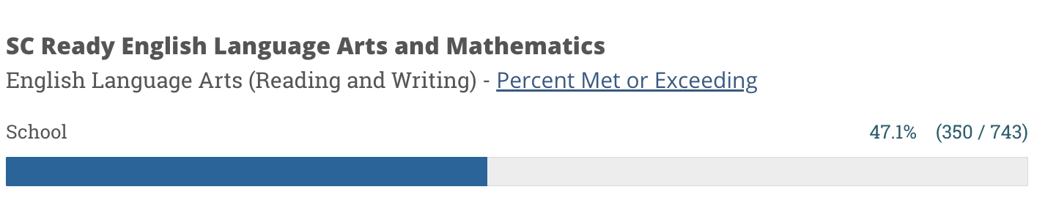
- iReady Winter 2025 Diagnostic
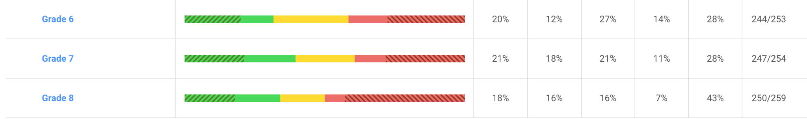i-Ready Reading data indicate strong overall student growth, particularly in Grades 7 and 8. Grade 8 demonstrated the strongest performance (156% median growth; 62% met typical growth). However, overall proficiency remains below the 50% target, indicating that while students are growing, many remain below grade level.

Math Performance Baselines:
- SCREADY Spring 2025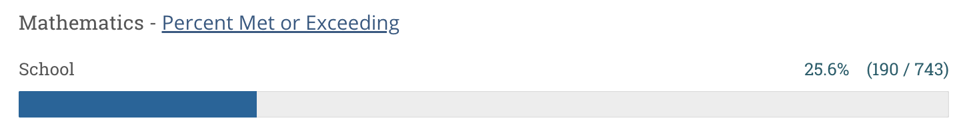
- i-Ready Math Winter 2025 Diagnostic
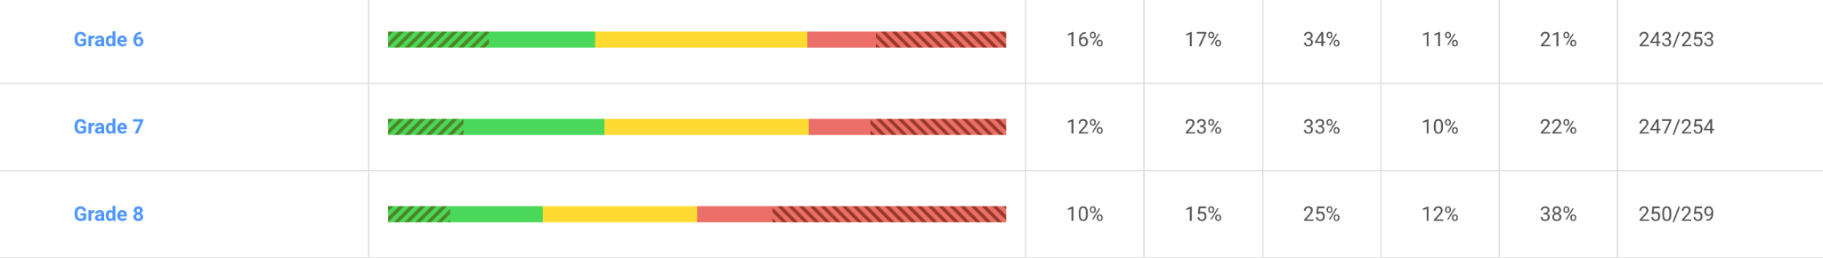

i-Ready Math performance presents a greater area of need. Grade 6 is the most significant leverage point, with only 62% median growth and 37% meeting typical growth. Although Grade 8 shows strong gains (150% median growth), overall math proficiency remains below target.

i-Ready correlates and provides projections towards proficiency on SCREADY, and this interim performance data will be used to set goals and progress monitor throughout the year.

We are part of the Palmetto Math Project and are identified as a Tier 3 school based on SCREADY scores from the 2023-2024 school year. The project specifically targets underperforming schools, defined as those where 50% or more students score in the “Does Not Meet Expectations” category on the SC READY math assessment (particularly in grades 5 and 8). We have an assigned coach who is working to help build instructional capacity and directly support students.
Using i-Ready data, selected students are receiving Tier 2 support through High Intensity Tutoring through TFA Ignite (90) or Varsity Tutors (120).
Analysis of SC READY Science performance indicates that HMS Grade 6 demonstrates that 50% of students met or exceeded expectations for Preparing for Success. The performance is above the district average of 39.5% and comparable to the state average of 49.5%, but with critical gaps in student proficiency that require targeted intervention.
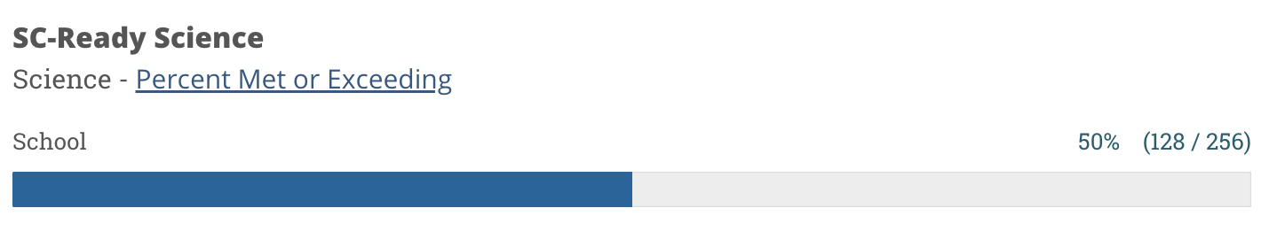
We have been identified as an ATSI school due to the low achievement of our students with disabilities. Teachers who provide resource support are being coached in using i-Ready data to support students. They will also provide intervention support during the last 10 weeks of school.
Teacher/Administrator Quality
HMS is staffed by a dedicated faculty and a leadership team with a combined 65 years of educational experience.
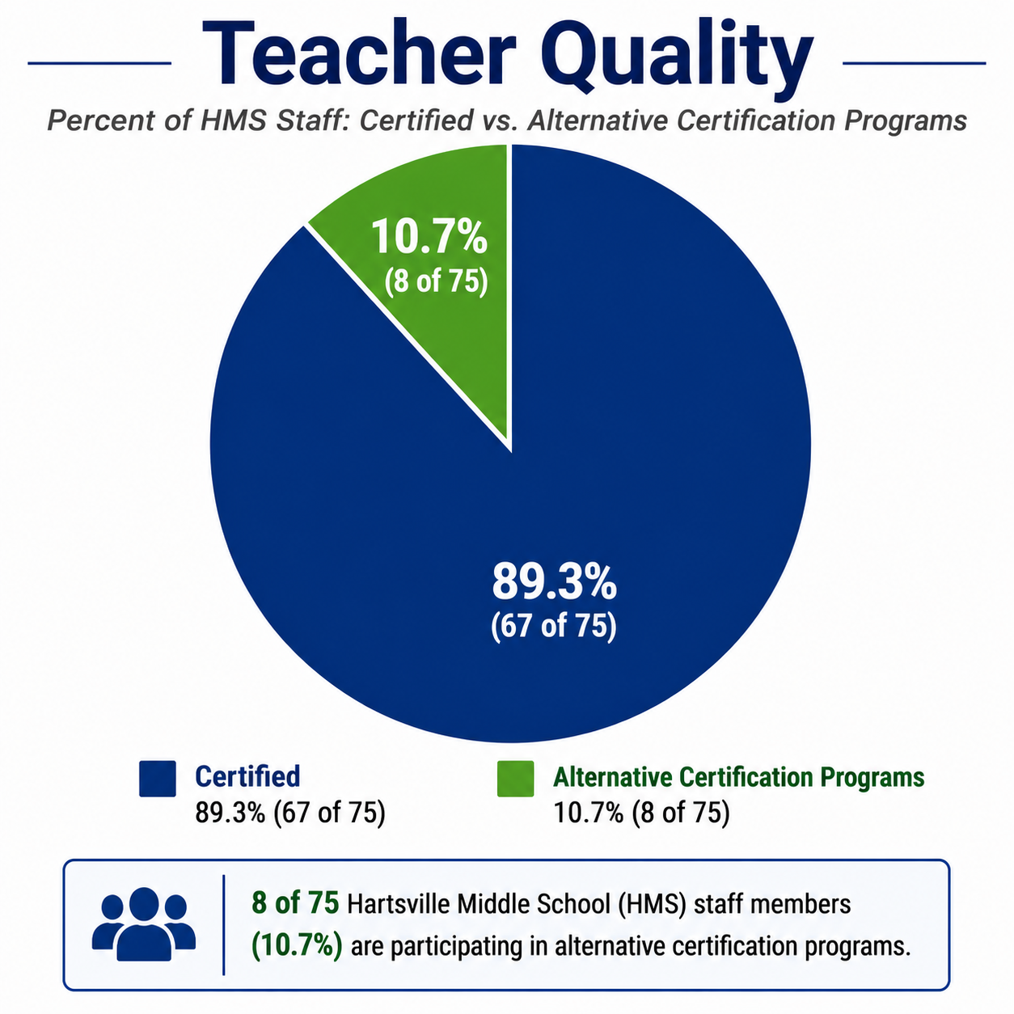
Systems are in place to support instructional quality, including:
- Weekly PLCs and department meetings
- Cross-school collaboration
- Walkthrough observations and feedback cycles
- Data conferences
- Tiered teacher support system
- Learning Passport professional growth initiative
Areas requiring response include:
- Certification gaps in high-need areas (Math)
- Need for improved classroom behavior support
- Opportunity to strengthen teacher voice and responsiveness systems
- Continued refinement of job-embedded professional learning
The Strategic Compensation Pilot Program is a statewide initiative by the South Carolina Department of Education (SCDE) designed to support innovative educator pay models that reward teachers for measurable student academic growth in English Language Arts (ELA) and mathematics, particularly in grade bands where assessment data is robust. The pilot aims to recognize, retain, and reward effective instruction by awarding educators whose students demonstrate significant academic progress.
All educators in alternative certification programs are required to check in with the district Director of Personnel. They have been given the opportunity to participate in support sessions to prepare for PRAXIS tests.
School Climate
Over the past year, Hartsville Middle School has demonstrated measurable improvement in overall school performance and climate indicators. The school’s overall report card rating improved from Below Average in Fall 2024 to Average in Fall 2025, reflecting positive momentum in key accountability areas.
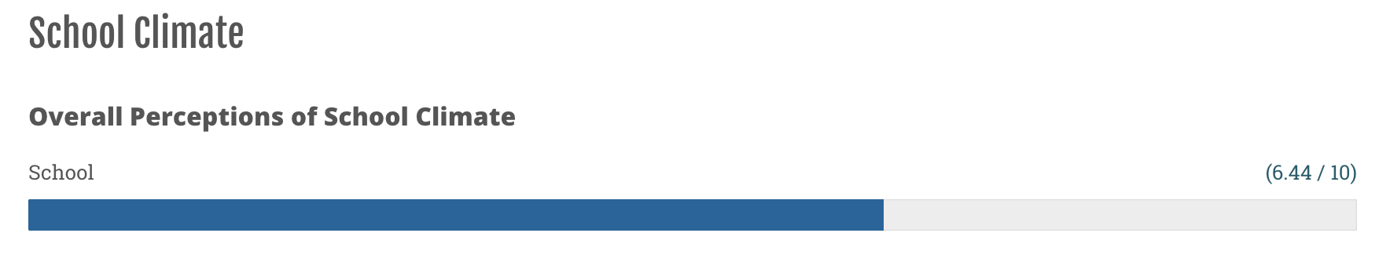Additionally, the School Climate Score increased to 6.44, indicating strengthened efforts to create a safer, more supportive learning environment. Student Progress ratings also improved significantly, moving from Unsatisfactory to Average, indicating growth in academic performance and instructional impact.
Despite these gains, several challenges remain. Major discipline referrals increased by 8%; however, this rise is primarily due to increased enforcement and changes in reporting procedures, rather than a substantial escalation in student misconduct. At the same time, chronic absenteeism has decreased mid-year to 17.8%, from the baseline of 28.9% for the 2024-2025 school year, demonstrating progress in attendance initiatives, though rates remain above ideal benchmarks and require continued attention.
Chronic Abseentism Baseline Data:
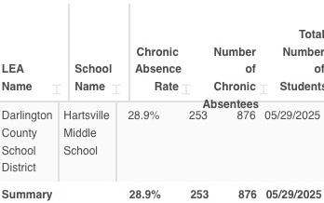
Baseline Data from Spring 2024 School Climate Survey:
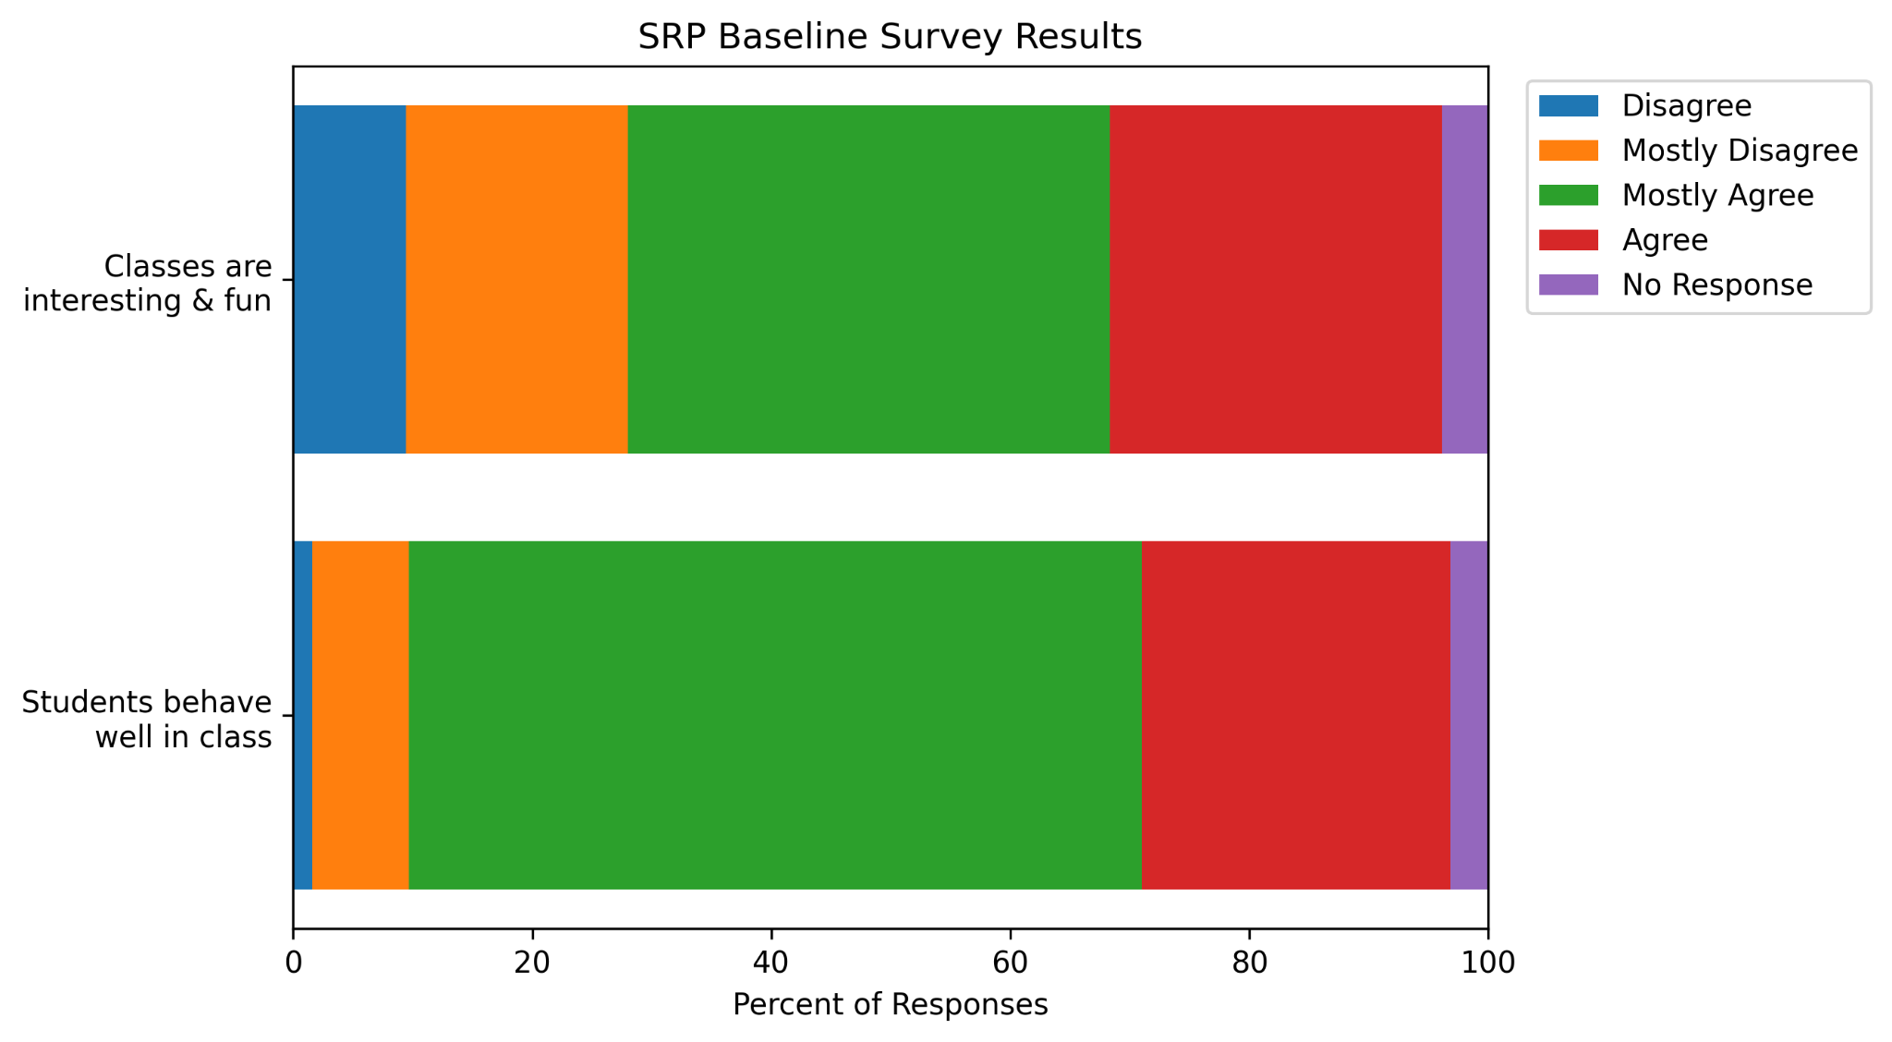

Teacher perception data highlights ongoing concerns regarding student behavior, with only 25.8% of teachers reporting that students behave well in their classrooms. This perception aligns with identified needs to strengthen behavior management systems and improve the overall classroom climate.
While 68% of students report that classes are interesting and engaging, this suggests room to enhance instructional relevance and student engagement to further support positive behavior and academic outcomes.
In summary, Hartsville Middle School is experiencing upward trends in accountability ratings and climate measures; however, sustained focus on behavior systems, classroom management, instructional engagement, and attendance improvement will be critical to maintaining progress and accelerating student success. We will continue to create opportunities for students to feel connected and have a sense of belonging to improve key areas of discrepancy.
Restorative practices and mentors will be implemented to assist with behavior systems.
Other (such as district and/or school priorities)
N/A

Performance Goals

Per SBE Regulation 43-261, measurable performance goals, written in five-year increments, shall be developed to address the major areas of discrepancy found in the needs assessment in key areas reported in the district and school report cards.
Performance Goal Area: Student Achievement*
(*required)
PERFORMANCE GOAL: By June 2031, at least 75% of students will score at the Meets or Exceeds Expectations performance levels on the SCREADY ELA assessment. Progress toward this goal will be monitored quarterly using interim i-Ready ELA assessments, with data used to inform instruction and implement targeted intervention strategies.
INTERIM PERFORMANCE GOAL: Meet annual targets below.

Data Source(s) | Average Baseline | 2026-2027 | 2027-2028 | 2028-2029 | 2029-2030 | 2030-2031
SCREADY | 47.1% | Target: 52.68 %  Actual: | Target: 58.26%  Actual: | Target: 63.84%  Actual: | Target: 69.42%  Actual: | Target: 75%  Actual:
6th Grade I-Ready | 31% | Target: 39.8%  Actual: | Target: 48.6%  Actual: | Target: 57.4%  Actual: | Target: 66.2%  Actual: | Target: 75%  Actual:
7th Grade I-Ready | 38% | Target: 45.4 %  Actual: | Target: 52.8%  Actual: | Target: 60.2%  Actual: | Target:67.6%  Actual: | Target: 75%  Actual:
8th Grade I-Ready | 34% | Target: 42.2%  Actual: | Target: 50.8%  Actual: | Target: 59.2%  Actual: | Target: 67.6%  Actual: | Target: 75%  Actual:

Student Achievement* STRATEGY #1

ACTION PLAN FOR STRATEGY #1: Promote Teacher Professional Growth and Build Capacity for Tier 1 Instruction
ACTIVITY | TIMELINE  (Start and  End Dates) | PERSON(S) RESPONSIBLE | ESTIMATED COST | FUNDING SOURCE | EVALUATION: INDICATORS OF IMPLEMENTATION
HQIM Training : Ongoing support for using the materials for StudySync and SAVAAS will be done by CTs and Coordinators as designated by CIA. | 8/2026-5/2031 | CTs | Substitutes $1200 | ATSI | PLC agendas and minutes  Walkthrough trend reports  PD attendance logs  Classroom Mosaic  Data Conference Reflections
PLCs: Focus will be on answering the 4 PLC questions using data from CFAs and classroom data. | 8/2026-5/2031 | CTs and Admin | $0 | N/A
Tiered Support: Teachers will receive observations and coaching based on their assigned tiers | 8/2026-5/2031 | CTs and Admin | $0 | N/A
Analyze i-Ready Diagnostic Data: Students will be grouped according to performance and grade level trends determined after each diagnostic administration. Use of the iReady Teacher Toolbox to support instructional needs will be utilized. | 8/2026-5/2031 | CTs, Admin, Teachers | $0 | N/A
Targeted Small Group Instruction: Within ELA and Math classes teachers will provide small group instruction based on Learning Path data. | 8/2026-5/2031 | Teachers | $0 | N/A
Data Conferences: Teachers will engage in SLO conferences and quarterly data conferences related to test data, grades, attendance and discipline referrals. | 8/2026-5/2031 | CTs and Admin | $0 | N/A
Unit Internalization Plan: The Unit Internalization Plan for planning instructional units in PLC and weekly department plannings. | 8/2026-5/2031 | CTs | $0 | N/A

Performance Goal Area: Student Achievement*
(*required)
PERFORMANCE GOAL: By June 2031, at least 75% of students will score at the Meets or Exceeds Expectations performance levels on the SCREADY Mathematics assessment. Progress toward this goal will be monitored quarterly using interim i-Ready mathematics assessments, with data used to inform instruction and implement targeted intervention strategies.
INTERIM PERFORMANCE GOAL: Meet annual targets below.

Data Source(s) | Average Baseline | 2026-2027 | 2027-2028 | 2028-2029 | 2029-2030 | 2030-2031
SCREADY | 25.6% | Target: 35.48 %  Actual: | Target: 45.36 %  Actual: | Target: 55.24%  Actual: | Target: 65.12 %  Actual: | Target: 75%  Actual:
6th Grade I-Ready | 33% | Target: 41.4 %  Actual: | Target: 49.8%  Actual: | Target: 58.2%  Actual: | Target: 66.6 %  Actual: | Target: 75%  Actual:
7th Grade I-Ready | 34% | Target: 42.2%  Actual: | Target: 50.8%  Actual: | Target: 59.2%  Actual: | Target: 67.6%  Actual: | Target: 75%  Actual:
8th Grade I-Ready | 25% | Target: 35 %  Actual: | Target: 45%  Actual: | Target: 55%  Actual: | Target: 65 %  Actual: | Target: 75%  Actual:

Student Achievement* STRATEGY #1

ACTION PLAN FOR STRATEGY #1: Promote Teacher Professional Growth and Build Capacity for Tier 1 Instruction
ACTIVITY | TIMELINE  (Start and  End Dates) | PERSON(S) RESPONSIBLE | ESTIMATED COST | FUNDING SOURCE | EVALUATION: INDICATORS OF IMPLEMENTATION
HQIM Training (PLOs): Math teachers will participate in PLOs through the Palmetto Math Project. | 8/2026-5/2031 | SDE, CTs | Substitutes ($1200) | ATSI | PLC agendas and minutes  Walkthrough trend reports  PD attendance logs  HIT Logs and progress reports  Classroom Mosaic  Data Conference Reflections
PLCs: Focus will be on answering the 4 PLC questions using data from CFAs and classroom data. | 8/2026-5/2031 | CTs and Admin | $0 | N/A
Tiered Support: Within ELA and Math classes teachers will provide small group instruction based on Learning Path data. | 8/2026-5/2031 | CTs and Admin | $0 | N/A
Data Conferences: Teachers will engage in SLO conferences and quarterly data conferences related to test data, grades, attendance and discipline referrals. | 8/2026-5/2031 | CTs and Admin | $0 | N/A
Analyze i-Ready Diagnostic Data: Students will be grouped according to performance and grade level trends determined after each Diagnostic administration. Use of the iReady Teacher Toolbox to support instructional needs will be utilized | 8/2026-5/2031 | CTs, Admin, Teachers | $0 | N/A
High Intensity Tutoring: Students will receive tutoring twice per week through Varsity tutors or four times per week through TFA Ignite. Students identified based on proficiency and AVTs. | 8/2026-5/2031 | TFA Ignite and Varsity Tutors | $? | ATSI/District

Student Achievement* STRATEGY #2

ACTION PLAN FOR STRATEGY #2: Launch an ELA and Math Intervention plan for students.
ACTIVITY | TIMELINE  (Start and  End Dates) | PERSON(S) RESPONSIBLE | ESTIMATED COST | FUNDING SOURCE | EVALUATION: INDICATORS OF IMPLEMENTATION
1. Analyze I-Ready Diagnostic Data after the Diagnostic assessments to set or reset lesson pacing to ensure all standards are being taught and re-taught for understanding. | 8/2026-5/2031 | Admin -Instructional Coaches --Grade Level Teams | N/A | N/A | Student Data Profiles, ensuring students are meeting stretch growth targets.
2. Student Data Chats in both the fall and spring semesters, providing students with an opportunity to reflect on their academic progress, analyze their i-Ready data. Students set smart goals to help achieve stretch growth targets | 8/2026-5/2031 | Teachers  Students  Admin | $0 | N/A | Data Dig Sheets
Targeted Small Group during class 3x per week. Students scoring 2 or more grade levels below will be placed in HIT as funding permits. | 8/2026-5/2031 | Teachers  HIT Providers | $10,000 | ATSI | Exit Tickets  Growth Checks  Service Logs
Performance Goal Area: Student Achievement*
(*required)
PERFORMANCE GOAL: By June 2031, at least 75% of students will score at the Meets or Exceeds Expectations performance levels on the SCREADY Science assessment. Progress toward this goal will be monitored quarterly using interim benchmark assessments and district common formative assessments, with data used to inform instruction and implement targeted intervention strategies.
INTERIM PERFORMANCE GOAL: Meet annual targets below.

Data Source(s) | Average Baseline | 2026-2027 | 2027-2028 | 2028-2029 | 2029-2030 | 2030-2031
SCREADY Science-6th Grade | 50% | Target: 55 %  Actual: | Target: 60 %  Actual: | Target: 65%  Actual: | Target: 70%  Actual: | Target: 75%  Actual:

Student Achievement* STRATEGY #1
ACTION PLAN FOR STRATEGY #1: Promote Teacher Professional Growth and Build Capacity for Tier 1 Instruction
ACTIVITY | TIMELINE  (Start and  End Dates) | PERSON(S) RESPONSIBLE | ESTIMATED COST | FUNDING SOURCE | EVALUATION: INDICATORS OF IMPLEMENTATION
PLC and Data-Driven Instruction Cycles: Plan → Teach → Assess → Analyze → Adjust | 8/2026-5/2031 | CTs, Teachers, Admin | $0 | N/A | Student Data Trackers, UIPs
Explicit instruction in science vocabulary and disciplinary literacy. (Frayer Model, Marzano Model, Two Column Notes) | 8/2026-5/2031 | CTs, Science Teachers | $0 | N/A | PLC agendas and minutes  Lesson Plans  PD Agendas
PLOs: The lead Science teacher will participate in regional and district PLOs. Information will be shared with other science teachers. | 8/2026-5/2031 | SDE and Teachers | $0 | N/A | PLC agendas and minutes  Lesson Plans  PD Agendas
Inquiry Based Strategies: Teachers will learn strategies that allow them to investigate questions rather than just receive content. (Think, Pair, Share; Use of released SC READY items for practice with justification of answers). | 8/2026-5/2031 | CTs and Teachers | $0 | N/A | Lesson Plans  CFA  Exit tickets
Performance Goal Area: School Climate*
(*required)
PERFORMANCE GOAL: By June 30, 2031, HMS will reduce chronic absenteeism from 28.9% to 5%, as measured by district PowerSchool attendance records.
INTERIM PERFORMANCE GOAL: Meet annual targets below.

Data Source(s) | Average Baseline | 2026-2027 | 2027-2028 | 2028-2029 | 2029-2030 | 2030-2031
Chronic Absenteeism and Attendance Reports | 28.9% | Target: 24.12%  Actual: | Target: 19.34%  Actual: | Target: 14.56%  Actual: | Target: 9.78%  Actual: | Target: 5%  Actual:

School Climate*STRATEGY #1

ACTION PLAN FOR STRATEGY #1: Tiered intervention system that includes family engagement and student accountability measures relating to attendance.

ACTIVITY | TIMELINE  (Start and  End Dates) | PERSON(S) RESPONSIBLE | ESTIMATED COST | FUNDING SOURCE | EVALUATION: INDICATORS OF IMPLEMENTATION
- Attendance Incentive Program: Students who have perfect attendance are recognized and receive treats each quarter. | 8/2026-5/2031 | Attendance Leadership Team and Mentors | $400 | SAA | Quarterly decrease in chronic absenteeism rate  Increased attendance among previously Tier II students  Positive trend in grade-level attendance comparisons  Correlation between attendance improvement and academic performance
- School-Wide Attendance Campaign: The advisory class with the best attendance each month is recognized. | 8/2026-5/2031 | Attendance Leadership Team | $0 | NA
- Attendance Recovery: Students with AIPs attend attendance recovery after school to make up missed days. | 8/2026-5/2031 | Attendance Leadership Team | $2500 | District Funds

Performance Goal Area: School Climate*
(*required)
PERFORMANCE GOAL: By May 2031, Hartsville Middle School will increase the School Climate Score as measured by the SC School Report Card from 6.44 to at least 7.5, increase the percentage of teachers who agree that students behave well in their classrooms from 25.8% to 50%, and increase the percentage of students who report that classes are interesting and engaging from 68% to 80%, as measured by annual school climate surveys and report card indicators.
INTERIM PERFORMANCE GOAL: Meet annual targets below.

Data Source(s) | Average Baseline | 2026-2027 | 2027-2028 | 2028-2029 | 2029-2030 | 2030-2031
School Climate Score | 6.44 | Target: 6.65  Actual: | Target: 6.85  Actual: | Target: 7.05  Actual: | Target: 7.25  Actual: | Target: 7.5  Actual:
Teacher Perception of Behavior | 25.8% | Target: 30%  Actual: | Target: 35%  Actual: | Target: 40%  Actual: | Target: 45%  Actual: | Target: 50%  Actual:
Student Perception of Engagement | 68% | Target: 70%  Actual: | Target: 72%  Actual: | Target: 74%  Actual: | Target: 76%  Actual: | Target: 80%  Actual:

School Climate*STRATEGY #1

ACTION PLAN FOR STRATEGY #1: Strengthen Tier 1 Behavior Systems
ACTIVITY | TIMELINE  (Start and  End Dates) | PERSON(S) RESPONSIBLE | ESTIMATED COST | FUNDING SOURCE | EVALUATION: INDICATORS OF IMPLEMENTATION
1.Re-teach schoolwide behavior expectations quarterly.  2.Implement consistent minor/major referral definitions and calibration training.  3.Establish a behavior matrix aligned to common areas and classrooms.  4. Conduct monthly behavior data reviews during leadership and PLC meetings.  5. Increase positive behavior acknowledgments (minimum 4:1 ratio goal). | 8/2026-5/2031 | Assistant Principals  Team Leaders | $0 | N/A | Monthly discipline dashboard  Walkthrough behavior look-fors  Referral reduction trends  Staff survey mid-year pulse check  Positive referral data

School Climate* STRATEGY #1

ACTION PLAN FOR STRATEGY #1: Increase Leadership Responsiveness & Teacher Voice
ACTIVITY | TIMELINE  (Start and  End Dates) | PERSON(S) RESPONSIBLE | ESTIMATED COST | FUNDING SOURCE | EVALUATION: INDICATORS OF IMPLEMENTATION
- Implement “Teacher Voice Forums.”  - Create anonymous digital feedback form with quarterly leadership review.  - Communicate follow-up actions (“You Said, We Did” updates).  - Include teacher representatives in leadership planning committees. | 8/2026-5/2031 | Admin Team  School Leadership Team | $0 | N/A | Forum agendas and attendance  Action-response logs  Staff climate pulse survey results

Performance Goal Area: Teacher/Administrator Quality*
(*required)
PERFORMANCE GOAL: By June of 2031, HMS will maintain 99% high-quality, certified teachers and administrators who meet state certification and performance standards.
INTERIM PERFORMANCE GOAL: Meet annual targets below.

Data Source(s) | Average Baseline | 2026-2027 | 2027-2028 | 2028-2029 | 2029-2030 | 2030-2031
Certification Rates | 90% | Target: 91.8%  Actual: | Target: 93.6%  Actual: | Target: 95.4%  Actual: | Target: 97.2%  Actual: | Target: 99%  Actual:

Teacher/Administrator Quality*STRATEGY #1
ACTION PLAN FOR STRATEGY #1: Decreases the number of teachers on alternative certification pathways.
ACTIVITY | TIMELINE  (Start and  End Dates) | PERSON(S) RESPONSIBLE | ESTIMATED COST | FUNDING SOURCE | EVALUATION: INDICATORS OF IMPLEMENTATION
Praxis Preparation and Certification Support Program: Director of HR provides opportunities for alternative certified teachers to participate in Praxis Prep Classes | 8/2026-5/2031 | Consultant Providers | $? | HR | Individual study plans documented.  Praxis test pass rate.
Teacher Mentor Program: Each new teacher at HMS is assigned a buddy/mentor to help them adjust to HMS. The mentors check in at least twice per month to support new teachers at HMS. | 8/2026-5/2031 | Administrators Teacher Mentors | $200 | SAA | Percentage of new teachers assigned mentors.  Mentor meeting logs and support documentation.  First- and second-year teacher retention rates.  New teacher satisfaction survey results.
Strategic Recruitment of Highly Qualified Educators: Partner with local colleges to support internships while student teachers are training. Notify colleges of high need areas. Attend university recruitment events. | 8/2026-5/2031 | Administrators | $0 | N/A | Number of recruitment partnerships established, Number of candidates hired through recruitment events. Percentage of new hires meeting certification requirements at time of hire.

School Renewal Plan Checklist

Are the following complete?
School Renewal Plan Signature Page
Assurances for Plan
Stakeholder Involvement for Plan
Comprehensive Needs Assessment Data
Executive Summary of Needs Assessment Data Findings
Performance Goal and Action Plan: Area – Student Achievement
Performance Goal and Action Plan: Area – School Climate
Performance Goal and Action Plan: Area – Teacher/Administrator Quality
Once all boxes are checked, the plan can be submitted.

