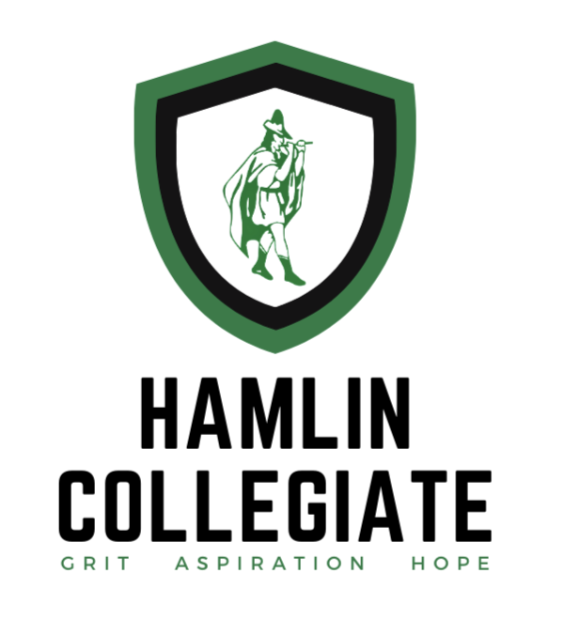
Hamlin Collegiate ISD

P-TECH 13-14 Program

Handbook & Agreement

The 13-14 component of the Hamlin Collegiate ISD P-TECH program offers Hamlin graduates the opportunity to pursue a postsecondary credential with partnering Institutes of Higher Education (IHE) and gain real-world experience through industry partnerships. This document serves as an agreement between the student entering the program and the school district, outlining the responsibilities of both parties. Students must agree to and abide by these terms to participate in the 13-14 Program. Through collaboration with IHEs and industry partners, Hamlin Collegiate ISD (HCISD) is committed to providing students with the academic, financial, and career support necessary for success.

Student Responsibilities

The student will:

Academic Expectations
- Maintain good academic standing with both HCISD and the selected IHE, abiding by all IHE academic policies.
- Maintain full-time enrollment (fall and spring terms) and a minimum 2.75 grade point average (GPA) each term.
  - Students falling below a 2.75 GPA will be placed on academic probation with intervention support.
      - Students on probation will meet with the College & Career Coach (CCC), the designated HCISD representative for academic support, to create an improvement plan.
  - A GPA of 1.0 or lower in any term will result in immediate dismissal from the program.
- Notify the CCC before withdrawing from or dropping a course. Unauthorized drops may impact program status and financial support.
- Complete and submit a FAFSA application annually and share financial aid award information with the CCC.

Enrollment & Program Commitment
- Remain continuously enrolled in the 13-14 Program from the fall after high school graduation for up to two years or until earning a certification and/or degree, whichever comes first.
- Meet with the CCC and/or Collegiate Edu-Nation (CEN) staff at least once per week, either in person or virtually.
- Log study hours at The Piper Center (if enrolled in a fully online program). Study hour requirements will be reviewed and adjusted based upon academic performance.

Financial Responsibilities
- Acknowledge HCISD’s financial support:
  - HCISD will cover tuition, textbooks, and academic fees during fall and spring terms for up to two years post-graduation.
  - Students should expect to use financial aid to cover other costs such as tools and equipment.
  - HCISD will not cover summer tuition or fees, but students may use personal funds or financial aid.
  - HCISD will not cover housing, meals, transportation, fuel, or parking fees—these are the student’s responsibility.
- Be responsible for all HCISD-issued property, including, but not limited to, textbooks, laptops, and key cards. Fees will be assessed for lost, broken, or destroyed items.

Professionalism & Conduct
- Uphold professional behavior and communication standards when interacting with HCISD staff, IHE faculty, employers, and peers.
- Respond within 24 hours to communications from the CCC or HCISD administration.
- Schedule proctored tests at least two weeks in advance with the CCC.

Drug-Free Participation Policy
- As a condition of participation in the 13-14 Program, students are expected to remain drug-free. Students may be subject to random drug testing at the discretion of Hamlin Collegiate ISD.
  - Refusal to participate in a required drug test or a confirmed positive result may result in disciplinary action, including probation or dismissal from the program.
  - All testing will follow HCISD’s board-approved drug testing policy, and results will be handled in accordance with student privacy laws.

Internship Requirement
- Complete an internship in the chosen field of study before program completion.
  - The CCC will assist in securing internship opportunities.
  - Additional internship guidelines, including hour requirements, will be provided by the CCC.

Participation & Engagement
- Participate in at least one P-TECH event per year.
- Engage in career readiness activities as recommended by the CCC.

Appeals & Exceptions
- Students may appeal academic or financial eligibility decisions. Appeals must be submitted in writing to the CCC and HCISD administration within 10 days of notification.
- Extenuating financial circumstances will be reviewed by HCISD administration, with determinations made on a case-by-case basis.

Hamlin Collegiate ISD Responsibilities

HCISD will:

Financial & Academic Support
- Cover tuition, textbooks, and academic fees for students enrolled in the 13-14 Program during fall and spring terms for up to two years post-graduation.
  - HCISD will not cover summer tuition or fees unless an exception is approved due to extenuating financial circumstances.
  - Students must follow the IHE financial aid processes, including completing FAFSA annually and sharing award details with the CCC.
- Provide academic support through weekly check-ins with the CCC to track progress, discuss challenges, and offer guidance on coursework and career pathways.
- Offer additional academic intervention if students fall below a 2.75 GPA, including tutoring resources or study plan adjustments.

Technology & Study Resources
- Equip students with required textbooks and a laptop necessary for coursework.
  - Students are responsible for the care and proper use of these items.
  - Damaged or lost devices must be replaced at the student’s expense.
  - Laptops must be returned upon program completion.
- Provide students remaining in the Hamlin area with a quiet study space and internet access at The Piper Center to complete coursework.
- The Piper Center’s operating hours and guidelines will be communicated to students.

Testing & Internships
- Proctor exams as needed, with a minimum two-week advance scheduling notice.
- Assist students in securing internships related to their field of study in collaboration with industry partners.

Property, Privacy, and Program Commitments

School Property
Any textbooks, tools, laptops, key cards, or equipment purchased by the school are the property of the State of Texas. You are responsible for keeping these items in good condition. If you fail to return them—especially laptops—we are required to report them as stolen to the Texas Education Agency. This may lead to an investigation by the Department of Public Safety (DPS) and possible criminal charges.

Student Records and FERPA
Most colleges we partner with allow Hamlin staff to view your grades and academic progress through formal agreements. In some cases, you may need to give written permission (proxy access) so we can support you throughout the program.

Under federal law (FERPA), your college can only share your academic records with HCISD if you’ve granted access. Without this, we can’t monitor your progress or help if issues come up. You’ll be asked to complete this permission form when enrolling in your college.

Post-Completion Data Agreement
To ensure the effectiveness and continued improvement of the P-TECH 13-14 Program, Hamlin Collegiate ISD requires all participants to provide post-program follow-up data for up to five years after completion. This includes information such as current employment status, job title, length of employment, and annual salary.

By signing this agreement, students consent to being contacted periodically by HCISD staff to collect this information. This data will be used solely for program evaluation purposes and to demonstrate that the P-TECH 13-14 Program is preparing students for high-wage, high-demand careers. All personal information will be kept confidential and reported only in aggregate form unless otherwise permitted by law.

Hamlin Collegiate ISD
P-TECH 13-14 Program Agreement

By signing this document, I acknowledge my obligations as a participant in the Hamlin Collegiate ISD P-TECH 13-14 Program. I commit to adhering to all policies and procedures and comprehend the expectations placed upon me. This agreement will be retained in my academic file within HCISD throughout my tenure in the program. In the event of any concerns, this document will serve as a reference to ensure clarity regarding my responsibilities within the program.

Student Name (Printed)

Student Signature Date

Parent/Guardian Name (Printed)

Parent/Guardian Signature Date

For Office Use Only
Name (Printed): |  |  |  |  | Date:
Title:
Signature:

