Student and Family Handbook
Gregory Heights Elementary
2026-27



Gregory Heights Elementary School
16201 16th Avenue SW
Burien, Washington 98166

Phone: (206) 631-3800
Fax: (206) 631-3862
Website: http://www.gregory.highlineschools.org

“Every student in Highline Public Schools is known by name, strength, and need, and graduates prepared for the future they choose.”

Welcome

Dear Gregory Heights Families,

Welcome to the 2026-27 school year! My name is Jodi Robertson, and I am honored to join the Gregory Heights community as your new principal. I am excited to partner with you as we work together to create a safe, inclusive, and engaging learning environment where every student can thrive.

Thank you for trusting us with your child’s education and well-being. I also appreciate you taking the time to review the information in this handbook. It contains important safety procedures, school expectations, and helpful resources that we hope you will refer to throughout the school year.

Family partnership is one of the greatest contributors to student success. There are many meaningful ways you can support your child's learning and growth at home. Here are a few suggestions:
- Spend time talking with your child every day.
- Provide regular, healthy meals.
- Ensure your child gets adequate sleep each night (8-10 hours, depending on age).
- Let your child know every day that they are loved, valued, and accepted for who they are.
- Read with your child for at least 20 minutes each day, whether through books, e-books, newspapers, or online resources.
- Monitor and balance screen time, including television, gaming, and other digital activities.
- Model respectful communication and peaceful problem-solving.
- Plan family vacations during school breaks whenever possible.
- Schedule medical appointments outside of the school day whenever feasible.

We recognize that families today balance many responsibilities and demands. Whether you can volunteer regularly, attend school events occasionally, or support learning from home, your involvement matters. We hope you will consider joining us through volunteer opportunities, attending PTSA meetings, or participating in school activities throughout the year. If you are interested in getting involved, please reach out to your child's teacher or connect with our PTSA to learn more.

At the same time, we understand that every family's circumstances are different. Please know that your support of your child at home is deeply valued. You are your child's first and most important teacher, and the partnership between home and school plays a vital role in student success.

If you have questions, concerns, or ideas to share throughout the year, please don't hesitate to contact me, your child's teacher, or our school office at 206-631-3800. We are here to support you and look forward to working together to make this a wonderful year for every Gregory Heights student.

Warmly,

Jodi Robertson, Principal

Table of Contents

School Hours and District Calendar | 3 | District Owned Technology Use | 12-13
Communication | 4 | Health Information | 13-14
Arrival | 4-5 | Student Management and Discipline | 14
Transportation | 5-6 | Playground Expectations | 14-17
Attendance, When to Stay Home & Vacation Policy | 6-9 | Social-Emotional Learning | 17-18
Visitors, Volunteers, and School Security | 9-10 | Ladder of Accountability to Make Change | 19
School Lunch & Breakfast | 10 | Buses | 20
Dress Code | 10 | Harassment, Intimidation, and Bullying (HIB) Policy | 20
Bicycles | 10 | Non-Discrimination | 21
Pets | 11 | Sexual Harassment | 21-22
Lost and Found and Personal Belongings | 11 | Complaint Options | 22
Water bottles | 11 | Gender Inclusive Schools | 23-24
Personal Electronic Devices and Cell Phones | 11-12 | Highline Public Schools Emergency Information & Emergency Drills | 24-25
Cyberbullying | 12 | Gregory Heights PTSA | 26

School Hours
8:25am | Students may arrive on the play field  Students eating breakfast may enter the cafeteria
8:40am | All students should be on school grounds
8:40am | Bell rings; students may enter classrooms
8:45am | School begins  Students should be seated in class and ready to learn  Students arriving after 8:45 are marked tardy
3:15pm | Dismissal (Monday, Tuesday, Wednesday and Thursday)  Please note: Students are dismissed early at 1:45 p.m. on Fridays

District Calendar
A year-long calendar on our district website - https://www.highlineschools.org/about/calendar

Important Dates, Holidays, and Breaks for 2026-27 School Year
September 2025 | - September 3 - First Day of school for 1st - 5th grade  - Sept. 3, 4, 8 - Kindergarten Family Conferences  - September 9 - First Day of school for Kindergarten  - September 14 - First Day of school for Preschool
October 2025 | - October 9 - Teacher Workshop Day (No School)
November 2025 | - November 2- Teacher Workshop Day (No School)  - November 11 - Veterans Day (No School)  - November 23, 24, 25 - Student-Led Conferences (No School)  - Only come during your scheduled conference day / time  - November 26-27 - Thanksgiving Break (No School)
December 2025 | - December 21 – January 1 - Winter Break (No School)
January 2026 | - January 4 - Return from Winter Break  - January 18 - Martin Luther King Jr. Day (No School).
February 2026 | - February 12 – Mid-Winter Break (No School)  - February 15 - Presidents Day (No School)
March 2026 | - March 12 - Teacher Workshop Day (No School)
April 2026 | - April 5-9 - Spring Break (No School)
May 2026 | - May 31 - Memorial Day (No School)
June 2026 | - June 16 - Last Day of Preschool  - June 17- Last Day of School  - June 18 -Juneteenth (Observed) - School Offices Closed
Communication
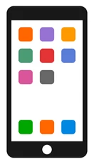
Communication between our families and the school is very important. We have a variety of means of communication to provide families with important information about student progress, classroom activities, and school events. We welcome communication from families as well!

- The district’s website (www.highlineschools.org) and mobile app (Highline Public Schools) offer information about Highline Public Schools. In addition, families can access the school website through the district webpage.
- Information is sent home weekly on Tuesdays in your student’s Blue “Paw Pride” folder. Please look over this information and return the folder the following day.
- In addition to information sent home, texts and emails will be sent to families as well. Please check our website for additional information.
- The Gregory Heights PTSA newsletter is generally sent home monthly in the parent pack. This will also be posted on the Gregory Heights PTSA Facebook page.
- Parents and guardians will also be able to access their students’ enrollment profiles, report cards, and test results in ParentVue, and the ParentVue app. You can receive your activation code from the school office.
- Classroom teachers will communicate through Parent Square. Parents and guardians may contact teachers by email or phone; please allow at least 24 hours for a response. In case of an urgent or emergent situation, please call the school office.

Arrival
K-5th Grade students may begin arriving on campus after 8:25 a.m. We do not have supervision available before this time. Time before school is not a designated recess time. Preschool families must stay with preschool students until 8:40 when teachers pick up students.

Students are not allowed on the lower playground area before school. Students are not allowed in any of the areas of the building other than the cafeteria, office, or restrooms near the lunchroom before 8:25 a.m.

School begins at 8:40 a.m. Teachers will escort their class line into the building when the 8:40 a.m. bell rings. After this time, all students should enter through the front door of the building.

Students who eat breakfast at school:
- Proceed directly to the cafeteria upon arrival on campus. Students going to breakfast enter the building through a door near the cafeteria.
- Breakfast service ends at 8:45 a.m.
- When finished eating breakfast, students should proceed to their classroom “line-up” space.

Student who do not eat breakfast at school:
- Proceed directly to their classroom’s designated “line-up” space on the playground.

Dismissal:
- Students should travel directly to their dismissal route.
- Students who meet siblings or walking partners should do so in a designated space in the front by the flagpole or in the back of the building at the basketball court.

Use of the playground after school:
- Students are not allowed to play on the playground immediately after school unless accompanied by a parent/guardian.
- After school, all students must go home and check in with their family before returning to the playground after 4:30.
- No students may stay after school to use play equipment unless their own parent or guardian is with the student.
- The school does not provide supervision for students after 3:25 PM.

Transportation

The safety of our students is very important to all of us at Gregory Heights Elementary. For the safety of our children, please observe our traffic procedures and patterns. Please be patient and cautious.

Please establish a regular routine for your child’s transportation to and from school. If there are changes in a student’s regular routine to or from school, please send a note to school with your child or call the school no later than 2:45PM. If you are picking up your child for early release, you must do so prior to 3:00PM.

Walking:
- Students who walk to or from school should use designated crosswalks and be safe and cautious. Walkers must go home immediately.
- Parents please also use the crosswalks to help us model safe behavior to students.
- If they wish to go to a friend’s house, students must make arrangements before coming to school or after they arrive home.
- Students must follow the safe walking routes to and from home; they may not enter school grounds through the bus lanes in the back of the school.

Bus Riders:
- Students are expected to be at their assigned bus stop on time.
- If you have any questions about school bus service, please call the Transportation Office at (206) 631-7502.

Family provided Transportation (Car):
- Drop off and pick up students in the designated loading areas only. Please drop off kindergarteners and preschoolers only in the front (16th Ave.)
- If families wish to accompany their child on campus during arrival and dismissal at school, please park in a designated parking space or on the street.
- Parking is not permitted in designated loading areas AT ANY TIME during the school hours. These are fire lanes. Please do not leave cars unattended!

Front of School Drop-off and Pick-Up:
- Entry to the loading area is only permitted from southbound travel on 16th Ave SW.
- Students should load and unload from the curbside lane only.
- Cars may travel through the left lane to exit the loading area.
- Move as far forward as possible in the loading lane before stopping to allow for as many vehicles to enter the loading area as possible.
- Preschool families will need to continue to pull forward until 8:40am when preschool staff is available to meet students.
- Be cautious of children when proceeding through the crosswalk area in the middle of the loading zone. Please monitor your speed in the loading area and follow the guidance of directing staff.
- All adults and students crossing the parking lot should do so only at the crosswalk
- Do not leave your vehicle unattended in the loading area for any reason. The loading lanes are designated fire lanes and need to be cleared quickly in case of emergencies.
- Students are not permitted to load to and from vehicles parked in the parking lot unless accompanied by an adult. It is unsafe for students to walk through the parking area, between cars, or cross the loading lane area without supervision.
- Please watch out for children in or near the crosswalk on 16th Avenue SW. Do not park in the crosswalk. Please monitor your speed, proceed with caution in this area, and follow guidance of directing staff.

Back of School Drop-off and Pick-up:
- Entry to the loading zone is permitted through the south entrance on 19th Ave SW for first through fifth grade only.
- Students may load from the curbside lane next to the playground.
- Move as far forward as possible in the loading lane before stopping to allow for as many vehicles to enter the loading area as possible.
- Do not wait in the small area between the back parking lot and the entry gate as it prevents buses from being able to enter the parking lot.
- Private vehicles are not permitted into the bus lane area adjacent to the back of the school during arrival and dismissal.
- To exit the loading area, travel through the parking area and proceed through the north gate onto 19th AVE SW.
- Do not leave your vehicle unattended in the loading area for any reason. The loading lanes are designated fire lanes and need to be cleared quickly in case of emergencies.
- Students are not permitted to load to and from vehicles parked in the parking lot unless accompanied by an adult. It is unsafe for students to walk through the parking area, between cars, or cross the loading lane area without supervision.

Attendance
Attending school and being on time on a regular basis helps a student receive the maximum benefit of daily learning. Most classroom experiences cannot be duplicated on an individual basis, so being in the classroom is vital to student academic growth. Absences and tardies result in a loss of learning from direct instruction, discussion, and participation.
Research shows that students with poor attendance do not perform as well in school as their peers with good attendance. Your support of your student’s attendance is essential to their academic and social success!

If your student is absent from school, parents and guardians are required to call the school office at 206-631-3800 or send a note stating the reason for the absence with their student when they return.

Repeated absences (as outlined in Highline Public Schools Board Policy 3122) will result in implementing the Washington State Becca Bill process. Students are responsible for making up missed work. Families may request homework directly from the teacher; please allow 24 hours to prepare assignments.
Our school attendance policy is based on state law and Highline Public Schools Board Policy 3122.

Becca Bill- Washington State RCW 28A.225 requires:
Excused Absences:
- If a student has five (5) or more excused absences, the school will contact the child’s parent/guardian for the purpose of identifying barriers to the student’s regular attendance.
- If the student has three (3) or more excused absences due to illness in one month, a medical note may be requested for future absences.
- If a student has ten (10) or more excused absences, a parent conference will be requested. If the student had ten (10) or more excused absences in the prior school year, a doctor’s note will be requested for future absences.
- If a student has 15 or more excused absences OR a multi-year pattern of 10 or more absences, the nurse will request doctors’ notes for future absences, depending on circumstances.
Unexcused Absences:
- After one (1) unexcused absence, the parent or guardian will be notified; an unexcused absence is an absence that does not meet the criteria for excused absences OR an absence which has not been excused by providing a note or informing the school within 48 hours. After two unexcused absences, the school will request a parent conference to plan for improving the student’s attendance.
- After five unexcused absences, the district is required to enter into an agreement with the students and parents that establishes attendance requirements, or refer the student to a community truancy board, or file a petition with juvenile court alleging the violation.

The Highline Public Schools Truancy Officer can be reached at (206) 433-0111.

Excused Absence Definitions:
The Principal or designee has the authority to determine if an absence meets the criteria to be deemed an excused absence. An absence may not be considered excused if it causes an adverse effect on the student's educational progress.

School attendance is important to student success. Excessive excused absences may result in a parent conference with the student and an administrator, implementation of an attendance contract, and/or requirement of doctor’s notes to excuse absences due to illness.

Based upon the Regional Code of Washington (RCW), the following are valid excuses for absences:
- Participation in a district or school approved activity or instructional program;
- Illness, health condition or medical appointment for the student or a person for whom the student is legally responsible.
- Family emergency including, but not limited to, a death or illness in the family;
- Religious or cultural purpose including observance of religious or cultural holiday or participation in religious or cultural instruction;
- Court or judicial proceeding.
- State-recognized search and rescue activities consistent with RCW 28A.225.055;
- Absence directly related to the student’s homeless status;
- Absence due to a student’s exercise of their First Amendment rights with prior notification to principal.
- Absences related to deployment activities of a parent/guardian who is an active duty member consistent with RCW 28A.705.010;
- Absence resulting from a disciplinary/corrective action (e.g. suspension or expulsion);
- Absence due to student safety concerns, including absences related to threats, assaults, or bullying, only after required meeting with school staff to develop a plan for the student’s continued education.
- Principal and parent/guardian/emancipated youth mutually agreed upon activity.
- If you are requesting a principal excuse for an event or circumstance not listed above, please complete the pre-approved absence form at the back of this handbook and turn it into the school office in advance of the absence. You will be notified if the absence is not excused.

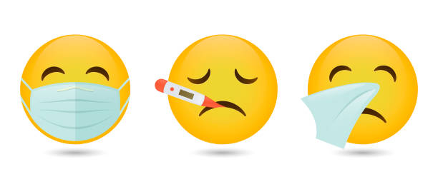
When to Stay Home:
To ensure the health and safety of the school population, a student who has any of the following conditions should stay home from school:
- Fever of 100 degrees or higher
- Vomiting twice within the past 24 hours
- 3 or more loose stools (diarrhea) within the past 24 hours
- Rash with itching, fever or swelling
- Sore throat, with a fever or swollen glands
- Eye infection with itchiness or pus drainage
- Doctor’s note to stay home or staying in the hospital
Students returning to school following the treatments of contagious conditions must check in with the office or school nurse before returning to class.

Tardies/Early Dismissals:
Late arrival to and early dismissal from school is detrimental to student learning and results in loss of instruction. To limit interruptions to your student’s learning and that of the students in his or her classroom, please ensure your child arrives promptly at school each day and make appointments outside of the school day whenever possible.

Students should arrive on campus by 8:40 each day, as any student not in his or her classroom by 8:45 will be considered tardy. Students must report to the office before entering the classroom.

Families of students with five (5) or more tardies will be contacted by phone, email, or letter. Families of children with ten (10) or more tardies will be contacted to confer with school staff to create a plan to improve on-time arrival at school.

If your child must miss part of the school day or leave early for a special appointment (e.g., with the doctor or dentist), they should attend school for as much of the school day as possible to reduce loss of instruction time. Students are only dismissed early from school via the office. If you need to pick up your child during the school day, please come to the office – not to the student’s classroom. You will be required to fill out a student dismissal form and show photo ID to ensure student safety. Please make sure you plan sufficient time for your student to transition from the classroom to the office. We will not call the student to the office until you have checked in with office staff. The names of adults you designate to pick up your child must be on file in the office. If you are bringing your student to school after an appointment, please walk them into the office to ensure safe arrival into the building. Providing a doctor’s or dentist’s note for appointments is helpful.

Vacation Policy:
- If your family is going on vacation and will absent from school, please notify the main office (206) 631-3800 as soon as possible.
- Each family will receive 5 days of excused absences for vacation each school year
- If the vacation exceeds 5 school days, the family may work with administrators and teachers to do a make-up work plan. Anything beyond 5 days will be excused vacation days upon receipt of the completed make-up work plan.

Visitors, Volunteers, and School Security
Safety of students and staff is our highest priority. There is a specific volunteer clearance process in our district. First, complete the volunteer clearance form and provide appropriate ID. Then your clearance must be approved by the district office before coming into school, classrooms or on field trips. If you are able to help teachers with projects or work from home please let your teacher know.

We welcome visitors and volunteers and ask that all of our visitors and volunteers enter by the front office and sign in when they enter the building. Visitors will be asked to show identification so that we know you are a child’s legal guardian or are a person listed by the family as a safe visitor or emergency contact for the child.

By Washington State law, all volunteers must complete the Volunteer Application Form bi-annually. In addition, all visitors and volunteers must wear a badge while working in the building. Anyone who wishes to volunteer for school activities, to work in the classroom, or to chaperone field trips must submit the application.

There are several visitor spaces in the front lot off 16th Avenue SW; please use these for short-term visits to the school (15 minutes or less). We ask that all other volunteers and visitors use the parking lot in the back of the building off 19th Avenue SW. Please be aware of school buses and only enter through the entrance and leave through the exit (north of the lot), avoiding the bus lane. No one should drive through the north service lane at any time.

School Lunch & Breakfast
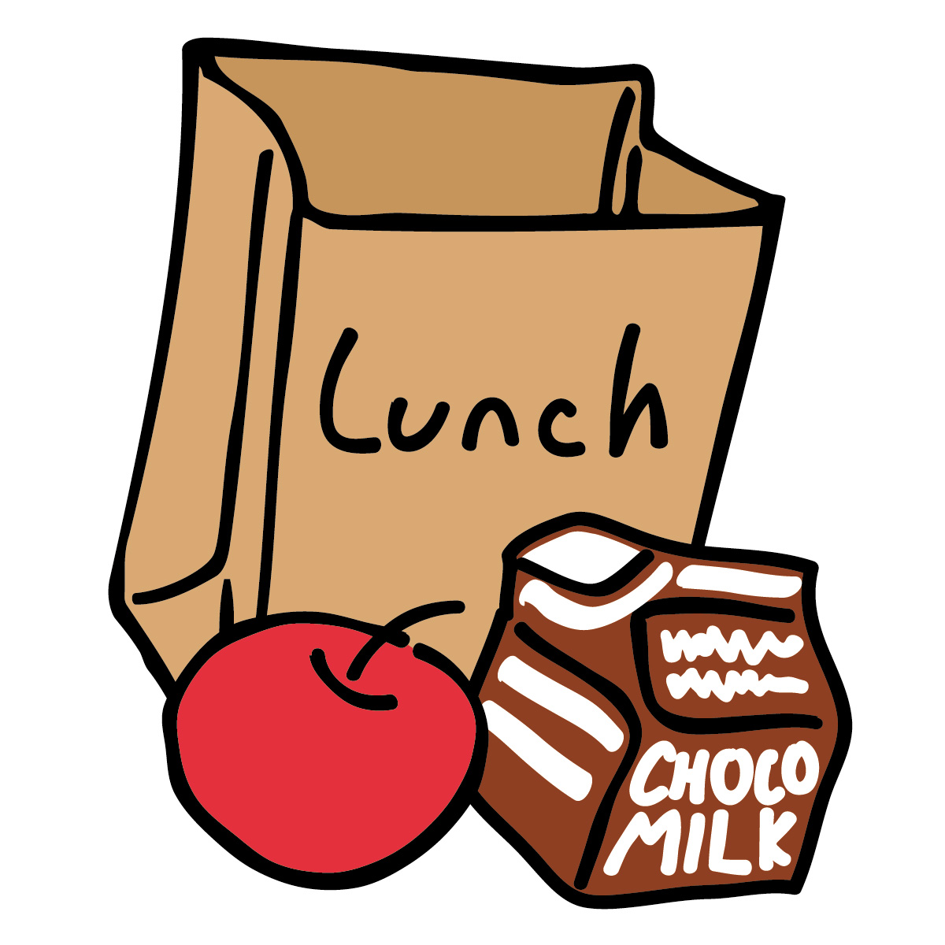
For the 2026-27 school year breakfast and lunch will be provided at no cost for all children.

Please notify your child’s teacher AND our health room attendants if your child has food allergies. In addition, any classroom that has a student with a nut allergy will have a posted sign alerting others of the nut allergy.

The breakfast program begins at 8:25 a.m. in the school cafeteria. Lunch is served from 10:55-1:05 by grade level. If a child would like milk with their lunch from home they will be asked to pick two additional items. They can enjoy them or place the items in the lunchroom “share box”.

We would like families who qualify to please fill out the online application for free and reduced price meals. A great deal of our school funding is dependent on the percentage of our students who qualify. This may also qualify your child for state “Sun Bucks” in the summer months.

Dress Code
Students should dress appropriately for the weather and activities of the day. On days your child’s classroom goes to PE or on field trips, tennis shoes are recommended.

A jacket, raincoat, and other weather appropriate clothing (hat, gloves, etc.) are necessary when children will be outside for recess on rainy or cold days. Umbrellas are not permitted at school during recess.

Bicycles
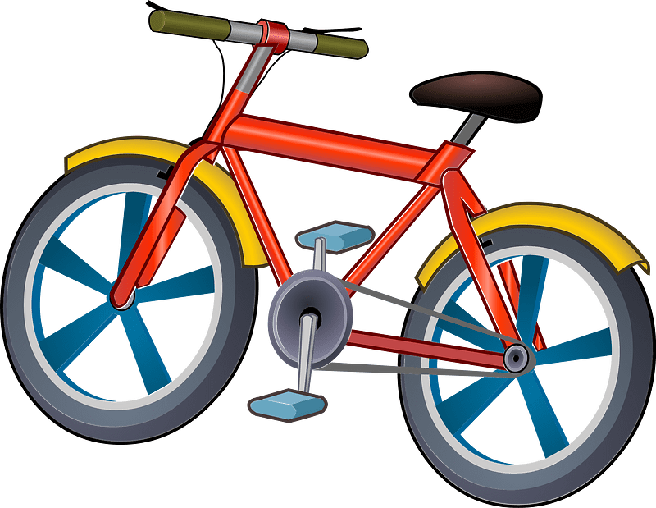
No bicycles, scooter, skates, or skateboards may be ridden on school grounds from 8 a.m. to 3:30 p.m. Students will have to walk their bikes during these times. For safety reasons, students must walk bikes and all “wheels” across intersections and patrolled crossings. The school will not be responsible for lost or stolen bicycles. Students not wearing a helmet will not be allowed to ride their bicycle home.

Pets
Pets are not allowed at school unless authorized in advance by the teacher. If the teacher authorizes the pet to be on campus, they must be properly caged or leashed and accompanied by the student’s parent. Please be sure that the family dog or cat does not follow the children to school. Animals are prohibited on school grounds and must be reported to the animal shelter or police department. Pets are not allowed to be transported on school buses.

Lost and Found & Personal Belongings
Please label your child’s coats, backpacks, etc., with their first and last name and room number. All valuable articles found at school are taken to the school office. Other personal articles are placed in our lost and found area located Next to the main staircase. Unclaimed clothing will be donated to a local charitable organization at the end of each trimester. Parents
and students may check the lost and found area for lost items.

Electronic media, cell phones, and other playthings/toys can be disturbing to the student and the class. We ask parents to see that toys and other electronic devices do not accompany children to school. Please do not send valuables to school with your child. The school will not be responsible for lost, stolen, or broken items, including electronic media, cell phones, and other playthings/toys. These items are disruptive to the student and the class. If students bring these items to school and they become disruptive to learning, parents may be called to pick them up, or the item may be confiscated until the parent can be notified.

Water Bottles
We do have water fountains and two water bottle filling stations at school. We encourage our students to bring a refillable water bottle from home, labeled with their name that can be left at school.

Personal Electronic Devices & Cell Phones
Gregory Heights Elementary recognizes that personal electronic devices and cell phones are a part of our way of life. We also recognize that the use of these devices is becoming increasingly interwoven into educational activities. As such, students may use personal electronic devices, including cell phones, on the way to school and until 8:25 and after school from 3:15 but not during school hours except at the discretion of the teacher or principal. Cell phones should remain off and in student backpacks during the school day.

If you need to contact your child during the school day, please contact the main office at (206) 631-3800 or call your child’s teacher’s classroom phone. Do not attempt to communicate with your student via their personal cell phone or smart watch.

Smart watches may be worn but may only be used to tell time during the school day. If smart watches are being used to send messages or do other non-approved tasks, they may be asked to be removed and placed in the student’s backpack.

Visitors and students shall not take, possess, distribute or publish pictures, audio or video of staff or students. Distribution includes emailing, texting, or showing to anyone. Publishing includes posting images, videos or audio, online or in print. To protect student privacy, cell phones or other mobile devices may not be used or seen at any time in restrooms, or any other location where there is an expectation of privacy.

Any use of an electronic device while on school property or via district networks requires compliance with all expectations and policies indicated in this handbook.

Unauthorized use of cell phones or other electronic devices during school hours may result in the device being confiscated, depending on the circumstances. Appropriate disciplinary action will follow. Students are responsible for protecting their own user IDs and passwords. The school will not assume responsibility if electronic devices are damaged, lost, or stolen.

Cyberbullying
Students engaging in harassment in any electronic form (e.g. Facebook, Twitter, Snapchat, Instagram, texting, “sexting,” the transmission of photos, etc.) that disrupts the educational process will be subject to discipline according to Highline Public Schools policies and discipline procedures.

Electronic harassment that invades the privacy or endangers the safety of another student will be subject to discipline in accordance with the Harassment, Intimidation or Bullying (HIB) guidelines.

District Owned Technology Usage
Use of the electronic resources provided by the Highline School District is an expectation and a privilege. Where they are available, these resources are offered to staff, students, and other patrons. In order to maintain this privilege, end users agree to learn and comply with all of the provisions of these procedures.


All use of the electronic resources must be in support of educational and research objectives consistent with the mission and objectives of the Highline School District. All use of the electronic resources must be in compliance with district policies, local, state and federal laws; thus allowing the school district to meet requirements (i.e., FCC CIPA compliance). District Policy No. 2022P outlines specific suitable and unacceptable uses for district technology.

All district owned devices are monitored by Highline Public Schools. Please note, connection of a personal electronic device to the school network requires compliance with all expectations and policies indicated in this handbook.

Gregory Heights Technology Usage Expectations:
- Treat devices with care and respect.
  - Use two hands when transporting devices.
  - Use keyboards properly – do not pull on or remove keys.
  - Use devices on a desk or table.
  - Do not eat or drink anything while using school devices.
  - Only use your own login
- Report malfunctioning technology to a teacher immediately.
- Report a missing device to the school office or teacher immediately.
- When plugging in chargers, use caution to do so correctly to avoid wear and tear on charging cables.
- When not in use, devices should be stored in locked technology carts.

Health Information
The school nurse at Gregory Heights is here two days each week, or when called for emergencies. Please notify the school of any health concerns that could affect your child’s education. Please update your child’s information by sharing information on the student system and/or the emergency card/medical information should any changes occur. It is important that emergency contact information is kept current.

Please notify the school nurse or office immediately if your child has any kind of medical condition. State law requires that students with health concerns have a health plan in place. Please notify the school immediately if your child has been diagnosed by a physician with a communicable disease, such as COVID-19, chicken pox, head lice, mumps, flu, scabies, scarlet fever, measles, hepatitis, fifth disease, whooping cough, etc.

Illness/Injury:
It is important that parents provide and keep current telephone numbers and other information for your child at all times, particularly in case of illness or injury. If you move or change any contact information, please notify us or make the changes using the parent portal (ParentVUE). The school staff is trained to administer first aid for minor injuries. If a student becomes ill, emergency contacts will be notified immediately to take the child home. In case of an emergency or accident, involving serious injury, 911 will be called; parents/guardians will be notified as soon as possible.

Medications:
By state law, no medication may be taken at school without a signed authorization form from the doctor. This includes aspirin, cough syrup or drops, eye drops, antibiotics, inhalers, or any over-the-counter medications.
Requirements are:
- Washington State Medication Authorization Form must be completed and signed by the physician and parent or guardian.
- Medication needs to have a current prescription label that matches the authorization form; over-the-counter medications must be in the original container.
- Parents or guardians must bring in the medication to the office with the appropriate form which includes the name of the medication, and the time and amount to be dispensed.
- All medications will be kept in the health room and must be administered in the office by an employee with medication training or a nurse. No medications may be in a student’s possession while at school, unless approved by the school nurse.

Immunizations:
For the protection of your child, Washington State Law requires that we have a Certificate of Immunizations Status (CIS) on filed for each student. This certificate must be presented at the time the student is registered for school. These forms and current immunization guidelines are available in the school office. If your child’s records show that immunizations are needed, the school nurse will contact you. All immunizations are the parent’s or guardian’s responsibility.

Student Management and Discipline
The Gregory Heights staff believes teaching self-management will lead to our students being successful at school as well as setting them up for success in the future. Our discipline rules and strategies give every student the opportunity to manage his or her own behavior. We actively teach children how to manage themselves and solve problems without fighting. Your child deserves a positive school climate for academic growth.


At Gregory Heights Elementary, we have implemented Positive Behavioral Interventions and Supports (PBIS), a system of school-wide discipline which focuses on proactive strategies for defining, teaching, and supporting appropriate student behaviors to create a positive school and classroom environment. Our school expectations all align to four major focus areas with the acronym PAWS: Problem-solve; Act responsibly and safely; Work together; and Show respect.

Inside the Building:
Students are taught expected behaviors during the first days of school, with refresher lessons throughout the year as needed, including after longer school breaks. Each teacher will also develop rules, routines, and procedures for the classroom or learning space.

School expectations include:
- Use a level 0-2 voice in the hallway, bathroom, and when entering and exiting an assembly.
- Respect other people and property.
- Use hall passes to travel to the bathroom, office, library, etc. Students are not allowed to travel through hallways without teacher permission.
- No toys from home are allowed. This includes electronic devices, iPods, trading cards, playground equipment (including balls), etc. The school is not responsible for valuables or toys that students bring to school.

Playground Expectations

General Rules | - Stay inside the fenced areas and on the playground side of the track line.  - Students must have a pass to come inside the building/go past the yellow line; no more than two people with each pass. Primary students should always take a buddy. Only enter the building by cafeteria during recess.  - During recess, use the bathrooms and drinking fountain by the cafeteria.  - Keep out of the bushes and planted areas on the upper playground.  - NO tag games are allowed.  - When the bell rings, stop playing, drop balls, and move quickly to your class . When in line, all games stop and balls are held.  - Everyone should be included in ALL games if they would like to play.  - Be a good sport. Play fairly and kindly.  - We are a hands-off school (This means no hugging others without their permission. No hitting, slapping, grabbing arms etc.)  - Solve conflicts with words or rock-paper-scissors or go to another activity. If you can’t work it out, ask a playground teacher for help.  - Report fights and injuries to a playground teacher immediately.  - Toys from home and phones or personal electronic devices are not allowed on the playground.  - Dress appropriately for the weather. If you take off your jacket, be sure to pick it up when you head back to class.  - Food, gum, and beverages (including water) are not allowed on the playground.  - At the last recess of the day, return balls to the equipment cart when recess ends.  - Use appropriate language for school.
Recess Dismissal /Return Rules | - When dismissing, teachers must supervise students until they have exited the pod and the door is closed.  - Teachers pick up their students from their class lines and escort them back into the building.  - Minimal voices when moving through pods to recess – save the chatting for outside! Be aware of other classes that are still learning.  - Walk through pods and on stairways.  - When coming up and down stairs, stay to the right.
Big Toy | - One student at a time on the monkey bars.  - One student at a time on the slide.  - Use the stairs or ladder to get on and off the Big Toy. Do not jump off.  - Slide down on your bottom, feet first. Get off right away at the bottom so you don’t get run into by the next person.  - No climbing, or crawling up the slide or on the outside of the big toy.  - Walking only on the big toy.  - Soccer, Football, Tag and other running games may be played only on the lower field. Do not run or play tag on or around the big toy or on the upper playground.  - Keep your hands to yourself. Do not push or pull students from the big toy.
Tetherball | - No sitting on the tetherballs.  - No kicking the tetherballs.  - Be cautious when you pass a tetherball court and stay out of the circle if you’re not playing.
Basketball Court | - Basketball is the priority in this area before other games, including wall ball.  - Dribble the ball; do not run with it in your hands.  - Basketballs are for BOUNCING and PASSING, not kicking.  - Pass the ball to other players – no hogging the ball.  - No full body contact (body slamming)  - Ask a playground monitor to get balls that go outside the fence.
Wall Ball Court | - No roofies, ball hogging, or tag.  - Players agree to rules before play.
Lower Field | - Tag games are not allowed.  - Only enter the lower field if a recess teacher is present.  - BE A GOOD SPORT. Play fairly and kindly and leave the game if you don’t like how someone is playing.
Soccer | - Our PE teachers will teach the soccer rules and procedures to all students the last week in September. Afterward, third-fifth grade students must have a parent or guardian sign a soccer “contract”, which will be sent home at the end of September. This will detail all the expected soccer rules for the year. First and second graders may play soccer after they have learned the expectations during PE, but will not be required to sign a parent contract.
Football | - One hand touch only. Rough play is not allowed – including pushing, shoving, and grabbing.  - No rushing or blitzing.  - Teams should be even.  - Remember, the goal is to have fun when you play.
Baseball Field | - This is off limits during school recess, due to limited supervision. Students may use this area when a teacher is present.  - Dirt, sticks, and rocks stay on the ground. They are not for throwing. No digging in dirt.  - Stay out of big puddles. If you get wet, you cannot change your clothes. No splashing others.  - No fence climbing.  - Kickball is allowed.
Aero-Glider | 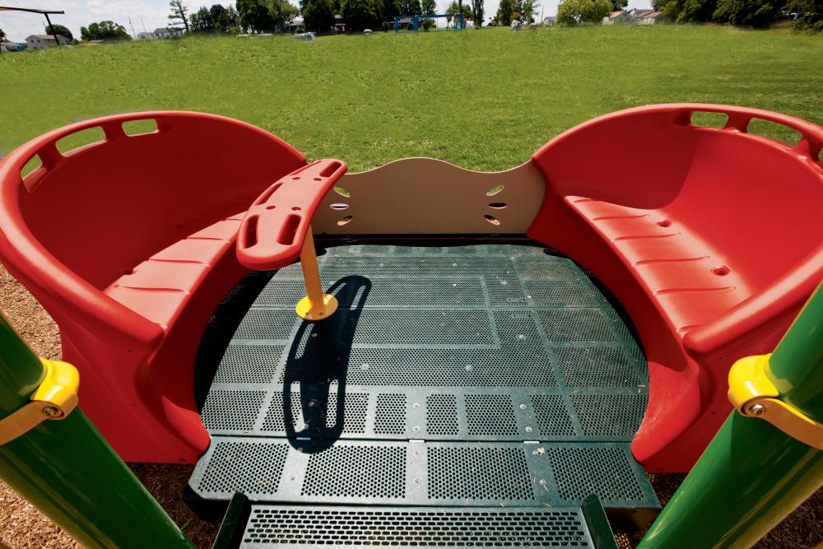  - Only three students may stand on the back on each end standing up  - Only four students may sit on each seat. Do not lay down on the seats.  - Only two students may stand in the middle, or one wheelchair. Wheelchairs have priority for the middle.  - Up to 16 students total may be on the toy at any one time: 10 in 6 out  - If on inside seats, stay seated while it is moving, no standing up from the seats.  - On the back, hold on with two hands only facing the middle of the glider.  - Do not put your hands through the holes and do not stand backward.  - Stay out of glider zone around the toy  - Do not go under the glider  - No holding onto the outside unless it's your turn and you are holding handles at the back.  - When waiting in the line, do not cross the painted line on the ramp when the glider is moving  - Students may get on only by going through the line at the ramp  - Do not jump off while in motion  - When everyone is on, signal “3-2-1 go”  - To begin, the back, front, and middle must work together to push and pull in unison to make it move. Using the words “forward” (toward basketball court) and “back” is useful with the k and 1st graders.)

Social-Emotional Learning (SEL)
In Highline Schools, we believe that social-emotional learning is important and supports academic growth, as well as helping students to become better citizens. As part of this effort, we utilize evidence-based tools from the RULER curriculum schoolwide.

RULER involves four main tools, including the Mood Meter, Class Charter, Meta-Moment, and Blueprint. Below are listed brief descriptions of each tool. More information can be found online through the Yale Center for Emotional Intelligence at ei.yale.edu/ruler.

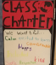
Class Charter
The charter is a document created by students in collaboration with the teacher, that helps create a productive and supporting learning environment. For the charter, the teacher and students identify how they want to feel at school, which behaviors will help maintain those feelings, and guidelines for preventing or addressing unwanted conflict and negative feelings. Using a class charter, students can hold themselves and one another accountable for creating a positive classroom environment. At Gregory Heights, you will see different class charters hanging up inside each classroom, often designed by the students!
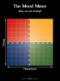
Mood Meter
Students use the mood meter to label their emotions, which is important to gaining emotional intelligence. Emotions change many times throughout the day, and emotions affect actions. Students will become more mindful of this as they utilize the mood meter as a tool. Additionally, students gain emotional vocabulary, as basic feelings such as “happy” or “sad” can be recognized more specifically on the mood meter with such words as “grateful” or “exhausted,” depending on the emotion. Once an emotion is identified, students are taught
to determine if they want to continue or “keep” this emotion or choose a strategy to change it. In the middle of the green zone is the best emotional zone for learning. You will see these colorful Mood Meter posters throughout the school, in classrooms, and even on the playground. On the poster, the emotions run left to right for the amount of pleasantness, and top-down for the amount of energy. A Mood Meter app is also available for purchase on most app stores for your phone or tablet.
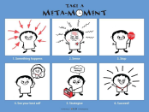
Meta-Moment
The Meta-Moment provides a way for students to pause during a challenging situation and think before acting, asking how their “best self” would handle a difficult moment. Through practice, utilizing the Meta-Moment helps students manage strong emotions, and to make better decisions. You may also see posters of the Meta-Moment in schools and classrooms.

The steps in a Meta-Moment are as follows:
1. Something happens
2. You SENSE a strong emotion
in your body
3. Stop
4. See your “Best self”
5. Choose a strategy to apply
6. Succeed!
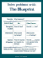
Blueprint
With the blueprint, students manage conflict by considering a disagreement not only from their own point of view, but from the perspective of the other person as well. This helps the students develop empathy. The students work together to identify positive solutions to conflicts. The blueprint aids in repairing relationships, leading to a better school climate.

PAWS Regulation Stations (Break Spaces):
At Gregory Heights, we use calm down spaces in class and on the playground. The teacher will identify rules for classroom break spaces. On the playground, break spaces are called PAWS stations or Regulation Stations. Students may self-select a regulation station as needed. Only one student may be on a PAWS regulation station at a time. If a recess teacher assigns a student to a regulation station, the student must remain there until excused by the recess monitor or until the bell rings. The recess monitor will release the student once he or she is calm and has talked through the problem with the recess monitor.

Our school utilizes Character Strong: PurposeFull People as a supplemental resource for teaching SEL strategies and supporting whole-child development.

Ladder of Accountability to Make Change
When unexpected behaviors occur, staff will engage in the use of the Ladder of Accountability as a tool to support students in reflecting, restoring, and re-engaging.

Ladder of Accountability to Make Change
Everyone makes mistakes,
how can we learn and grow from them?
What happens if we need more opportunities to make change?

1st  Incident |   Call home about your choices.
2nd  Incident |   Call home about your choices and next steps. | 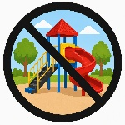    1 day of no recess or loss of other privilege.
3rd  Incident |   Attend a meeting with your family. |   2 days of no recess or loss of other privilege.
4th  Incident | Meet with your family to create a success contract.     |   3 days of no recess or loss of other privilege.
5th  Incident  (or more) | Consequences discussed with your family on your success contract. Meeting with your family or a call home (as needed).    

Buses
School bus drivers have the authority to discipline students for misconduct related to school district rules. Each student is expected to follow the rules and regulations of the Highline School District for Bus Riders. Misbehavior on the bus may result in short-term suspension from the bus. Ongoing misbehavior may result in suspension for the remainder of the school year. Parents/guardians will be notified of misconduct slips written for their child.

Harassment, Intimidation, and Bullying (HIB) Policy
The Highline School District is committed to a safe and civil educational environment for all students, employees, parents/legal guardians, volunteers, and community members that is free from harassment, intimidation, or bullying.

“Harassment, intimidation, or bullying” means any intentionally written message or image - including those that are electronically transmitted - verbal, or physical act, including but not limited to one shown to be motivated by race, color, religion, ancestry, national origin, gender, sexual orientation including gender expression or identity, mental or physical disability, or other distinguishing characteristics, when an act:
- Physically harms a student or damages the student’s property.
- Has the effect of substantially interfering with a student’s education.
- Is so severe, persistent, or pervasive that it creates an intimidating or threatening educational environment; and/or
- Has the effect of substantially disrupting the orderly operation of the school.
“Other distinguishing characteristics” can include but are not limited to physical appearance, clothing or other apparel, socioeconomic status, and weight.

Harassment, intimidation, and bullying can take many forms, including but not limited to, slurs, rumors, name calling, jokes, insinuations, demeaning comments, drawings, cartoons, pranks, ostracism, gestures, hazing, physical attacks, or threats.

In order to ensure respect and prevent harm, it is a violation of district policy for a student to be harassed, intimidated, or bullied by others in the school community, at school sponsored events, or when such actions create a substantial disruption to the educational process.
Incident Reporting

Any student or students who believe they have been the target of unresolved, severe, or persistent harassment, intimidation, or bullying, or any other person in the school community who observes or receives notice that a student has or may have been the target of unresolved, severe, or persistent harassment, intimidation, or bullying may report incidents verbally or in writing to any staff member.

You can report Harassment, Intimidation or Bullying (HIB) to any school staff member or to the district's HIB Coordinator. For a copy of your district’s HIB Policy 3207 , Procedure 3207 and Form 3207, contact your school or district office or view it online here: https://www.highlineschools.org/departments/student-support/bullying-civil-rights-sexual-harrassment

Your School Compliance Official: Jodi Robertson, Principal
Any person having inquiries should contact:
- HIB Coordinator: District Ombudsman, Isuzu Niizuma Arambula
206.631.3100
isuzu.niizumaarambula@highlineschools.org
Address: 15675 Ambaum Blvd. SW, Burien, WA 98166

Non-Discrimination
Highline School District does not discriminate in any programs or activities on the basis of race, religion, creed, color, national origin, age, honorably discharged veteran or military status, sex, sexual orientation, gender expression and identity, marital status, the presence of any sensory, mental or physical disability, or the use of a trained dog guide or service animal by a person with a disability. This holds true for all students who are interested in participating in educational programs and/or extracurricular activities. Highline Public Schools also provides equal access to the Boy Scouts and other designated youth groups.

You can report discrimination and discriminatory harassment to any school staff member or to the district's Civil Rights Coordinator. For a copy of your district’s nondiscrimination Policy 3210 and Procedure 3210, contact your school or district office or view it online here: https://www.highlineschools.org/departments/student-support/bullying-civil-rights-sexual-harrassment

Your School Compliance Official: Jodi Robertson, Principal
Any person having inquiries should contact:
- Civil Rights Act (students) and Title IX: District Ombudsman, Isuzu Niizuma Arambula
206.631.3100
civilrightscoordinator@highlineschools.org
titleixofficer@highlineschools.org
- Section 504 of the Rehabilitation Act: Health & Social Services Compliance Manager, 206.631.3011, 504coordinator@highlineschools.org
Address: 15675 Ambaum Blvd. SW, Burien, WA 98166

Sexual Harassment
Highline Public Schools is committed to a positive and productive education free from discrimination, including sexual harassment. This commitment extends to all students involved in academic, educational, extracurricular, athletic, and other programs or activities of the school, whether that program or activity is in a school facility, on school transportation or at a class or school training held elsewhere.

Definitions
For purposes of this policy, sexual harassment means unwelcome conduct or communication of a sexual nature. Sexual harassment can occur adult to student, student to student or can be carried out by a group of students or adults and will be investigated by the District even if the alleged harasser is not a part of the school staff or student body. The district prohibits sexual harassment of students by other students, employees or third parties involved in school district activities.
The term “sexual harassment” may include:
- Acts of sexual violence;
- Unwelcome sexual or gender-directed conduct or communication that interferes with an individual’s educational performance or creates an intimidating, hostile, or offensive environment;
- Unwelcome sexual advances;
- Unwelcome requests for sexual favors;
- Sexual demands when submission is a stated or implied condition of obtaining an educational benefit;
- Sexual demands where submission or rejection is a factor in an academic, or other school-related decision affecting an individual.
A “hostile environment” has been created for a student when sexual harassment is sufficiently serious to interfere with or limit the student’s ability to participate in or benefit from the school’s program. The more severe the conduct, the less need there is to demonstrate a repetitive series of incidents. In fact, a single or isolated incident of sexual harassment may create a hostile environment if the incident is sufficiently severe, violent, or egregious.

You can report sexual harassment to any school staff member or to the district's Title IX Officer. For a copy of your district’s sexual harassment Policy 3205 and Procedure 3205, contact your school or district office, or view it online here: https://www.highlineschools.org/departments/student-support/bullying-civil-rights-sexual-harrassment

Your School Compliance Official: Jodi Roberston Principal
Any person having inquiries should contact:
- Title IX Coordinator: District Ombudsman, Isuzu Niizuma Arambula
206.631.3100
titleixofficer@highlineschools.org
Address: 15675 Ambaum Blvd. SW, Burien, WA 98166

Complaint Options: Discrimination and Sexual Harassment
Before filing a complaint, you can discuss your concerns with the school principal or with the school district’s Title IX Officer or Civil Rights Coordinator. This is often the fastest way to revolve your concerns.

Complaint to the School District
Step 1. Write Out Your Complaint
In most cases, complaints must be filed within one year from the date of the incident or conduct that is the subject of the complaint. A complaint must be in writing. Be sure to describe the conduct or incident, explain why you believe discrimination, discriminatory harassment, or sexual harassment has taken place, and describe what actions you believe the district should take to resolve the problem. Send your written complaint—by mail, fax, email, or hand delivery—to the district superintendent or civil rights compliance coordinator.
Step 2: School District Investigates Your Complaint
Once the district receives your written complaint, the coordinator will give you a copy of the complaint procedure and make sure a prompt and thorough investigation takes place. The superintendent or designee will respond to you in writing within 30 calendar days—unless you agree on a different time period. If your complaint involves exceptional circumstances that demand a lengthier investigation, the district will notify you in writing to explain why staff need a time extension and the new date for their written response.
Step 3: School District Responds to Your Complaint
In its written response, the district will include a summary of the results of the investigation, a determination of whether or not the district failed to comply with civil rights laws, notification that you can appeal this determination, and any measures necessary to bring the district into compliance with civil rights laws. Corrective measures will be put into effect within 30 calendar days after this written response—unless you agree to a different time period.
Appeal to the School District

If you disagree with the school district’s decision, you may appeal to the school district’s board of directors. You must file a notice of appeal in writing to the secretary of the school board within 10 calendar days after you received the school district’s response to your complaint. The school board will schedule a hearing within 20 calendar days after they received your appeal, unless you agree on a different timeline. The school board will send you a written decision within 30 calendar days after the district received your notice of appeal. The school board’s decision will include information about how to file a complaint with the Office of Superintendent of Public Instruction (OSPI).

Complaint to OSPI
If you do not agree with the school district’s appeal decision, state law provides the option to file a formal complaint with the Office of Superintendent of Public Instruction (OSPI). This is a separate complaint process that can take place if one of these two conditions has occurred: (1) you have completed the district’s complaint and appeal process, or (2) the district has not followed the complaint and appeal process correctly.

You have 20 calendar days to file a complaint to OSPI from the day you received the decision on your appeal. You can send your written complaint to the Equity and Civil Rights Office at OSPI:
Email: Equity@k12.wa.us ǀ Fax: 360-664-2967

Mail or hand deliver: PO Box 47200, 600 Washington St. S.E., Olympia, WA 98504-7200
For more information, visit our website, or contact OSPI’s Equity and Civil Rights Office at 360-725-6162/TTY: 360-664-3631 or by e-mail at equity@k12.wa.us.

Other Discrimination Complaint Options
Office for Civil Rights, U.S. Department of Education
206-607-1600 ǀ TDD: 1-800-877-8339 ǀ OCR.Seattle@ed.gov ǀ OCR Website
Washington State Human Rights Commission
1-800-233-3247 ǀ TTY: 1-800-300-7525 ǀ Human Rights Commission Website

Gender Inclusive Schools
Civil rights laws prohibit discrimination and discriminatory harassment on the basis of gender expression and gender identity in K–12 public schools.
Discrimination is the unfair or unequal treatment or harassment of a person or group because they are part of a defined group, known as a protected class.
Gender expression and gender identity are protected classes under Washington State law.
Discriminatory harassment is harassment based on a protected class. It can take many forms, such as threats, name-calling, derogatory jokes, physical assault, or other conduct that is physically threatening, harmful, or humiliating.
Common Terms and Definitions
- Assigned sex at birth: The sex a person was given at birth, usually based on anatomy or chromosomes (e.g., male, female, intersex, etc.)
- Cisgender: A term used to describe people whose assigned sex matches their gender identity and/or gender expression (e.g., someone who was assigned female at birth and whose gender identity and/or gender expression is also female.)
- Gender Expansive: A wider, more flexible range of gender identities or expressions than those typically associated with the binary gender system.
- Gender Expression: The external ways in which a person expresses their gender to the world, such as through their behavior, emotions, mannerisms, dress, grooming habits, interests, and activities.
- Gender Identity: A person’s internal and deeply-felt sense of being female, male, both, non-binary, gender-expansive, or other—regardless of the gender assigned at birth.
- Transgender: A term often used to describe a person whose gender identity or expression, or both, are different from those traditionally associated with their sex assigned at birth.
- Transitioning: The process in which a person goes from living and identifying as one gender to living and identifying as another.
You can report discrimination based on gender expression or gender identity to any school staff member or to the district's Gender Inclusive Schools Officer. For a copy of your district’s Gender Inclusive Schools policy and procedure, contact your school or district office, or view it online here: Policy 3211 and Procedure 3211

Your School Compliance Official: Jodi Roberston, Principal
Any person having inquiries should contact:
- GIS Coordinator: District Ombudsman, Isuzu Niizuma Arambula
206.631.3100
isuzu.niizumaarambula@highlineschools.org
Address: 15675 Ambaum Blvd. SW, Burien, WA 98166

Highline Public Schools Emergency Information
In case of emergencies during school hours, like earthquakes, fire, or lockdowns, please do not call the school. We need the phone lines open during emergencies for use by first responders and staff. You will be notified if your child is hurt. We have staff trained in first aid to help in case of an emergency.

Emergency Information:
Emergency information is kept in our online district records management system. This information should be changed through Parent Vue each time your address, phone or contact info changes. In the event of an emergency, it is important that we know where the children are to go, who can pick them up, current phone numbers, and how to reach parents and family contacts. Please notify the office of any changes that take place during the school year.

Emergency Changes to the School Schedule:
In the event of an emergency such as a threat to campus, snow, windstorms, earthquake, or similar events, Highline Public Schools may change school start or dismissal times for student safety.
We will communicate with parents through:
- Automated phone calls. (Please ensure your school has a working phone number where you can be reached.)
- Announcements on district and school websites.
- Announcements on email and mobile app alerts.
- Announcements on phone text.
- Announcements on social media (Twitter and Facebook).
- Announcements on TV and radio.

Standard Response Protocol (SRP):
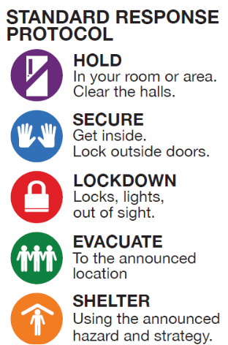
Highline School District utilizes the Standard Response Protocol (SRP) for emergencies. The following are the types of SRP emergencies:
- HOLD: Used when hallways or open areas need to be kept clear of people, such as a medical emergency. Everyone stays in their room or assigned area until “all clear” is announced.
- SECURE: Used when a threat is outside the building (e,g, nearby law enforcement activity, weather hazard, dangerous animal, etc.). Everyone moves indoors as per usual, anyone outdoors comes inside immediately, and lock all exterior doors to protect occupants.
- EVACUATE: Used to move people from one place to another, either inside or outside the building, such as during a fire, gas leak, or severe weather.
- LOCKDOWN: Used when there is an immediate threat inside the building (e.g. intruder, active shooter, suspicious person, etc.). Interior and exterior doors are locked, lights are turned off, occupants move out of sight, remain silent, and do not open doors.
- SHELTER: Used for group and self-protection when the threat is ongoing or cannot be immediately resolved such as during an earthquake, tornado, or hazardous material release.

Emergency Drills:
We conduct drills for each of the above SRP emergencies so that our students will be prepared in case of an emergency. If you are visiting the school during a safety drill, please follow the drill procedures along with our staff and students.

Gregory Heights PTSA
The PTSA supports Gregory Heights Elementary by:
- Providing enrichment opportunities for students and staff
- Coordinating volunteer support for school activities
- Encouraging culturally responsive community involvement
- Increasing communication between parents, staff and community
ALL are welcome!

