SETTING UP THE RAPTOR SAFE APP

Raptor Safe is engineered to help save you time while keeping everyone protected. Follow these steps to get started:
- Download the App
iOS Device
  - Select the  (App Store) icon to open the App Store from your iPhone or iPad.
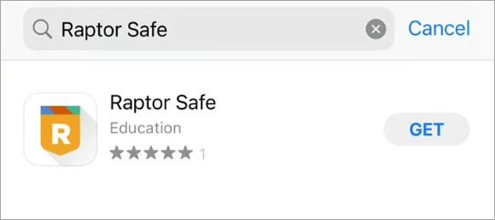
  - Search for and select Raptor Safe.
  - Select Get to download the Raptor Safe app.
  - Select Open to launch the Raptor Safe app.

Android Device
- Select the 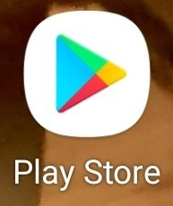 (Play Store) icon to open the Google Play Store from your mobile Android device.
- Search for and select Raptor Safe.
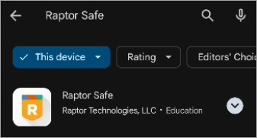
- Select Install to install the Raptor Safe app.
- Select Open to launch the Raptor Safe app.

CREATE YOUR RAPTOR PASSPORT
Your school wants to ensure only safe individuals are on campus. By creating your secure ID (also known as your Raptor Passport), you can provide that level of safety, while enjoying the convenience of a faster, easier sign-in process.
Once you have the Raptor Safe app on your mobile device, open the app and perform the following steps:
1. Enter your Phone Number and press Next to create a Raptor Passport.
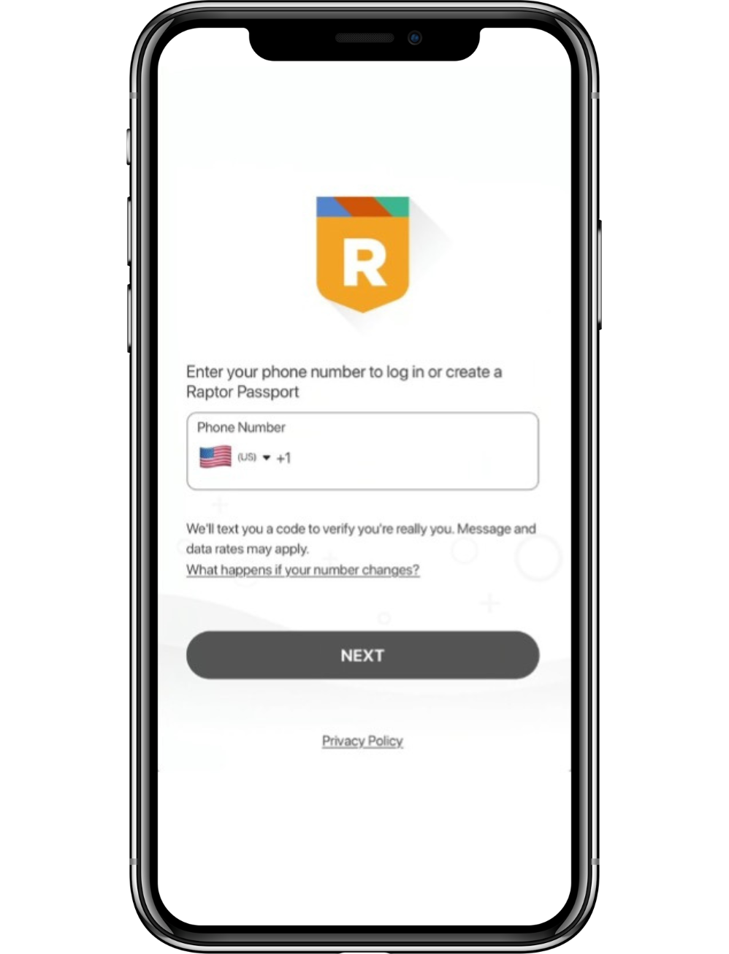

2. Enter the Verification Code you received at the phone number you entered previously and press Next.

Note:
There is an option to Enable Biometrics
to keep you signed in.
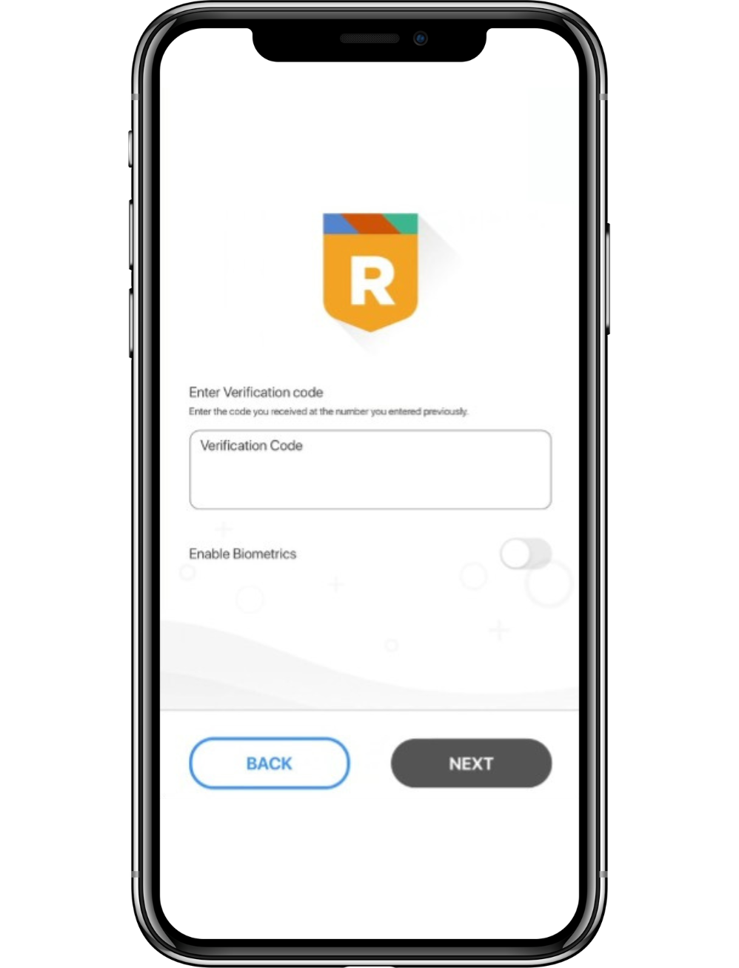

3. Press Scan ID to set up your Raptor Passport by scanning your driver's license, official state ID, or National Passport.

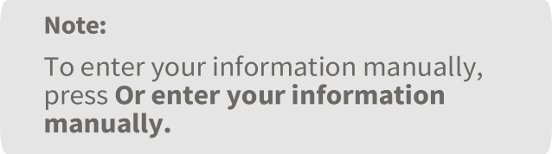
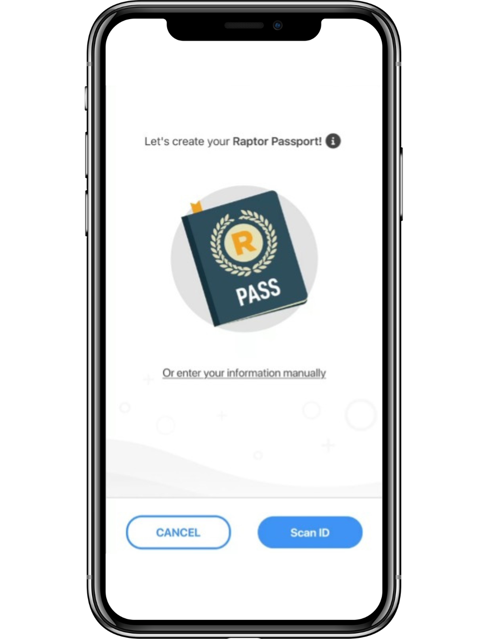

4. Press OK to allow Raptor Safe access to your camera to capture the ID's data.

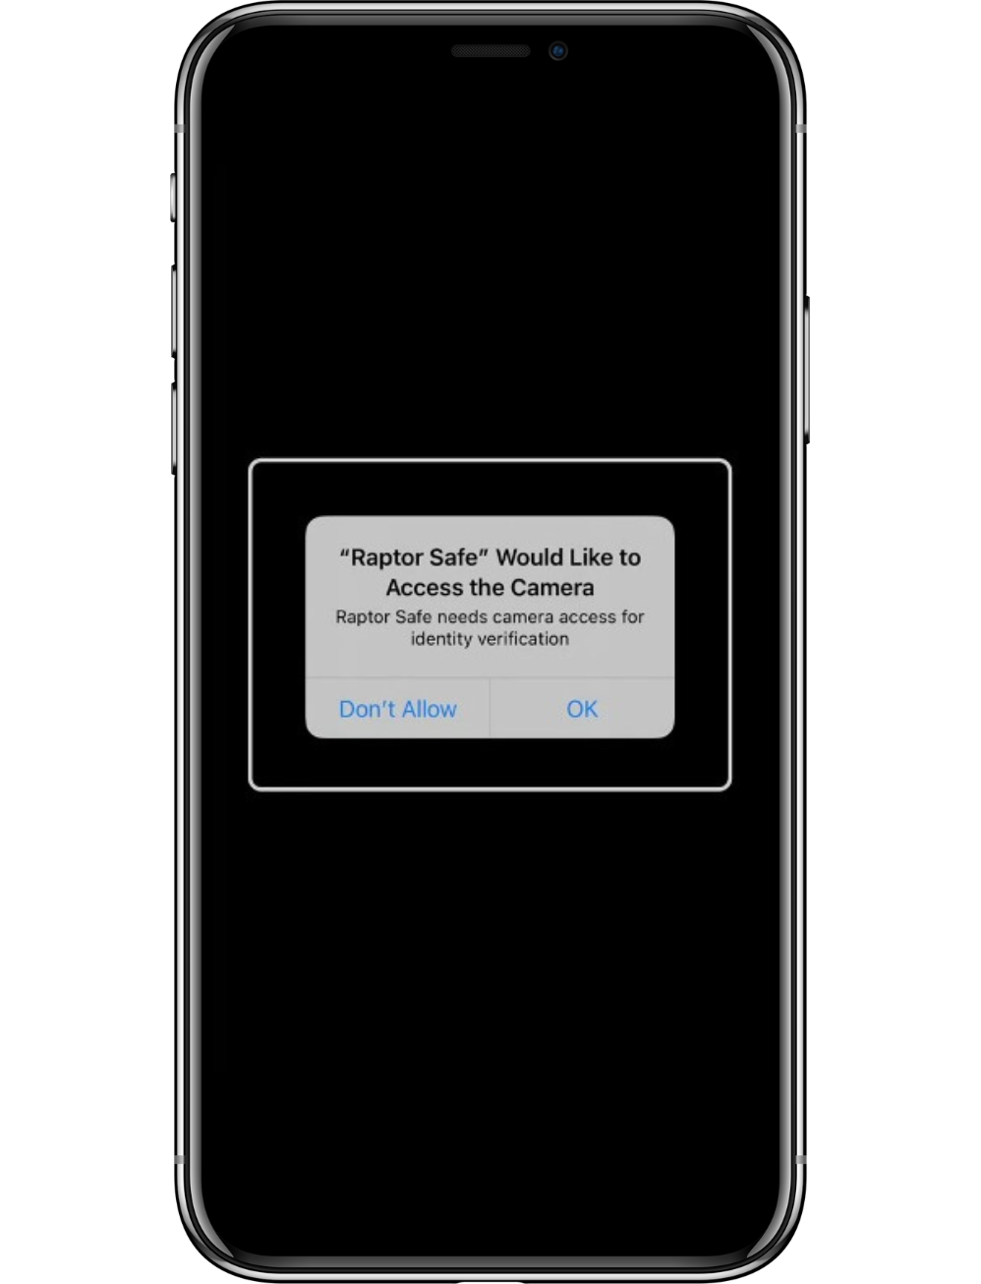

5. Hold up and fit the front of your ID within the white box to be scanned.

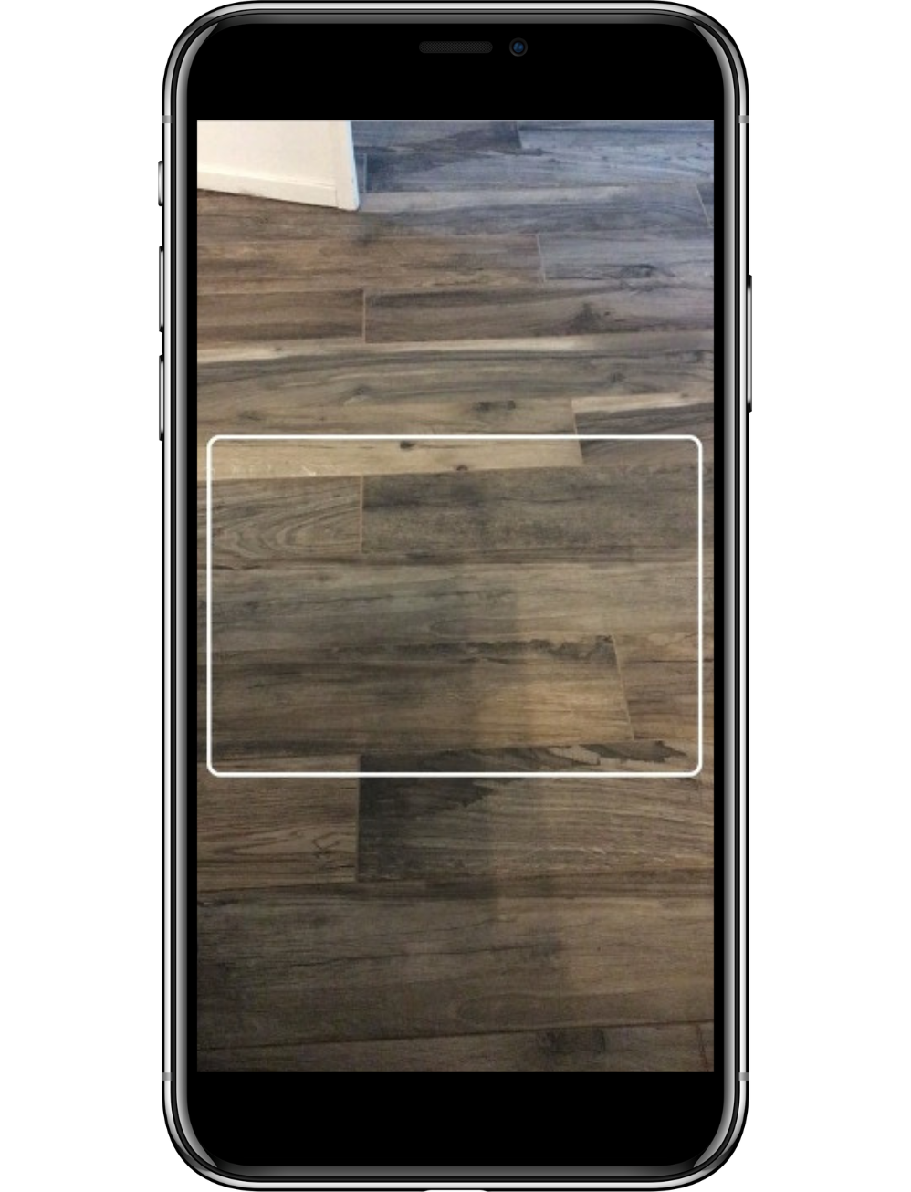

6. Once the front of the ID is successfully scanned and the app asks you to "Please provide the next page", flip the ID over and scan the back.

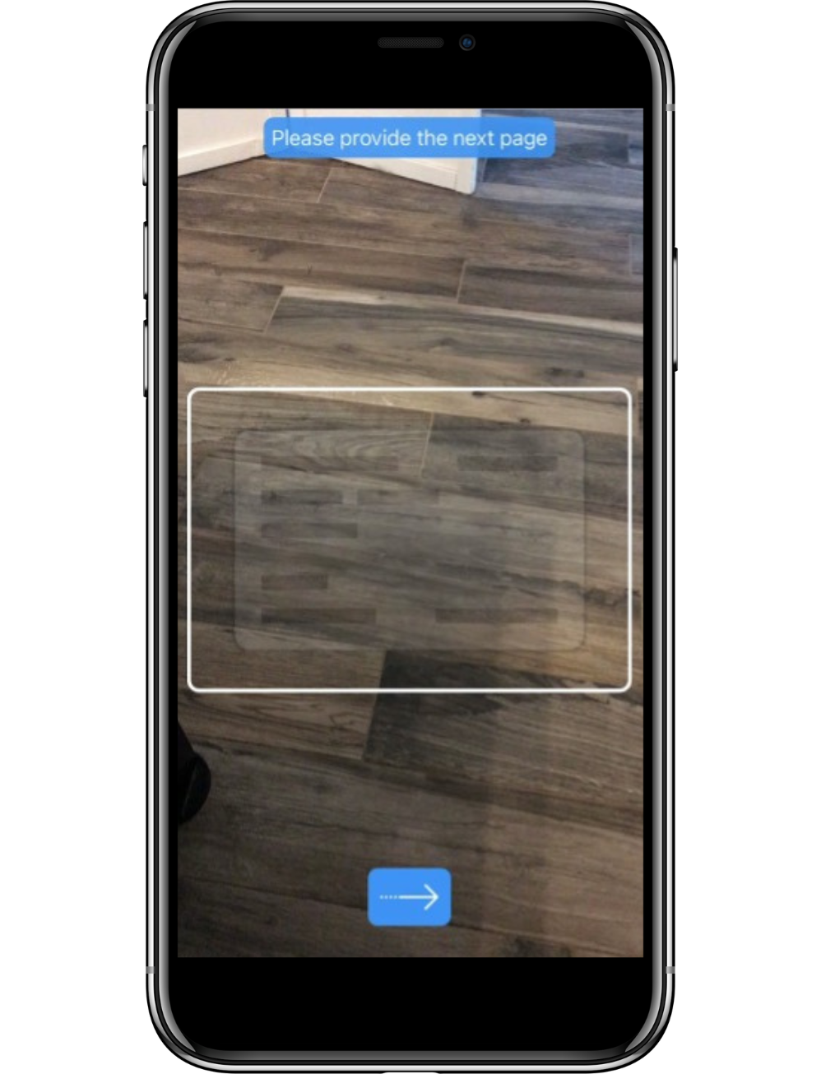

7. Press Next to walk through taking a selfie. Taking a selfie helps ensure that the person on the ID and the person setting up this account are the same – you! You will be asked to move your head around while taking the selfie. This verifies that you are a live person and someone isn’t using a picture of you to create an account.
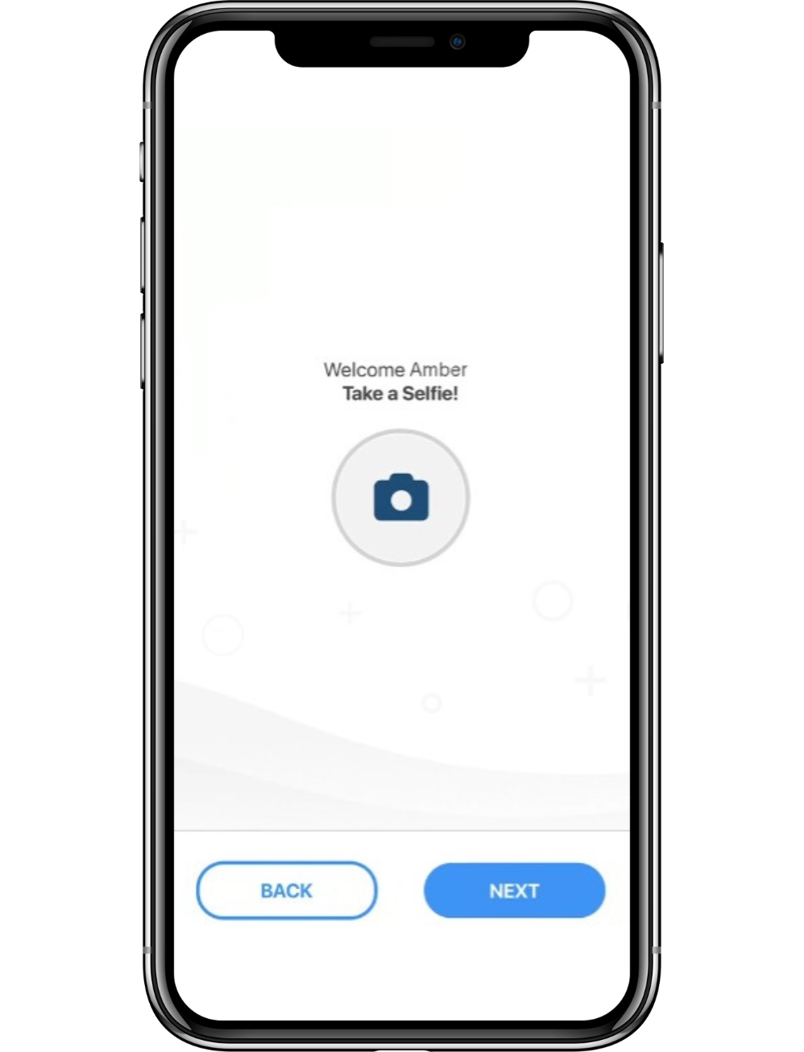

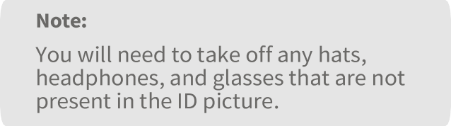

8. Be sure to read the directions and press Go.

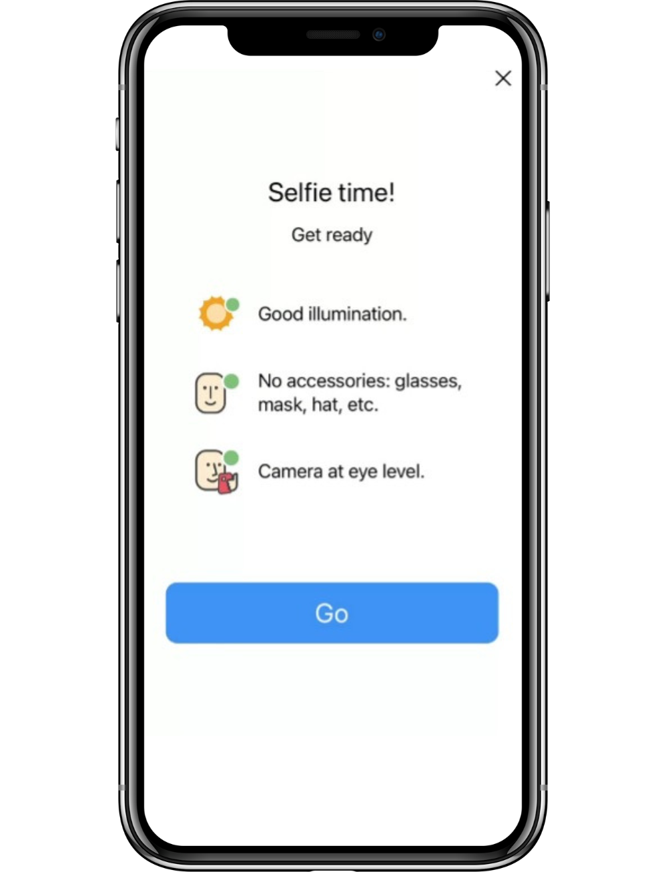

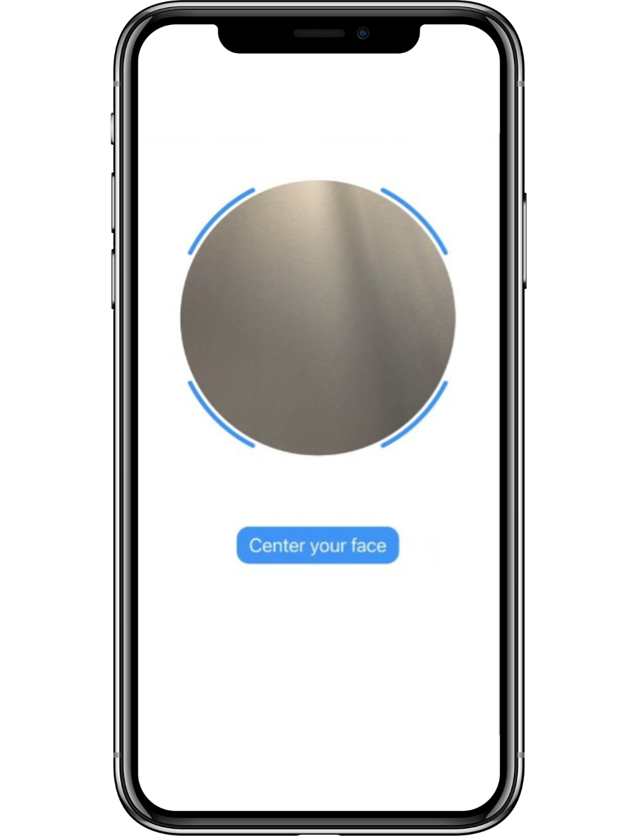

- Center your face in the circle and follow the instructions.

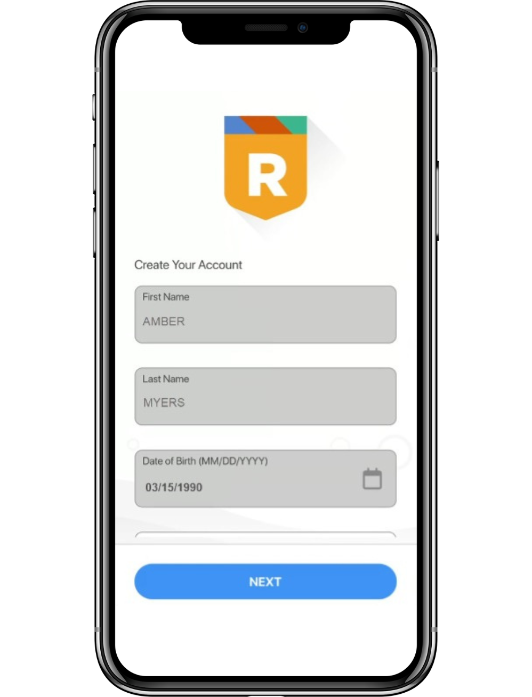

- Once the selfie has been taken, verify your information is accurate.

- Scroll down and, if needed, add a Recovery Email, Preferred First Name, and/or Preferred Last Name. You might want a preferred name if, for example, your ID uses a formal name, like David, but you prefer Dave. Once complete, press Next.
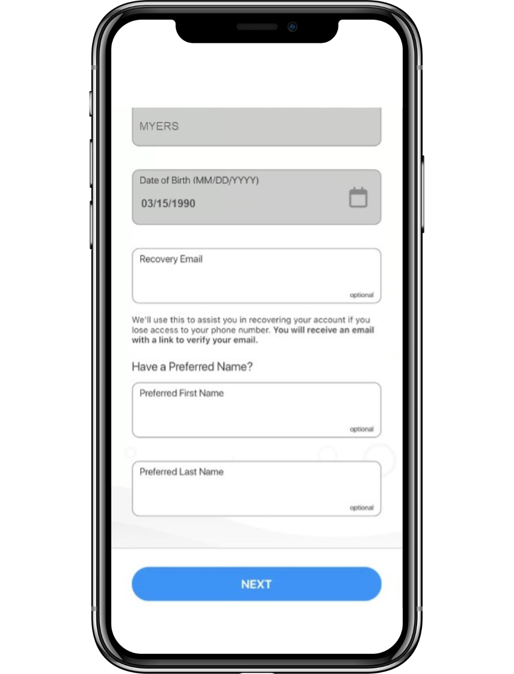

12. If you entered a Recovery Email, please add the Invitation Code
and press Next.

Note:
If you do not have an Invitation Code, you can press Click here to continue without one.

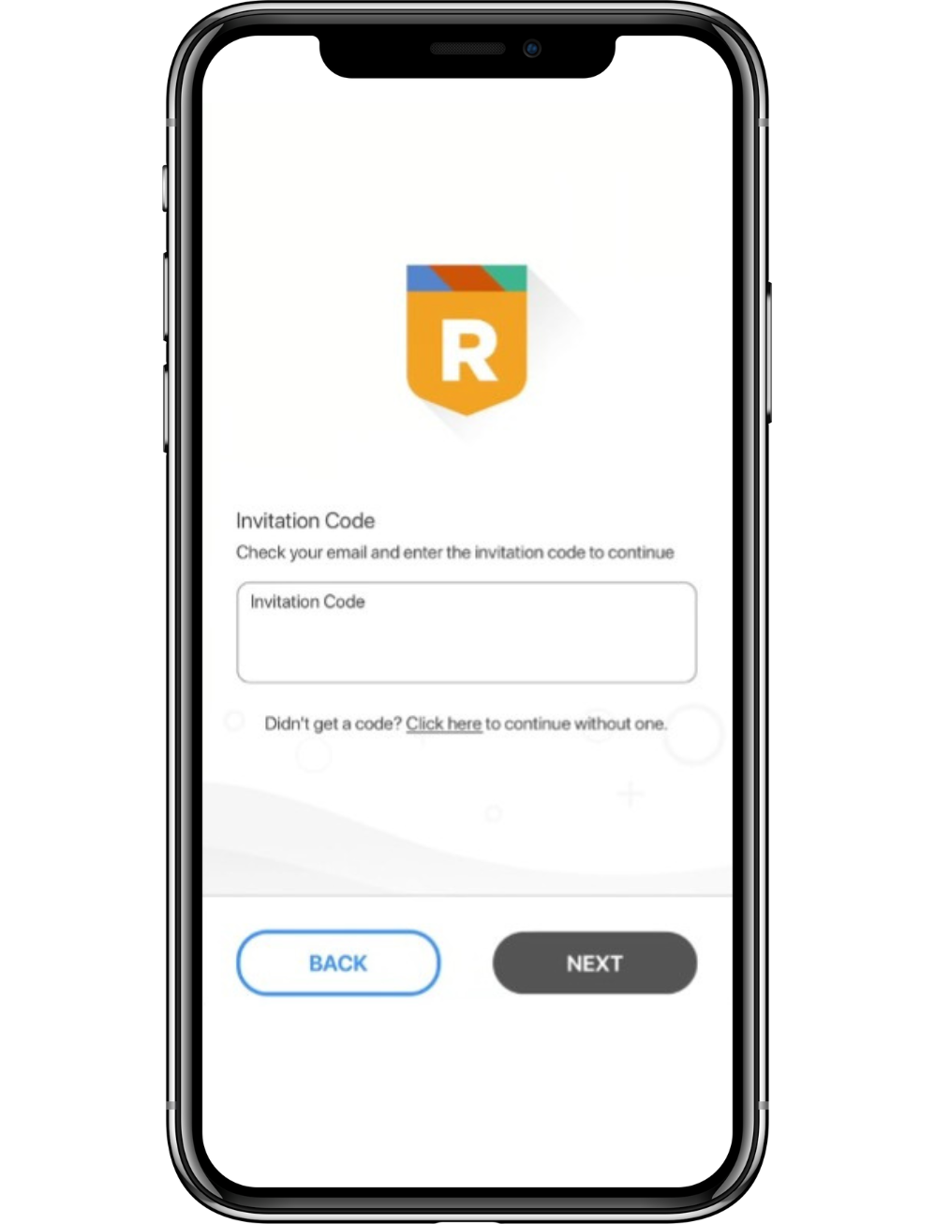

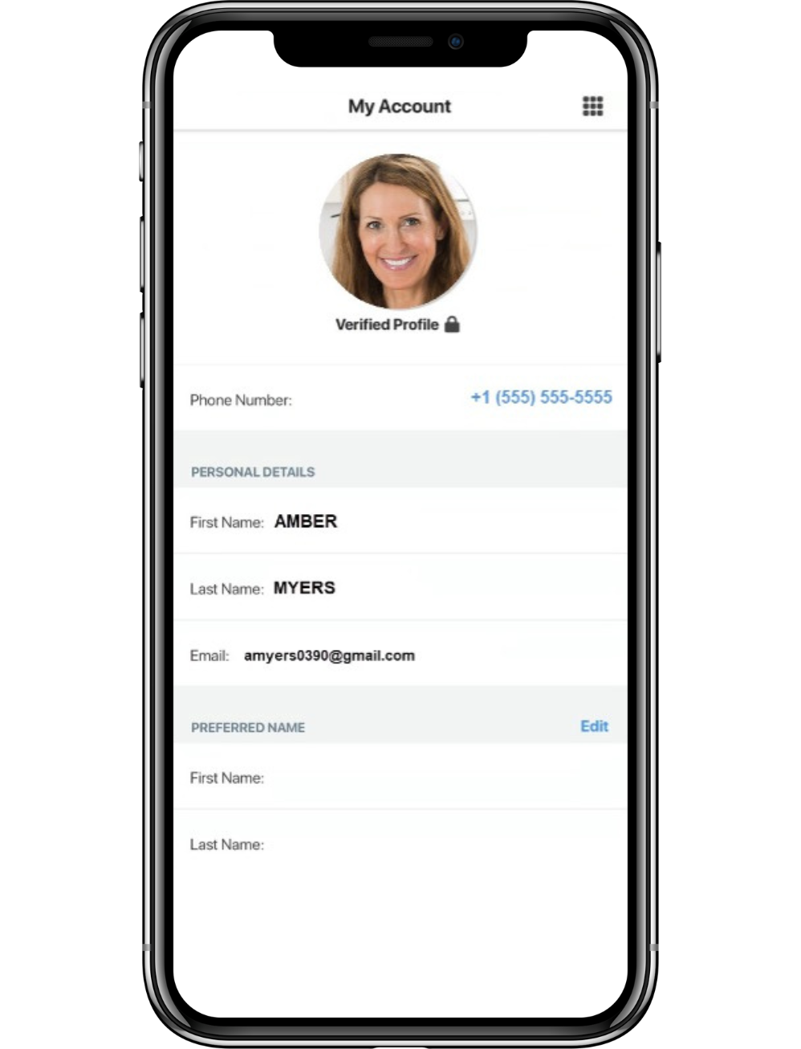

- Verify your account profile information is accurate.

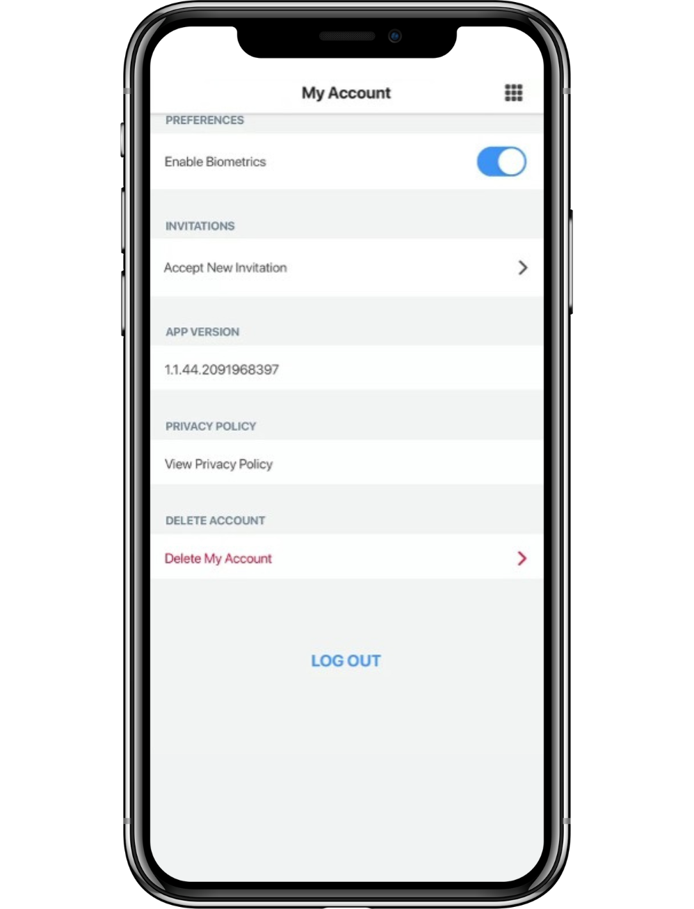

- Scroll down to view the rest of your account profile.

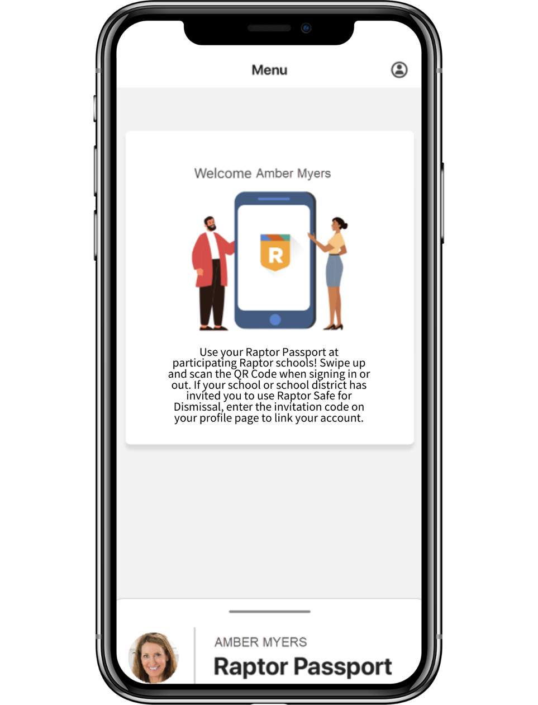

- Press the (App Launcher) icon.

16. Swipe up on the bottom of the screen to display your Raptor Passport QR code to use at your school.

