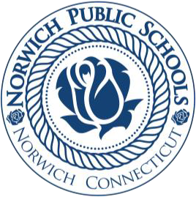
Maria V. Parrillo, Transportation & Safety Director
526 E. Main Street, Norwich, CT 06360
Phone (860) 823-6284

Dear Parents and Guardians,
The safety of our students and staff is our highest priority. To make our schools safer and our check-in processes smoother, we use the Raptor Technologies suite, specifically VisitorSafe and EventSafe.
What is Raptor VisitorSafe?
- Daily Security Screening: Checks all visitors against national databases to block restricted individuals.
- ID Requirement: All visitors must show a valid government-issued ID upon arrival.
- Instant Badges: Prints temporary visitor badges with your photo, name, date, and destination.
- Privacy Protection: Only scans name, date of birth, and photo; no other data is saved or shared.

What is Raptor EventSafe?
- Pre-Registration: Lets you sign up before large school events like assemblies or programs.
- Faster Entry: Use the mobile app to store digital tickets or QR codes for quick scanning.
- Digital Records: Keeps accurate attendance logs for safety and emergency preparedness.

How You Can Help
- Always bring your physical ID when visiting the main office during school hours.
- Download the official mobile companion app to pre-register for upcoming school events.
- Reach out to our main office if you have questions about our campus security procedures.

Thank you for your partnership in keeping our school community safe and secure.
Sincerely,

Director of Transportation & Safety

