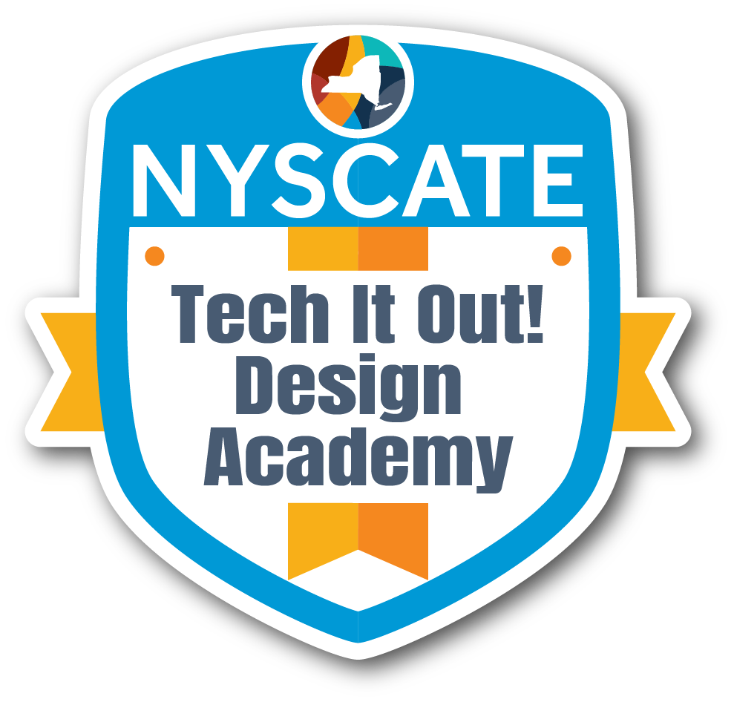
Professional Learning Design Template

Presenter Name:
Position/Role:
School & District:

Session Basics
Session Title: | Shaking It Up!: Rethinking CKLA Instruction Through Blended Learning Models
Session Description: | This 12-hour asynchronous (or hybrid) course begins with an introduction to blended learning and its benefits for both teachers and students. Participants will learn what makes an effective instructional video, how to create their own videos using screencasting tools, and how to share this content through Seesaw and Google Classroom. They'll also explore strategies for introducing blended learning to students and managing a modern classroom. The course culminates with participants designing their own blended learning activity to replace a traditional CKLA component, supported by flexible in-person or online office hours.
Session Abstract (Pitch): | "Shaking It Up: Rethinking CKLA Instruction Through Blended Learning Models” is a professional development course aimed at helping teachers confidently integrate time-saving blended learning strategies into their daily CKLA instruction. Participants will learn how to use short instructional videos to deliver CKLA components outside of the ELA block-freeing up valuable class time while increasing student engagement. The course is ideal for CKLA teachers, as well as administrators and instructional specialists who support CKLA implementation.
Session Format: | Asynchronous with the option of in-person office hours
Duration: | 12 hours over a 4 week period

Timeline
Activity |  | Description | Duration
Introduction & Welcome |  | -Short intro video from facilitator  -Opening course discussion post:  *Please introduce yourself, including your name, your job title, your grade level(s), your and building(s)  *What are you hoping to get out of this course? | Asynchronous  15 minutes
Preassessment (if given) |  | Google Form | Asynchronous  5 minutes
Engage | Hook/Interest Builder  - Opening activity/scenario  - Connection to participants' experiences  - Questions to spark curiosity | Have a look at the images from two of the articles you can read to help you better understand blended learning. What 3-5 words stick out to you? What do you want most for your students? What do you want most for yourself as an educator? Once you have responded, please read your colleague’s responses and comment on at least two of them. | Asynchronous  20 minutes
Learning Objectives | - By the end of this professional development, participants will be able to: | By the end of this course, participants will be able to:  - Create an effective instructional video using screencasting tools  - Share original content they have created through Seesaw and Google Classroom  - Plan how and when they will introduce blended learning theory to their students  - Use a variety of strategies to manage their modern classroom  - Use their own blended learning activity to replace a traditional CKLA component in a lesson of their choosing  What questions do you have before we begin? Please share them in the discussion post. | Asynchronous  5 minutes
Explore | Hands-On Discovery Activities  - Investigation activities  - Collaborative exploration tasks  - Resource exploration  - Data analysis opportunities  Guided Discovery Questions:  - What patterns do you notice?  - How does this connect to your practice?  - What questions arise from this exploration? | Learning Module 1: Blended Learning Theory  Watch the video and read the 3 short articles about blended learning. Then, respond to the following prompts:  - How would you describe blended learning to a colleague? What are some benefits? What are some challenges?  - What blended learning strategies do you already use in your classroom?  Learning Module 2: Setting up a Modern Classroom  Watch the videos then respond to the following prompts:  - What adjustments do you need to make to your physical classroom space in order to allow for the use of self-paced video learning?  - What supports will your students need to learn new routines and blended learning expectations?  - How will you roll out this new way of learning in your classroom?  - What strategies do you think will be the most effective to manage your new classroom? | Asynchronous  210 minutes
Explain | Concept Introduction:  - Key concepts/theories to be presented  - Research base to be shared  - Best practices to be demonstrated  Student Learning Standards  - NYS CSDF  - Other content area standards  Expert Input Methods:  - Presentation format  - Guest expert involvement  - Resource sharing | Learning Module 3: Creating Effective Instructional Videos  Read the articles on creating effective instructional videos. Then describe the most important characteristics of an effective instructional video.  Explore some of the video examples I have used in my classroom and the videos in A 5-Step Guide to Creating Your Own Instructional Videos. What do you notice? What do you wonder?  Watch the 3 video recording tutorials. Which tool will you choose to record your video?  Use your chosen video recording tool to create a 30-second video about your favorite area restaurant. Then share your video in the discussion thread. | Asynchronous  120 minutes
Elaborate | Application & Extension:  - Practice opportunities:  - Scenario applications:  - Skill building activities:  - Peer collaboration tasks  Deepening Understanding:  - How will participants extend their learning?  - What additional contexts will be explored?  - How will learning be differentiated for various needs? | Performance Module  For your culminating project, you will choose a lesson from your grade’s CKLA curriculum. After studying the lesson, choose one part of the lesson that you would like to use an instructional video to present the material to your students. Document your choices on the lesson planning template.  Please sign up to check in with the instructor during their posted office hours before uploading your completed lesson plan and instructional video. You are welcome to attend an asynchronous or in person work session. | Asynchronous  210 minutes  Office Hours:  Asynchronous or in person  90 minutes
Evaluate | Satisfaction Measures:  - Overall satisfaction survey  - Engagement observations  - Participation quality indicators  Data Collection Methods:  - Exit tickets  - Satisfaction surveys  - Focus groups  - Observation/Engagement checklists/observations  - Pre/post assessments  - Skill demonstration  - Concept understanding checks | Exit Ticket  District required questionnaire | 30 minutes
Closure |  | Final Discussion Post:  How do you envision yourself using instructional videos in your classroom in the upcoming school year? | 15 minutes

Professional Development Context & Alignment
Primary Professional Standards Addressed:  (ISTE Standards for Education Leaders) | 3.1.d Leaders engage others in establishing a vision, strategic plan and ongoing evaluation cycle for transforming learning with technology.
 | 3.3.c Leaders inspire a culture of innovation, creative problem-solving, and collaboration that allows the time to explore and develop teaching practices using digital tools.
 | 3.3.d Leaders support educators in using technology to advance learning that meets the diverse learning, cultural and social-emotional needs of individual students.
 | 3.5.a Leaders set goals to remain current on emerging technologies for learning, innovations in pedagogy and advancements in the learning sciences.
Learner Agency Elements:
- Choice in learning | Participants will have choice in the CKLA lesson and lesson component that they choose for their culminating project.
- Self-assessment | Participants will self-assess at the beginning and end of the course.
- Goal-setting | Participants will be able to complete their final projects in the ways that suit them best. Guidance and support will be offered to help participants to create projects that meet their needs and goals.
Prior Experience Utilization:
- Activation of prior knowledge | Blended learning has been presented to the teachers in our district as part of our Engagement Strategies Handbook. All participants will complete an introductory module on principles of blended learning. Participants who are unfamiliar with screencasting tools will be provided with tutorials and they will have access to a variety of instructional videos to watch as examples.
- Shared experiences to build upon | As mentioned above, blended learning as a way of engaging students has been presented to the teachers in my district via school- and district-level professional development sessions. These shared experiences will provide a foundation for the building of new knowledge. Participants will also be able to engage in conversations about the course readings/videos throughout the course.
- Accommodations for varied experience levels | The office hours/work sessions will make sure that accommodations are made for the variety of participant experience levels. Participants that need more assistance with creating their projects can receive that help in person. Participants that are more experienced are able to do quick, asynchronous check-ins when they need them.
Relevance Connections:
- Immediate application opportunities: | The culminating submission encourages participants to create an instructional video that they will be able to use in their classrooms as soon as they would like to.
- Role-specific relevance: | Each participant will make a video for their own students/classroom that aligns with their particular grade level’s curriculum.
Real-World Applications:
- Authentic problems to be solved: | The authentic problems to be solved are those of time constraints and the provision of differentiated instruction for students.
- Immediate implementation opportunities: | As mentioned above, participants will be able to use their final project in their classrooms whenever they are ready to.

Resource Requirements
Technology needs: | District laptop and Google account  Screencasting application  Google Slides, Canva, or other presentation creation software
Physical materials: | N/A
Training location/space requirements: | In-person: classroom or library space  Asynchronous: N/A

Differentiation Strategies
Novice accommodations: | Tutorials and office hours are offered for novice learners.
Expert challenges: | Expert learners can use their hours to complete a series of connected video lessons for the classrooms.
Mixed-group strategies: | Because this course is mostly or completely asynchronous, participants will be able to move at their own pace through the course. Guided opportunities will be offered as needed.

