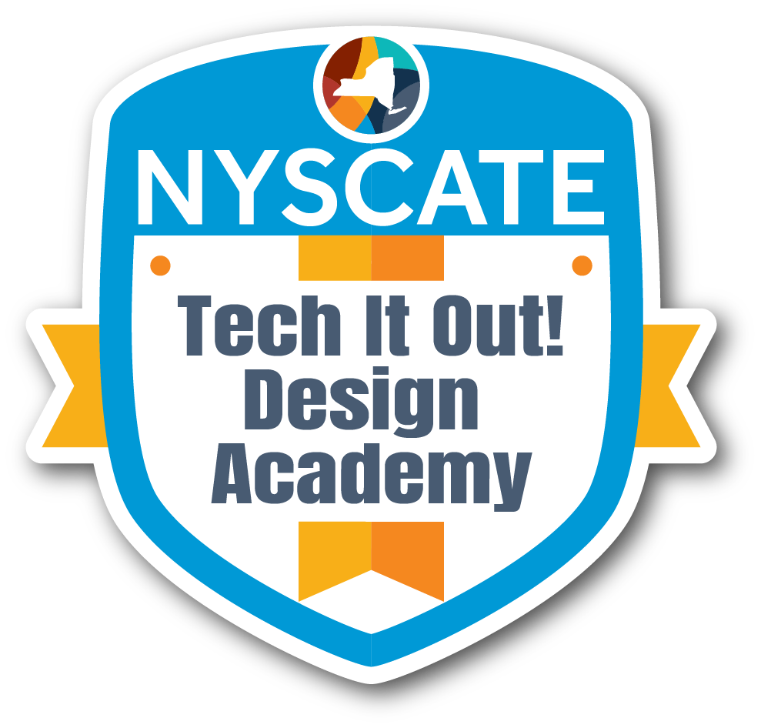
Professional Learning Proposal

Presenter Name:
Position/Role:
School & District:

Session Basics
Session Title: | Improve Student Learning and Engagement Using Virtual Reality (VR) Technology
Session Description: | In this session, elementary, middle, and high school teachers  will explore how to use VR headsets in their classrooms  so they can help students improve their schemas about the world.  Participants will create a shared space of ideas and outlines for lessons for teachers to help students improve reading comprehension, subject competency, and awareness of the world while using cutting edge, engaging technology.
Session Abstract (Pitch): | This class aims to demonstrate how VR can provide students with immersive experiences—such as performing a spacewalk or witnessing historical events like the Titanic—that would otherwise be impossible.  Key Benefits of VR in Education  - High Engagement: VR is a fun and highly engaging tool for students.  - Background Knowledge: It helps students build foundational knowledge through direct digital experience.  - Student Empowerment: Struggling students who have prior VR experience are given the opportunity to be the "experts" in the classroom.  - Professional Relevance: VR is increasingly used across various professional fields. Teachers need to learn to use VR for instruction.
Session Format and Duration: | 10 hours of hybrid learning – 3 hours online using Canvas for materials, resources, assignments, and discussions and 7 hours in person

Timeline
Activity |  | Description | Duration
Introduction & Welcome |  | Introduction will include information about what VR is and how I use it in my class. Learning intentions and the outline of the course will be presented. I will share some of my own experiences using VR with my students. | 10 minutes online
Preassessment (if given) |  | Participants will use a Google Form as a pre-assessment of their comfort level with VR technology and their expectations for the class.  Pre-Assessment of VR Course | 5 minutes online
Engage | Hook/Interest Builder  - Opening activity/scenario  - Connection to participants' experiences  - Questions to spark curiosity | Online and In Class - Participants will have an opportunity to introduce themselves using Canvas online and during the in-person class. They will have a chance to discuss their comfort level with VR technology as well as what they hope to learn from the course. | 30 minutes online  30 minutes in person
Learning Objectives | - By the end of this professional development, participants will be able to: | By the end of this course, participants will be able to:  - Facilitate safe, effective VR experiences with students in their classrooms.  - Observe a specific unit of study utilizing VR.  - Brainstorm, outline, plan, and create unique classroom activities involving VR.  - Collaborate by sharing ideas and receiving feedback from peers.
Explore | Hands-On Discovery Activities  - Investigation activities  - Collaborative exploration tasks  - Resource exploration  - Data analysis opportunities  Guided Discovery Questions:  - What patterns do you notice?  - How does this connect to your practice?  - What questions arise from this exploration? | Participants will have a chance to use Canvas online to explore a unit of study I created which utilizes VR technology. They will have several videos, as well as samples of documents and activities used by students in my classes.  Other resources such as New York State Digital Literacy Standards and links to additional websites and documents will be available on the Canvas page.  Participants will be required to post their own reactions, thoughts, and ideas in online discussions.  Additionally, participants will be asked to read and respond to comments posted by other participants in the online discussions throughout the course.  Participants will be asked to consider how they might use VR technology in their own work throughout the course.  Ultimately, each participant will post an outline or plan to the Canvas page as a resource for other participants. | 2 hours online
Explain | Concept Introduction:  - Key concepts/theories to be presented  - Research base to be shared  - Best practices to be demonstrated  Student Learning Standards  - NYS CSDF  - Other content area standards  Expert Input Methods:  - Presentation format  - Guest expert involvement  - Resource sharing | Participants will be able to observe the full unit of study I use with my students on Canvas as an example of a VR unit. Step-by-step guides and videos will assist teachers who are novices with VR technology in familiarizing themselves with how to use the VR headsets. Explanations and examples will be provided.  Teachers who already know how to use VR headsets will be able to group together to further their experiences with using VR in a classroom.  Participants will be able to use VR headsets in person! They will learn safety protocols as well as tips for using the headsets with students in a classroom. They will be able to explore several videos to get a sense of the different “experiences” they can have using VR headsets.  Flexible grouping and “stations” will allow participants to share the VR headsets and work through aspects of the course at their comfort level.  Teachers will learn tools to address the New York State Computer Science and Digital Fluency Learning Standards. Examples of the standards addressed are:  6R7: Compare and contrast how different formats, including print and digital media, contribute to the understanding of a subject. (RI&RL)  4-6.CT.2 Collect digital data related to a real life question or need.  4-6.DL.2 Select appropriate digital tools to communicate and collaborate while learning with others.  Source: New York State ELA Standards (6) & Computer Science and Digital Fluency Standards (4-6) | 1.5 hours in person  1.5 hours in person
Elaborate | Application & Extension:  - Practice opportunities:  - Scenario applications:  - Skill building activities:  - Peer collaboration tasks  Deepening Understanding:  - How will participants extend their learning?  - What additional contexts will be explored?  - How will learning be differentiated for various needs? | Participants will work together in pairs or small groups to brainstorm ideas for how they might be able to use VR headsets in their own work. Creativity and outside-the-box thinking will be encouraged!  Small groups or pairs will share their ideas with the larger group. Feedback and suggestions will be encouraged.  Each participant will develop an outline for a plan to use VR with their students based on their needs, subject areas, and students’ age groups.  Participants will have a chance to collaborate and share their outlines and plans to showcase their plans and receive feedback both in person and online. They will post their outlines/plans to the Canvas page for the course. Discussions will be encouraged! | 30 minutes in person  1 hour in person  1 hour in person  1 hour in person
Evaluate | Satisfaction Measures:  - Overall satisfaction survey  - Engagement observations  - Participation quality indicators  Data Collection Methods:  - Exit tickets  - Satisfaction surveys  - Focus groups  - Observation/Engagement checklists/observations  - Pre/post assessments  - Skill demonstration  - Concept understanding checks | Participants’ outlines and plans to use VR technology with their students will be shared with the instructor and other class participants to the course page on Canvas so they can give and receive feedback from other participants. There is a rubric for the outline/plan.  Rubric for Outline/Plan for Participants  Participants will use a Google Form for a post-assessment of any changes to their comfort level with VR technology as well as a chance to share their ideas about the class or other information they would like to learn. The instructor will use the data collected from the Google Form spreadsheet to inform future instruction.  Post-Assessment of VR Course  Participants are also required to complete a follow-up form about the course for the district Staff Development Center. | 10 minutes online  5 minutes online
Closure |  | Total time for hybrid course: 10 hours | 3 hours online  7 hours in person

Professional Development Context & Alignment
Primary Professional Standards Addressed: | 2.1.a. Set professional learning goals to apply teaching practices  made possible by technology, explore promising  innovations, and reflect on their effectiveness.  2.1.b. Pursue professional interests by creating and actively  participating in local and global learning networks.  2.3.b. Foster digital literacy by encouraging curiosity, reflection,  and the critical evaluation of digital resources.  2.3.c. Mentor students in safe, legal, and ethical practices with  digital tools and content.
Learner Agency Elements:
- Choice in learning | Participants will be able to create their own outlines and plans for lessons using VR technology.
- Self-assessment | Participants will use a pre- and post-assessment to be metacognitive about their comfort level with VR technology. They will also have multiple opportunities to get ideas and feedback from peers throughout the course, both online and in person.
- Goal-setting | Participants will be able to choose how and to what extent they want to use VR technology in their classrooms. They will express their personal goals in the pre-assessment, and they will evaluate their progress toward those goals in the post-assessment on Google Forms and in the course evaluation for the Staff Development Center.
Prior Experience Utilization:
- Activation of prior knowledge | Participants will come to the class with expertise from teaching different subjects and working with different age levels. They will bring their own knowledge to this class through discussions and participation both online and in person.
- Shared experiences to build upon | Participants will brainstorm ideas together, and they will get and receive feedback on their ideas. They will also work in small groups in a “station” format in person. Participants will be able to share their lessons via Canvas, and they will be able to comment on posts made by other participants.
- Accommodations for varied experience levels | Although this is an introductory course, participants may have various levels of experience with technology, and specifically with VR technology. All comfort levels will be respected, and small groups for the station work will be made with comfort level in mind. People are in the class to learn from and with each other!
Relevance Connections:
- Immediate application opportunities: | Participants will finish the class with an outline and plans for how they can use VR in their classrooms. Additionally, participants will see the work of peers to get even more ideas for using VR technology. The ideas and plans will be archived in Canvas for future use.
- Role-specific relevance: | Participants will create an outline and a plan for how they can use VR in their classrooms with their students and their subject areas.
Real-World Applications:
- Authentic problems to be solved: | Many students are performing two or more years below grade level in reading. Students often lack basic background knowledge and real-world experiences that create schema to help with reading comprehension. Students need to improve their reading skills to increase their reading comprehension so they can be successful in school, careers, and life beyond school. Students also need to be able to use various modes of technology, such as VR technology, to acquire knowledge and exhibit career-ready skills.
- Immediate implementation opportunities: | Students are given opportunities to develop schema by being “in the action” when they use VR technology. These immersive experiences may not be possible otherwise. Increased schema can assist with reading comprehension which can help students learn through reading non-fiction texts.

Resource Requirements
Technology needs: | Internet access  Personal laptops for instructor and participants  Canvas and access to Canvas course  VR Headsets (Meta 3S)  iPad  Curated list of VR/360 degree videos  Screen and projector or portable video monitor
Physical materials: | Tables and chairs  Chart paper and markers  Sticky notes  Extra paper  Pens/pencils/highlighters
Training location/space requirements: | Internet access  Personal laptop for each participant  Canvas and access to Canvas course  VR Headsets  iPad  Curated list of VR/360 degree videos  Screen and projector or portable video monitor  Space in a room to be able to set up VR stations

Differentiation Strategies
Novice accommodations: | This course includes an introduction to using VR technology. Some participants may find the technology a bit overwhelming or confusing. Step-by-step guides, examples, and videos will be used to demonstrate how to use VR technology safely.
Expert challenges: | Some participants may already be very comfortable with VR technology, so they will be called on to share some of their experiences with other participants. Their expertise will be valuable for the participants who are using VR for the first time. Additionally, participants who are experts will be able to move forward into the brainstorming and idea station so they have extra time to create lessons for their students.
Mixed-group strategies: | A “station” format will be used to accommodate the limited number of headsets (4), and allow participants to work at their comfort level.

