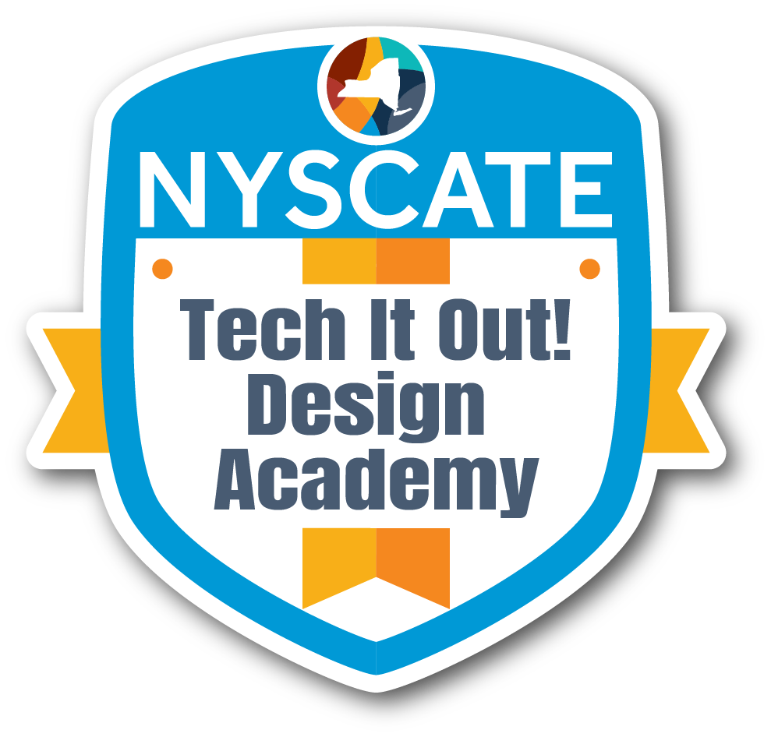
Professional Learning Design Template

Presenter Name:
Position/Role:
School & District:

Session Basic
Session Title: | Discover the Power: Boost Your Lessons with Library Resources
Session Description: | helping teachers confidently use library media center databases and resources to enhance classroom instruction, support research and inquiry, and expand student access to high-quality, credible materials.
Session Abstract (Pitch): | designed for classroom teachers across grade levels and content areas, as well as instructional coaches and support staff who want practical, curriculum-aligned strategies for integrating library resources into everyday teaching.
Session Format: | In person or online - tbd
Duration: | 5 hours

Timeline
Activity |  | Description | Duration
Introduction & Welcome |  | Combined we have over 40 years of experience working in k-12 libraries.  We are passionate about the role the school library plays in instruction and know how to successfully collaborate with teachers.
Preassessment (if given)
Engage | Hook/Interest Builder  - Opening activity/scenario  - Connection to participants' experiences  - Questions to spark curiosity | GOOGLE v the LIBRARY: Who would win?. Teachers receive a real classroom prompt and have about 3 minutes to search and locate credible information that they can use and that students can use. Discuss what they found and call attention to: ads, reading level, accuracy, authority, etc. Show a resource from a database and compare. Library databases aren’t extra - they are instructional tools. | 10-12 min
Learning Objectives | - By the end of this professional development, participants will be able to: | - Identify and navigate key library media center databases and digital tools  - Select age-appropriate, curriculum-aligned resources
Explore | Hands-On Discovery Activities  - Investigation activities  - Collaborative exploration tasks  - Resource exploration  - Data analysis opportunities  Guided Discovery Questions:  - What patterns do you notice?  - How does this connect to your practice?  - What questions arise from this exploration? | Find one feature in your database that would improve student success or save teacher time.  Teachers can work in pairs and use one assignment to find resources in the assigned database.  How does this resource improve what you have and what students can do?  Databases aren’t extra - they enhance what you already do
Explain | Concept Introduction:  - Key concepts/theories to be presented  - Research base to be shared  - Best practices to be demonstrated  Student Learning Standards  - NYS CSDF  - Other content area standards  Expert Input Methods:  - Presentation format  - Guest expert involvement  - Resource sharing | This session supports CSDF by increasing equitable access to high-quality, culturally responsive resources; strengthens NYS ELA research, reading, writing, and discussion skills; and directly aligns with AASL standards for inquiry, inclusion, and ethical information use.  Best practice: Treat the librarian as an instructional partner, not a resource gatekeeper.  - Co-design inquiry questions  - Align databases to units  - Plan skill progression across grades  AASL Alignment:  Collaboration and shared responsibility for learning.
Elaborate | Application & Extension:  - Practice opportunities:  - Scenario applications:  - Skill building activities:  - Peer collaboration tasks  Deepening Understanding:  - How will participants extend their learning?  - What additional contexts will be explored?  - How will learning be differentiated for various needs? | Find one feature in your database that would improve student success or save teacher time.  Ask teachers to think of a real assignment they give (research project, article response, inquiry question, etc.).  In pairs, assign each pair one database:  PebbleGo: read-aloud, tabs, vocabulary, videos  Britannica: Lexile levels, image/media gallery, citations  Gale: topic overviews, viewpoints, primary sources, citation tools  Use the database to find a resource this student could actually use independently. Identify:Reading level controls; Audio supports; Visuals; Vocabulary scaffolds; Primary vs. secondary sources  Show how the same inquiry evolves across grade levels.  Give everyone the same essential question. Each group finds: One fact students would learn; One media element (image, video, primary source); One way students could cite or explain learning. Discuss: How depth increases by grade level; Vertical alignment across databases; How inquiry can grow with students
Evaluate | Satisfaction Measures:  - Overall satisfaction survey  - Engagement observations  - Participation quality indicators  Data Collection Methods:  - Exit tickets  - Satisfaction surveys  - Focus groups  - Observation/Engagement checklists/observations  - Pre/post assessments  - Skill demonstration  - Concept understanding checks | Engagement measured through hands-on participation, collaborative discussion, creation of instructional artifacts, and post-session reflections indicating intent to implement.  Scale Questions (1–5)  - I feel more confident using library databases in my instruction.  - Today’s activities were directly applicable to my classroom.  - I understand when to use PebbleGo, Britannica, and Gale.  - This session respected my time and instructional priorities.  Open-Ended (Choose 1–2): One idea I plan to try in my classroom; One question or support I still need:
Closure |  | In pairs or tables: Share one way you could partner with the library media specialist; Write one co-planning idea and one resource you will use. Prompt: “One unit where the library could support my instruction is…

Professional Development Context & Alignment
Primary Professional Standards Addressed: | Instructionally Relevant and Actionable: Professional learning is anchored in instruction and is sustained in a coherent system of collaborative planning, classroom practice, observation, feedback, and continuous cycles of  inquiry grounded in evidence of student learning.  This session aims to ensure that the use of library resources is not an “extra” but a core part of the instructional space. The inclusion of hands-on discovery activities align with the requirement for sustained duration and active learning
Learner Agency Elements:
- Choice in learning | Teachers choose a "real assignment" from their own curriculum to work on, and they can select which database (PebbleGo, Britannica, or Gale) best fits their students' needs
- Self-assessment | Participants will use scale questions to self-assess their confidence in using databases and their understanding of when to use specific tools.
- Goal-setting | Participants will identify a specific unit or lesson and one co-planning idea they will implement with the library media specialist.
Prior Experience Utilization:
- Activation of prior knowledge | Participants will connect their existing habits of searching for information and compare them to database features.
- Shared experiences to build upon | The presenters will facilitate peer-led discussions about collaborative experiences and credible sources.
- Accommodations for varied experience levels | Participants can be grouped by grade level or by experience level with technology.
Relevance Connections:
- Immediate application opportunities: | Participants will discover ways to apply what they learned about using library resources immediately with students.
- Role-specific relevance: | The workshop is geared to anyone who wants to use high quality resources with students, regardless of their role in the building.
Real-World Applications:
- Authentic problems to be solved: | Participants will be able to self-select an upcoming lesson or unit to boost their teaching and student learning while addressing the real-world challenge of finding credible, age-appropriate, and high-quality materials amidst the sea of inaccurate information found in general web searches.
- Immediate implementation opportunities: | Participants will be able to implement what they learn in this workshop as soon as they want through the creation of instructional artifacts during the session ensures that teachers leave with a resource or plan they can use in their next unit.

Resource Requirements
Technology needs: | High-speed internet access; devices for all participants; active subscriptions and access to library databases: PebbleGo, Britannica, and Gale.
Physical materials: | Projector or screen share for demonstrations. "Real classroom prompts" for the Engage activity; access to database passwords.
Training location/space requirements: | If in person: flexible learning space that supports collaboration, allowing for both whole-group presentations and small-group pair work.

Differentiation Strategies
Novice accommodations: | Focus on user-friendly databases like PebbleGo, emphasizing scaffolds like read-aloud features, visuals, and simple vocabulary.
Expert challenges: | Advanced participants can dive into Gale, focusing on complex tools like primary source analysis, citation management, and Lexile level controls.
Mixed-group strategies: | Group participants by grade-level bands (e.g., K-2, 3-5) to discuss how inquiry depth increases as students grow.

