Dear Parent or Guardian:

Fulton County Schools takes seriously the personal/social and physical safety of our students. In order to proactively address concerns of depression and child/adolescent suicide, the district is providing faculty suicide prevention training and a student
suicide prevention lesson as part of the Signs of Suicide (SOS) Prevention Program. The SOS program has proven successful at increasing help-seeking by students who are concerned about themselves or a friend. It is the only school-based suicide prevention program selected by the Substance Abuse and Mental Health Services Administration for its National Registry of Evidence-Based Programs and Practices that addresses suicide risk and depression, while reducing suicide attempts. Our SOS program goals are as follows:

- To explain that suicide is a preventable tragedy that often occurs as a result of untreated depression.
- To provide students training in how to identify serious depression and potential risk of suicide in a friend.
- To impress upon students that they can help themselves or a friend by taking the simple step of talking to a
responsible adult about their concerns.

Your local School Counseling Department will be coordinating/delivering the Signs of Suicide Lesson through our Health Classes or another appropriate class on the following dates: ______________________________________.

If you DO NOT wish for your child to participate in the SOS suicide prevention lesson at school, please complete the
enclosed form and return it to your local School Counseling Department. If we DO NOT hear from you by the following date: ___________________, we will assume your child has permission to participate in this program.

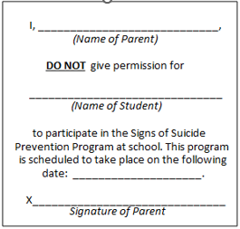
If you have any questions or concerns about this program, please do not hesitate to contact your local School Counseling Department.

Sincerely,

