

Mill Levy Override Revenue Report
Pursuant to
Section 22-2-113.8, C.R.S.
Fiscal Year: 2024-2025

Prepared by:
School Finance Unit

August 25, 2025

Table of Contents

Executive Summary 3

Section 1 - Mill Levy Override Revenue Report 4-7

Section 2 – Addendums 8

Executive Summary
In 2014, the General Assembly of the State of Colorado enacted the “Student Success Act” House Bill 14-1292. Part of this act requires the Colorado Department of Education to annually compile a report concerning the collection of additional local property tax revenues (mill levy override revenues) by school districts. The Mill Levy Override Revenue Report will show:

- The total amount of additional local property tax revenues the district is authorized to collect
- The total amount of authorized revenues that was actually collected by the school district
- The amount distributed to charter schools within the district
- The amount distributed to non-charter schools within the district
- The amount retained by the district

The report will show the above information at the district level and aggregated statewide.

The Department allowed each school district and each district charter school to review the report before publication. School districts and charter schools were allowed to request that the Department compile an addendum to the report, specific to the requesting school district or charter school which examines the overall level of funding distributed by the school district to the charter schools of the district, including:

- Capital construction and facilities funding
- Technology funding
- Any other funding that the district distributes to charter schools of the district

The Department collects annual audited financial information from all school districts via Finance December in Data Pipeline. All districts were required to submit the required information for the FY2023-2024 Mill Levy Override Report specific to their district, even if the amounts were zero (not all school districts are authorized to collect mill levy override revenues).

After the Department collected the Fiscal Year 2024-2025 financial data, a preliminary Mill Levy Override Revenue Report was prepared and sent to the primary financial contacts for district and charter schools. Districts and charter schools reviewed the preliminary report and if needed, addendum requests were sent to the Department.

Note: The Fiscal Year 2024-2025 financial data and audits have not been finalized for Huerfano Re-1, East Otero R-1, Wiley Re-13 Jt and South Routt Re 3. In Fiscal Years 2023-24 these districts were also late.

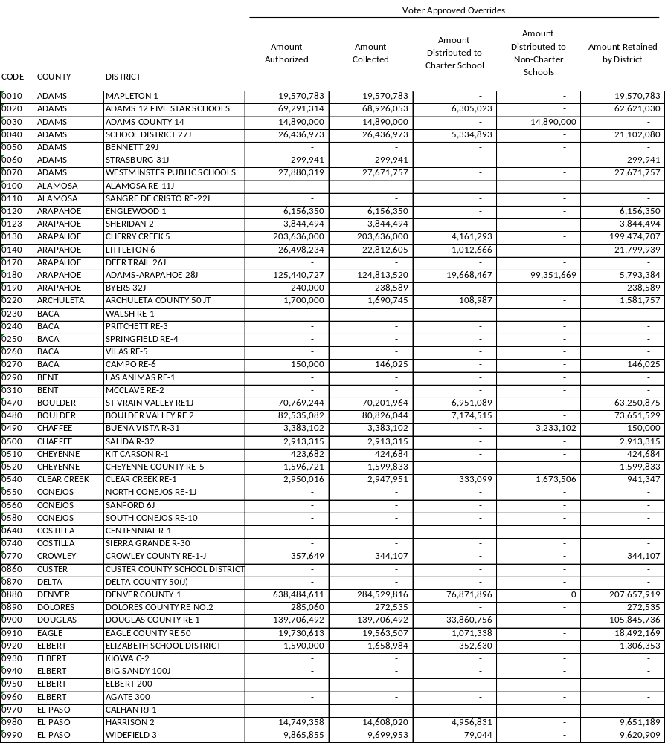

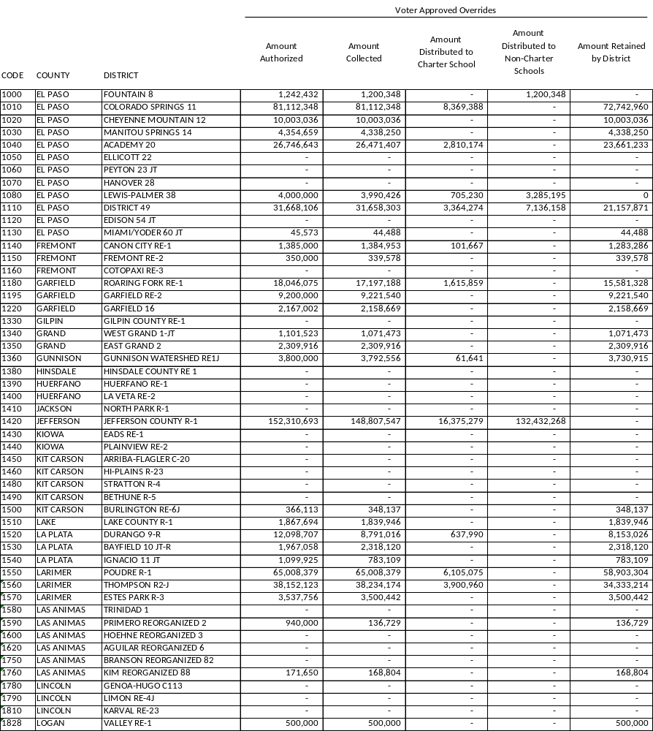

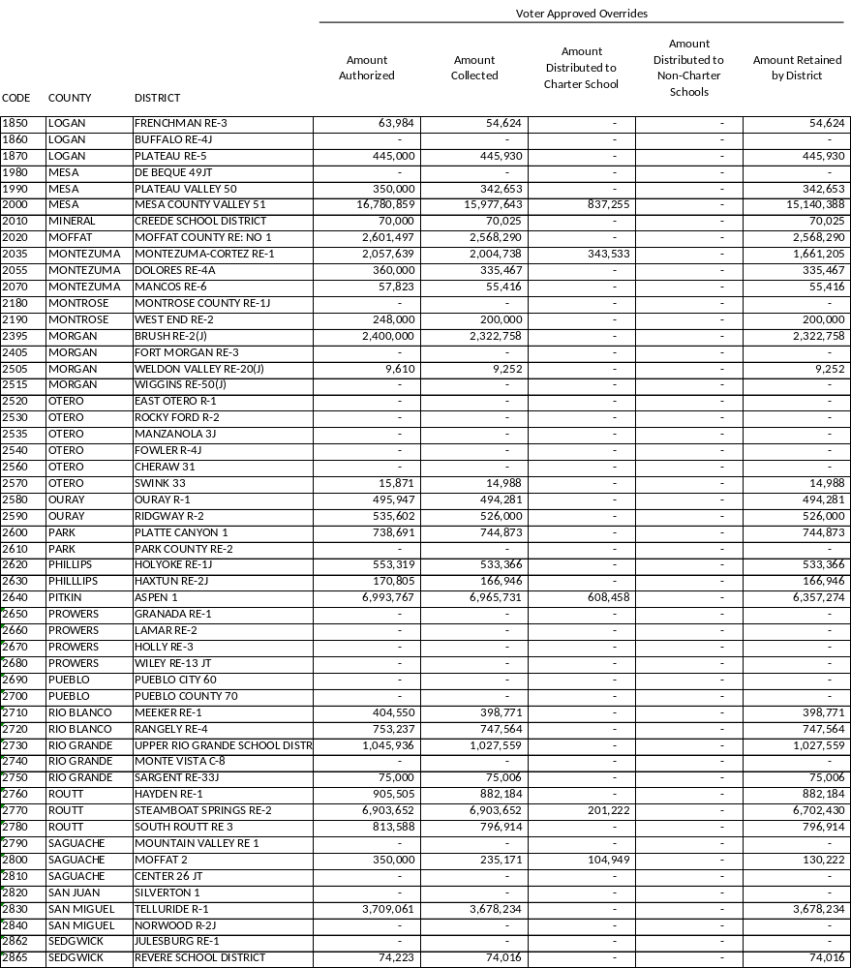

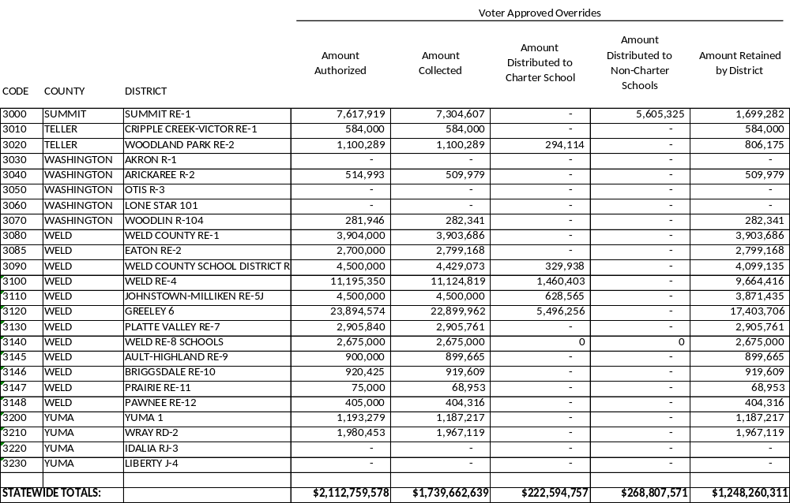

CRS 22-2-113.8
(1) For the 2014-15 budget year and each budget year thereafter, each school district shall report the total amount of additional local property tax revenues the district is authorized to collect in addition to the district's total program mill levy, but not including amounts authorized pursuant to section 22-40-110, article 42 of this title, or article 43 of this title, and the amount of the additional local property tax revenues that the school district distributes directly to schools of the school district, stated as a dollar amount.

(2) The department shall annually compile a report of the information received pursuant to subsection (1) of this section concerning the collection of additional local property tax revenues by each school district and the distribution of the revenues to the schools of the school district, including the charter schools. In addition to the compiled information, the report must include a comparison of the amount of additional local property tax
revenues received by the school district and the amount distributed to the schools of the district, including the charter schools, at the district level and aggregated statewide (aggregated statewide report available on CDE website upon collection and approval of statewide data).

(3) (a) The department shall allow each school district and each district charter school to review the report before publication. A school district or a charter school may request that the department compile an addendum to the report that is specific to the requesting school district or charter school and that examines the overall level of funding distributed by the school district to the charter schools of the district, including:
(I) Capital construction and facilities funding;
(II) Funding for technology; and
(III) Any other funding that the school district distributes to the charter schools of the district.
(b) The department shall simultaneously publish on the department web site the report and any addenda prepared for the report in response to a school district or charter school request.

Addendums: Mill Levy Override Revenue Report
Based on addendum requests submitted to the Colorado Department of Education, Steamboat Springs school district prepared an addendum for charter school in their district.

School District Name: Moffat School #2
District Financial Contact Name and Title: Rebecca Quintana, Finance Director
Phone Number and Email: 719-588-1568, rquintana@moffatschools.org

Charter School Name: Crestone Charter School

Charter School Funding Sources
District Per Pupil Revenue Funding $2,173,519.00
Capital Construction Funding $36,473.00
Other Funding Provided (District to List):
SRS - Forest Reserve Funding $14,808.22
State Match MLO $24,467.18

Mill levy Override $102,585.96
Title I $85,934.00
Title II $14,871.00
Title IV $10,488.00

TOTAL Funding Provided to Charter School $2,463,146

Additional Information Provided by School District
The district extends invitations to the charter school to participate in district sponsored events such as professional development, family nights, etc. Crestone did not participate in FY 2025-2026. Crestone does receive special education support through the district and SLV BOCES under §7.14 of the charter contract, ongoing fiscal, grant, and reporting support from the district business office, and services under IT, facilities, transportation, and food service MOUs.

Please contact district financial contact with questions.

